**Research Article**

**Application of 24-Hour Ambulatory Blood Pressure Monitoring to Measure the Effect of COVID-19 Infection on Cardiovascular Health: A Pilot Study**

**Mulubrhan F. Mogos1#, PhD, MSc1; Soojung Ahn, PhD, RN1, James Muchira, PhD1, Chorong Park, PhD1, Joshua H van der Eerden2, Haileab T. Hilafu, PhD3**

1#Center for Research Development and Scholarship, Vanderbilt University, School of Nursing, Nashville, Tennessee, USA

2Medical College of Georgia, Augusta University, Augusta, Georgia, USA

3Department of Business Analytics and Statistics, University of Tennessee, Knoxville, Tennessee, USA

#**Corresponding author:** Mulubrhan F. Mogos, Assistant Professor, School of Nursing, Vanderbilt University, Family Care Community, 21st South Ave, Nashville, Tennessee 37240, USA

**How to cite this article:** Mogos MF, et al. (2024) Application of 24-Hour Ambulatory Blood Pressure Monitoring to Measure the Effect of COVID-19 Infection on Cardiovascular Health: A Pilot Study. Int J Nurs & Healt Car Scie 04(12): 2024-390.

**Submission Date:** 24 October, 2024; **Accepted Date:** 18 December, 2024; **Published Online:** 31 January, 2025

**Abstract**

**Background:** Up to 30% of patients hospitalized with Coronavirus Disease 2019 (COVID-19) have cardiovascular complications. Identifying early vascular changes that precede overt development of cardiovascular disease (CVD) is crucial for preventing and treating CVD. Therefore, we examined 24-hour ambulatory blood pressure (ABP) parameters that could serve as early markers of vascular change in COVID-19 survivors.

**Methods:** We recruited three categories of adults (18-65 years of age) who had either: (1) COVID-19 with hospitalization; (2) COVID-19 with no hospitalization, or (3) no history of COVID-19. Using a validated oscillometric ABP monitor (Mobil-O-Graph), we measured 24-hour ABP profiles including peripheral and central BP, augmentation index (AIx@75), and pulse wave velocity (PWV). We performed an analysis of variance and chi-square tests to compare means and standard errors of continuous and categorical variables, and created linear models to examine group difference in mean 24-hour ABP profiles across the three study groups, controlling for confounding factors.

**Results:** Thirty-three participants completed the study. On average, participants who had been hospitalized due to COVID-19 were older compared with those with COVID-19 but not hospitalized and those who did not contract COVID-19. After adjusting for potential confounders, participants with COVID-19 who were hospitalized had higher AIx@75.

**Conclusion:** Our finding suggests that 24-hour ABP monitoring profiles, especially AIx@75, may provide early information regarding cardiovascular complications in patients hospitalized with COVID-19. A large-scale study is warranted to confirm the findings of our study.

**Keywords:** 24-hour ambulatory blood pressure; Blood pressure variability; COVID-19; Diastolic; Night dipping; Systolic

**Plain Language Summary**

* The study provided preliminary evidence for the potential role of augmentation index obtained from a non-invasive 24-hour ambulatory blood pressure device in identifying early vascular changes following COVID-19 infection related hospitalization.
* Patient with COVID-19-related hospitalization demonstrated different pattern of 24-hour ambulatory blood pressure than COVID-19 patients with no hospitalization and those with no COVID-19 infection.

**Introduction**

Throughout the Coronavirus Disease 2019 (COVID-19) pandemic, our understanding of the SARS-CoV-2 virus long-term effects has progressively expanded. Although the virus affects multiple organ systems in the post-acute phase, its most notable effects are on the cardiovascular system, manifesting as an increased risk for arrhythmias, myocarditis, cardiac injury, heart failure, and hypertension [1-4]. Evidence shows that SARS-CoV-2 increases the risk of cardiovascular disease (CVD) by infecting artery wall tissue leading to endothelial dysfunction, inflammation, thrombosis, and microvascular obstruction [5]. Given the notable cardiovascular effects of COVID-19, the need for continuous cardiovascular monitoring techniques becomes increasingly evident. Twenty-four-hour ambulatory blood pressure (ABP) monitoring is an advanced method that continuously records several blood pressure (BP) parameters such day/night systolic BP (SBP) and diastolic BP (DBP), night-time dipping, morning surge, pulse wave velocity (PWV), and augmentation index at heart rate of 75 per minutes (AIx@75) over a 24-hour cycle. This technique is particularly crucial in the context of COVID-19, as it helps in the early detection and management of potential cardiovascular complications that are now known to be associated with COVID-19. Unlike standard clinic-based BP measurements, which only offer a snapshot in time, 24-hour ABP monitoring delivers a comprehensive profile of BP changes that are strongly predictive of incident CVD, future cardiovascular events, and mortality [6,7].

Previous studies examining the associations of COVID-19 infection with 24-hour ABP have shown mixed results. Two studies [8,9] showed no significant increases in 24-hour ABP parameters 4-8 months after COVID-19 infection.However, other research [10,11] focusing on patients with history of COVID-19-related hospitalization reported elevated 24-hour ABP and office BP [12] readings 6 months after discharge. Additionally, a study [4] using clinic BP measures also reported that COVID-19 patients had elevated SBP and DBP after 31.6 ± 5.0 days on average after diagnosis. The variance in existing findings can likely be ascribed to a range of factors, including the diverse severity of COVID-19 symptoms experienced by individuals and the critical aspect of when the outcomes are measured after COVID-19 infection. For example, one [8] of the two studies that reported comparable 24-hour ABP among groups reported a significant inverse relationship between time since COVID-19 diagnosis and BP, with higher BP readings when measured closer to the acute infection. Recognizing the significance of contextualizing the severity of COVID-19 infection, in the current study, we recruited three groups of participants (COVID-19 with hospitalization, COVID-19 with no hospitalization, and no COVID-19). We also incorporated a comprehensive analysis of self-reported symptoms associated with COVID-19, providing a more granular view of the disease's impact. Additionally, we integrated the fatigue severity score scale, recognizing that fatigue can be a pervasive and often underestimated aspect of the post-COVID-19 experience. The aim of this pilot study was to generate preliminary data on the association between COVID-19 severity and 24-hour ABP parameters after ≥ 3-months of initial diagnosis of COVID-19.

**Methods**

**Study Design, Setting, and Participants**

In this prospective cross-sectional study, we recruited adults (18-65 years of age) who met one of the following three criteria: had a diagnosis of COVID-19 (≥3 months ago) that resulted in hospitalization; had a diagnosis of COVID-19 (≥3 months ago) that did not result in hospitalization; or had a negative COVID-19 test ≥3 months ago and did not have history of COVID-19 diagnosis. Exclusion criteria included: (1) receiving treatment for high BP, (2) a diagnosis of atrial fibrillation or other arrhythmia, arteriovenous fistula in the brachial arm, or lymphedema, (3) those with history of angina pectoris, myocardial infarction, stroke, heart failure, peripartum cardiomyopathy, or bleeding disorder, (4) those who were currently on blood thinners, and (5) body mass index ≥ 40 kg/m2.

**Procedures**

After obtaining written consent, participants visited our research clinic. During this baseline visit, participants completed: 1) a baseline questionnaire including demographic characteristics and fatigue using the fatigue severity score [13]; 2) anthropometric measurements (weight, height, and upper-mid-arm circumference); and 3) brachial artery resting BP measurement using Omron oscillometer device (Omron 907L, Omron, Lake Forest, IL) [14] per the American Heart Association and the international consensus on standardized clinic BP measurement guidelines [15,16]. We obtained three BP readings, and the mean of the three measurements was used for analysis. When leaving the clinic, participants were fit with the ABP monitor (Mobil-O-Graph, IEM GmbH, Stolberg, Germany), which they wore for 24 hours.

**24-Hour ABP Monitoring**

The 24-hour ABP monitoring device was configured to record BP measurements every 30 minutes during the day (while awake) and every hour during the nighttime (while asleep) based on the participants-reported wake and sleep times. In accordance with the American Heart Association guidelines for BP measurement, appropriately sized cuffs were applied to the participants' non-dominant mid-upper arm circumferences [16]. Participants were instructed to maintain their usual daily activities during the measurement period, ensuring their arm remained still and extended at cuff inflation. Subsequently, all ABP parameters, including 24-hour ambulatory brachial and aortic BP (cSBP, cDBP), mean arterial pressure, (AIx@75), PWV, and related metrics, were extracted from the device using HMS Client Server software. Utilizing these data, we computed the average values for 24-hour ABP parameters. Nocturnal BP dipping was assessed by calculating the percentage of BP drop, employing the formula: dipping (%) = (mean daytime BP-mean nighttime BP) * 100/ mean daytime BP. This percentage was categorized into two groups: non-dipping BP (defined as a < 10% decrease) and dipping (10% to 20% decrease) [17]. In addition, we calculated ABPV indices including standard deviation (SD), coefficient of variation (CoV), weighted standard deviation (wSD), [18] average real variability (ARV), [19,20]and successive variation (SV) [21].

**Data Analysis**

Descriptive statistics were used to describe the sample characteristics by COVID-19 diagnosis and hospitalization status. Adherence/compliance to 24-hour ABP monitoring was assessed by calculating the percentage of participants completing the measurement over 24 hours and the number of valid BP readings obtained over the period. Participants who had at least 70% of the expected number of valid BP readings within the 24-hour period were considered compliant and included in the analysis [22,18]. Analysis of variance and chi-square tests were used to compare means and standard errors of continuous and categorical variables across the three study groups. Multivariable linear regression was conducted to examine group difference in mean 24-hour ABP profiles across the three study groups. The multivariate linear regression model was adjusted for timing of BP, age, sex, race, smoking, weight, presence of chronic illness, and standard errors for clustering by subject. The additional adjustment for standard errors for clustering was necessary because the repeated measures within a subject were likely correlated, not independent. The data underlying this article cannot be shared publicly due to the small sample size and the risk this might cause for the privacy of individuals that participated in the study. The data will be shared on reasonable request to the corresponding author.

**Results**

Thirty-eight participants successfully completed the study procedure. Of those, four participants were excluded because less than 70% of the desired ABP readings were obtained during the 24-hour cycle. On average, participants with COVID-19 diagnosis that resulted in hospitalization were older (mean age=56 years, SD=6) than those with the diagnosis of COVID-19 who were not hospitalized (mean age=38years, SD=14) and those with no-COVID-19 diagnosis (mean age=35 years, SD=12). Patients with COVID-19 hospitalization had higher mean fatigue severity score (38.8) than those with COVID-19 who were not hospitalized (32.4) and those with no COVID-19 (29.5). A fatigue severity score of 36 or more suggests that an individual is suffering from possible fatigue and require further investigation. Table 1 provides a summary of selected demographics, anthropometric measurements, BP, and fatigue score by COVID-19 diagnosis and hospitalization status. Compared to COVID-19 patients that were not hospitalized, those with COVID-19 related hospitalization were more likely to report cough, fatigue, fever, hoarse voice, shortness of breath, and weakness (Figure 1). Fifty percent of COVID-19 patients requiring hospitalization experienced an illness duration exceeding 4 weeks. Among COVID-19 patients admitted to the hospital, 25% had an illness duration ranging from 3 to 4 weeks, while another 25% had an illness duration of 1 to 2 weeks. Conversely, 37.5% of those not requiring hospitalization experienced an illness duration exceeding 4 weeks, and 62.6% of COVID-19 patients without hospitalization had an illness duration of less than two weeks. Compared to those not hospitalized with COVID-19 and those with no COVID-19 diagnosis, 24- hour- SBP, DBP, cSBP, cDPB, AIx@75, PWV, SD, COV, wSD, ARV, and SV parameters were mostly higher for patients hospitalized with COVID-19 (See Figures 2a-f). However, these differences were not statistically significant. After adjusting for timing of BP (day vs. night), age, sex, race, smoking, weight presence of chronic illness, and standard errors (to account for potential within subject correlation in repeated BP measures), patients with COVID-19 that did not result in hospitalization had lower AIx@75 (mean difference of 4.30, SD = 2.38; p < 0.1) than those hospitalized with COVID-19 (Table 2). Other 24-hour ABP parameters (SBP, DBP, cSBP, cDBP, and PWV) were also lower for COVID-19 patients that were not hospitalized when compared to those who were hospitalized, although the difference did not reach statistical significance in the adjusted model.

|  |  |  |  |  |  |
| --- | --- | --- | --- | --- | --- |
| Blood pressure parameters and indices | Total | COVID-19 with hospitalization (n=4) | COVID-19 without hospitalization (n=17) | No COVID-19 (n=13) | p-value (Kruskal-Wallis Test/Chi-square Test) |
|  | M±SD/n (%) | M±SD/n (%) | M±SD/n (%) | M±SD/n (%) |  |
| Demographics/Anthropometric measure/Fatigue score | | | | | |
| Age in years (Mean± SD) | 39±14 | 56±6 | 38±14 | 35±12 | 0.052 |
| aWeight in pounds (Mean±SD) | 163.5±44.5 | 187.2±18.9 | 172.6±53.9 | 143.5±27.6 | 0.038* |
| bUpper-mid-arm circuference in inches (Mean±SD) | 12.4±8.5 | 13.1±0.9 | 14.3±11.1 | 9.5±4.9 | 0.106 |
| Fatigue serverity scale score (Mean±SD) | 31.7±13.6 | 38.8±13.2 | 31.7±13.6 | 29.5±14.2 | 0.475 |
| Race (%) |  |  |  |  | 0.32 |
| White | 24 (70.6) | 2 (50.0) | 14 (82.4) | 8 (61.5) |  |
| Black | 6 (17.6) | 2 (50.0) | 2 (11.8) | 2 (15.4) |  |
| Hispanic | 2 (5.9) | - | 1 (5.9) | 1 (7.7) |  |
| Asian | 2 (5.9) | - | - | 2 (15.4) |  |
| Location (%) |  |  |  |  | 0.162 |
| Urban | 29 (85.3) | 3 (75.0) | 13 (76.5) | 13 (100.0) |  |
| Rural | 5 (14.7) | 1(25.0) | 4 (23.5) | - |  |
| SBP | | | | | |
| cOffice BP | 119.3±16.3 | 132.3±15.3 | 114.6±9.8 | 121.2±22.5 | 0.033* |
| ABP-24hours | 117.8±9.8 | 127.9±12.6 | 116.7±9.4 | 116.1±8.1 | 0.139 |
| ABP-day | 120.3±10.9 | 130.4±13.9 | 120.0±10.9 | 117.7±9.1 | 0.267 |
| ABP-night | 107.2±9.0 | 117.6±13.0 | 105.7±7.0 | 106.1±8.6 | 0.189 |
| ARV | 9.5±2.5 | 10.2±2.1 | 9.7±3.0 | 9.1±1.8 | 0.667 |
| SV | 12.7±3.4 | 14.1±3.2 | 12.9±4.2 | 12.0±2.1 | 0.581 |
| SD | 12.1±3.4 | 13.3±3.3 | 12.3±4.1 | 11.5±2.5 | 0.595 |
| COV | 10.2±2.5 | 10.3±2.2 | 10.4±3.1 | 9.9±1.8 | 0.884 |
| wSD | 10.2±2.6 | 11.7±2.1 | 10.2±3.0 | 9.8±2.2 | 0.314 |
| Dipping |  |  |  |  |  |
| <10% | 13 (38.2) | 1 (25.0) | 6 (35.3) | 6 (46.2) | 0.699 |
| ≥10% | 21 (61.8) | 3 (75.0) | 11 (64.7) | 7 (53.8) |  |
| DBP | | | | | |
| Office BP* | 70.4±14.6 | 79.0±3.8 | 71.7±12.8 | 64.4±18.7 |  |
| ABP-24hours | 73.3±7.0 | 79.1±6.6 | 73.0±6.4 | 71.8±7.5 | 0.206 |
| ABP-day | 76.1±7.7 | 81.8±7.1 | 76.3±7.1 | 74.2±8.1 | 0.236 |
| ABP-night | 62.0±6.4 | 68.1±7.4 | 61.4±5.6 | 60.8±6.6 | 0.398 |
| ARV | 8.5±2.0 | 8.8±1.7 | 8.9±2.4 | 7.8±1.1 | 0.514 |
| SV | 11.1±2.8 | 11.8±2.8 | 11.6±3.6 | 10.2±1.3 | 0.631 |
| SD | 11.1±2.2 | 11.3±1.8 | 11.5±2.5 | 10.5±1.9 | 0.453 |
| COV | 15.3±3.4 | 14.3±2.6 | 15.9±4.1 | 14.7±2.4 | 0.807 |
| wSD | 9.0±2.1 | 9.8±0.9 | 9.3±2.6 | 8.4±1.8 | 0.232 |
| Dipping |  |  |  |  |  |
| <10% | 6 (17.6) | 1 (25.0) | 2 (11.8) | 3 (23.1) | 0.842 |
| ≥10% | 28 (82.4) | 3 (75.0) | 15 (88.2) | 10 (35.7) |  |
| ABP measures of arterial stiffness | | | | | |
| AIx@75 | 22.9±7.1 | 26.8±10.4 | 20.9±6.0 | 24.2±7.2 | 0.219 |
| PWV | 6.2±1.3 | 8.0±1.1 | 6.0±1.3 | 5.7±1.0 | 0.030* |
| amissing=2; bmissing=4 ; cmissing=6 ; *p < 0.05  m= mean; SD= standard deviation, BP = blood pressure; ABP = ambulatory blood pressure; ARV= average real variability; SV= successive variation; wSD = weighted standard deviation; AIx@75= augmentation index at heart rate of 75 beat per minute; PWV = pulse wave velocity. | | | | | |

**Table 1:** Summary of selected demographics, anthropometric measurements, fatigue score, ambulatory blood pressure profiles, and ambulatory blood pressure variability indices, by COVID-19 diagnosis and hospitalization status.

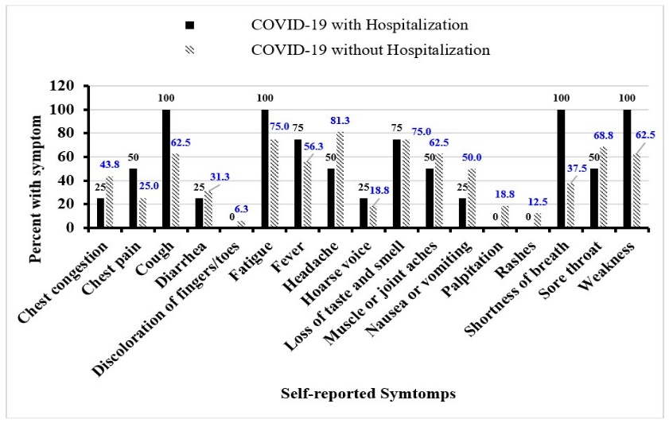

**Figure 1:** Percentage of patient-reported COVID-19 related symptoms at the time of COVID-19 diagnosis by hospitalization status.

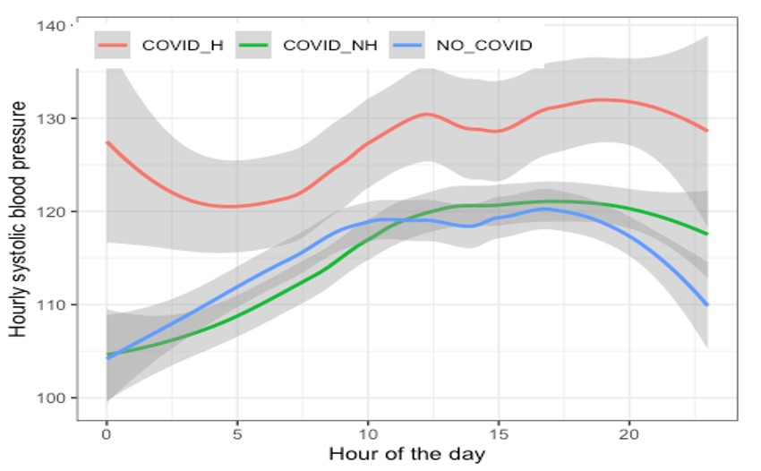

**Figure 2a:** Distribution of hourly peripheral SBP by COVID-19 diagnosis/hospitalization status during a 24-hour ABP measurement cycle.

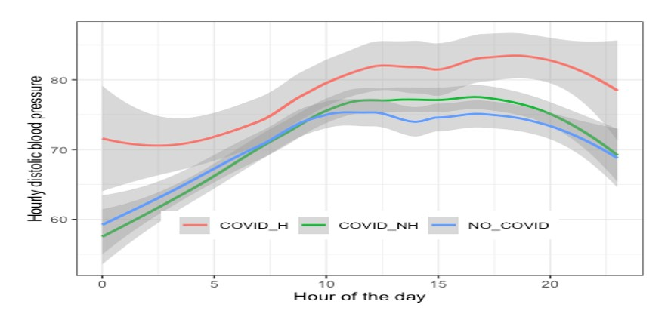

**Figure 2b:** Distribution of hourly peripheral DBP by COVID-19 diagnosis/hospitalization status during a 24-hour ABP measurement cycle.

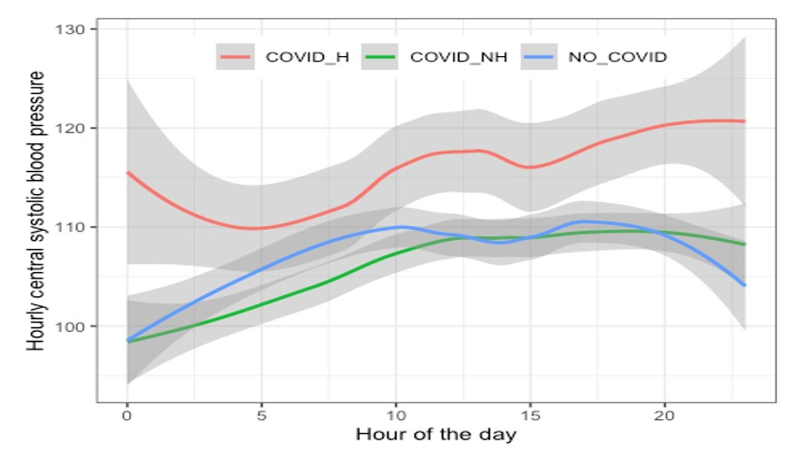

**Figure 2c:** Distribution of hourly peripheral cDBP by COVID-19 diagnosis/hospitalization status during a 24-hour ABP measurement cycle.

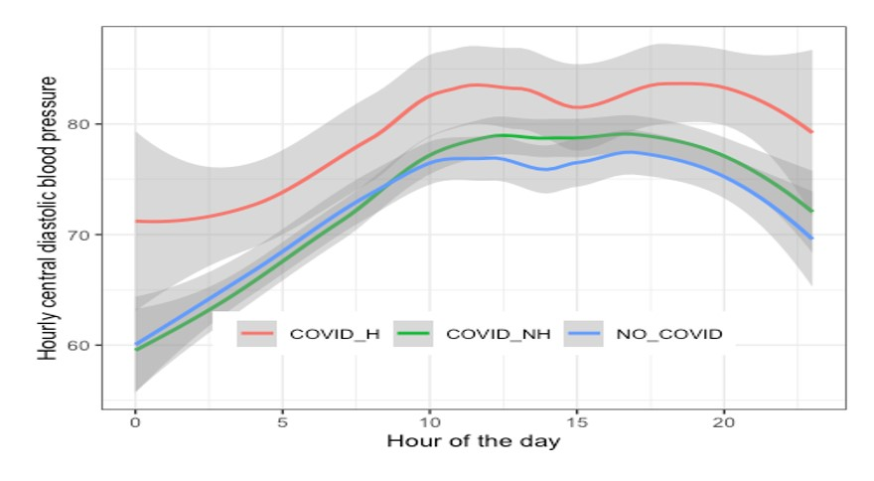

**Figure 2d:** Distribution of hourly peripheral cDBP by COVID-19 diagnosis/hospitalization status during a 24-hour ABP measurement cycle.

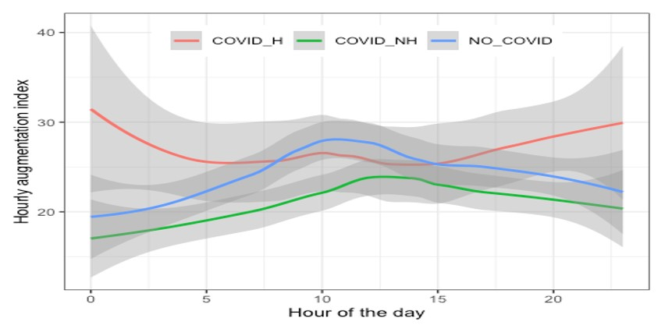

**Figure 2e:** Distribution of hourly peripheral AIx@75 by COVID-19 diagnosis/hospitalization status during a 24-hour ABP measurement cycle.

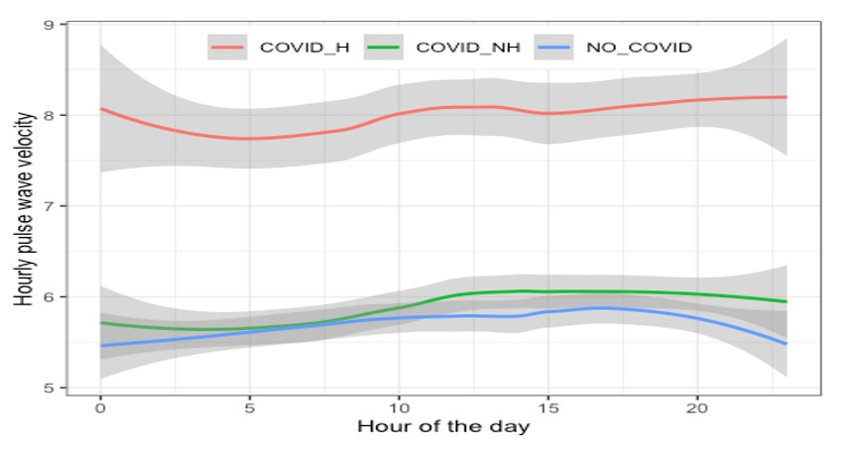

**Figure 2f:** Distribution of hourly peripheral PWV by COVID-19 diagnosis/hospitalization status during a 24-hour ABP measurement cycle.

|  |  |  |  |  |  |  |
| --- | --- | --- | --- | --- | --- | --- |
| Study Group | Dependent Variable | | | | | |
| Study Group | SBP β(SD) | DBPβ(SD) | cSBP β(SD) | cDBP β(SD) | AIx@75 β(SD) | PWV β(SD) |
| COVID-19 with no hospitalization | -6.33  (6.55) | -5.80 (4.83) | -3.36 (4.59) | -5.10 (4.68) | -4.30* (2.38) | -0.33 (0.34) |
| No COVID-19 | -3.58 (7.16) | -6.35 (6.02) | 0.80 (5.37) | -5.60 (5.91) | -3.97 (2.77) | -0.25 (0.31) |
| Observations | 1,110 | 1,110 | 1,008 | 1,008 | 1,110 | 1,110 |
| Adjusted R2 | 0.28 | 0.24 | 0.25 | 0.28 | 0.24 | 0.87 |
| The reference group is Hospitalization with COVID-19 **Notes:** Cluster robust standard errors (at 24-hour ABP measurement level) are reported in parenthesis Model adjusted for covariates (timing of BP [day/night], age, sex, race, smoking, weight, chronic illness) and standard errors; *p<0.1  SBP = systolic blood pressure; DBP= diastolic blood pressure; cSBP = central systolic blood pressure; cDBP= central diastolic blood pressure; AIx@75= augmentation index at heart rate of 75 beat per minute; SD = standard deviation | | | | | | |

**Table 2:** Multiple linear regression results for the association of 24-hour ABP parameters with COVID-19 diagnosis/hospitalization status.

**Discussion**

This pilot study presents 24-hour ABP parameters in patients with and without the diagnosis of COVID-19. The main findings of the study are: (1) Patients hospitalized with COVID-19 had different pattern of 24-hour ABP parameters than COVID-19 patients with no hospitalization and those with no COVID-19; (2) COVID-19 patient with hospitalization were, on average, older than those with a COVID-19 diagnosis who were not hospitalized and those with no COVID-19 diagnosis; (3) those with COVID-19-related hospitalization reported more symptoms such as cough, fatigue, fever, hoarse voice, shortness of breath, and weakness compared to those with COVID-19 diagnosis who were not hospitalized. Patients with COVID-19 hospitalization also had a higher fatigue severity score compared to those with COVID-19 who were not hospitalized and those with no COVID-19 diagnosis. Various 24-hour ABP measures, including SBP, DBP, cSBP, cDBP, AIx@75, and PWV, were all higher in COVID-19 patients who were hospitalized compared to those who were not, both during the day and night. The elevated 24-hour ABP measurements in hospitalized COVID-19 patients are consistent with studies indicating that severe COVID-19 can lead to cardiovascular complications [4,11]. However, the specific BP parameters and the extent of elevation may vary between studies, potentially due to differences in patient populations or timing of the measurements. For example, a recent study investigating the impact of COVID-19 on ABP in young adults did not find a difference between COVID-19 patients and controls, but did report higher BP parameters in COVID-19 patients with more recent infection [8]. After adjusting for various factors like day vs. night BP, age, sex, race, smoking, weight and the presence of chronic illness, patients with COVID-19 diagnosis not resulting in hospitalization had significantly lower AIx@75 compared to those hospitalized with COVID-19. The significant difference in AIx@75 between hospitalized and non-hospitalized COVID-19 patients, even after adjusting for various factors, is a noteworthy finding. It suggests that this parameter may be a potential predictor of the severity of cardiovascular outcomes related to COVID-19. AIx@75 has been previously reported to be associated with increased risk of CVD in hemodialysis patients [23] and improved cardiovascular risk prediction in patients at low cardiovascular risk [24]. A study comparing 24-hour ABP among patients hospitalized with COVID-19 and control groups with known history of hypertension but no history of COVID-19 infection reported significantly higher average 24-hour SBP and DBP, average night times SBP and DBP, and average daytime SBP among those with COVID-19 hospitalization than hypertensive controls with no history of COVID-19 infection. Another study reported increased new-onset non-dipper hypertension in patients with history of COVID-19 hospitalization [11].

In the current study, hospitalized patients with the diagnosis of COVID-19 were, on average, older than those with a COVID-19 diagnosis who were not hospitalized and those with no COVID-19 diagnosis. Other studies have also reported that hospitalized COVID-19 patients tend to be older than non-hospitalized ones [25,26].This finding is consistent with the general understanding that older individuals are at a higher risk of severe disease and hospitalization due to COVID-19.The higher prevalence of symptoms such as cough, fatigue, fever, hoarse voice, shortness of breath, and weakness in hospitalized Covid-19 patients aligns with findings from various studies, emphasizing that severe cases of COVID-19 often present with a more extensive range of symptoms [27,28]. However, the specific symptoms observed may vary across studies. A significant proportion (75%) of COVID-19 patients who were hospitalized reported an illness duration of more than 3 weeks, in contrast to only 37.5% of those not hospitalized. The extended illness duration observed in hospitalized patients, with 75% experiencing more than 3 weeks of illness, is in line with some literature suggesting that severe COVID-19 cases may have a longer recovery period [27,29]. Generally, a fatigue score of 36 or more is a score that indicates severe fatigue and hence warrants further evaluation by a clinician [30].The higher fatigue severity score in hospitalized COVID-19 patients is in line with reports of persistent fatigue as a post-COVID symptom in some individuals [31-33]. The degree of fatigue can differ between studies, possibly due to variations in measurement methods or patient demographics.

Despite being one of the first few studies investigating 24-hour ABP parameters in patients with COVID-19 with different levels of severity, the study has some limitations worth mentioning. The sample size was small, and the study used convenient sampling, potentially limiting the generalizability of the findings. Additionally, the presence and absence of chronic conditions was determined based on self-reporting and therefore is prone to bias. Overall, our findings indicate that individuals hospitalized with COVID-19 exhibit significant differences in terms of age, symptom severity, illness duration, BP measurements, and fatigue severity compared to those with a COVID-19 diagnosis not resulting in hospitalization. The specific significance of these differences, particularly the elevated AIx@75 in the non-hospitalized group after adjusting for covariates and potential correlation, suggests potential implications for clinical management and patient care. Twenty four-hour ABP monitoring profiles, especially AIx@75 might provide an early sign of CVD in patients hospitalized with COVID-19 infection. Our results should serve as preliminary data to help set parameters used in monitoring cardiovascular health post-COVID-19 infection and assist in designing a larger study. ABP monitoring may prove beneficial as a non-invasive approach to predict the long-term cardiovascular effects of COVID-19 infection [8]. A large-scale study is warranted to confirm the findings of our study. In summary, this study contributes to the growing body of literature on COVID-19 by highlighting key differences between hospitalized and non-hospitalized patients, particularly in terms of age, symptoms, illness duration, and 24-hour ABP measurements.

**Funding**

This study is partially funded by the Oak Ridge Associated Universities through the 2021 Ralph E. Powe Junior Faculty Enhancement Award in Engineering and Applied Science.

**Registration Number**

This study doesn’t qualify as a clinical trial and therefore we do not have a registration number

**Author’s Contributions**

MFM and HTH (Conception and design of the study, acquisition of data, analysis and interpretation of data, drafting, revising, and final approval of the article); SA, JM, CP, and JHE (acquisition of data, analysis and interpretation of data, drafting, revising, and final approval of the article)

**Acknowledgement**

We thank Riya Chinni for her help in recruitment and data collection.

**Conflict of Interest**

All authors report no conflict of interest.

**References**

1. [Guzik TJ, Mohiddin SA, Dimarco A, Patel V, savvatis K, et al. (2020) COVID-19 and the cardiovascular system: implications for risk assessment, diagnosis, and treatment options. Cardiovasc Res. Aug 116: 1666-1687.](https://pubmed.ncbi.nlm.nih.gov/32352535/)
2. [Abbasi J (2022) The COVID Heart-One Year After SARS-CoV-2 Infection, Patients Have an Array of Increased Cardiovascular Risks. JAMA 327: 1113-1114.](https://pubmed.ncbi.nlm.nih.gov/35234824/)
3. [Wang W, Wang CY, Wang SI, Wei JC (2022) Long-term cardiovascular outcomes in COVID-19 survivors among non-vaccinated population: A retrospective cohort study from the TriNetX US collaborative networks. EClinicalMedicine 53: 101619.](https://pubmed.ncbi.nlm.nih.gov/35971425/)
4. [Akpek M (2022) Does COVID-19 Cause Hypertension? Angiology 73: 682-687.](https://pubmed.ncbi.nlm.nih.gov/34889662/)
5. [Yugar-Toledo JC, Yugar LBT, Sedenho-Prado LG, Schreiber R, Moreno H (2023) Pathophysiological effects of SARS-CoV-2 infection on the cardiovascular system and its clinical manifestations a mini review. Mini Review. Frontiers in Cardiovascular Medicine 16:10: 1162837.](https://pubmed.ncbi.nlm.nih.gov/37260945/)
6. [Yang WY, Melgarejo JD, Thijs L (2019) Association of Office and Ambulatory Blood Pressure with Mortality and Cardiovascular Outcomes. JAMA 322: 409-420.](https://pubmed.ncbi.nlm.nih.gov/31386134/)
7. [Pena-Hernandez C, Nugent K, Tuncel M (2020) Twenty-Four-Hour Ambulatory Blood Pressure Monitoring. J Prim Care Community Health 11: 2150132720940519.](https://pubmed.ncbi.nlm.nih.gov/32646277/)
8. [Nandadeva D, Skow RJ, Grotle AK, Stephens BY, Young BE, et al. (2022) Impact of COVID-19 on ambulatory blood pressure in young adults: a cross-sectional analysis investigating time since diagnosis. J Appl Physiol 133: 183-190.](https://pubmed.ncbi.nlm.nih.gov/35708703/)
9. [Heckel AR, Arcidiacono DM, Coonan KA (2022) Twenty-Four-Hour Central Hemodynamic Load in Adults With and Without a History of COVID-19. Am J Hypertens 35: 948-954.](https://pubmed.ncbi.nlm.nih.gov/36006055/)
10. [Wasim D, Alme B, Jordal S (2021) Characteristics of 24-hour ambulatory blood pressure monitoring in a COVID-19 survivor. Future Cardiology 17: 1321-1326.](https://pubmed.ncbi.nlm.nih.gov/33876965/)
11. [Sivri F, Türköz I, Şencan M, İçen YK, Aksoy F, et al. (2020) Does COVID-19 Cause Non-Dıpper Hypertension? Angiology 20: 00033197231209584.](https://pubmed.ncbi.nlm.nih.gov/37864346/)
12. [Zhang V, Fisher M, Hou W, Zhang L, Duong TQ (2023) Incidence of New-Onset Hypertension Post–COVID-19: Comparison With Influenza. Hypertension 80: 2135-2148.](https://pubmed.ncbi.nlm.nih.gov/37602375/)
13. [Krupp LB, LaRocca NG, Muir-Nash J, Steinberg AD (1989) The fatigue severity scale. Application to patients with multiple sclerosis and systemic lupus erythematosus. Arch Neurol 46: 1121-1123.](https://pubmed.ncbi.nlm.nih.gov/2803071/)
14. [El-Assaad MA, Topouchian JA, Darné BM, Asmar RG (2002) Validation of the Omron HEM-907 device for blood pressure measurement. Blood Press Monit 7: 237-241.](https://pubmed.ncbi.nlm.nih.gov/12198340/)
15. [Cheung AK, Whelton PK, Muntner P (2023) International Consensus on Standardized Clinic Blood Pressure Measurement - A Call to Action. Am J Med 136: 438-445.e1.](https://pubmed.ncbi.nlm.nih.gov/36621637/)
16. [Muntner P, Shimbo D, Carey RM (2019) Measurement of Blood Pressure in Humans: A Scientific Statement from the American Heart Association. Hypertension 73: e35-e66.](https://pubmed.ncbi.nlm.nih.gov/30827125/)
17. [Tang A, Yang E, Ebinger JE (2024) Non-Dipping Blood Pressure or Nocturnal Hypertension: Does One Matter More? Current Hypertension Reports 26: 21-30.](https://pubmed.ncbi.nlm.nih.gov/37955827/)
18. [Bilo G, Giglio A, Styczkiewicz K (2007) A new method for assessing 24-h blood pressure variability after excluding the contribution of nocturnal blood pressure fall. J Hypertens 25: 2058-2066.](https://pubmed.ncbi.nlm.nih.gov/17885548/)
19. [Mena L, Pintos S, Queipo NV, Aizpúrua JA, Maestre G, et al. (2005) A reliable index for the prognostic significance of blood pressure variability. J Hypertens 23: 505-511.](https://pubmed.ncbi.nlm.nih.gov/15716690/)
20. [Mena LJ, Felix VG, Melgarejo JD, Maestre GE (2017) 24-Hour Blood Pressure Variability Assessed by Average Real Variability: A Systematic Review and Meta-Analysis. J Am Heart Assoc 6: e006895.](https://pubmed.ncbi.nlm.nih.gov/29051214/)
21. [Schächinger H, Langewitz W, Schmieder RE, Rüddel H (1989) Comparison of parameters for assessing blood pressure and heart rate variability from non-invasive twenty-four-hour blood pressure monitoring. J Hypertens Suppl 7: S81-S84.](https://pubmed.ncbi.nlm.nih.gov/2760718/)
22. [Lithovius R, Gordin D, Forsblom C, Saraheimo M, Harjutsalo V, et al. (2018) Ambulatory blood pressure and arterial stiffness in individuals with type 1 diabetes. Diabetologia 61: 1935-1945.](https://pubmed.ncbi.nlm.nih.gov/29797021/)
23. [Sarafidis PA, Loutradis C, Karpetas A (2017) Ambulatory Pulse Wave Velocity Is a Stronger Predictor of Cardiovascular Events and All-Cause Mortality Than Office and Ambulatory Blood Pressure in Hemodialysis Patients. Hypertension 70: 148-157.](https://pubmed.ncbi.nlm.nih.gov/28483919/)
24. [Desbiens LC, Fortier C, Nadeau‐Fredette AC (2022) Prediction of Cardiovascular Events by Pulse Waveform Parameters: Analysis of CARTaGENE. Journal of the American Heart Association 11: e026603.](https://pubmed.ncbi.nlm.nih.gov/36056725/)
25. [Killerby ME, Link-Gelles R, Haight SC (2020) Characteristics Associated with Hospitalization Among Patients with COVID-19 - Metropolitan Atlanta, Georgia, March-April 2020. MMWR Morb Mortal Wkly Rep 69: 790-794.](https://pubmed.ncbi.nlm.nih.gov/32584797/)
26. [Birkmeyer JD, Barnato A, Birkmeyer N, Bessler R, Skinne J (2020) The Impact Of The COVID-19 Pandemic On Hospital Admissions In The United States. Health Affairs 39: 2010-2017.](https://pubmed.ncbi.nlm.nih.gov/32970495/)
27. [Pérez-González A, Araújo-Ameijeiras A, Fernández-Villar A (2022) Long COVID in hospitalized and non-hospitalized patients in a large cohort in Northwest Spain, a prospective cohort study. Scientific Reports 12: 3369.](https://pubmed.ncbi.nlm.nih.gov/35233035/)
28. [Augustin M, Schommers P, Stecher M (2021) Post-COVID syndrome in non-hospitalised patients with COVID-19: a longitudinal prospective cohort study. The Lancet Regional Health-Europe 6: 100122.](https://pubmed.ncbi.nlm.nih.gov/34027514/)
29. [Samadizadeh S, Masoudi M, Rastegar M, Salimi V, Shahbaz MB, et al. (2021) COVID-19: Why does disease severity vary among individuals? Respiratory Medicine 180: 106356.](https://pubmed.ncbi.nlm.nih.gov/33713961/)
30. [Neuberger GB (2003) Measures of fatigue: The Fatigue Questionnaire, Fatigue Severity Scale, Multidimensional Assessment of Fatigue Scale, and Short Form-36 Vitality (Energy/Fatigue) Subscale of the Short Form Health Survey. Arthritis Care & Research 49: S175-S183.](https://onlinelibrary.wiley.com/doi/epdf/10.1002/art.11405)
31. [Gross M, Lansang NM, Gopaul U (2023) What Do I Need to Know About Long-Covid-related Fatigue, Brain Fog, and Mental Health Changes? Arch Phys Med Rehabil 104: 996-1002.](https://pubmed.ncbi.nlm.nih.gov/36948378/)
32. [Ceban F, Ling S, Lui LMW (2022) Fatigue and cognitive impairment in Post-COVID-19 Syndrome: A systematic review and meta-analysis. Brain Behav Immun 101: 93-135.](https://pubmed.ncbi.nlm.nih.gov/34973396/)
33. [Joli J, Buck P, Zipfel S, Stengel A (2022) Post-COVID-19 fatigue: A systematic review. Front Psychiatry 13: 947973.](https://pubmed.ncbi.nlm.nih.gov/36032234/)