**Review Article**

**Recognizing the Need for an Interdisciplinary Approach**

**Michal J. Plavsa M.Ed.#, Krisanna Machtmes Ph.D.\***

**#corresponding author:** Michal Plavsa, Director of Professional Programs and Partnerships, College of Health Sciences and Professions, Ohio University, Athens, Ohio 45701, USA

**How to cite this article:** Plavsa MJ and Machtmes K (2024) Recognizing the Need for an Interdisciplinary Approach. Int J Nurs & Healt Car Scie 04(12): 2024-391.

**Submission Date:** 03 December, 2024; **Accepted Date:** 16 December, 2024; **Published Online:** 18 December, 2024

**Abstract**

Recognizing the multifaceted nature of health literacy challenges, an interdisciplinary approach emerges as a promising avenue for comprehensive and sustainable solutions. This article delves into the nexus between health literacy, education, and Community Health Workers (CHWs), examining the synergies that an interdisciplinary framework can bring to bridge gaps in health communication and empower individuals and communities. Considering that CHWs have a unique position that enables them to navigate the cultural, social, and linguistic complexities that often contribute to heath disparities, integrating an interdisciplinary lens into the study of health literacy and the role of CHWs allows for a holistic exploration of the factors influencing health communication, education, and promotion within diverse communities. This article aims to contribute to the existing body of knowledge by investigating how collaborative efforts across disciplines, such as public health, education, and communication studies, can enhance the effectiveness of health literacy interventions delivered through CHW programs. Through an examination of successful interdisciplinary models, challenges, and potential best practices, this research seeks to provide insights that can inform policy, practice, education, and future research opportunities. As the world faces ongoing public health challenges, understanding the interconnectedness of health literacy and the pivotal role of CHWs becomes paramount. By embracing an interdisciplinary perspective, this article seeks to illuminate pathways toward more inclusive and tailored interventions, ultimately fostering healthier and more resilient communities.

**Keywords:** Community health workers; Education; Health literacy; Interdisciplinary; Nursing; Public health

**Recognizing the Need for an Interdisciplinary Approach**

William Bruce Cameron [1] is quoted “Not everything that counts can be counted, and not everything that can be counted counts” (p.13). The crux of interdisciplinary studies is to approach research with a wide-angle lens and to create a cohesive and unified understanding. Interdisciplinary research seeks to combine insights and methodologies from different disciplines to create a more comprehensive understanding of a complex issue rather than traditional, discipline-specific approaches [2]. Across various academic disciplines, including health literacy, Community Health Workers (CHWs), nursing, cultural studies, education, and law, a common thread of concern emerges: the intricate intersection between human health and societal structures. Despite their distinct focuses and methodologies, these disciplines share a fundamental commitment to understanding and improving the health and well-being of individuals and communities. Public health faces a myriad of challenges that demand a united, interdisciplinary effort. Beyond health literacy, education, cultural studies, CHWs, and legal frameworks, nursing assumes a pivotal role in tackling health disparities and fostering community wellness. This article aims to identify and expand on the synergies across these fields of study to craft robust and effective public health campaigns, particularly concerning CHWs and health literacy as illustrated in (Figure 1).

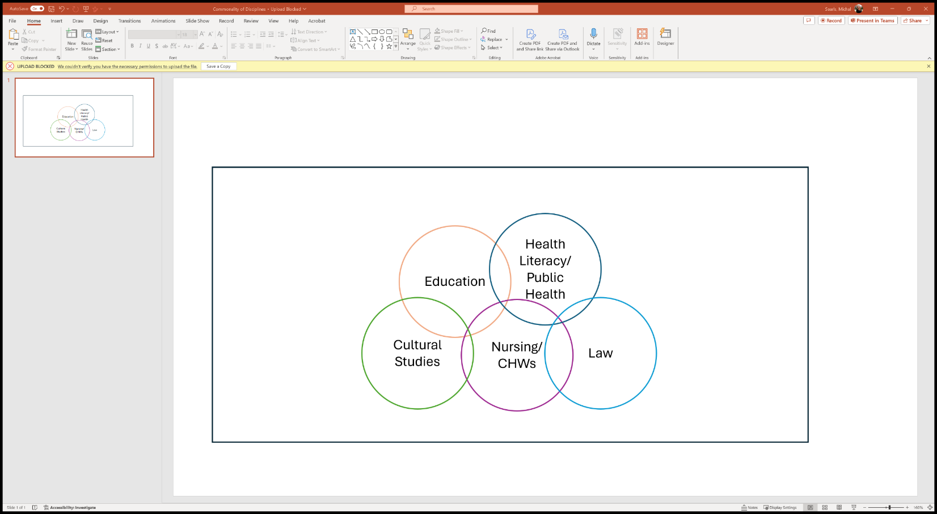

**Figure 1:** Commonality of Disciplines (Author developed).

**Health Literacy**

Health Literacy (HL) is a fundamental pillar of public health, and healthcare workers are at the forefront of patient communication (Office of Disease Prevention and Health Promotion, n.d.). HL impacts areas such as healthcare utilization, readmissions, and medication adherence [3]. In Ohio, collaborations between nurses, health educators, community organizations, and legal experts can enhance health literacy initiatives, ensuring that individuals are able to find, understand, and navigate health information for improved decision making concerning their health and well-being. Health literacy as a field recognizes the imperative for individuals to access, understand, and use information to make informed decisions regarding their health [4]. For instance, low health literacy impacts medication adherence, readmission, and higher mortality rates. Health literacy represents the convergence of healthcare, effective communication, and cultural understanding between providers and the communities they serve.

**Community Health Workers**

CHWs are trusted individuals within their respective communities who function as liaisons between community members and healthcare providers [5]. CHWs have a set scope of practice yet work in diverse settings and varying populations promoting health and wellness of the communities they serve. CHWs are often embedded within communities, and bridge gaps in healthcare access and delivery through health education, outreach, and connecting community members to resources. These individuals work in clinics, behavioral health practices, hospitals, health departments, and other healthcare organizations. In Ohio, the collaboration between CHWs, healthcare practitioners, and educators can amplify the impact of outreach programs, ensuring that interventions are community-specific and address underlying social determinants of health. Training curriculum and certification requirements are standardized for consistency in education, skill development, and core competencies to produce highly qualified candidates to deliver quality care and address community health challenges [6]. CHWs can affect change and enhance the overall effectiveness of healthcare delivery and health promotion efforts.

**Nursing**

Nursing, a cornerstone of healthcare, encompasses a broad spectrum of roles, from direct patient care to advocacy and policy development, all aimed at promoting health and preventing illness. Nursing professionals contribute significantly to health education, both in clinical settings and community outreach. Collaborative efforts between nurses, educators, and policymakers can strengthen health education programs, fostering a population equipped with essential health knowledge and skills. In Ohio, the Board of Nursing is charged with the oversight of community health worker certification [7].

**Cultural Studies**

Understanding and respecting cultural diversity is integral to public health initiatives such as health literacy. Collaborations between cultural studies, CHWs, healthcare workers, and educators can ensure that interventions are culturally competent and considerate of the unique needs of Ohio’s communities. For example, Beach et al. [8] found that by incorporating cultural competence training, providers improved skills and attitudes, which increased patient satisfaction and improved health outcomes.

**Education**

Education is a powerful tool in shaping health behaviors and attitudes. Collaborations between educators and healthcare professionals are crucial. Education and training are the cornerstones of knowledge for CHWs in building capacity, confidence, and skill. In Ohio, integrating health education into curriculum with health literacy as a focus can empower individuals and organizations with the knowledge and skills needed for lifelong well-being. Furthermore, continuing education provides opportunities for skill refinement and enhanced learning. For over forty years research has pointed to providing offerings for an interdisciplinary audience and how to promote collaboration and a deeper understanding of common goals [9], yet educators rarely capitalize on the inter-disciplinarity and use of research in practice [10].

**Law**

Legal frameworks shape the policies that underpin public health initiatives in Ohio. Collaboration between all parties is essential to develop and implement effective and appropriate policies and laws that support health equity, safeguard patient rights, and address systemic health disparities. Specifically, the certification of community health workers, qualifications, and program criteria are outlined in the Ohio Administrative Code [6].

The significance of law within the context of CHW certification and health literacy cannot be overstated. Law plays a pivotal role in establishing the standards, guidelines, and regulations that ensure the competency and effectiveness of CHWs, thereby directly impacting the quality of healthcare services delivered to individuals and communities. Legal frameworks provide the foundation for CHW certification programs, which may involve specific educational requirements, training modules, and assessments aimed at equipping CHWs with the necessary knowledge and skills to effectively fulfill their roles and responsibilities. By adhering to established legal standards, certification ensures that CHWs and other healthcare professions possess the competence and credibility needed to engage with diverse populations and address various health needs within communities. Essentially, laws pertaining to certification are enacted to safeguard public health interests and help to mitigate risks associated with inadequate training or improper conduct, thereby enhancing the overall safety and well-being of community members. By upholding legal standards, CHWs and other healthcare professionals can build trust and confidence among the populations they serve, fostering better engagement and collaboration in healthcare initiatives. In addition, law plays a crucial role in promoting health literacy among CHWs and the communities they serve. Health literacy refers to the ability of individuals to access, understand, and navigate health information effectively, enabling them to make informed decisions [4]. Legal frameworks can support efforts to enhance health literacy by ensuring the availability of accurate and accessible health information, promoting transparency in healthcare practices, and protecting the rights of individuals to make informed decisions about their care.

Moreover, legal frameworks utilized for improving health literacy often intersect with broader social and economic policies addressing factors such as education, language access, and healthcare affordability. By addressing these underlying determinants of health, legal interventions can empower CHWs and community members to overcome barriers to accessing and utilizing healthcare services with the ultimate goal of better health outcomes. Examples of such laws or frameworks include but are not limited to Affordable Care Act (ACA): Includes provisions that promote health literacy by requiring healthcare providers and insurers to use plain language in communications with patients. Also supports initiatives to improve health literacy through community health programs and preventive services [11]. Plain Writing Act of 2010- Requires federal agencies to use clear and understandable language in government communications including those related to healthcare. By upholding and promoting plain language, this Act aims to promote and enhance health literacy and improve access to health information for all Americans [12].

Health Insurance Portability and Accountability Act (HIPAA): HIPAA provides provisions to protect patient privacy and require providers with clear and understandable language to explain rights regarding their health information. By ensuring that patients understand their rights, HIPAA promotes health literacy and empowers individuals in making informed healthcare decisions [13]. National Action Plan to Improve Health Literacy- Provides a framework for federal agencies and stakeholders to promote health literacy nationwide. It outlines goals and strategies for improving health literacy across various sectors, including healthcare, education, and public health [14]. In essence, law plays a vital role in CHW certification and health literacy by establishing standards, promoting accountability, and safeguarding public health interests. By upholding legal frameworks, stakeholders can ensure the competence of CHWs through education, enhance health literacy within communities, and ultimately contribute to the advancement of equitable and effective healthcare delivery systems.

Summary

The convergence of disciplines to address health literacy emphasizes the necessity of interdisciplinary collaboration. By recognizing the commonalities and synergies among public health experts, education, cultural studies, community health workers, law, and healthcare workers such as nurses, stakeholders can work collectively to develop more robust, inclusive, effective, and culturally sensitive strategies. Additionally, this article contributes to the body of knowledge demonstrating that interdisciplinary education yields improved outcomes by intertwining diverse perspectives and expertise. By integrating disciplines such as education, nursing, law, cultural studies, and public health, practitioners are better equipped to make informed decisions. This collaborative methodology is imperative for addressing the dynamic and multifaced public health challenges faced by Ohio’s diverse population.

**References**

1. [Cameron WB (1963) Informal sociology: A causal introduction to sociological thinking. Random House.](https://books.google.co.in/books/about/Informal_Sociology.html?id=I6JIAAAAMAAJ&redir_esc=y)
2. [CohenMiller AS, Pate E (2019) A model for developing interdisciplinary research theoretical frameworks. The Qualitative Report 24: 1211-1226.](https://nsuworks.nova.edu/cgi/viewcontent.cgi?article=3558&context=tqr)
3. [Rasu RS, Bawa WA, Suminski R, Snella K, Warady B (2015) Health literacy impact on national healthcare utilization and expenditure. International Journal of Health Policy and Management 4: 747-755.](https://www.ijhpm.com/article_3081_616.html)
4. [Coughlin SS, Vernon M, Hatzigeorgiou C, George V (2020) Health literacy, social determinants of health, and disease prevention and control. Journal of Environment and Health Sciences 6: 3061.](https://pmc.ncbi.nlm.nih.gov/articles/PMC7889072/)
5. [Berthold T (2016) Foundations for community health workers (2nd Edition) Jossey-Bass.](https://www.wiley.com/en-gb/Foundations+for+Community+Health+Workers%2C+2nd+Edition-p-9781119060734)
6. [Ohio Administrative Code 4723-26-13. (2021) Community health worker training program curriculum requirements.](https://codes.ohio.gov/ohio-administrative-code/chapter-4723-26)
7. [Ohio Board of Nursing (2024) Types of applications: Community health workers. Ohio Board of Nursing.](https://nursing.ohio.gov/licensing-and-certification/types-of-applications/community-health-workers)
8. [Beach MC, Price EG, Gary TL, Robinson KA, Gozu A, et al. (2005) Cultural competency: A systematic review of health care provider educational interventions. Medical Care 43: 356-373.](https://pubmed.ncbi.nlm.nih.gov/15778639/)
9. [Blockstein WL (1983) Interdisciplinary continuing education. Möbius: A Journal for Continuing Education Professionals in Health Sciences 3: 60-75.](https://onlinelibrary.wiley.com/doi/abs/10.1002/chp.4760030310)
10. [Hofmann R (2024) The four paradoxes that stop practitioners from using research to change professional practice and how to overcome them. Education Sciences 14: 996.](https://www.researchgate.net/publication/383957110_The_Four_Paradoxes_That_Stop_Practitioners_from_Using_Research_to_Change_Professional_Practice_and_How_to_Overcome_Them)
11. [U.S. Centers for Medicare & Medicaid Services (2010) Where can I read the Affordable Care Act? HealthCare.gov.](https://www.healthcare.gov/where-can-i-read-the-affordable-care-act/)
12. [U.S. Government Publishing Office (2010) Public Law 111-274: Plain Writing Act of 2010. GovInfo.](https://www.govinfo.gov/app/details/PLAW-111publ274)
13. [U.S. Government Publishing Office (1996) Public Law 104-191: Health Insurance Portability and Accountability Act of 1996. GovInfo.](https://www.govinfo.gov/app/details/PLAW-104publ191)
14. [U.S. Department of Health and Human Services, Office of Disease Prevention and Health Promotion (2010). National Action Plan to Improve Health Literacy. Washington DC.](https://odphp.health.gov/our-work/national-health-initiatives/health-literacy/national-action-plan-improve-health-literacy)