**Research Article**

**Awareness of Forensic Medicine Services Staff in Hail with Appropriate Infection Control Practices**

**Musleh Samil Reshidi1#, Abdulah Saadi Algarni1, Mohammed Hamdan Alshammari1, Mohammad Ayed Alreshidi1, Mubarak Saad Alshammari1, Naif Sulaiman Alenezi1, Ahmed Mahal Alreshidi1, Mamdouh Awad Alonezi1**

1Forensic Medical Services, Hail Health, Hail, Saudi Arabia

**Corresponding author:** Musleh Samil Reshidi, Forensic Medical Services, Hail Health, Hail, Saudi Arabia

**How to cite this article:** Reshidi MS, et al. (2024) Awareness of Forensic Medicine Services Staff in Hail with Appropriate Infection Control Practices. Int J Comm & Publ Healt 04(02): 2024-156.

**Submission Date:** 07 December, 2024; **Accepted Date:** 11 December, 2024; **Published Online:** 13 December, 2024

**Abstract**

The study provides a comprehensive evaluation of infection control awareness, implementation, and attitudes among forensic medical staff in Hail. Given the high-risk nature of forensic work, which frequently involves exposure to biological hazards and infectious materials, adherence to strict infection control measures is essential. The findings reveal a generally strong awareness and agreement on the importance of infection control practices among forensic staff. This is reflected in their recognition of the challenges faced and the value they place on formal training and adherence to protocols.

However, the study also highlights some areas needing improvement. Despite a high level of agreement on the necessity of infection control measures and their implementation, there are inconsistencies in practice adherence and understanding of certain infection control measures. For instance, while personal protective equipment (PPE) usage and sterilization protocols are generally well-regarded and applied, the responses indicate variability in their routine application and the overall understanding of infection control guidelines.

These findings underscore the need for ongoing efforts to enhance infection control practices within forensic medicine. Recommendations include strengthening training programs to address identified gaps, ensuring clearer and more comprehensive infection control guidelines, and improving the consistency of resource availability and application. Addressing these areas will help bridge the gap between theoretical knowledge and practical implementation, ensuring that forensic medical staff in Hail can better manage the risks associated with their work.

The study's insights are crucial for informing policy and practice improvements in forensic medical settings. By identifying current strengths and weaknesses, the research provides a foundation for developing targeted interventions that will enhance safety and efficacy in forensic medicine. Ultimately, this research contributes to safeguarding both forensic medical professionals and the broader community by ensuring adherence to robust infection control standards, aligned with both national and international guidelines.

**Keywords:** Forensic Medicine; Infection Control; Medicine; Forensic; Awareness; Hail Region

**Abbreviations**

PPE : Personal Protective Equipment

CPHIMS : World Health Organization

ICT : Centers for Disease Control and Prevention

**Introduction**

Infection control within forensic medicine is not just a precaution but a fundamental responsibility, given the unique and high-risk nature of the work. Forensic medical staff, including pathologists, forensic nurses, and technicians, are routinely exposed to various biological hazards, such as blood borne pathogens, airborne infections, and other infectious materials during autopsies, crime scene investigations, and handling of cadavers. These risks necessitate strict adherence to infection control practices to safeguard both the healthcare professionals and the broader community [1].

The importance of infection control has been well-established globally, with guidelines from the World Health Organization (WHO), Centers for Disease Control and Prevention (CDC), and other health bodies emphasizing the need for comprehensive infection control measures in all healthcare settings, including forensic facilities. These measures include the use of personal protective equipment (PPE), proper handling and disposal of hazardous materials, sterilization of instruments, and environmental controls to prevent the spread of infectious diseases [2].

However, the level of awareness and implementation of these practices can vary, particularly in specialized fields like forensic medicine, where the focus is often on the forensic analysis itself rather than on infection control. In regions like Hail, Saudi Arabia, where healthcare infrastructure is developing, understanding the extent of awareness and adherence to infection control protocols among forensic medical staff is crucial. This knowledge can help in identifying potential gaps in training, resources, and institutional support that may compromise safety [3].

This study aims to assess the current state of infection control awareness among forensic medical staff in Hail. By evaluating their knowledge, attitudes, and practices, the research seeks to identify areas of strength and weakness. The findings will not only provide insights into the current practices but also offer recommendations for enhancing infection control measures. Ultimately, this research contributes to improving the safety and quality of forensic medical services in Hail, ensuring that they meet both national and international standards.

In an environment where the stakes are high, and the risks are significant, ensuring that forensic medical staff are fully aware of and compliant with infection control protocols is essential. This study, therefore, serves as a critical step towards safeguarding the health of those on the frontlines of forensic medicine and, by extension, the communities they serve.​

**Research Problem**

Despite the critical importance of infection control in forensic medicine, there is limited understanding of the current level of awareness and adherence to infection control practices among forensic medical staff in Hail, Saudi Arabia. Forensic medical professionals, including pathologists, forensic nurses, and technicians, face significant expo-sure to biological hazards and infectious materials, necessitating stringent infection control measures. However, there may be variability in the knowledge, attitudes, and implementation of these practices, potentially compromising both the safety of the healthcare workers and the integrity of forensic services [4].

Given the evolving healthcare infrastructure in Hail, it is essential to investigate the extent of awareness and adherence to infection control protocols among forensic medical staff. This study aims to identify gaps in infection control practices, evaluate the effectiveness of current measures, and provide recommendations to enhance safety and compliance. Understanding these aspects will help address any deficiencies in training, resources, and institutional sup-port, thereby improving the overall safety and quality of forensic medical services in the region.

This research problem highlights the need to assess the level of infection control awareness and practices among forensic medical staff and underscores the importance of this evaluation in improving forensic medicine's safety standards [5].

**Research Questions**

* What is the current level of awareness among forensic medical staff in Hail regarding infection control practices?
* To what extent are infection control practices, such as the use of personal protective equipment (PPE) and proper sterilization, implemented by forensic medical staff in Hail?
* What are the attitudes of forensic medical staff in Hail towards the importance of infection control in their daily work?
* What factors influence adherence or non-adherence to infection control protocols among forensic medical staff in Hail?

**Research Objectives**

* Assess the level of awareness of forensic medical staff in Hail regarding infection control practices, including knowledge of PPE use, sterilization, and handling of biological hazards.
* Evaluate the implementation of infection control practices among forensic medical staff in Hail, focusing on adherence to guidelines during autopsies, crime scene investigations, and other forensic activities.
* Examine the attitudes of forensic medical staff towards infection control and its significance in their work environment.
* Identify the factors that influence compliance or non-compliance with infection control protocols, including personal, institutional, and environmental factors.
* Determine the gaps in training, resources, and institutional support that may hinder effective infection control practices among forensic medical staff in Hail.

**Research Importance**

This study holds significant importance as it addresses a critical aspect of healthcare and public safety-infection control within forensic medicine. Forensic medical staff, due to the nature of their work, face elevated risks of exposure to infectious diseases through contact with biological hazards, including blood borne pathogens and airborne infections. The implications of inadequate infection control in this field extend beyond the individual workers to the community at large, as breaches in safety protocols can lead to the spread of dangerous infections.

**Research Limitations**

The study focused on assessing Awareness of forensic medicine services staff in hail with appropriate infection control practices from the period of 2024 to 2025 in Hail Region in KSA.

**Theoretical Framework and Previous Studies**

**Research Definitions**

Forensic Medical Staff: Forensic medical staff include professionals involved in forensic investigations, such as forensic pathologists, forensic nurses, forensic technicians, and other healthcare workers who participate in the ex-amination and analysis of human remains and crime scene evidence [6].

Infection Control: Infection control refers to the policies, procedures, and practices employed in healthcare settings to prevent the transmission of infectious agents. In forensic medicine, infection control practices aim to protect medical staff and the public from exposure to pathogens during autopsies, crime scene investigations, and the handling of biological materials [7].

**Literature Review**

**Infection Control in Forensic Medicine**

**General Principles**

Infection control practices in forensic medicine are crucial due to the potential exposure to infectious agents during forensic investigations and autopsies. The following provides an overview of key infection control practices specific to forensic medicine [8].

**Personal Protective Equipment (PPE)**

In forensic medicine, the use of personal protective equipment (PPE) is essential to minimize the risk of exposure to infectious agents. Gloves are fundamental in protecting hands from direct contact with bodily fluids and other potential contaminants. They should be used during all procedures and examinations where exposure to biological materials is possible. Gowns or lab coats provide additional protection, covering the body and preventing contamination of personal clothing. Face shields or masks are critical for protecting the face and respiratory tract from splashes and airborne pathogens. In high-risk situations, such as those involving aerosol-generating procedures, N95 respirators are recommended due to their higher efficiency in filtering airborne particles. Eye protection, such as goggles, should also be worn to guard against accidental splashes and contamination. Proper use of PPE, including correct donning and doffing techniques, is crucial to prevent self-contamination and ensure the safety of forensic professionals [9].

**Hand Hygiene**

Hand hygiene is a cornerstone of infection control in forensic settings. Forensic medical staff must wash their hands thoroughly with soap and water both before and after patient contact and after removing gloves. This practice helps to remove any contaminants that may have been transferred during procedures. When soap and water are not available, an alcohol-based hand sanitizer can be used as an alternative, provided the hands are visibly clean. Regular reinforcement of hand hygiene practices through training and continuous monitoring is necessary to maintain high standards of cleanliness and prevent the spread of infections within forensic settings [10].

**Sterilization and Disinfection**

Effective sterilization and disinfection are critical in maintaining a safe forensic environment. Reusable instruments and tools must be sterilized to eliminate all microorganisms, including spores. Autoclaving is the preferred method for this process, using steam under pressure to achieve complete sterilization. For items that cannot withstand high temperatures, chemical sterilant such as ethylene oxide or hydrogen peroxide vapor are utilized. Additionally, sur-faces that have come into contact with bodily fluids require routine disinfection. Appropriate disinfectants should be chosen based on their efficacy against a broad spectrum of pathogens. Implementing regular cleaning protocols helps ensure that all surfaces and equipment remain free of potential contaminants, thus enhancing overall safety in forensic practice [11].

**Importance and Challenges**

In forensic medicine, infection control is paramount due to the heightened risk of exposure to various biological hazards. Forensic professionals, such as forensic pathologists and crime scene investigators, are routinely exposed to potentially infectious materials during activities like autopsies and crime scene examinations. This exposure presents significant health risks, including blood borne pathogens (such as HIV, hepatitis B, and hepatitis C) and air-borne infections (such as tuberculosis). The nature of forensic work, involving direct contact with bodily fluids and other potentially contaminated materials, necessitates robust infection control measures to protect both practitioners and the broader public [12,13].

The unique challenges faced in forensic settings include:

Diverse Biological Hazards: Forensic professionals encounter a wide range of biological hazards, each requiring specific control measures. For instance, handling decomposed bodies or samples from suspected infectious cases demands specialized protocols.

Varied Work Environments: Forensic work occurs in diverse environments, including morgues, crime scenes, and laboratories. Each setting presents different infection control challenges, from maintaining sterility in a morgue to managing environmental contamination at a crime scene.

Complex Cases: Cases often involve multiple pathogens or unknown contaminants, complicating infection control efforts. Forensic professionals must be prepared to adapt their practices to the specific risks associated with each case.

Resource Limitations: Some forensic facilities may lack the necessary resources or equipment to fully implement infection control protocols. This can result in gaps in protective measures and increased risk of exposure.

Training and Compliance: Ensuring that all personnel are adequately trained and consistently adhere to infection control protocols is an ongoing challenge. Continuous education and reinforcement of practices are necessary to maintain high standards of safety [12,13].

**Guidelines and Best Practices**

To address these challenges, global health organizations like the World Health Organization (WHO) and the Centers for Disease Control and Prevention (CDC) have developed comprehensive guidelines for infection control applicable to forensic medicine. Key recommendations include:

Use of Personal Protective Equipment (PPE): Proper PPE is essential to minimize exposure to infectious agents. This includes gloves, masks, gowns, and eye protection. The selection and use of PPE should be tailored to the specific risks associated with each forensic procedure [2,14].

Sterilization and Disinfection: Instruments and surfaces in forensic settings must be regularly sterilized or disinfected to prevent cross-contamination. Effective sterilization methods, such as autoclaving or chemical disinfection, should be employed based on the type of equipment and level of contamination.

Safe Handling and Disposal: Proper protocols for the handling and disposal of hazardous materials, including biological specimens and contaminated waste, are crucial. This includes the use of biohazard containers and following local regulations for waste management.

Training and Protocols: Regular training for forensic personnel on infection control practices is essential. This training should cover the correct use of PPE, procedures for decontamination, and emergency response protocols.

Monitoring and Evaluation: Continuous monitoring and evaluation of infection control practices help identify potential areas for improvement. Regular audits and feedback mechanisms can ensure adherence to established guide-lines and prompt adjustments as needed [15].

By adhering to these guidelines and best practices, forensic professionals can significantly reduce the risk of infection and enhance overall safety in their work environments.

**Methodology**

**Research Design**

The research design is the comprehensive plan that brings all the parts of the study together in a consistent and logical way. We did this to make sure we solved the research challenge. To gather, measure, and analyze data, the study design serves as a guide or plan.

A study's design includes procedures for gathering data, analyzing it, drawing conclusions, and reporting those findings. Put simply, the study design lays out the necessary data, the methods for gathering and analyzing it, and how the results will be applied to the study's main research problem. The author Kumar (2018) differentiates between exploratory, descriptive, and explanatory research strategies. He sorts the designs according to the study's objectives as they are all unique.

A descriptive study aims to provide a vivid image of a situation, person, or event or show how phenomena are related and occur naturally. Nonetheless, because it cannot give a causal explanation, descriptive research is most helpful in emerging areas of study. When descriptive data is plentiful, switching to another research strategy, such as an explanatory or exploratory one, is best.

When just a limited amount of information is available regarding a phenomenon or topic, researchers perform exploratory studies to learn more. Its purpose is not to address all the questions raised by the topics under investigation but to go deeper into each. Since this is a review, we look for areas with little prior research. Even under the most trying circumstances, exploratory investigations are vital since they define the main study's first research plan, sample, and data collection strategy.

The goal of descriptive research is to provide a detailed account of a subject, scenario, or population. To probe the relevant factors, the descriptive research approach may use a variety of research methodologies. Quantitative data is used most often, with qualitative data being utilized for descriptive reasons on occasion.

The researcher must then draft a research design after formulating hypotheses (There is a statistically significant relationship between the critical success factor and project success). The research design is essentially the blueprint for the research process because the plan specifies each step that must be taken. A design like this would show whether or not the intended activity will maximize efficiency and minimize waste. When designing a study, balancing achieving your study's goals and keeping costs down is essential.

Quantitative research "utilizes inquiry tactics such as trials and surveys and gathers data using preset statistical data generation tools." After gaining a basic grasp of quantitative analysis, it is critical to study the divide between quantitative and qualitative research.

The research approach is quantitative, involving collecting data from present and potential consumers using sampling techniques and distributing online surveys, online polls, and questionnaires, the results of which may be stated numerically. To anticipate the future of a product or service based on an in-depth grasp of these figures and to make necessary modifications.

The researcher conducted a descriptive study because the investigation demanded it. The researcher must apply this methodology to fulfill the study's goals and objectives.

**Sample Population**

The term "population" refers to the group of people or things that the researcher believes to contain the necessary facts and particular hints. Any group of things, including living things and inanimate objects, that share an interesting quality is called a population. According to Bujang et al. (2018), academics are unable to reach out to all members of the target community because to the resource's financial, time, and goal limits.

The purpose of sampling is to select a representative subset of a population in order to provide data on that subset's characteristics. Modern research employs a wide range of techniques to better gauge the interest group (the target audience) and obtain reliable data from them.

The questionnaire was prepared, where the study sample was 100 Forensic medical staff working in Hail, including forensic pathologists, medical examiners, and other relevant personnel.

**Sample Types**

Sampling is a technique for selecting a representative sample from a larger population in order to draw conclusions about that group's characteristics. Modern research employs a wide range of techniques to better gauge the interest group (the target audience) and obtain reliable data from them.

Assigning participants to a sampling group at random is known as randomization or distribution. It is essential to make this basic assumption while analyzing statistical data. Statistical power, control for se-lection bias, and control for allocation bias (or confounding) can all be enhanced by randomization, which is particularly useful in subgroup research. In addition, it helps ensure that all traits, whether quantifiable or not, visible or invisible, known or unknown, are distributed evenly among all classes. Researchers use a variety of randomization procedures according to the research aim and findings.

Using simple random sampling, every member of the population has an equal chance of being selected for a survey. This technique is employed when the sample frame is accessible, the population is little, and there is a high degree of homogeneity. For example, a computer that is mechanically created, a table of random numbers, and the lottery system.

The study employed a system of random sampling. This technique includes at least two strata or subgroups in its subject selection process in order to ensure that the sample is representative of the population as a whole. There is an appropriate sample frame that can be used to determine the stratified features of the target research population, and stratified random sampling helps to decrease sampling errors. Therefore, stratified random sampling was chosen.

**Data Collection**

Data collection refers to collecting and evaluating data on relevant variables to formulate and test hypotheses, answer planned research questions, and analyze results. Data collection is a priceless research tool that may be used across many academic fields, including the hard sciences, humanities, business, etc. While the means to guarantee a correct and honest selection may vary from lot to area, the goal remains the same. The goal of every data collection effort should be to amass sufficient detail for thorough analysis, yielding convincing and believable answers. No matter the area of study or method of identification preferred, accurate data collection is essential to maintaining the credibility of scientific findings. Errors are less likely to occur if appropriate data-gathering instruments are used (whether they exist, have been updated, or have been invented from scratch) and if their usage is well explained.

**Primary Data**

Primary data is defined as information that researchers get directly from the subject of study. When secondary sources of information are inadequate, they contend, it is essential to do primary research. Interviews, questionnaires, and comment sections are just a few of the primary data collection tools at your disposal. It is critical to understand the many primary data gathering procedures that may be used for both quantitative and qualitative research. Since the questionnaire was the main tool for gathering information from the target industry, it may be said that the researcher employed "primary information" in this study.

Leedy (2015) points out that questionnaires are commonly used to gather observational data, even while the researcher has location constraints. The study objectives are reduced to manageable questions and their associated answers in the questionnaire. Classify, execute, tabulate, and evaluate any component of an effective quiz in little time at all. The hallmarks of a well-designed questionnaire include clarity, conciseness, and logical organization. There has to be a progression from easy to hard questions. The reliability of the surveys is guaranteed by their written form and the use of first-person replies.

Primary data is represented by the responses came from the questionnaires sent to all participants in the study.

**Secondary Data**

Helps researchers understand the problem better, formulate more plausible ideas, and learn more about the topic at hand. Also, it provides a firm base for future study and aids in identifying appropriate research methods. When working with main data, secondary sources can help you get to the meat of the matter faster. This is why we employ a methodical approach to literature and archival material reviews in all of our research. A data collecting tool was developed after several perspectives were obtained through the examination of relevant government policy publications. According to Andrew (2019) the information was culled from a variety of secondary sources, such as books and articles that have already appeared in print.

**Data Analysis**

When you analyze data, you sort and make sense of information from many sources. There is a lot of confusion, chaos, time, innovation, and excitement surrounding the process. Even though it is not a linear process, understanding, analyzing, and comprehending data may be seen as a quest for generalizable assertions that can be applied to many forms of data. So, it's safe to say that using logic in the study is a requirement of data analysis.

Data analysis is also defined by Marshall (2014) as the act of organizing obtained data from its inherent disorder. Some have said it's messy, unclear, and time-consuming, yet it's also creative and thrilling. Data interpretation, analysis, and conceptualization is not a linear process, but it does include looking for generalizable claims that apply to different kinds of data. Data analysis necessitates the utilization of reasoning in research. Research employs both deductive and inductive reasoning in data processing and interpretation.

After the questionnaire responses were cleaned up and organized, they were imported into the SPSS computer to facilitate the analysis using descriptive statistics. The information gathered from the participants was summarized using frequency distribution tables. To facilitate understanding and analysis, the data was presented visually using charts and tables displaying frequency distributions.

**Reliability and Validity of the Research**

Always keep dependability and validity in mind, no matter what method you choose. Nonetheless, the methodology that has been used for this study is now focused on the inquiries regarding qualitative analysis. For the study to be truly useful and thorough, its reliability and validity must be at the highest possible level. In order to be applicable to the widest range of instances, organizations, and contexts, the study should be as generalizable as possible.

**Validity**

To be legitimate in research and data collecting, information must be applicable to the phenomena or topic under study and must measure what it set out to measure. Presenting the findings and conclusions clearly is also crucial for strengthening their validity.

Another important concept for investigations in the social sciences is validity. The question of validity pertains to the study's ability to accurately assess its intended variables. Compared to quantitative investigations, qualitative studies especially those that use exploratory methods or grounded theory make the answer to that issue more complicated. Consequently, the results have to align with the theories that were develop based' suggests that the reliability of the research methodology dictates and impacts the research's validity. Reliability of the data collection environment and the inclusion of supporting examples are prerequisites for accurate data interpretation.

**Reliability**

In terms of evaluation methodologies, reliability refers to how consistent and accurate the outcomes are. Included in this category are faith in parallel shapes, internal consistency, and test reliability. You can accomplish the test rehearsal's reliability twice in a time using the same test. Fixing two outcomes, the dependability Several iterations of the assessment procedure are mandated by parallel. Although outcomes like this cannot be produced by human observations, the degree can be determined using the dependability of the inter-rater. Internal consistency reliability measures how consistently various test items provide the same outcomes.

Reliability is the criterion used to assess how well the study results hold up. Examining the data's consistency and stability reveals the reliability of the measurements. An easy-to-understand framework was used to conduct the interview in order to guarantee reliable study results.

**Data Analysis and Results**

**Demographic Questions**

**Gender**

It is clear from the following table on the distribution of the study sample by gender that the proportion of males is 90%, and females 10%. (Table 1, Figure 1).

|  |  |  |  |  |  |
| --- | --- | --- | --- | --- | --- |
|  | Gender | Frequency | Percent | Valid Percent | Cumulative Percent |
| Valid | Male | 90 | 90 | 90 | 90 |
| Female | 10 | 10 | 10 | 10 |
| Total | 100 | 100 | 100 |  |

**Table 1:** Gender.

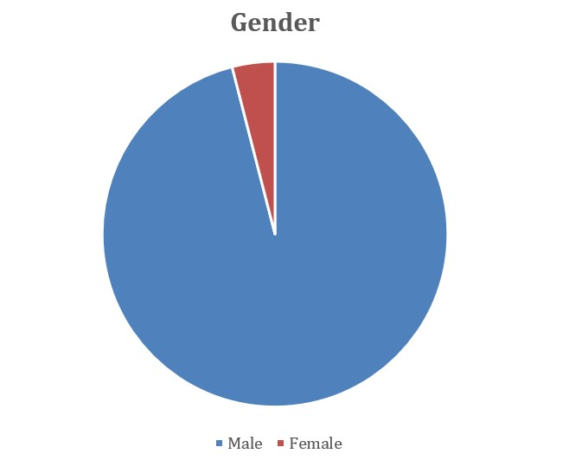

**Figure 1:** Gender.

**Nationality**

It is clear from the following table on the distribution of the study sample by Nationality that the proportion of Saudi is 92 %, and non-Saudi 8%. (Table 2, Figure 2).

|  |  |  |  |  |  |
| --- | --- | --- | --- | --- | --- |
|  | Nationality | Frequency | Percent | Valid Percent | Cumulative Percent |
| Valid | Saudi | 92 | 92 | 92 | 64 |
| Non- Saudi | 8 | 8 | 8 | 100 |
| Total | 100 | 100 | 100 |  |

**Table 2:** Nationality.

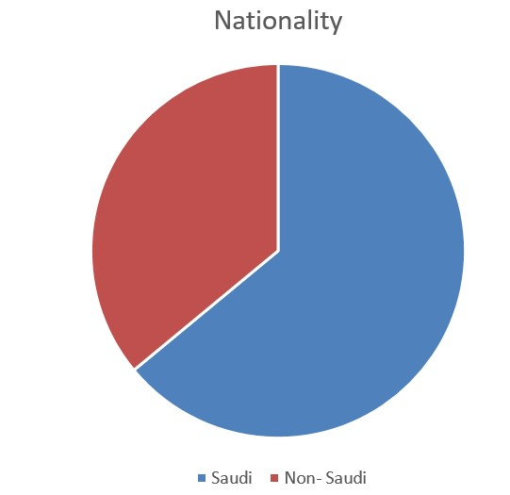

**Figure 2:** Nationality.

**Age**

It is evident from the following table regarding the distribution of the study sample according to age, that the highest percentage is (36-40 years) with 40%, followed by (31-35 years) with a percentage of 21%, (26-30 years) with a percentage of 20% (More than 40 years) with a percentage of 11% and (21- 25 years) with a percentage of 8%. (Table 3, Figure 3).

|  |  |  |  |  |  |
| --- | --- | --- | --- | --- | --- |
|  | Age | Frequency | Percent | Valid Percent | Cumulative Percent |
| Valid | 21- 25 years | 8 | 8 | 8 | 8 |
| 26-30 years | 20 | 20 | 20 | 28 |
| 31-35 years | 21 | 21 | 21 | 49 |
| 36-40 years | 40 | 40 | 40 | 89 |
| More than 40 years | 11 | 11 | 11 | 100 |
| Total | 100 | 100 | 100 |  |

**Table 3:** Age.

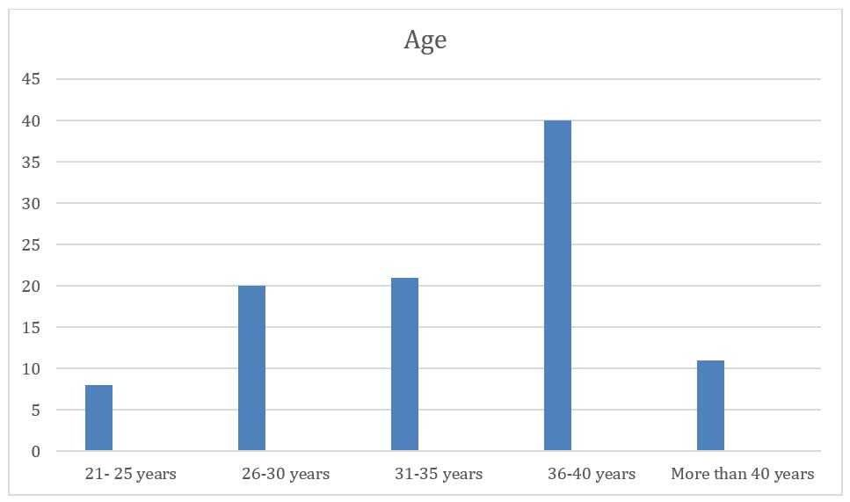

**Figure 3:** Age.

**Working status**

It is evident from the following table regarding the distribution of the study sample according to Working status, that the highest percentage is (Doctors) with 38%, followed by (Pharmasists) with a percentage of 22%, (Laboratory Technicians) with a percentage of 19% (Staff Nurses) with a percentage of 16% and (House Keeping Staff) with a percentage of 5%. (Table 4, Figure 4).

|  |  |  |  |  |  |
| --- | --- | --- | --- | --- | --- |
|  | Working status | Frequency | Percent | Valid Percent | Cumulative Percent |
| Valid | Doctors | 38 | 38 | 38 | 38 |
| Pharmacists | 22 | 22 | 22 | 60 |
| Staff Nurses | 16 | 16 | 16 | 76 |
| Laboratory Technicians | 19 | 19 | 19 | 95 |
| House Keeping Staff | 5 | 5 | 5 | 100 |
| Total | 100 | 100 | 100 |  |

**Table 4:** Working status.

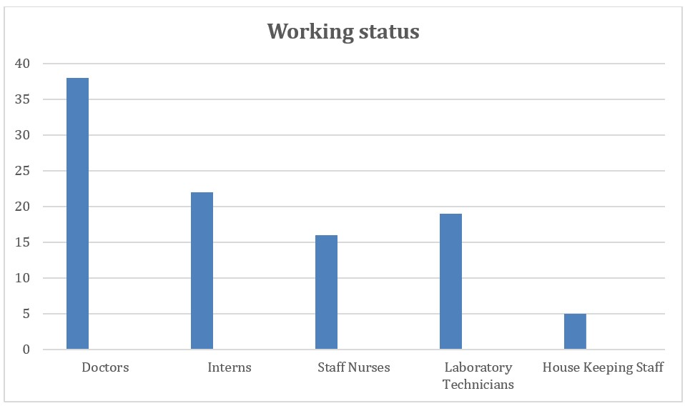

**Figure 4:** Working status.

**Working Experience**

It is evident from the following table regarding the distribution of the study sample according to Working status, that the highest percentage is (6-10 years) with 40%, followed by (More than 10 years) with a percentage of 35%, (Less than 1 year) with a percentage of 13% and (1-5 years) with a percentage of 12%. (Table 5-13, Figure 5).

|  |  |  |  |  |  |
| --- | --- | --- | --- | --- | --- |
|  | Working experience | Frequency | Percent | Valid Percent | Cumulative Percent |
| Valid | Less than 1 year | 13 | 13 | 13 | 13 |
|  | 1-5 years | 12 | 12 | 12 | 25 |
|  | 6-10 years | 40 | 40 | 40 | 65 |
|  | More than 10 years | 35 | 35 | 35 | 100 |
|  | Total | 100 | 100 | 100 |  |

**Table 5:** Working experience.

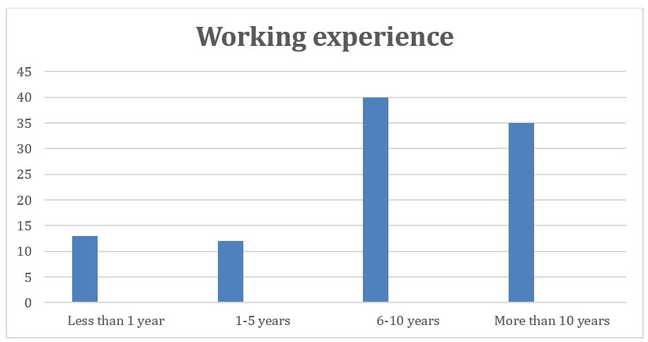

**Figure 5:** Working experience.

The current level of awareness among forensic medical staff in Hail regarding infection control practices:

* Statement “Significant challenges are encountered in adhering to infection control practices” came in the first place with an arithmetic mean of 4.22 and a standard deviation of .675. Therefore, the direction of the responses of the study sample is Agree.
* Statement “Formal training in infection control practices specific to forensic medicine is regularly provided “came in the second order, with a mean of 4.21 and a standard deviation of .832. Therefore, the direction of the responses of the study sample is Agree.
* Statement “Infection control practices are consistently adhered to during forensic examinations” came in the third order, with an arithmetic " mean of 4.15 and a standard deviation of .687. Therefore, the direction of the responses of the study sample is Agree.
* Statement “A range of infection control measures, including personal protective equipment, hand hygiene, and safe specimen handling, is well-understood “in the fourth rank came with an arithmetic mean of 3.89 and a standard deviation of .751. Therefore, the direction of the responses of the study sample is neutral.
* Statement “There is a high level of awareness regarding standard infection control protocols relevant to the field of forensic medicine” came in the fifth order, and its arithmetic mean was 3.87 and a standard deviation was .812. Therefore, the direction of the responses of the study sample is neutral.

|  |  |  |  |  |  |  |
| --- | --- | --- | --- | --- | --- | --- |
| Descriptive Statistics | N | Minimum | Maximum | Mean | Std. Deviation | p-value |
| There is a high level of awareness regarding standard infection control protocols relevant to the field of forensic medicine | 100 | 3 | 5 | 3.87 | 0.812 | 0.001 |
| Infection control practices are consistently adhered to during forensic examinations | 100 | 3 | 5 | 4.15 | 0.687 | 0.001 |
| Formal training in infection control practices specific to forensic medicine is regularly provided | 100 | 2 | 5 | 4.21 | 0.832 | 0.32 |
| A range of infection control measures, including personal protective equipment, hand hygiene, and safe specimen handling, is well-understood | 100 | 3 | 5 | 3.89 | 0.751 | 0.121 |
| Significant challenges are encountered in adhering to infection control practices | 100 | 3 | 5 | 4.22 | 0.675 | 0.603 |
| the current level of awareness among forensic medical staff in Hail regarding infection control practices | 100 | 3 | 4.6 | 4.068 | 0.36979 |  |

**Table 6:** Descriptive Statistics of the current level of awareness among forensic medical staff in Hail regarding infection.

|  |  |  |  |  |  |  |  |  |  |  |
| --- | --- | --- | --- | --- | --- | --- | --- | --- | --- | --- |
| S | Strongly disagree | | Not agree | | Neutral | | Agree | | Strongly Agree | |
|  | F | % | F | % | F | % | F | % | F | % |
| There is a high level of awareness regarding standard infection control protocols relevant to the field of forensic medicine | - | - | - | - | 40 | 40% | 33 | 33% | 27 | 27% |
| Infection control practices are consistently adhered to during forensic examinations | - | - | - | - | 17 | 17% | 51 | 51% | 32 | 32% |
| Formal training in infection control practices specific to forensic medicine is regularly provided | - | - | 2 | 2% | 20 | 20% | 33 | 33% | 45 | 45% |
| A range of infection control measures, including personal protective equipment, hand hygiene, and safe specimen handling, is well-understood | - | - | - | - | 34 | 34% | 43 | 43% | 23 | 23% |
| Significant challenges are encountered in adhering to infection control practices | - | - | - | - | 14 | 14% | 50 | 50% | 36 | 36% |

**Table 7:** The current level of awareness among forensic medical staff in Hail regarding infection control practices.

Extent are infection control practices, such as the use of personal protective equipment and proper sterilization, implemented by forensic staff in Hail.

Statement “The use of personal protective equipment (PPE) is consistently applied during forensic examinations” came in the first place with an arithmetic mean of 4.21 and a standard deviation of .902. Therefore, the direction of the responses of the study sample is Agree.

Statement “There is a high level of compliance with infection control practices, such as PPE usage and proper sterilization “came in the second order, with a mean of 4.13 and a standard deviation of .884. Therefore, the direction of the responses of the study sample is Agree.

Statement “Sterilization protocols are strictly adhered to in order to maintain a sterile environment” came in the third order, with an arithmetic mean of 4.13 and a standard deviation of .812. Therefore, the direction of the responses of the study sample is Agree.

Statement “Personal protective equipment, including gloves, masks, and gowns, is routinely utilized “in the fourth rank came with an arithmetic mean of 4.09 and a standard deviation of .818. Therefore, the direction of the responses of the study sample is neutral.

Statement “Proper sterilization procedures are regularly followed to prevent infection” came in the fifth order, and its arithmetic mean was 4.00 and a standard deviation was .888. Therefore, the direction of the responses of the study sample is neutral.

|  |  |  |  |  |  |
| --- | --- | --- | --- | --- | --- |
| Descriptive Statistics | N | Minimum | Maximum | Mean | Std. Deviation |
| The use of personal protective equipment (PPE) is consistently applied during forensic examinations | 100 | 2 | 5 | 4.21 | 0.902 |
| Proper sterilization procedures are regularly followed to prevent infection | 100 | 1 | 5 | 4 | 0.888 |
| Personal protective equipment, including gloves, masks, and gowns, is routinely utilized | 100 | 3 | 5 | 4.09 | 0.818 |
| Sterilization protocols are strictly adhered to in order to maintain a sterile environment | 100 | 3 | 5 | 4.13 | 0.812 |
| There is a high level of compliance with infection control practices, such as PPE usage and proper sterilization | 100 | 2 | 5 | 4.13 | 0.884 |
| extent are infection control practices, such as the use of personal protective equipment and proper sterilization, implemented by forensic staff in Hail | 100 | 3 | 5 | 4.112 | 0.48017 |
| Valid N (listwise) | 100 |  |  |  |  |

**Table 8:** Descriptive Statistics of extent are infection control practices, such as the use of personal protective equipment and proper sterilization, implemented by forensic staff in Hail.

|  |  |  |  |  |  |  |  |  |  |  |
| --- | --- | --- | --- | --- | --- | --- | --- | --- | --- | --- |
| S | Strongly disagree | | not agree | | Neutral | | Agree | | Strongly Agree | |
|  | F | % | F | % | F | % | F | % | F | % |
| The use of personal protective equipment (PPE) is consistently applied during forensic examinations | - | - | 3 | 3% | 23 | 23% | 24 | 24% | 50 | 50% |
| Proper sterilization procedures are regularly followed to prevent infection | 2 | 2% | 2 | 2% | 21 | 21% | 44 | 44% | 31 | 31% |
| Personal protective equipment, including gloves, masks, and gowns, is routinely utilized | - | - | - | - | 29 | 29% | 33 | 33% | 38 | 38% |
| Sterilization protocols are strictly adhered to in order to maintain a sterile environment | - | - | - | - | 27 | 27% | 33 | 33% | 40 | 40% |
| There is a high level of compliance with infection control practices, such as PPE usage and proper sterilization | - | - | 3 | 3% | 24 | 24% | 30 | 30% | 43 | 43% |

**Table 9:** Extent are infection control practices, such as the use of personal protective equipment and proper sterilization, implemented by forensic staff in Hail.

The attitudes of forensic staff in Hail toward the importance of infection control in their daily work

* Statement “The necessity of adhering to infection control guidelines is widely acknowledged and supported in daily forensic activities.” came in the first place with an arithmetic mean of 4.24 and a standard deviation of .712. Therefore, the direction of the responses of the study sample is Agree.
* Statement “Infection control procedures are seen as essential to upholding professional standards in forensic work.” came in the second place with an arithmetic mean of 4.12 and a standard deviation of .844. Therefore, the direction of the responses of the study sample is Agree.
* Statement “The importance of infection control in daily forensic work is highly valued. “came in the third order, with a mean of 4.09 and a standard deviation of .911. Therefore, the direction of the responses of the study sample is Agree.
* Statement “There is a strong belief in the effectiveness of infection control measures in preventing the spread of infections” came in the fourth order, with an arithmetic mean of 4.07 and a standard deviation of .820. Therefore, the direction of the responses of the study sample is Agree.
* Statement “Infection control practices are considered crucial for maintaining safety during forensic examinations “in the fifth rank came with an arithmetic mean of 3.95 and a standard deviation of .880. Therefore, the direction of the responses of the study sample is neutral.

|  |  |  |  |  |  |
| --- | --- | --- | --- | --- | --- |
| Descriptive Statistics | N | Minimum | Maximum | Mean | Std. Deviation |
| The importance of infection control in daily forensic work is highly valued. | 100 | 2 | 5 | 4.09 | 0.911 |
| Infection control practices are considered crucial for maintaining safety during forensic examinations. | 100 | 2 | 5 | 3.95 | 0.88 |
| There is a strong belief in the effectiveness of infection control measures in preventing the spread of infections. | 100 | 2 | 5 | 4.07 | 0.82 |
| Infection control procedures are seen as essential to upholding professional standards in forensic work. | 100 | 3 | 5 | 4.12 | 0.844 |
| The necessity of adhering to infection control guidelines is widely acknowledged and supported in daily forensic activities. | 100 | 3 | 5 | 4.24 | 0.712 |
| the attitudes of forensic staff in Hail toward the importance of infection control in their daily work | 100 | 2.5 | 5 | 4.0575 | 0.5172 |
| Valid N (listwise) | 100 |  |  |  |  |

**Table 10:** Descriptive Statistics of the attitudes of forensic staff in Hail toward the importance of infection control in their daily work.

|  |  |  |  |  |  |  |  |  |  |  |
| --- | --- | --- | --- | --- | --- | --- | --- | --- | --- | --- |
| S | Strongly disagree | | Not agree | | Neutral | | Agree | | Strongly Agree | |
|  | F | % | F | % | F | % | F | % | F | % |
| The importance of infection control in daily forensic work is highly valued. | - | - | 5 | 5% | 22 | 22% | 32 | 32% | 41 | 41% |
| Infection control practices are considered crucial for maintaining safety during forensic examinations. | - | - | 2 | 2% | 35 | 35% | 29 | 29% | 34 | 34% |
| There is a strong belief in the effectiveness of infection control measures in preventing the spread of infections. | - | - | 2 | 2% | 24 | 24% | 39 | 39% | 35 | 35% |
| Infection control procedures are seen as essential to upholding professional standards in forensic work. | - | - | - | - | 30 | 30% | 28 | 28% | 42 | 42% |
| The necessity of adhering to infection control guidelines is widely acknowledged and supported in daily forensic activities. | - | - | - | - | 16 | 16% | 44 | 44% | 40 | 40% |

**Table 11:** Frequency & Percent of the attitudes of forensic staff in Hail toward the importance of infection control in their daily work.

The factors influencing adherence or non-adherence to infection control protocols among forensic staff in Hail

* Statement “Support from management and institutional policies impact the adherence to infection control protocols” came in the first place with an arithmetic mean of 4.37 and a standard deviation of .747. Therefore, the direction of the responses of the study sample is Agree.
* Statement “Workload and time constraints affect the adherence to infection control practices during forensic examinations “came in the second order, with a mean of 4.07 and a standard deviation of 1.112. Therefore, the direction of the responses of the study sample is Agree.
* Statement “The clarity and comprehensiveness of infection control guidelines play a role in whether protocols are consistently followed” came in the third order, with an arithmetic mean of 4.03 and a standard deviation of .784. Therefore, the direction of the responses of the study sample is Agree.
* Statement “The availability of resources, such as personal protective equipment and sterilization supplies, significantly impacts adherence to infection control protocols “in the fourth rank came with an arithmetic mean of 3.84 and a standard deviation of. 368.Therefore, the direction of the responses of the study sample is neutral.

|  |  |  |  |  |  |  |
| --- | --- | --- | --- | --- | --- | --- |
| Descriptive Statistics |  |  |  |  |  |  |
|  | N | Minimum | Maximum | Mean | Std. Deviation | p-value |
| The availability of resources, such as personal protective equipment and sterilization supplies, significantly impacts adherence to infection control protocols. | 100 | 3 | 4 | 3.84 | 0.368 | 0.344 |
| Workload and time constraints affect the adherence to infection control practices during forensic examinations. | 100 | 1 | 5 | 4.07 | 1.112 | - |
| The clarity and comprehensiveness of infection control guidelines play a role in whether protocols are consistently followed. | 100 | 3 | 5 | 4.03 | 0.784 | 0.314 |
| Support from management and institutional policies impact the adherence to infection control protocols. | 100 | 3 | 5 | 4.37 | 0.747 | 0.013 |
| Valid N (listwise) | 100 |  |  | 4.07 | 0.443 |  |

**Table 12:** Descriptive Statistics of the factors influencing adherence or non-adherence to infection control protocols among forensic staff in Hail.

|  |  |  |  |  |  |  |  |  |  |  |
| --- | --- | --- | --- | --- | --- | --- | --- | --- | --- | --- |
| S | Strongly disagree | | Not agree | | Neutral | | Agree | | Strongly Agree | |
|  | F | % | F | % | F | % | F | % | F | % |
| The availability of resources, such as personal protective equipment and sterilization supplies, significantly impacts adherence to infection control protocols. | - | - | - | - | 16 | 16% | 84 | 84% | - | - |
| Workload and time constraints affect the adherence to infection control practices during forensic examinations. | 3 | 3% | 7 | 7% | 19 | 19% | 22 | 22% | 49 | 49% |
| The clarity and comprehensiveness of infection control guidelines play a role in whether protocols are consistently followed. | - | - | - | - | 29 | 29% | 39 | 39% | 32 | 32% |
| Support from management and institutional policies impact the adherence to infection control protocols. | - | - | - | - | 16 | 16% | 31 | 31% | 53 | 53% |

**Table 13:** Frequency & Percent of the factors influencing adherence or non-adherence to infection control protocols among forensic staff in Hail.

The results from the survey of forensic medical staff in Hail reveal a nuanced understanding of infection control practices and their implementation. The high mean scores for statements about significant challenges in adhering to infection control practices (4.22) and the regular provision of formal training specific to forensic medicine (4.21) indicate a general agreement among staff regarding the importance of these practices and the efforts made to support them. This suggests that while the staff recognizes the critical nature of infection control and the value of training, they also face notable difficulties in consistently adhering to these practices. The challenge in adherence might be influenced by factors such as complex procedures, high workload, or resource constraints.

The consistent adherence to infection control practices during forensic examinations, with a mean of 4.15, reinforces the commitment of forensic staff to maintain safety protocols. However, this is slightly less than the agreement on the provision of training, suggesting that practical application of the training may encounter hurdles. This disparity points to potential gaps between theoretical knowledge and its practical execution, which could be addressed by more targeted interventions or resources.

Regarding the understanding of infection control measures, the neutral responses (mean of 3.89) indicate that while staff are somewhat aware of infection control practices, there may be room for improvement in their comprehension and application. The same neutral stance is observed for the awareness of standard infection control protocols (mean of 3.87), suggesting that despite the recognition of their importance, the depth of understanding and routine application may vary among staff members.

In terms of the implementation of infection control practices, the results show a high level of agreement on the use of personal protective equipment (PPE) and compliance with sterilization protocols. The high mean scores for statements related to PPE usage (4.21) and compliance with infection control practices (4.13) underscore that forensic staff are committed to maintaining a sterile environment. However, the slightly lower mean for the routine utilization of PPE (4.09) and proper sterilization procedures (4.00) points to a neutral response, suggesting variability in practice adherence. This variability might be due to practical constraints or inconsistencies in how these practices are enforced.

The attitudes of forensic staff toward the importance of infection control reflect a strong agreement on the necessity of these practices. With means ranging from 4.24 to 3.95, the staff clearly values infection control as essential to up-holding professional standards and preventing infections. The high mean scores indicate a robust recognition of the importance of these practices, though the neutral stance on their crucial nature during examinations suggests that while their importance is acknowledged, the practical implementation may still face challenges.

Finally, the factors influencing adherence to infection control protocols highlight several key aspects. The high mean scores for support from management (4.37) and the impact of workload and time constraints (4.07) suggest that these factors significantly influence adherence. The clarity and comprehensiveness of infection control guidelines (mean of 4.03) also play a crucial role, reflecting the importance of clear and detailed protocols. However, the neutral response regarding the availability of resources (mean of 3.84) indicates that while resources are important, their impact on adherence may not be as pronounced, potentially due to existing resource availability or other mitigating factors.

Overall, the results underscore the importance of continuous improvement in infection control practices, including enhancing understanding, consistency in application, and addressing practical challenges. These findings highlight the need for ongoing training, clearer guidelines, and support systems to ensure that infection control practices are effectively implemented and maintained in forensic settings.

**Conclusion**

The study provides a comprehensive evaluation of infection control awareness, implementation, and attitudes among forensic medical staff in Hail. Given the high-risk nature of forensic work, which frequently involves exposure to biological hazards and infectious materials, adherence to strict infection control measures is essential. The findings reveal a generally strong awareness and agreement on the importance of infection control practices among forensic staff. This is reflected in their recognition of the challenges faced and the value they place on formal training and adherence to protocols.

However, the study also highlights some areas needing improvement. Despite a high level of agreement on the necessity of infection control measures and their implementation, there are inconsistencies in practice adherence and understanding of certain infection control measures. For instance, while personal protective equipment (PPE) usage and sterilization protocols are generally well-regarded and applied, the responses indicate variability in their routine application and the overall understanding of infection control guidelines.

These findings underscore the need for ongoing efforts to enhance infection control practices within forensic medicine. Recommendations include strengthening training programs to address identified gaps, ensuring clearer and more comprehensive infection control guidelines, and improving the consistency of resource availability and application. Addressing these areas will help bridge the gap between theoretical knowledge and practical implementation, ensuring that forensic medical staff in Hail can better manage the risks associated with their work.

The study's insights are crucial for informing policy and practice improvements in forensic medical settings. By identifying current strengths and weaknesses, the research provides a foundation for developing targeted interventions that will enhance safety and efficacy in forensic medicine. Ultimately, this research contributes to safeguarding both forensic medical professionals and the broader community by ensuring adherence to robust infection control standards, aligned with both national and international guidelines.

**Compliance with Ethical Standards**

ped from the qualitative analysis's validity. Seeking to comprehend if a study is 'conceptually and em-pirica.

**Disclosure of Conflict of Interest**

No conflict of interest to be disclosed.

**Statement of Informed Consent**

Informed consent was obtained from all individual participants included in the study.

**References**

1. [Tan X (2020). The Development of an Optofluidic Biosensing Platform for Multi-Functional Biomolecular Analysis (Doctoral dissertation).](https://deepblue.lib.umich.edu/handle/2027.42/155315)
2. [World Health Organization (WHO) (2022). Infection Prevention and Control in Healthcare Settings. Retrieved from WHO Infection Control Guidelines.](https://www.who.int/teams/integrated-health-services/infection-prevention-control)
3. [Baharuddin AS, Ahmad MH, Ismail WAF, et al. (2020). Offense of Spreading Infectious Disease and Methods of Proof Through Forensic Science. INSLA E-Proceedings 3: 340-350.](https://oarep.usim.edu.my/entities/publication/a789d18d-e7bb-498b-84b7-aef9e06bf5b9/full)
4. [Sacco MA, Gualtieri S, Tarzia P, et al. (2024). The role of operative protocols for the prevention of occupational infectious risk on the crime scene. La Clinica Tera 175 :187-191.](https://pubmed.ncbi.nlm.nih.gov/39101423/)
5. [Barranco R, Vallega Bernucci Du Tremoul, L, Ventura F (2021). Hospital-acquired SARS-Cov-2 infections in patients: inevitable conditions or medical malpractice?. Int J Environ Res Public Health 8: 489.](https://pmc.ncbi.nlm.nih.gov/articles/PMC7827479/)
6. Rakei S, Rad HI, Arbabisarjou A, et al. (2019). Effect of workshop education on knowledge of specialized assistants in Arak University of Medical Sciences about professional medical and forensic medicine laws. Drug Invention Today.
7. [Posfay-Barbe KM, Zerr DM, Pittet D (2008). Infection control in paediatrics. Lancet Infect Dis 8 :19-31.](https://pubmed.ncbi.nlm.nih.gov/18156087/)
8. Vij K (2011). Textbook of forensic medicine and toxicology: principles and practice, 5/e. Elsevier India.
9. Tian Z, Stedman M, Whyte M, et al. (2020). Personal protective equipment (PPE) and infection among healthcare workers–What is the evidence?. International journal of clinical practice, 74(11), e13617.
10. [Abdulhassan AF, Ali SA (2020). Hand Hygiene Practices and Infection Control Measures among Emergency Units Health Care Providers. Indian Journal of Forensic Medicine & Toxicology.](https://medicopublication.com/index.php/ijfmt/article/view/10652)
11. [Mohapatra S (2017). Sterilization and disinfection. Essentials of Neuroanesthesia: 929–944.](https://pmc.ncbi.nlm.nih.gov/articles/PMC7158362/)
12. Johnson T, Wright L (2020). Infection Control in Forensic Medicine: A Review of Practices and Protocols. Journal of Forensic Sciences 65: 452-459.
13. Garcia M, Lee R, Patel S (2018). Challenges in Forensic Medicine: Infection Control and Risk Management. Forensic Science International 287: 142-149.
14. [Centers for Disease Control and Prevention (CDC) (2021). Infection Control Guidelines for Healthcare Settings. Retrieved from CDC Infection Control Guidelines](https://www.cdc.gov/index.html)
15. Smith J, Brown H, Davis A (2019). Adherence to Infection Control Protocols: A Stuy in Forensic Settings. Journal of Clinical Microbiology 57: 987-994.