Case Report

Sodium-Glucose Cotransporter-2 (Sglt-2) Inhibitors: Pharmacodynamic Profile Case Reviews

Vishal Dalal, PA-C^{1,2}, Rocco Panico, PA-C¹, Emily Mignogni, PharmD^{1,3}, Michael B. Rodricks, MD^{1,4}

¹Department of Critical Care, Robert Wood Johnson University Hospital Somerset, New Jersey, USA
²Rutgers Biomedical and Health Sciences, Department of Physician Assistant Studies and Practice, New Jersey, USA
³Oncology Specialty Clinical Pharmacist, Summit Health, New Jersey, USA
⁴Acute Care Surgery, Rutgers Robert Wood Johnson Medical School, New Jersey, USA

#Corresponding author: Vishal Dalal, PA-C, Physician Assistant, Department of Critical Care, Robert Wood Johnson University Hospital Somerset, 110 Rehill Avenue, Somerville, New Jersey 08876, USA

How to cite this article: Dalal V, et al. (2023) Sodium-Glucose Cotransporter-2 (Sglt-2) Inhibitors: Pharmacodynamic Profile Case Reviews. Colu J Cas Repo 03(01): 2023-34.

Submission Date: 19 February, 2023; Accepted Date: 01 March, 2023; Published Online: 06 March, 2023

Introduction

Sodium-Glucose Cotransporter-2 (SGLT-2) inhibitors were first approved for use in the management of type 2 diabetes mellitus by the United States Food and Drug Administration (US FDA) in 2013. Dapagliflozin, ertugliflozin, empagliflozin, and canagliflozin are the currently utilized agents in this drug category [1]. Clinical trials have shown improved renal as well as cardiovascular outcomes in diabetic patients prescribed SGLT-2 inhibitors [2-4]. Despite proven benefits, these drugs have a unique adverse event profile associated with them. It is imperative for clinicians to recognize the pharmacodynamic profile of these drugs as their use is likely to continue to increase given their proven benefits. The cases presented here highlight several aspects of the risk profile associated with SGLT-2 inhibitors.

Keywords: Diabetes mellitus; Euglycemic DKA; Sodium-glucose cotransporter-2 (SGLT-2) inhibitor

Case 1

History and Initial Presentation

A 41 year old white male with a history of type 2 diabetes mellitus presented with two days of nausea, vomiting, weakness, and anorexia. He was prescribed metformin 1,000 mg twice daily, ertugliflozin 15 mg daily, and dulaglutide 1.5 mg subcutaneous injection weekly; however, he had not taken his medications since the onset of symptoms. A detailed history was challenging at the time of presentation given his altered mental status. He was oriented only to person and time, and was toxic-appearing. He was tachycardic with dry mucous membranes and pale skin. There was nonspecific diffuse abdominal tenderness, although no guarding or rebound tenderness was present.

His workup revealed a metabolic acidosis with an elevated anion gap, hyperglycemia and the presence of serum acetones. His serum creatinine was elevated. The lipase was elevated at 451 U/L. There was no evidence of hepatobiliary dysfunction. His hemoglobin A1c was 9.3, and his triglyceride level was 227 mg/dL. Specific values are listed in (Table 1). A non-contrast Computed Tomography (CT) scan of the abdomen and pelvis showed no acute intra-abdominal pathology. An infectious work up including blood cultures, urinalysis, SARS-CoV-2 PCR, streptococcus PCR, and a chest radiograph revealed no signs of infection. He was transferred to the intensive care unit (ICU) with a diagnosis of mild acute pancreatitis (based on 2013 Atlanta criteria) and Diabetic Ketoacidosis (DKA).

Clinical Course and Management

 | Admission Labs | ICU Day 5:  Labs at time of insulin transition | ICU Day 5:  Labs after transition from IV insulin | ICU Day 11:  Labs at time of transfer from ICU
Sodium (mmol/L) | 120 | 141 | 135 | 138
Corrected Sodium (mmol/L) | 135 | 143 | 138
CO₂ (mmol/L) | 4 | 16 | 15 | 23
Anion Gap (mEq/L) | 38 | 20 | 20 | 13
Creatinine (mg/dL) | 2.1 (baseline 0.77) | 0.93 | 0.87 | 0.6
Glucose (mg/dL) | 1041 | 245 | 261 | 109
Acetones | Moderate | Moderate | Large | Negative
Beta-Hydroxybutyrate (mmol/L) |  |  | 2.6

Table 1: Pertinent labs values for case 1. The corrected sodium values accounts for serum glucose levels.

The patient received isotonic crystalloids and a titrating infusion of intravenous insulin per our facility’s protocol for DKA. His daily insulin requirements are shown in (Figure 1). His hospital stay was complicated by a prolonged course of DKA refractory to traditional management. By ICU day 4, the patient’s intravenous insulin requirements had substantially decreased (Table 2), and by day 5, his anion gap was resolving and his serum bicarbonate was improving. After consultation with endocrinology, an attempt was made to discontinue the insulin infusion and transition to insulin glargine. Several hours later, he developed a worsening metabolic acidosis along with a recrudescence of acetones and beta-hydroxybutyrate in the serum. Intravenous insulin infusion and crystalloids were reinitiated. He continued to remain persistently acidemic over the next six days and required treatment with a bicarbonate infusion and titrating intravenous insulin. By ICU day 10, he was started on subcutaneous insulin glargine in addition to intravenous insulin given his persistent acidemia. The following day, his anion gap resolved and the serum bicarbonate normalized (Table 1). He was successfully transitioned to subcutaneous glargine and lispro with adequate control of his blood sugars and resolution of DKA. He was transferred from the ICU on day 11, and discharged from the hospital 14 days after his initial presentation.

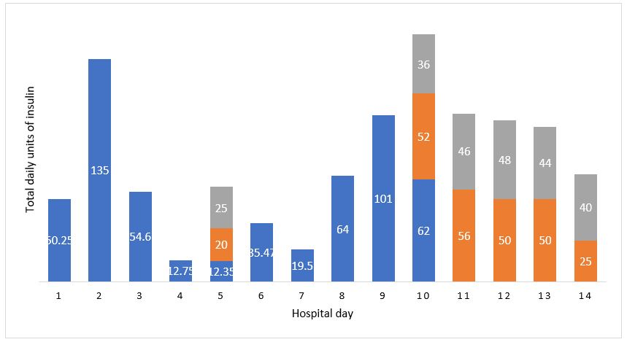

Figure 1: Total daily units of insulin for case 1. Intravenous insulin is represented in blue, glargine in orange, and lispro in gray. On day 5, subcutaneous insulin was administered in an attempt to transition from intravenous insulin, however intravenous insulin was restarted due to recurrence of DKA.

 | Admission Labs | ICU Day 5 | ICU Day 8: Labs at time of insulin transition | ICU Day 8: Labs 10 hours after transition from IV insulin | ICU Day 15: Labs at time of transfer from ICU
Sodium (mmol/L) | 139 | 164 | 151 | 149 | 142
Corrected Sodium (mmol/L) | 155 | 166 | 152 | 151
CO₂ (mmol/L) | 5 | 21 | 23 | 8 | 26
Anion Gap (mEq/L) | 42 | 8 | 11 | 31 | 11
Creatinine (mg/dL) | 2.9 | 1.38 | 1.04 | 1.06 | 0.62
Glucose (mg/dL) | 1100 | 255 | 157 | 236 | 115
Acetones | Moderate |  | Negative | Large | Negative
Triglycerides (mg/dL) | 1890 |  | 299
Lipase (U/L) | 408 |  | 33
Amylase | 516 |  | 77

Table 2: Pertinent lab values for case 2. The corrected sodium values accounts for serum glucose levels.

Case 2

History and Initial Presentation

A 67 year old white male with a past medical history of hyperlipidemia, hypertension, type 2 diabetes mellitus, stage 2 Chronic Kidney Disease (CKD), and Chronic Obstructive Pulmonary Disease (COPD) presented after being found unresponsive. He was unable to participate in the initial history due to his stuporous state with a Glasgow Coma Score (GCS) of 9. Medication reconciliation showed that the patient’s medications included fenofibrate 145 mg every other day, empagliflozin 10 mg daily, and insulin lispro reported to be 30 units four times daily. He was ill-appearing, tachypneic, and tachycardic. He had generalized abdominal tenderness; however, his altered mentation limited the utility of the physical exam.

The initial work-up showed a metabolic acidosis with an increased anion gap, hyperglycemia, the presence of serum acetones, and acute on chronic renal failure. His hemoglobin A1c was 11.3, and his triglycerides, lipase, and amylase were elevated (Table 2). A urinalysis showed ketonuria and glucosuria, but no signs of infection. A non-contrast CT of the abdomen and pelvis was obtained which revealed a normal pancreas; a jejunal infarction was noted and was managed non-surgically. A non-contrast CT of the head did not show acute intracranial pathology. The patient was admitted to the ICU with DKA, acute on chronic renal failure, and hypertriglyceridemia induced mild pancreatitis.

Clinical Course and Management

The patient was resuscitated with balanced crystalloids and received an insulin infusion. Daily insulin values are shown in (Figure 2). Shortly after admission, he developed respiratory failure secondary to multi-organ failure and required mechanical ventilation. His course was further complicated by generalized tonic-clonic seizures felt to be precipitated by metabolic derangements including hypernatremia with a peak serum sodium of 164 mmol/L. A continuous electroencephalogram was obtained and the patient was initiated on levetiracetam. By ICU day 7, the anion gap metabolic acidosis had resolved, there were no further seizures, and the patient’s neurological status had improved allowing for successful liberation from mechanical ventilation. The following day, an attempt was made to transition from an insulin infusion to insulin glargine. Within ten hours, repeat serum chemistries showed a severe metabolic acidosis with an anion gap of 31 and elevated serum acetones (Table 2). He was reinitiated on an insulin infusion and received additional intravenous fluids. He remained persistently acidemic until day 12. Despite resolution of his acidosis, there continued to be the presence of serum acetones. The patient was maintained on an intravenous insulin infusion and subcutaneous glargine until there was a complete absence of serum acetones, which did not occur until day 15. The patient was then successfully converted to subcutaneous glargine and lispro, and transferred from the ICU. Twenty-one days after initial admission, the patient’s cognition had normalized and he was discharged.

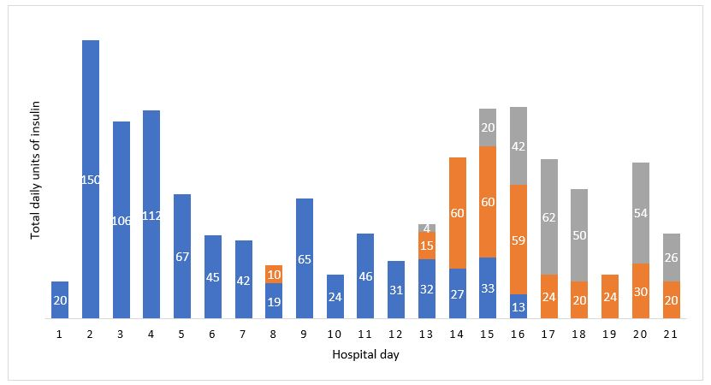

Figure 2: Total daily units of insulin for case 2. Intravenous insulin is represented in blue, glargine in orange, and lispro in gray. On day 8, intravenous insulin was reinitiated following administration of insulin glargine due to recurrence of DKA. During hospital days 13-16, subcutaneous insulin was administered in combination with intravenous insulin to help wean the insulin infusion.

Discussion

Sodium-Glucose Cotransporter-2 (SGLT-2) inhibitors serve as an important adjunct in the treatment of type 2 diabetes mellitus. In addition to their role in the management of diabetes mellitus, recent data have shown that SGLT-2 inhibitors can reduce progression of nephropathy as well as improve cardiovascular outcomes in patients with heart failure regardless of ejection fraction [2-4]. Adverse effects associated with sodium-glucose cotransporter-2 (SGLT-2) inhibitors include the propensity to develop euglycemic DKA, drug induced pancreatitis, and prolonged courses of DKA.

Euglycemic DKA in the setting of SGLT-2 inhibitors is a well described phenomenon. The US FDA released a warning regarding SGLT-2 induced DKA in 2015. SGLT-2 inhibitors competitively inhibit the sodium-glucose transport protein 2 in the proximal tubules of nephrons which prevents glucose resorption. This promotes glucosuria and improves glucose homeostasis⁵. The pathophysiology of euglycemic DKA is from insulinopenia in the setting of relatively low serum glucose levels, which leads to lipolysis and the production of ketones [6]. Patients typically present with ketosis, serum glucose levels less than 250 mg/dL, and glucosuria [7,8].

In contrast to euglycemic DKA associated with SGLT-2 inhibitors, both of our patients were hyperglycemic with a serum glucose level greater than 1,000 mg/dL. We suspect this may have been multifactorial as they were both prescribed other hypoglycemic agents in addition to SGLT-2 inhibitors. The combination of medications may have confounded their initial blood glucose level on presentation. Pancreatitis was also present in both patients which may have exacerbated hyperglycemia.

Drug-induced pancreatitis secondary to SGLT-2 inhibitors has also been reported [1,7]. The specific pathophysiology of SGLT-2 induced pancreatitis remains unclear at this point in time; however, postulated mechanisms include direct toxic effects, immune reactions, and hypersensitivity reactions [7,9]. In the first case, the work-up did not reveal any other etiology of pancreatitis, making ertugliflozin-induced pancreatitis the most likely culprit. It is unclear whether our second patient had SGLT-2 induced pancreatitis, as he also presented with hypertriglyceridemia and was prescribed fenofibrate [10]. Regardless of etiology, it is plausible that pancreatitis triggered hyperglycemic DKA, rather than euglycemic DKA.

SGLT-2 inhibitors can also lead to prolonged and relapsing courses of DKA [8,11]. DKA, in the absence of SGLT-2 inhibitors, tends to resolve in 11 hours on average, with a typical 3 day hospital Length of Stay (LOS) [5]. Both cases presented here had a longer time to resolution as well as a longer hospital LOS due to recurrent acidosis after transition to subcutaneous insulin, which necessitated reinitiating intravenous insulin. The protracted acidosis may be related to the longer half-lives of SGLT-2 inhibitors, which can range from 10 to 19 hours [5]. These drugs are contraindicated in patients with reduced renal function-ertugliflozin is contraindicated in patients with an Estimated Glomerular Filtration Rate (eGFR) of less than 45, and empagliflozin is contraindicated with an eGFR below 30. Both patients presented here were critically ill and had acute kidney injury with a GFR below that which these agents would be recommended. The presence of glucosuria late into the hospital admission for both cases further supports that both patients had prolonged effects of SGLT-2 inhibiting drugs in the presence of acute kidney injury. Glucosuria was present until hospital day 4 in case 1, and day 8 in case 2. This highlights the need to identify patients who present with hypovolemia and acute kidney injury, and ensure that SGLT-2 inhibitors are not prescribed on an inpatient basis.

In summary, we present two cases of critically-ill patients prescribed SGLT-2 inhibitors who were admitted with DKA and pancreatitis. Their hospital course was complicated by a prolonged and relapsing course of DKA. The use of an SGLT-2 inhibitor can often go unrecognized especially in encephalopathic patients in whom a detailed history can be challenging to obtain. Early identification of patients prescribed SGLT-2 inhibitors is imperative because they have a unique set of adverse reactions which are disparate from other oral hypoglycemic medications. Clinicians should maintain a high index of suspicion in patients who present with either euglycemia or hyperglycemia, significant glucosuria, abdominal pain associated with pancreatitis, as well as those that appear refractory to traditional management of DKA with intravenous fluids and insulin. Patients being treated for SGLT-2 induced DKA typically have a prolonged course prior to being able to be weaned off of an insulin infusion. Serial serum acetone levels, beta-hydroxybutyrate levels, urinary ketones and glucose should be monitored prior to transitioning from an intravenous insulin infusion. Failure to recognize complications associated with SGLT-2 inhibitors can lead to increased mortality, prolonged hospital length of stay, and increased costs.

References

- Sujanani SM, Elfishawi MM, Zarghamravanbaksh P, et al. (2020) Dapagliflozin-Induced Acute Pancreatitis: A Case Report and Review of Literature. Case Reports in Endocrinology.
- Packer M, Stefan D, Anker, MD, et al. (2020) Cardiovascular and Renal Outcomes with Empagliflozin in Heart Failure. New England Journal of Medicine 383: 1413-1424.
- Anker SD, Butler J, Filippatos G, et al. (2021) Empagliflozin in Heart Failure with a Preserved Ejection Fraction. New England Journal of Medicine 385: 1451-1461.
- Perkovic V, Jardine MJ, Neal B, et al. (2019) Canagliflozin and Renal Outcomes in Type 2 Diabetes and Nephropathy. New England Journal of Medicine 380: 2295-2306.
- Ogawa W, Sakaguchi K (2016) Euglycemic diabetic ketoacidosis induced by SGLT2 inhibitors: possible mechanism and contributing factors. Journal of Diabetes Investigation 7: 135-138.
- Ata F, Yousaf Z, Khan AA, et al. (2021) SGLT-2 inhibitors associated euglycemic and hyperglycemic DKA in a multicentric cohort. Nature Scientific Reports.
- Wang KM, Isom RT (2020) SGLT-2 Inhibitor Induced Euglycemic Diabetic Ketoacidosis: A Case Report. Kidney Medicine 2: 218-221.
- Westcott GP, Segal AR, Mitri J, et al. (2020) Prolonged glucosuria and relapse of diabetic ketoacidosis related to SGLT-2 inhibitor therapy. Endocrinology, Diabetes & Metabolism 29: e00117.
- Kaufman MB (2013) Drug Induced Pancreatitis A Potentially Serious and Underreported Problem. Pharmacy and Therapeutics 38: 349-351.
- Jones MR, Hall OM, Kaye AM, et al. (2015) Drug-induced acute pancreatitis: a review. Ochsner J 15: 45-51.
- Pujara S, Ioachimescu A (2017) Prolonged Ketosis in a Patient with Euglycemic Diabetic Ketoacidosis Secondary to Dapagliflozin. Journal of Investigative Medicine 5: 2324709617710040.

