Case Report

Mesial Temporal Sclerosis (MTS) and Refractory Seizures: A Sign Of Chronic Traumatic Encephalopathy (CTE)

Peter S. Tatum, DO, Kimberly Parkerson MD, PhD, Joel M. Oster, MD#

#TUFTS Neurology, School of Medicine, Tufts University, Massachusetts, USA

#Corresponding author: Joel M. Oster, MD, TUFTS Neurology, Tufts Medical Center, Tufts University, 800 Washington St Box 314 Boston, Massachusetts 02111, USA

How to cite this article: Tatum PS, et al. (2022) Mesial Temporal Sclerosis (MTS) and Refractory Seizures: A Sign Of Chronic Traumatic Encephalopathy (CTE). Int J Nurs & Healt Car Scie 02(11): 2022-154.

Submission Date: 26 September, 2022; Accepted Date: 15 October, 2022; Published Online: 20 October, 2022

Abstract
Background: This is a unique case report of unsuspected chronic traumatic encephalopathy which was ultimately diagnosed at autopsy in a patient with ten years of refractory seizures. The clinical course described in this paper may yield earlier diagnosis of Chronic Traumatic Encephalopathy (CTE) in future patients with similar presentations. The discussion also provides a concise review of the pathologic findings of chronic traumatic encephalopathy. This case serves as a concise review of the pathology of chronic traumatic encephalopathy although conclusions may be limited in that it is observational as a retrospective study of one patient- but this review indicates that the combination of mesial temporal sclerosis and refractory seizures may be a sign of CTE although the clinical team was not suspecting CTE as a significant diagnostic or clinicopathologic finding in differential diagnoses during the patient’s lifetime. Although the clinicopathologic findings of both MTS and CTE have been previously described, this report seeks to review the noted clinical features of this case, and to highlight that patients with refractory epilepsy who have Mesial Temporal Sclerosis (MTS) may have concomitant CTE as an adjunctive clinicopathologic diagnosis or pathology, indicating that CTE might be considered earlier in the clinical course of evaluation of such patients although there is limited documentation or investigation into the relationship of CTE and MTS. It is unclear to what extent refractory seizures and MTS may be associated with CTE from literature review and this report therefore highlights this unique case report.
Case Presentation: A 42-year-old male with an unclear history of head trauma presented with refractory epilepsy, progressively worsening memory and gait which started in 2010. His seizures remained refractory to numerous seizure medications over a ten-year course until his death. 3 years prior to the patient’s death he fell off a trampoline with head-strike prompting a Computed Tomography (CT) of the brain which showed obstructive hydrocephalus so a third ventriculostomy was placed. Symptoms progressively continued to worsen and a Ventriculoperitoneal (VP) shunt was placed one year prior to his death which prompted status epilepticus with left temporal onset. The VP shunt was removed 6 months after being placed due to large subdural hygromas, but his seizures and cognitive decline persisted. Seizure frequency was a minimum of once per week often requiring emergency room presentations for abortive intravenous Levetiracetam. His evaluations included normal Cerebrospinal Fluid (CSF), protein electrophoresis, infectious, toxic, and inflammatory labs and anti-seizure medications were up titrated to include four medications. A gadolinium-enhanced brain MRI showed extensive nodular and patchy enhancement of the pons, cerebral hemispheres, basal ganglia and left frontal lobe which raised concern for malignant or inflammatory processes which were ruled out with a normal diagnostic cerebral angiogram. The patient continued to decline and dies 9 months later. At the time of his death there was still no clear explanation for a ten year course of refractory seizures. Gross and microscopic examination of the brain, highlighted in the figures of this manuscript, were consistent with chronic traumatic encephalopathy.
Discussion and Conclusions: The combination of refractory seizures and MTS should raise suspicion of chronic traumatic encephalopathy, regardless of known head trauma history.

Keywords: Case; CTE; MTS; Report; Seizure

List of Abbreviations

CT : Computed Tomography
MRI : Magnetic Resonance Imaging
VP : Ventriculo-Peritoneal
LTM : Long Term Monitoring
EEG : Electroencephalography
CTE : Chronic Traumatic Encephalopathy
MTS : Mesial Temporal Sclerosis
CSF : Cerebrospinal Fluid
GMS : Gomori's Methenamine Silver
PAS : Periodic Acid-Schiff
CD68 : Cluster of Differentiation 68
GFAP : Glial Fibrillary Acidic Protein

Background
This case report highlights middle aged male in his forties with a 10-year course of refractory epilepsy and MRI findings consistent with bilateral Mesial Temporal Sclerosis (MTS) among other findings. The clinical team was not suspecting Chronic Traumatic Encephalopathy CTE as a significant diagnosis during the patient’s lifetime and the etiology of his seizures therefore remained unclear until his autopsy exhibited pathologic findings consistent with the diagnosis. Although the MTS and CTE have been independently well-described, literature review does not reveal a close association and this case report highlights that the combination of refractory epilepsy and Mesial Temporal Sclerosis (MTS) may have been the only early sign of CTE.
Case Presentation
A 42-year-old male with unclear head trauma history presented with refractory epilepsy and progressively worsening memory and gait which started in 2010. Seizures remained refractory to numerous seizure medications over a ten-year course until his death. His seizures consisted of neck extension and loud vocal output followed by right sided head rotation and rhythmic, symmetric, high-velocity, low-amplitude shaking of all four extremities followed by post ictal confusion but no urinary incontinence or tongue bite. While prior head trauma history was subjectively negative, approximately 3 years prior to the patient’s death he fell off a trampoline with head-strike at which time enlarged lateral, third, and fourth ventricles consistent with obstructive hydrocephalus was seen on a Computed Tomography (CT). Neurosurgeons placed an endoscopic third ventriculostomy, but symptoms progressively continued to worsen. Two years later the patient experienced status epilepticus with left temporal onset electrographic seizures on Electroencephalography (EEG) immediately after a Ventriculoperitoneal (VP) shunt was placed. At that time EEG monitoring was placed for one month during which seizures remained refractory to treatments and electrographic findings included cortical irritability and bitemporal periodic lateralized epileptiform discharges more prominent on the left side. The EEG gradually improved to diffuse slowing with no seizure activity.

The VP shunt was removed 6 months after placement due to large subdural hygromas. Seizures and cognitive decline persisted with a frequency of at least one per week and the patient presented to the emergency department many times for abortive intravenous Levetiracetam. His extensive clinical assessment included normal Cerebrospinal Fluid (CSF), protein electrophoresis, infectious, toxic, and inflammatory workups. Anti-seizure medications were up titrated to include four agents but seizures persisted. A gadolinium-enhanced MRI of the brain showed extensive nodular and patchy enhancement of the pons, cerebral hemispheres, basal ganglia and left frontal lobe raising concern for malignant and inflammatory diagnoses. However, these pathologies were ruled out with a normal diagnostic cerebral angiogram. By that point, the etiology of his seizures remained unknown for over ten years. The patient had no known children, next of kin or living family and consented to a brain biopsy which was performed approximately 8 months before his death and showed normal right frontal dura, right frontal gray and white matter with reactive astrocytosis, microglial activation and mild tau deposition seen with tau immunostaining in neurons, glial cells, and neuropil. GMS and PAS stains were showed no abnormality. Luxol blue showed uneven staining in white matter, and CD68 revealed diffuse microglial activation without microglial nodules. CD68 labeling was present in subarachnoid space but there was no increase of inflammatory cells. GFAP (glial fibrillary acidic protein) stain showed diffuse reactive astrocytosis. Collectively these findings constituted the first suggestion of chronic traumatic encephalopathy. The patient continued to decline cognitively and functionally and died 9 months later.

Gross examination of the brain showed marked hydrocephalus of lateral and 3rd ventricles, fenestrations of the septum pellucidum, atrophy of mamillary bodies, bilateral mesial temporal sclerosis, and thinning of the posterior corpus callosum. Microscopically there was mild to moderate tau deposition in the neocortex, basal nucleus of meynert, locus ceruleus, substantia nigra, 3rd and 4th nerve nuclei. This was accompanied by neuronal loss, gliosis and microglial activation. There was also gliosis and microglial activation of the amygdala and hippocampus, but no tau deposition (Figure 1, 2).
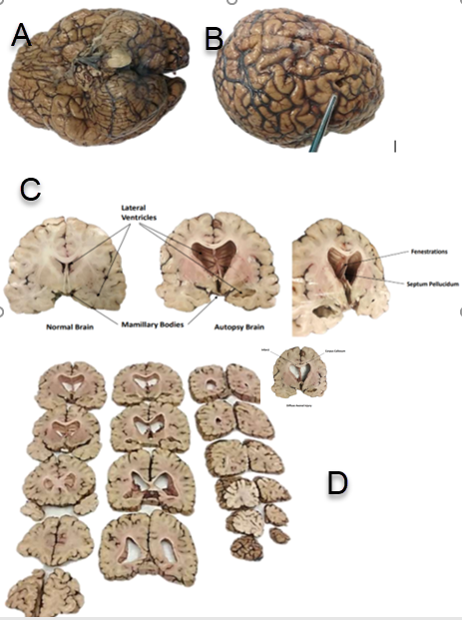
Figure 1: Gross pathology. Panel A: Showing base of the brain with meninges attached and B: Right superior and frontal view with probe identifying prior site of Ventriculoperitoneal Shunt entry point, note weight of brain was 1550 g. Panel C on the left showing a normal cross section for reference and middle and right sided windows showing relative left and right cell loss in the mesial hippocampal areas correlating with MTS(Mesial Temporal Sclerosis) see figure 2- microscopic pathology. Panel C also highlights fenestration of the septum pellucidum. Panel D shows coronal gross sections consistent with ventriculomegaly, thinning of the corpus callosum with a small prior infarct, and MTS as previously noted.

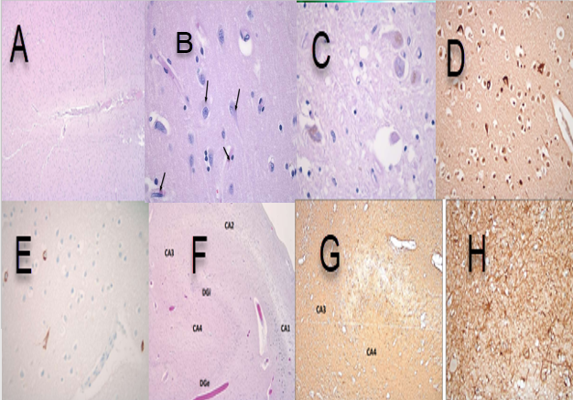

Figure 2: Microscopic pathology. Panel A: Gross section of Hematoxylin and Eosin (H+E) showing normally preserved cortical lamination in general. Panel B shows features consistent with neurofibrillary tangles- intracytoplasmic proliferation of twisted filaments- see arrows. Panel C indicates typical pigmented neurons within substantia nigra with some Globose tangles. Panel D identifies ubiquitin staining within neurons consistent with a pathologic diagnosis of neurofibrillary tangles and senile plaque. Panel E shows positive immunostaining for Tau protein, Panels F and G show relative cell loss in the granule cell layer of the hippocampus along with panel H identifying GFAP(Glial fibrillary acidic protein) staining consistent with identifying reactive astrocytes within the hippocampus consistent with Mesial Temporal Sclerosis (MTS).

Discussion and Conclusions

The findings on gross anatomy and microscopy were both consistent with Chronic Traumatic Encephalopathy (CTE) - a process most well described in contact sport athletes and characterized by progressive cognitive decline secondary to traumatic brain injury [1]. The exact incidence and pathophysiology are unclear [1-3]. The diagnostic and staging criteria are also evolving as investigations of CTE progress [4,5]. CTE is currently known to have a neuropathologically distinct regional pattern of tau deposition in neurons, neuropil and glial cells which is seen predominantly in the depths of sulci and the superficial cortical layers (II and III) [1,4,8,9]. Tau tangles can also be seen in the locus ceruleus, substantia nigra, amygdala, hippocampus and other deep nuclei as the disease progresses [1,8,9]. However, it is unclear if CTE is purely a tauopathy. Recent hypotheses include cognitive reserve and genetic disposition potentially playing a role in CTE [6]. A 2019 study of sixty patients between ages 18 and 45 who underwent focal cortical resections for drug-resistant epilepsy between 2010 and 2017 described nineteen patients with head trauma and twenty-three with tau-immunoreactive lesions [2]. Three of the four patients with the most extensive tau burden had no history of head trauma [2]. CTE also has known associations with cerebral and medial temporal atrophy as well as ventricular dilatation with fenestrated septum pellucidum as seen in the patient described [1]. Beta-amyloid deposition occurs in fewer than half the cases and was absent in this patient [1].

Bilateral Mesial Temporal Sclerosis (MTS) was found in this patient and is commonly associated with refractory epilepsy [10]. MTS is characterized by loss of neurons and reactive gliosis of the deepest portion of the temporal lobe, including the hippocampus [7,10]. Traumatic brain injury can also cause MTS with up to 25-30% of post-traumatic epilepsy cases being associated with MTS [7]. The cause of this patient’s refractory seizures, and ultimately his clinical course culminating in his death, was therefore chronic traumatic encephalopathy and bilateral mesial temporal sclerosis. There is limited documentation or investigation into the relationship of CTE and MTS. This case raises the possibility that refractory seizures and MTS have any utility in raising early suspicion of CTE. Investigations into the exact pathophysiology and diagnostic criteria of CTE are ongoing. Further investigations are needed to assess whether the combination of refractory seizures and bilateral mesial temporal sclerosis may be an early sign of CTE.
Declarations

Consent to Publish
This patient is deceased and there are no known next of kin. According to the patient, he had no children and no living family.
Author Contributions
All authors have read and approved the manuscript.
PT: Contributed to this article by performing literature review, writing and editing
JO: Contributed to this article by documenting the case, review of literature, writing and editing
Funding/COI

None

Acknowledgments

None
References

- McKee AC, Cantu RC, Nowinski CJ, et al. (2009) Chronic Traumatic Encephalopathy in Athletes: Progressive Tauopathy After Repetitive Head Injury. J Neuropathol Exp Neurol 709-735.
- Smith KM, Blessing MM, Parisi JE, et al. (2019) Tau deposition in young adults with drug‐resistant focal epilepsy. Epilepsia 60: 2398-2403.
- Veksler R, Vazana U, Serlin Y, et al. (2020) Slow blood-to-brain transport underlies enduring barrier dysfunction in American football players. Brain 143: 1826-1842.
- Gupta PK, Sayed N, Ding K, et al. (2014) Subtypes of Post-Traumatic Epilepsy: Clinical, Electrophysiological, and Imaging Features. Journal of Neurotrauma 31: 1439-1443.
- Bieniek KF (2021) The Second NINDS/NIBIB Consensus Meeting to Define Neuropathological Criteria for the Diagnosis of Chronic Traumatic Encephalopathy. J Neuropathol Exp Neurol 80: 210-219.
- Hugon J, Hourregue C, Cognat E, et al. (2021) Chronic traumatic encephalopathy. Neurochirurgie 67: 290-294.
- Gupta PK, Sayed N, Ding K (2014) Subtypes of Post-Traumatic Epilepsy: Clinical, Electrophysiological, and Imaging Features. J Neurotrauma 31: 1439-1443.
- Tai XY, Koepp M, Duncan JS, et al. (2016) Hyperphosphorylated tau in patients with refractory epilepsy correlates with cognitive decline: a study of temporal lobe resections. Brain 139: 2441-2455.
- Alyenbaawi H, Allison WT, Mok SA (2020) Prion-Like Propagation Mechanisms in Tauopathies and Traumatic Brain Injury: Challenges and Prospects. Biomolecules 10: 1487.
- Jones AL, Britton JW, Blessing MM, et al. (2018) Chronic traumatic encephalopathy in an epilepsy surgery cohort. Neurology 90.

