Research Article

The Value of Oral Examinations and the Role it plays in Medical Student Education

Stephanie Larson#, Emily Wu DO, Sam Siddighi MD, Elaine Hart MD, Alexandra Chacko-Stacey MD, James C. Lynch

#Department of Obstetrics and Gynecology, School of Medicine, Loma Linda University, California, USA

#Corresponding author: Elaine Hart, Department of Obstetrics and Gynecology, School of Medicine, Loma Linda University, 11175 Campus St. Rm 11105, California 92354, USA

How to cite this article: Larson S, et al. (2022) The Value of Oral Examinations and the Role it plays in Medical Student Education. Colu J Cas Repo 02(04): 2022-29.

Submission Date: 30 August, 2022; Accepted Date: 16 September, 2022; Published Online: 22 September, 2022

Abstract

Background: Medical education has a long history of using Structured Oral Examinations (SOE) to evaluate trainee aptitude for high-order processing. However, the SOE has received substantial criticism in recent years regarding limited reliability, possibility of bias and high cost.
Methods: In this randomized control trial, 214 third year medical students rotating through the OB/GYN clerkship were divided into two groups, those who took the SOE (n=112) and those who did not (n=102). The mean scores of two required clerkship examinations, the Observed Standardized Clinical Examination (OSCE) and the National Board of Medical Examiners (NBME) subject exam, were compared between the SOE and the non-SOE groups.
Results: We found no difference between group mean NMBE scores (SOE group: 75.6%, SD: 7.951 | non-SOE group: 73.9%, SD: 8.302 | p = 0.698) and found that those who did not participate in the SOE outperformed those who did in the OSCE (SOE group: 72.8%, SD: 4.978 | non-SOE group: 76.3%, SD: 5.331| p = 0.002).
Discussion: Our results suggest that the implementation of the SOE in clerkship curriculum does not correlate with improved medical student performance or success.

Keywords: Clerkship; Medicine; NMBE subject exam; Obstetrics & gynecology; Oral exam; OSCE

Introduction

The Structured Oral Examination (SOE) has been a standard of medical student education for many years. Arguments for their long-standing use include the potential to evaluate higher-order processing and conceptual organization [1,2]. Examiners are able to ask students a series of related questions that can test both their knowledge base and application ability to a clinical setting [3-5]. Additionally, students are able to receive immediate feedback on their responses and can receive questions tailored to their abilities and needs [4,6].

However, the use of SOE has fallen out of favor in recent years with criticisms regarding low reliability, rater bias, lack of standardization within and between SOE, the cost effectiveness of such exams, and substantial time requirements [9-14]. Additionally, there is anecdotal evidence that SOE can cause unnecessary stress and underperformance on the exams. Given the variety of concerns, most medical licensing boards in the United States have abandoned the SOE over the last 30 years.

There is tremendous variation in what constitutes the SOE, which can vary by both format and number of examiners. Some examination types include (1) interviewing examinees by quizzing on general topics, (2) asking questions regarding diagnosis and treatments plans in a clinical style, (3) utilizing a cognitive style that involves problem solving around specific cases, and (4) role playing where the student assumes various “role” to assess knowledge base. Historically, the Obstetrics and Gynecology Department at this institution used a combination of cognitive and clinical styles to assess third year medical students in the OB/GYN clerkship.

Surprisingly, there have been very few studies comparing SOE to other assessment modalities. The most recent literature focuses primarily on subspecialties taking board examinations, but we have yet to find a study that compares or assesses the potential of oral examinations as a medical school teaching tool [16]. As mentioned previously, there have been studies that test the reliability and validity of scoring oral exams [10,17,18]. Additionally, the Department of Obstetrics and Gynecology at this institution has incorporated SOE as an integral part of the evaluation of medical education of third year OB/GYN clerkship students for many years with no real assessment of whether this provided any value in the education of students.

The goal of this study was to determine the usefulness of the SOE in medical student assessment by evaluating the exam’s relationship to student performance on other required clerkship examinations. These included the Observed Standardized Clinical Examination (OSCE), which uses actors to simulate patient encounters in order to assess trainee clinical reasoning, and the NBME subject examination, a national, discipline-specific, standardized test. This would provide useful data to assist the OB/GYN department in determining whether the oral exam should continue to be an integral part of the third year medical student curriculum.

Methods

A randomized control trial was performed on 214 third year medical students rotating through a 6-week obstetrics and gynecology rotation over a period of 19 months. This sample included one entire class of third year medical students along with half of the following year of third year students between June 2010 and December 2011. Institutional Review Board approval was obtained with all students being notified that participation was voluntary and were also provided informed consent. Randomization was achieved through a computer selection process placing students into either the control arm (n=112) or experimental arm (n=102). The control group was subject to a SOE which constituted 20% of overall OB/GYN clerkship grade while the experimental group had the SOE removed from their curriculum. Composition of the final grade for this group was modified and the 20% previously allocated to the SOE was split into remaining OSCE and clinical evaluation. The NBME subject OB/GYN exam remained 40% for both groups (Table 1).

All students were given a study booklet of 35 core clinical cases to review at the beginning of the rotation. Two examining attending or resident physicians administered a 10-minute SOE to each student in the control group. Each SOE consisted of 2 different patient scenarios. The cases presented were used for all participating students. Each examiner assigned a grade and these were averaged to give a final SOE score. All student scores from the SOE, OSCE, and NBME subject exam were collected and student identifiers were removed. Scores from each group were averaged and compared between groups to assess the impact of the SOE on students’ NBME subject exam and OSCE performance. Statistical analyses were performed using SPSS 20.0. Independent sample T- tests were performed to compare the mean of the two groups and α ≤ 0.05 was considered statistically significant.

Results

Mean score comparisons of the NBME subject exam and OSCE between the control group (n=112) and experimental group (n-102) were analyzed with a sample T-test. The mean oral exam score was 7.55/9 (83.9%). The mean NBME subject exam score was 74.81/99 (75.6%, SD: 7.951) for those that took the oral examination and 73.18/99 (73.9%, SD: 8.302) for those students that did not (Figure 1). The difference in mean NBME subject exam scores was not statistically significant (p = 0.698). The mean OSCE clinical exam score was 46.95/64.5 (72.8%, SD: 4.978) for those that took the oral examination and 49.197/64.5 (76.3%, SD: 5.331) for those students that did not (Figure 2). The mean OSCE score comparison was found to have a statistically significant (p = 0.002) increase in examination scores for the non-oral examination group. The mean NBME subject exam (Figure 3) and OSCE (Figure 4) scores were broken down into individual student distribution components across grade percentages to better visualize the relatively equal distribution among the NBME subject exam scores across the groups and the unequal distribution among the OSCE scores across the groups.

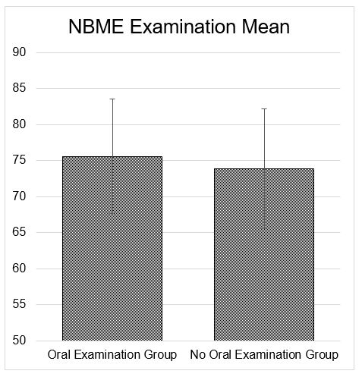

Figure 1: For those students that took the standard oral examination as part of the 3rd year medical student curriculum, the mean National Board of Medical Examiners (NBME) subject exam score was 74.81/99 (75.6%, SD: 7.951) and 73.18/99 (73.9%, SD: 8.302) for those students that did not take the standard oral exam. There was no statistically significant difference between the two groups.

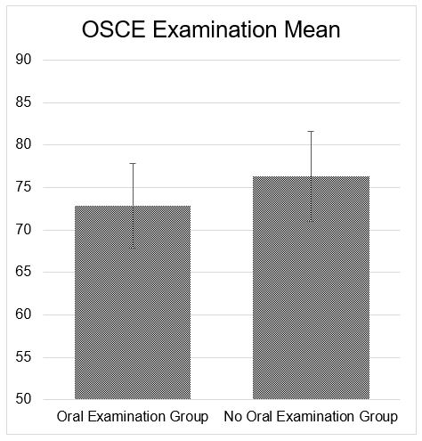

Figure 2: The mean Observed Standardized Clinical Examination (OSCE) clinical exam score was 46.95/64.5 (72.8%, SD: 4.978) for those 3rd year medical students that took the standard oral examination and 49.197/64.5 (76.3%, SD: 5.331) for those that did not (Figure 2). The mean OSCE score comparison was found to have a statistically significant (p = 0.002) increase in examination scores for those in the non-oral examination group.

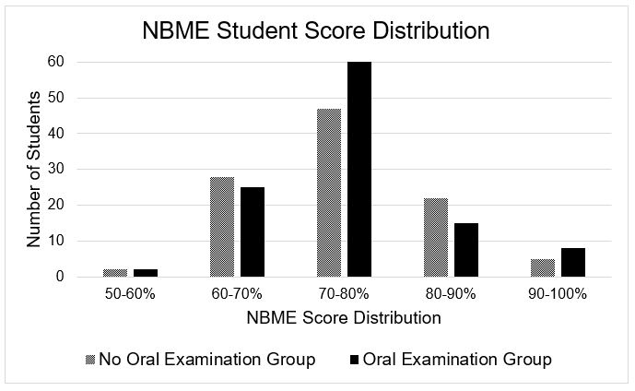

Figure 3: The mean National Board of Medical Examiners (NBME) subject exam scores were broken down into individual student distribution components across grade percentages to better visualize the relatively equal results among those who took the standard oral exam and those who did not.

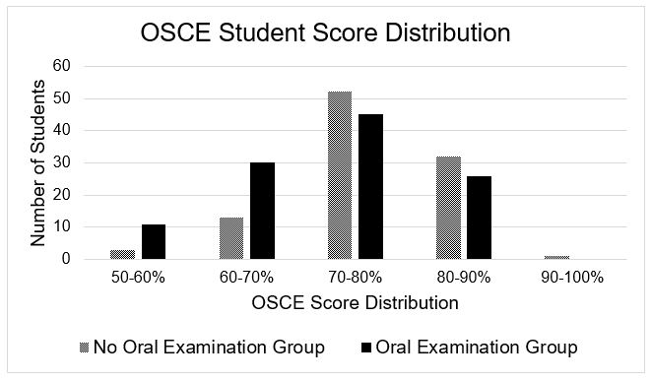

Figure 4: The mean Observed Standardized Clinical Examination (OSCE) scores were broken down into individual student distribution components across grade percentages to better visualize the relatively unequal results among those who took the standard oral exam and those who did not.

Discussion

The results of this study demonstrate that the SOE does not correlate with a statistically significant improvement in medical student clerkship performance. First, we see no statistically significant advantage to the SOE when we compare the group means of the NBME subject exam of the students who did not participate in SOE compared to those who did. The NBME is a U.S. organization that develops discipline-specific, multiple-choice exams, which are often administered by medical schools across the country as a standard component of clerkship curriculum. It is also the governing body that creates and oversees the United States Medical Licensing Examination, otherwise known as the USMLE [19]. Studies have shown correlations between the NBME scores and overall clerkship success as well as with the USMLE Step 2 Clinical Knowledge exam scores [20]. These are figures particularly important to graduate medical programs when evaluating potential residency candidates. According to our findings the SOE appears to play a limited role if any in NBME scores and, thus, may also have inadequate utility in preparing students for licensing examinations.

Additionally, the mean OSCE scores showed better performance in the students who did not take the SOE in comparison to those who did participate in the SOE. It does not appear the administration of the OB/GYN clerkship SOE benefits the student prior to taking the OSCE and may hinder student performance. A potential explanation for this unexpected result includes study time allocation for the SOE at the expense of OSCE preparation. We looked at OSCE performance as potential indicator for SOE student benefit because it has become a standard in undergraduate medical curriculum throughout the United States. The exam mimics a hospital or clinical setting using trained actors to simulate a patient and allows students to receive feedback regarding integration of medical knowledge and interpersonal skills [21]. Additionally, evidence suggests that use of the OSCE in undergraduate is correlated with better performance on national licensing examinations, especially the USMLE Step 2 Clinical Skills exam required of all U.S. students [22].

Limitations to this study include subjectivity in the evaluation of student performance. For example, although observing examiners adhere to a rubric, there is always a risk of human error, bias and subjectivity during the grading process. In addition, interpersonal interaction is a weighted component of the OSCE grade and is often determined by the hired patient actor rather than a medically trained, which can also broaden the margin of error. Additionally, the SOE like the OSCE can be a difficult to standardize and may contribute to the discrepancy seen in our data.

While this particular study did not perform a learner perceptions questionnaire following the oral exam, previous studies have cited that learners perceive the oral exam to be a useful way of assessing fund of knowledge [23]. We argue that learner perception alone is not reason enough to offset the potential pitfalls of the SOE, nor to warrant continuation, given its apparent inability to positively effect standardized exam scores.

In conclusion, the SOE has negligible impact on NBME shelf examinations scores and may possibly even hinder OSCE performance of third year medical students. It provides questionable benefits in assessing or expanding medical student knowledge and performance. After analysis of this data, the OB/GYN department has chosen to eliminate the administration of the SOE and focus on other educational modalities for third year medical student curriculum.

Acknowledgements

The completion of this manuscript is dedicated to Emily Wu, the first author, after her untimely death in April 2018.

Declarations

Funding: No funding was received for this study
Conflicts of Interest/Competing Interests: None to report
Code Availability: Not applicable
Ethics Approval: This study and its methodology were granted ethical clearance by the Institutional Review Board at Loma Linda University
Consent to Participate: Informed consent was obtained from all individual participants included in the study.
Consent to Publish: The participant has consented to the submission of the case report to the journal.

References

- Sanders J (1998) MRCGP: approaching the New Modular Examination Approach to the Oral Examination Component.
- Wass V, Wakeford R, Neighbour R, et al. (2003) Achieving acceptable reliability in oral examinations: an analysis of the Royal College of General Practitioners membership examination's oral component. Med Educ 37: 126-131.
- Cox KR (1978) How to improve oral examinations. Med J Aust 2: 176-177.
- Gibbs G, Habeshaw S, Habeshaw T (1990) 53 Interesting Ways to Assess your Students (Second Edition). Biochem Educ 18: 105.
- Jolly B, Grant J (1997) The Good Assessment Guide: A Practice Guide to Assessment and Appraisal for Higher Specialist Training. London: Joint Centre for Education in Medicine. J R Soc Med.
- Colton T, Peterson OL (1967) An assay of medical students' abilities by oral examination. J Med Educ 42: 1005-1014.
- Foster JT, Abrahamson S, Lass S, et al. (1969) Analysis of an oral examination used in specialty board certification. J Med Educ 44: 951-954.
- Kelley PR Jr., Matthews JH, Schumacher CF (1971) Analysis of the oral examination of the American Board of Anesthesiology. J Med Educ 46: 982-988.
- Thomas CS, Mellsop G, Callender K, et al. (1993) The oral examination: a study of academic and non-academic factors. Med Educ 27: 433-439.
- Burchard KW, Rowland-Morin PA, et al. (1995) A surgery oral examination: interrater agreement and the influence of rater characteristics. Acad Med 70: 1044-1046.
- Esmail A, May C (2000) Commentary: oral exams--get them right or don't bother. BMJ (Clinical research ed) 320: 375.
- Roberts C, Sarangi S, Southgate L, et al. (2000) Oral examinations-equal opportunities, ethnicity, and fairness in the MRCGP. BMJ (Clinical research ed) 320: 370-375.
- Schuwirth LWT, van der Vleuten CPM (1996) Quality control: assessment and examinations.
- McGuire CH (1966) The oral examination as a measure of professional competence. J Med Educ 41: 267-274.
- Davis MH, Karunathilake I (2005) The place of the oral examination in today's assessment systems. Med Teach 27: 294-297.
- Falcone JL, Gagne DJ, Lee KK, et al. (2013) Validity and interrater reliability of a regional mock oral board examination. J Surg Educ 70: 402-407.
- Anastakis DJ, Cohen R, Reznick RK (1991) The structured oral examination as a method for assessing surgical residents. Am J Surg 162: 67-70.
- Schwiebert P, Davis A (1993) Increasing inter-rater agreement on a family medicine clerkship oral examination--a pilot study. Fam Med 25: 182-185.
- NBME (2017) Guide to the Subject Examination Program.
- Zahn CM, Saguil A, Artino AR Jr, et al. (2012) Correlation of National Board of Medical Examiners scores with United States Medical Licensing Examination Step 1 And Step 2 scores. Acad Med. 87(10): 1348-1354.
- Dong T, Saguil A, Artino AR Jr, et al. (2012) Relationship between OSCE scores and other typical medical school performance indicators: a 5-year cohort study. Mil Med 177(9 Suppl): 44-46.
- Dong T, Swygert KA, Durning SJ, et al. (2014) Validity evidence for medical school OSCEs: associations with USMLE(R) step assessments. Teach Learn Med 26: 379-386.
- Kelly SP, Weiner SG, Anderson PD, et al. (2010) Learner perception of oral and written examinations in an international medical training program. Int J Emerg Med 3: 21-26.

