Research Article

Brain Tumor Segmentation in MRI Images Using Customized Convolutional Neural Networks

Bukya Ramu^{1#}, Sandeep Bansal²

¹Research Scholar, School of Electronics & Electrical Engineering, Lovely Professional University, Jalandhar, Punjab, India
²Associate Professor, School of Electronics & Electrical Engineering, Lovely Professional University, Jalandhar, Punjab, India

#Corresponding author: Bukya Ramu, Research Scholar, School of Electronics & Electrical Engineering, Lovely Professional University, Jalandhar-Delhi, G.T. Road, Phagwara, Punjab (INDIA) -144411, India

How to cite this article: Ramu B, Bansal S (2022) Brain Tumor Segmentation in MRI Images Using Customized Convolutional Neural Networks. Int J Nurs & Healt Car Scie 02(06): 2022-115.

Submission Date: 14 May, 2022; Accepted Date: 23 June, 2022; Published Online: 28 June, 2022

Abstract

Nowadays, brain tumor is one of the major problems in almost all countries due to pollution, genetic, and other related issues. As a result, therapy planning is essential in improving oncological quality of life. Magnetic Resonance Imaging (MRI) is a frequently used imaging technique for assessing these malignancies. Still, the massive amount of information generated by MRI precludes manual segmentation in a reasonable amount of time, thereby restricting the amount of data that can be segmented. This work proposes highly accurate tumor region segmentation from MRI images. The proposed technique can reduce the computational time and increase accuracy compared to conventional methods. The performance of this work is performed by calculated using accuracy, sensitivity, and specificity for various sized images.

Keywords: Computer vision; Magnetic resonance imaging; MRI segmentation; Sensitivity analysis; Tumor region segmentation

Introduction

Gliomas are brain tumors with the highest mortality rate and prevalence [1]. These neoplasm can be graded into Low-Grade Gliomas (LGG) and High-Grade Gliomas (HGG), with the former being less aggressive and infiltrative than the latter [1,2]. Even under treatment, patients do not survive on average more than 14 months after diagnosis [3]. Current treatments include surgery, chemotherapy, radiotherapy, or a combination [4]. MRI is especially useful for assessing gliomas in clinical practice since it can acquire MRI sequences providing complementary information [1]. Brain tumor segmentation from MR images can greatly impact improved diagnostics, growth rate prediction, and treatment planning. While some tumors such as Meningioma can be easily segmented, others like gliomas and glioblastomas are much more difficult to localize. These tumors (together with their surrounding oedema) are often diffused, poorly contrasted, and extend tentacle-like structures that make them difficult to segment. Another fundamental difficulty with segmenting brain tumors is that they can appear anywhere in the brain, in almost any shape and size [2].

The existing automatic and semi-automatic brain tumor segmentation methods can be broadly categorized as either generative model-based or discriminative model-based methods. The generative model-based brain tumor segmentation methods typically require prior information, which could be gained through probabilistic image atlases. The brain tumor segmentation problem can be modeled as an outlier detection problem [3]. Recent years saw the success of deep learning, with the methods being the top-performing automatic approaches in BRATS 2014 and 2015, using 3D and 2D Convolutional Neural Networks (CNNs), respectively. The latter approached the accuracy of the winning semi- automatic method. The fact that the employed models are rather simple in design reveals the high potential of CNNs. The method exhibited good performance based on a 3-layers deep 2D network that processes each axial slice separately.

The authors empirically showed that the class bias introduced to a network when training with patches extracted equiprobably from the task classes can be partially alleviated with a second training stage using patches uniformly extracted from the image [4]. 3D U-Net allows end-to-end training and testing for volumetric image segmentation. HighRes3DNet proposes a compact end-to-end 3D CNN structure that maintains high- resolution multi-scale features with dilated convolution and residual connection. Other works also propose using fully convolutional networks, incorporating large visual contexts by employing a mixture of convolution and down sampling operations, and handling imbalanced training data by designing new loss functions and sampling strategies [5].

Literature Survey

Mohammad et al. proposed a fully automatic brain tumor segmentation method based on Deep Neural Networks (DNNs). The proposed networks are tailored to glioblastomas (low and high grade) pictured in MR images. By their very nature, these tumors can appear anywhere in the brain and have almost any kind of shape, size, and contrast. These reasons motivate our exploration of a machine learning solution that exploits a flexible, high capacity DNN while being extremely efficient. Here, describe different model choices that have been found to be necessary for obtaining competitive performance. Explore in particular different architectures based on Convolutional Neural Networks (CNN), i.e. DNNs specifically adapted to image data. A novel CNN architecture which differs from those traditionally used in computer vision. The CNN exploits both local features and more global contextual features simultaneously. Also, unlike most traditional uses of CNNs, our networks use a final layer that is a convolutional implementation of a fully connected layer that allows a 40 fold speed up. Describe a 2-phase training procedure that allows us to tackle difficulties related to the imbalance of tumor labels. Finally, explore a cascade architecture in which the output of a basic CNN is treated as an additional source of information for a subsequent CNN [6].

Xiaomei Zhao et al. proposed a novel brain tumor segmentation method is developed by integrating Fully Convolutional Neural Networks (FCNNs) and Conditional Random Fields (CRFs) in a unified framework to obtain segmentation results with appearance and spatial consistency. Train a deep learning-based segmentation model using 2D image patches and image slices in the following steps: 1) training FCNNs using image patches; 2) training CRFs as Recurrent Neural Networks (CRF-RNN) using image slices with parameters of FCNNs fixed, and 3) fine-tuning the FCNNs and the CRF-RNN using image slices. Mainly, train three segmentation models using 2D image patches and slices obtained in axial, coronal and sagittal views, respectively, and combine them to segment brain tumors’ using a voting-based fusion strategy. This method could segment brain images slice-by-slice much faster than image patches. Evaluated this method based on imaging data provided by the Multimodal Brain Tumor Image Segmentation Challenge (BRATS) 2013, BRATS 2015 and BRATS 2016 [7].

Ramesh Babu, and Rajesh et al. An automatic brain tumors detection technique in noise corrupted images. The Denoising of the image is implemented using Edge Adaptive Total Variation Denoiesing Technique (EATVD). The method is used to preserve the edges in denoising the image. Once the noise is removed from the image, the image is segmented using mean shift clustering. For feature extraction, the segmented parts are sent to the gray level co-occurrence matrix. The features are used by multi-class SVM to detect the tumour in the images. The step followed extracts the tumors with increased precision in noisy images [8].

Mohammadreza et al. proposed novel 3D supervoxel based learning method for segmentation of tumors in multimodal MRI brain images (conventional MRI and DTI). Supervoxels are generated using the information across the multimodal MRI dataset. For each supervoxel, various features, including histograms of texton descriptor, are calculated using a set of Gabor filters with different sizes and orientations, and first-order intensity statistical features are extracted. Those features are fed into a Random Forests (RF) classifier to classify each supervoxel into tumors core, oedema or healthy brain tissue [9].

Anuja arora et al. proposed a brain tumor segmentation of MRI images using u-net architecture, by using u-net algorithm the main problem in brain tumor diagnosis and treatment to separate healthy tissue from the timorous region this is the first step in brain tumor diagnosis test, a MRI images gives a in detailed data about brain tumors for this we make it an very important algorithm for better diagnosis and it replace with previous algorithms, for this purpose the author used a U- net architecture, for this they can use 4 different MRI datasets FLAIR, T1Gd, T1, T2 are used and the proposed model is achieved a dice value of 0.98,0.98,0.98,0.99,0.94,0.99 on the tested datasets of BraTs 2018 dataset[10].

Dong et al. the worked in automatic brain tumor detection and segmentation using U-net architecture for BraTs2015 dataset, the data set was normalized for each sequence of the multimodal MRI images by subtracting the mean of each sequence and dividing it by its standard deviation for this the dataset extension is required by using different data augmentation techniques are used for this using fivefold cross validation technique for the HCC and LGG data respectively. In this they can take each patient data validation method on three sub regions of tumors are first one is the complete tumor region, the second is enhancing tumor region and the third is core tumor region. A dice similarity coefficient for the complete region and the enhancing tumor region is 0.88, 0.81 for HGG and for LGG is 0.85, 0.89 respectively.

Tuan et al. the author worked on the datasets of BraTs2018 and used a bit plane and unet, the proposed approach starts with bit plane to get the most significant and least significant bits which can cluster and generate more images, followed by U-net to segments all glioma regions. In this research work implemented the unet with multiple kernels to get better performance, furthered more the results is evaluated without any additional data. And it demonstrated promising performance with a mean dice score of 0.68, 0.82, 0.70 for enhancing tumor whole tumor, and tumor core respectively. In the present research work and we use some advanced methods and the achieved accuracy is better compared to existing work.

For this we modified and we proposed by Cahall et al. in the year 2019 by invite an end to end brain tumor segmentation framework that utilizes a modified U-net algorithm with inception modules to accomplish multi scale feature extraction, It is observed that for intra tumor structures adding inception modules to the u-net resulted in significant improvements in WT,Tc,ET(0.89 to 0.91, 0.93 to 0.95, and 0.94 to 94) the study performed by Cinar et al. in 2021 applied different preprinted CNN models like Google Net, ResNet50, Alex Net, and DenseNet201in this work a hybrid improved deep learning model is introduced by which achieved accuracy is 97.01.

Kermi et al. in the year 2019 used the data sets of BraTs2018 and in this preprocessing the authors removed one% of the highest and lowest intensities. Then each modality of MRI images was normalized [39], to find the imbalance problem in the data different types of data augmentation methods was used are translation, horizontal, rotation, mirroring, and flipping as the deep learning method CNN is used with similar architecture as that of U-Net, the designed network was trained with axial slices extracted from the training MRI datasets for including HGG, LGG cases for the corresponding ground true segmentation the accuracy of the work is evaluated using the dice coefficient where the whole tumor, enhanced tumor and core tumor detection dice coefficient are 0.867,0.798,0.717 respectively.

s.no | Authors | Title | Year of Publication | Methodology Used | Disadvantages
1. | R. Tamilselvi; A. Nagaraj; M. Parisa Beham | BRAMSIT: A Database for Brain Tumor Diagnosis and Detection | 2020 | SVM | Less accuracy
2. | Mircea Gurbină; Mihaela Lascu | Tumor Detection and Classification of MRI Brain Image using Different Wavelet Transforms and SVM | 2019 | Tumor wavelet transforms | Low Training
3. | T. M. Shahriar Sazzad; K. M. Tanzibul Ahmmed | Development of Automated Brain Tumor Identification Using MRI Images | 2019 | OTSU's thresholding-based Segmentation | No feature analysis
4. | Ashfaq Hussain; Ajay Khunteta | Semantic Segmentation of Brain Tumor from MRI Images and SVM Classification using GLCM Features | 2020 | Skull stripping  Watershed Segmentation,  GLCM features | Not suitable for large data
5. | Gajendra Raut; Aditya Raut; Jeevan Bhagade | Deep Learning Approach for Brain Tumor Detection and Segmentation | 2021 | CNN, MRI, noise, backpropagation,autoencoder,  K-Means algorithm | No output parameters
6. | Sahar | Automated Detection of Brain tumor through MRI using convolution Neutral network | 2021 | Focal loss function, transfer learning techniques, Google net | Complex Architecture
7 | Muhammad | Brain tumor detection and classification by MRI using biological inspired orthogonal wavelet transform and deep learning techniques | 2022 | GLCM features, GA based feature selection | Higher computational time
8 | Isselmou | Brain tumor detection and classification on MR images by a deep wavelet auto-encoder model | 2021 | Deep wavelet auto encoder | Dual classifier, more hidden units
9 | Aswathy | Brain tumor detection and segmentation using a wrapper based genetic algorithm for optimized feature set | 2017 | Co-occurance matrix, Wrapper based genetic algorithm, SVM | Less accuracy
10 | Chuanbo huang | Automated segmentation of brain tumor based on improved U-net with residual units | 2021 | U-net, residual learning model | More hardware resources are required and higher number of BRAM
11 | Dilip Ranjan nayak, Neelamadhab padhy, Sachin kumar | Brain tumor classification using dense efficient net | 2022 | Dense efficientNet | High computational time

Problem Statement

The previous brain tumor detection methods are inefficient in terms of accuracy and computational complexity.
The previous segmentation methods are not flexible. Which is not suitable for the maximum of the database used?

Objectives

The major objectives of this work are stated below:

To increase the computational accuracy of the segmentation with less computational complexity.
To increase the algorithm's flexibility to work with different MRI images generated by various machines.
To perform the prediction process with high-resolution MRI images with less computational time.

Material and Research Flow

The above studied literature broadens the understanding of the principal practices used to get the best performance and efficiency, based on the above literature. The brain tumor MRI scan of datasets was considered for experimental consideration and a research flow was designed we achieve the research objectives.

Material
The datasets was collected from kaggle site, the data provided as part of BraTS2018 to the same resolution of 1mm and it was also skull stripped, the brats dataset contains brain MRI images of patients in each class HGG & LGG we arrange each patient for separate folder in this datasets have four different models and the segmentation results, the various techniques are T1, T2, FLAIR and T1Gd (post contrast weighted) saved each tumor segmentation and tumor segmented region is record. In this propose of tumor segmentation are given three divided regions Tc (tumor core), whole tumor (wt) and ET (enhancing tumor) we use more datasets for validation and testing is provided along with that the details are given below (Table 1).

Size of Image (input) | 240*240*155
Training Data | HGG images | 220
 | LGG Images | 85
Test Datasets |  | 195
Validation of Datasets |  | 76

Table 1: Details of BraTS2018 datasets.

The above (Table 1) gives the multimodal scans of MRI images datasets of in the BraTS the ground truth output of segmented results is examined for verification with our predicted results, all the imaging datasets were segmented automatically and their observations were declared by experienced neurologist.

Research Flow

In this part how the research flow of our work done in to get the good accuracy for detection of brain tumor using scanned MRI images, this research moved was plan to get extracted segmented tumor region in contrast of classifying. Were the input images took from the well know BraTs2018 MRI datasets, in view this research work was done in two steps one is pre-processing and second is deep learning technique for tumor detection and segmentation. In the preprocessing the data flow starts with a image segmentation and a data transformation it change brain tumor image datasets into a python machine readable format, the subset part step was done to divide the dataset as the formed dataset is high in size and resource restriction, in this images we remove unnecessary content from the input images the basic level image segmentation was accomplished by using watershed algorithm and finally feature scaling was applied and we ended the pre-processing method.

For the problem of biomedical signal processing research area the location of image is a important and crucial part that need an adequate deep learning model is used. For this CNN networks are designed in that CNN network we are going to use U-Net model is used for locating the tumor region in MRI images. U-net model can provide the exact tumor region in the provided MRI images in this U-net model the edge detection method gives the clear location of tumor, irregular, and boundaries of the images and the researchers to evaluate the performance of the research problems easily, this performance measures to applicable to quantify the performance of tumor segmented region the overall frame work is given in below (Figure 1).

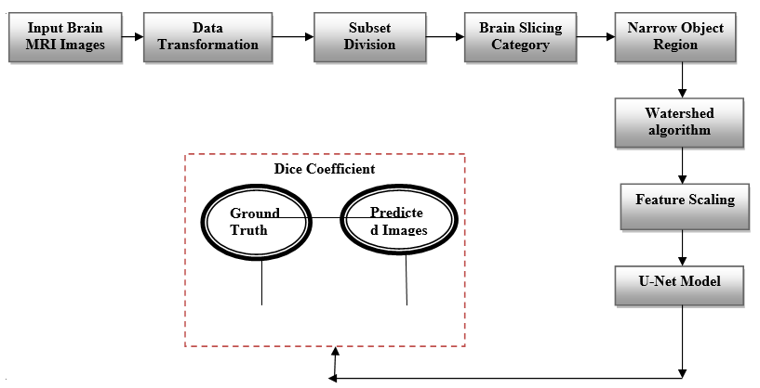

Figure 1: U-Net model for Brain tumor segmentation in deep CNN Networks (Figure taken from [20]).

As mentioned in the above data the multimodal sans in BraTS2018 dataset were formatted in NIFTI files. All the given images were processed to covert from the nii,gz format to numpy arrays, this was done using pythons simpleITK library since the given data was already skull stripped each patients MRI scans volume were collected and directly combined to form a numpy array.

Methodology (Figure 2)

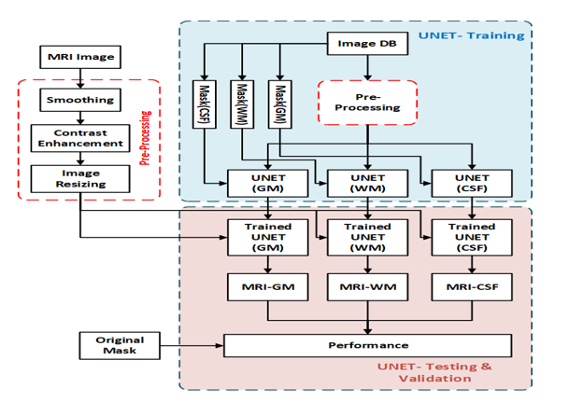

Figure: 2 Block Diagram of Proposed technique.

The MRI brain images were taken from the database and then preprocessed using smoothing, contrast enhancement, image resizing methods. In the training process, the UNET network was will be used for the training with the preprocessed image. The UNET is used to test the process with trained UNET and masked image. Finally we get the performance of the work. As for the above mentioned information the multimodal scanned MRI brain images in BraTs2018 dataset was formatted in NIFTI images format, so we convert all the images were processed to convert into nii.gz format to numpy data arrays we will done this by using python but the received data as already skull stripped of each patient MRI scanned images, MRI scan volumes were collected and directly combined to form a numpy array the formed numpy array is of each size (W, X, Y, Z) here W- Number of HGG or LGG data (BraTs 2018)

X- Number of total 2D slices corresponding to each MRI 3D volume)
Y- 2d slice of each dimensions
Z- Number of modalities

The formed numpy array is large, which required high RAM availability for further pre-processing and training. The data was handled by dividing it into four subsets, namely HGG-1, HGG-2, HGG-3, and LGG-1. This was done to reduce RAM consumption and feed the data sequentially. BraTS 2018 contains 210 patients’ scans under HGG and 75 patients’ scans under LGG. Thus, the HGG data was divided into three sets, each consisting of 70 patients’ scans, and the LGG data was considered as the fourth set. Similarly, the corresponding ground truth scans were also extracted and divided into four subsets. All the 2D slices corresponding to each MRI 3D volume image would not show the tumor region. Thus, the slices which can contain the tumor region were grouped to get better accuracy. This implementation of brain slicing can be automated by learning features or set manually by excluding some first and end slices. Thus, from the 155 slices that corresponded to each MRI 3D volume imager, only the mid-portion, i.e., from the 30th slice to 120th slice, was taken to generate the sliced data.

Each 2D image can be resized to minimize any unnecessary background and effectively implement deep learning. As a response, the images were resized before even being fed into the architecture. To narrow the object region, we trimmed the image size for all four modalities from (240,240) to (192,192). Before sending the brain image with the tumor to the feature extraction module, we segmented it to speeding up the learning process. The Tumor Region and the Non-Tumor Region were created as a result of picture segmentation. The watershed algorithm has been utilized for segmentation, and we employed OpenCV's marker-based watershed method in our experiments. This algorithm determines which valley points should be merged, i.e. included, and which should be excluded, i.e. excluded. During in the course of our work, we this marker-based watershed algorithm from OpenCV is used. This algorithm specifies which valley points should be merged, i.e. included, and which will be excluded, i.e. excluded. We used one color/intensity to mark the region we were certain was the foreground or object, and another color/intensity to label the region we were certain was the background, i.e., the non-object. Finally, we labeled the region where we're not sure of anything with 0 this was our marker. The watershed algorithm was then utilized. The borders of items were given a value of, and our marking was modified with the labels we gave. (Figure 3a, b) show the original image and its segmented image using the watershed algorithm, respectively.

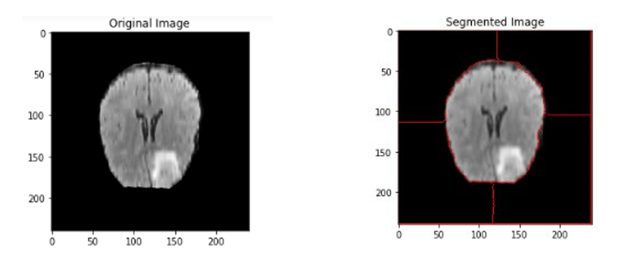

Figure 3: (a): Real image (b): Segmented image.

Feature Scaling

Feature scaling it is one of the techniques to used for the independent and standardize features given in the information in to particular time interval, by using the feature scalling model we dedect the particular part of tumor by using deep learning model and it gives more faster scaling compare to othre models here we can apply z score normalization here it will tranfor the each valye into zero to its unit variance by using below formula we calculate the the z score value.

Z = $X-U/σ$ (1)

Here z - Transformation value of the particular feature value
X, U- is the mean values
$σ$ - Image features of standard deviation

Deep Learning Model for tumor Region Segmentation

For biomedical signal processing required a particular alogrithm is needed for this we use a u-net based deep learning is used for location of tumor requirements we achive the perfect output, for locationg the tumor region and position of the tumor the U-net model is used as a deep learning technique. The fully convolutional neural network are the succesive layers, and pooling layer operators are replaced by upsampling layer because the follwing layers are increse the resolution of the output, in oder to localize and high resolution path are add with the upsampling operators. Based on this data, a good convolution layer can learn to construct a more precise output. We also have a large number of feature channels in the upsampling phase, which allow the network to pass contextual information to higher resolution layers. As a result, the expansive path is approximately symmetric to the contracting path, giving in a u-shaped architecture, each blue box refers to a multi-channel feature map, showing the network architecture. On the left, there is a contracting path, and on the right, it's an expansive path.

The convolutional network's expanding path follows the standard architecture. It consists of two 3*3 convolutions (unpadded convolutions) that are applied repeatedly, each followed by a rectified linear unit (ReLU) and a 2*2 maximum pooling operation with stride three for downsampling. In this work at every downsampling stage the number of features chaneels are incresed, every stage in the expansive path consits of an upsampling of the features maps follwing a 2*2 convolutional layer it haves the more feature chaneels to the corresponding cropped feature maps from the contracting path. A 3*3 convalutonal follwing by relu netwrok this crooping is mandatory because of the los of pixels in each convaluitonal layer. In the last layer we use 1*1 convolution lyaer is used to maps each 64 block of feature vector to the desired number of classes using U-net convaolution (Figure 4).
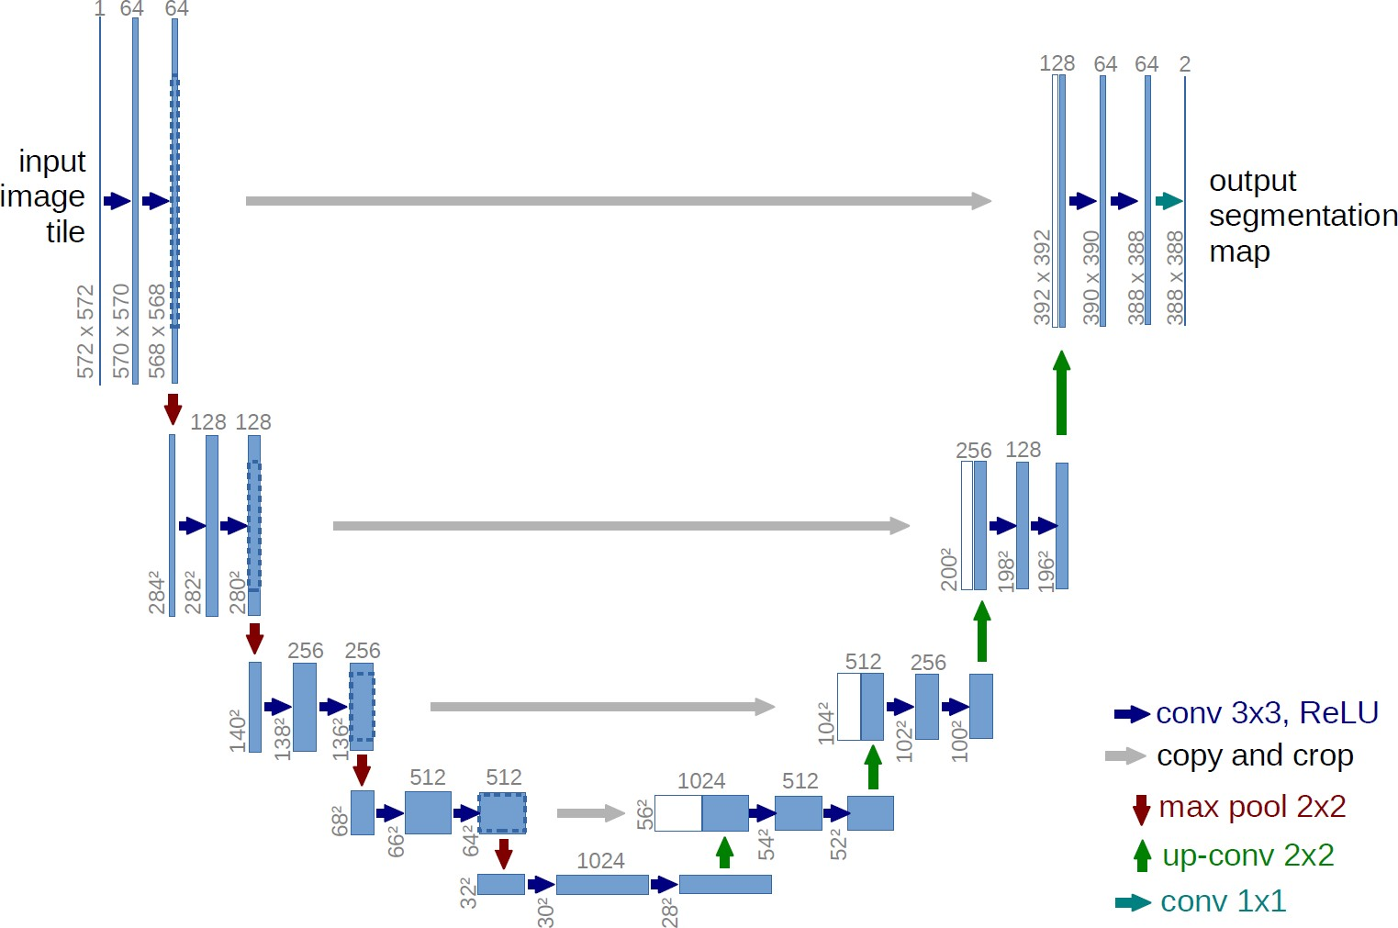

Figure 4: U-net architecture (example for 32 × 32 pixels in the lowest resolution) (Figure taken from) [20].

Results and Experimental Setup

In this work we mainly focued on the MRI brain tumor identification using deep learning based tumor segmentation model u-net is perfromed. For data validation the follwing parameters are considered loss funcation and dice coefficient, here we can use different python keywords to implement for segmented brain tumor region to the process and validate the output. Here we can mentioned some of the libraries used in python are open cv, glob, mahotas, numpy, random keras etc. We measure the performance of this algorithm on the training and test set for supervised learning model, The gap in between original and predicted mri images was computed by evaluating the output image to the actual growth truth image. The diced factor was thought to be a more simple way to evaluate the image segmentation problem's output effectiveness, It was used to estimate the % overlap between the ranges of the two images, that ranges from zero to 1. A value of 1 just on dice coefficient lot of satisfaction and full overlap. Mostly in known medical imaging issues, the dice value has been used to evaluate the model. As a result, the dice score/coefficient was used to quantify image segmentation performance.

$Dice score= 2*\frac{|Y∩Z|}{\left|Y\right|+|Z|}$ (2)

Here ‘Y’ is define as the ground truth in medical and ‘Z’ is the predicated segmentation, in this task of results of brain tumor training process get caught in the local minimum of the loss function. As an outcome, the foreground region is only partially spotted or completely missing in some cases. Several previous approaches depended on loss functions, which utilize sample re-weighting to assign the background area a lower status than the foreground during training. A novel objective function based on the dice coefficient is presented with the aim of optimizing the foreground the dice score between two binary volumes can be given as.
$Dice score= 2*(|Y∩Z|)/(Y+Z)2$ (3)

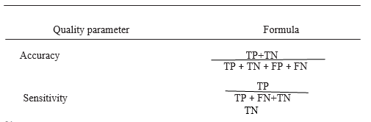

SVM is the conventional way for brain tumor detection since it combines feature selection with kernel class reparability. The performance of the SVM algorithm can be analyzed in terms of accuracy, sensitivity, and specificity. For the calculation of accuracy, sensitivity, and specificity, the confusion matrix specifies the terms TP, TN, FP, and FN from the expected outcome and ground truth result. The number of true positives (TP) is used to indicate the total number of abnormal cases correctly identified, whereas a number of true negatives (TN) are used to indicate the total number of abnormal cases improperly classified. is used to indicate normal cases correctly classified; FP is the number of false-positive, and it is used to indicate wrongly detected or classified abnormal cases; when they are actually normal cases and FN is the number of false negatives, it is used to indicate wrongly classified or detected normal cases; when they are actually abnormal cases, all of these outcome parameters are calculated using the total number of samples examined for the detection of the tumor. From the total cases examined, the quality rate parameter accuracy is the proportion of total correctly classified cases which are abnormally classified as abnormal and normally classified as normal. The formulas for developed a way, sensitivity, and specificity are shown (Figure 5) (Table 2,3).

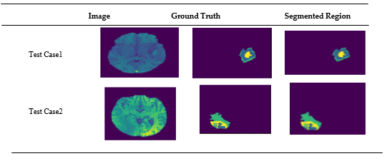

Figure 5: Sample successful test case after parameter tuning in U-Net architecture.

Set | Training | Validation | Test
HGG1 | 0.9955 | 0.9953 | 0.9815
HGG2 | 0.9965 | 0.9964 | 0.9844
HGG3 | 0.9962 | 0.9957 | 0.9804
LGG1 | 0.9954 | 0.9951 | 0.9854
LGG2 | 0.9956 | 0.9954 | 0.9857

Table 2: Performance measure Dice coefficient of training, validation, and test sets.

Evaluation parameter | ANFIS | Back Propagation | Proposed classifier (U-NET)
True negative | 64 | 63 | 66
False positive | 16 | 19 | 5
True positive | 118 | 110 | 129
False negative | 4 | 10 | 6
Specificity | 79.74 | 76.54 | 95.2
Sensitivity | 96.72 | 97.5 | 98.72
Accuracy | 90.04 | 85.57 | 97.51

Table 3: Comparison of accuracies in different classifiers.

(Figure 6) illustrates the Die factor values and loss curves of the training and validation for all of the subsets used in this study (HGG-1, HGG-2, HGG-3, and LGG-1), the model score represents the performance curve of the U-Net-based tumor segmentation model, where the vertical axis indicates the dice coefficient, while the horizontal axis is the number of epoch, the model loss plot, which shows the loss decreasing with each period both for train and test sets. Therefore, the results shown suggest that the proposed methodology is likely to obtain remarkable results in a lesser number of training epochs.

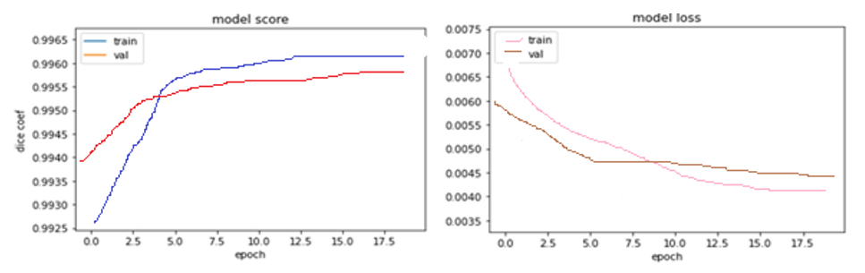

Figure 6(a): Dice coefficient and loss curve of HGG-1 Subset (b) Dice coefficient and loss curve of HGG-2 Subset.

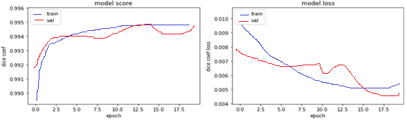

Figure 6: (c): Dice coefficient and loss curve of HGG-3 Subset (d) Dice coefficient and loss curve of LGG-1 Subset.

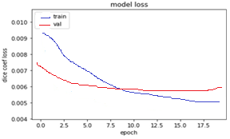

Figure 6: (d) Dice coefficient and loss curve of LGG-2 Subset.

Conclusion

A challenging problem of pixel label segmentation of brain tumors using MRI data, which is required for brain tumor diagnostic procedures, was tackled in the present work. The proposed model initially used diverse image processing steps to upgrade the brain image and images provided in sub-regions in a well-defined manner. Undoubtedly, accurate segmentation of a brain tumor into its sub-regions provides a deeper insight into the condition of the tumor, Hence, in the planned work, image knowledge transformation, image slicing for the refined region (category brain slicing, set division, and slender object region), initial level image segmentation (watershed algorithm), and have scaling were experimented with before inputting within the deep learning model. The U-Net deep learning model was accustomed localize the tumour region; the getting a part of U-Net captures the context from the compact feature illustration and growth path and performed correct localization. Parameter standardization of acquiring and enlargement path layers in an exceedingly regular manner was applied so as to realize high accuracy. The projected work achieved high accuracy on some 0.99 for the coaching and validation set and z0.98 for the check set that could be an exceptional performance for neoplasm detection. High dice scores, accuracy, and speed of this network afford large-scale application in brain tumour segmentation. This technique is enforced within the clinical progress for reliable tumour segmentation and for providing clinical steerage in diagnosing, surgical designing, and follow-up assessments. Though improvement and future analysis directions are opened during this furthermore, some are as follows.

Specifications

SL. NO | Operating system | Windows 8/10
1 | System Specifications | Intel(R) Core(TM) i5-3320M CPU @  1.60 GHz,1 .60 Ghz, and 4 GB
2 | Dataset | 1. Kaggle MRI image dataset
3 | Performance | Sensitivity Analysis Computation time  Training and testing graphs
4 | Programming Language | Python

Reference

- Pereira S, Adriano P, Victor A, et al. (2016) Brain tumor segmentation using convolutional neural networks in MRI images. IEEE transactions on medical imaging 5: 1240-1251.
- Havaei M, Axel D, David W, et al (2017) Brain tumor segmentation with deep neural networks. Medical image analysis 35: 18-31.
- Zhao X, Yihong W, Guidong S, et al. (2018) A deep learning model integrating FCNNs and CRFs for brain tumor segmentation. Medical image analysis 43: 98-111.
- Kamnitsas, K, Enzo F, Sarah P, et al. (2016) DeepMedic for brain tumor segmentation. In International workshop on Brainlesion: Glioma, multiple sclerosis, stroke and traumatic brain injuries 138-149.
- Wang G, Wenqi L, Sébastien O, et al. (2017) Automatic brain tumor segmentation using cascaded anisotropic convolutional neural networks. In International MICCAI brainlesion workshop 13: 178-190.
- Havaei M, Axel D, David W, et al. (2017) Brain tumor segmentation with deep neural networks. Medical image analysis 35: 18-31.
- Zhao X, Yihong W, Guidong S, et al. (2018) A deep learning model integrating FCNNs and CRFs for brain tumor segmentation. Medical image analysis 43: 98-111.
- Vallabhaneni RB, Rajesh V. (2018) Brain tumour detection using mean shift clustering and GLCM features with edge adaptive total variation denoising technique. Alexandria engineering journal 4: 2387-2392.
- Soltaninejad M, Guang Y, Tryphon L, et al. (2018) Supervised learning based multimodal MRI brain tumour segmentation using texture features from supervoxels. Computer methods and programs in biomedicine 157: 69-84.
- Pereira S, Adriano P, Victor A, et al. (2016) Brain tumor segmentation using convolutional neural networks in MRI images. IEEE transactions on medical imaging 5: 1240-1251.
- Riries R, Ain K (2009) Edge detection for brain tumor pattern recognition. In Proceedings of the International Conference on Instrumentation, Communication, Information Technology, and Biomedical Engineering, Bandung, Indonesia 1-3.
- Khare S, Bhandari A, Singh S, et al (2012) ECG Arrhythmia Classification Using Spearman Rank Correlation and Support Vector Machine. Adv. Intell. Soft Comput 131: 591-598.
- Urva L, Shahid AR, Raza B, et al. (2021) an end-to-end brain tumor segmentation system using multi-inception- UNET. Int. J. Imaging Syst 2: 1064
- Mora BL, Vilaplana V (2020) MRI brain tumor segmentation and uncertainty estimation using 3D-UNet architectures 15294.
- Jurdi E, Petitjean RC, Honeine P, et al. (2020) Bb-unet: U-net with bounding box prior. IEEE J. Sel. Top. Signal Process 14: 1189-1198.
- Mohammadreza S, Yang G, Lambrou T, et al. (2017) Automated brain tumour detection and segmentation using superpixel-based extremely randomized trees in FLAIR MRI. Int. J. Comput. Assist. Radiol. Surg 12, 183-203.
- Abdelrahman E, Hussein A, AlNaggar E, et al. (2016) Brain tumor segmantation using random forest trained on iteratively selected patients. In International Workshop on Brainlesion: Glioma, Multiple Sclerosis, Stroke and Traumatic Brain Injuries; Springer: Cham, Switzerland 129-137.
- Toktam H, Hamghalam M, Reyhani-Galangashi O, et al. (2019) Mirzakuchaki, S. A machine learning approach to brain tumors segmenta- tion using adaptive random forest algorithm. In Proceedings of the 2019 5th Conference on Knowledge Based Engineering and Innovation (KBEI) 76-82.
- Malathi M, Sinthia P (2017) BrainTumour Segmentation Using Convolutional Neural Network with Tensor Flow. Asian Pac. J. Cancer Prev 20: 2095-2101.
- Anuja A, Ambikesh J, Mayank G, et al. (2021) Brain Tumor Segmentation of MRI Images Using Processed Image Driven U-Net Architecture. Computers 10: 139.
- Dillip RN, Neelamadhab P, Pradeep KM, et al. (2022) Brain Tumour classification using dense efficient-net. Axioms 11: 34.
- Reddy AVN, Krishna CP, Mallick PK, et al. (2020) Analyzing MRI scans to detect glioblastoma tu-mor using hybrid deep belief networks. J. Big Data 7: 35.
- Rehman A, Naz S, Razzak MI, et al. (2020) Deep learning-based framework for automatic brain tumors classification using transfer learning. Circuits Syst. Signal Processing 39: 757-775.
- Dillip RN, Neelamadhab P, Pradeep KM, et al. (2022) Brain Tumour classification using dense efficient-net. Axioms 11: 34.

