Case Report

Metastatic Spinal Cord Compression in an Asymptomatic Early-50s Patient

Harsh Sharma D.O.¹, Elizabeth Macri M.D.²

¹Department of Internal Medicine, University of New Mexico Health Sciences Center, New Mexico, USA
²Department of Neurology, University of New Mexico Health Sciences Center, New Mexico, USA

#Corresponding author: Harsh Sharma D.O., Department of Internal Medicine, University of New Mexico, 915 Camino de Salud NE, Albuquerque, New Mexico 87106, USA

How to cite this article: Sharma H, Macri E (2022) Metastatic Spinal Cord Compression in an Asymptomatic Early-50s Patient. Colu J Cas Repo 02(02): 2022-21.

Submission Date: 05 March, 2022; Accepted Date: 31 March, 2022; Published Online: 05 April, 2022

Summary

An otherwise healthy 54-year-old male presented to the hospital with one day of bilateral lower extremity paresthesias and cramping. MRI T- and L-spine revealed extensive epidural disease at T3/T4, paraspinal masses at T3/T4 on the left and T5/T6 on the right. CT A/P with contrast showed diffuse sclerotic osseous metastatic disease, numerous pulmonary nodules concerning for pulmonary metastasis, and an enlarged, heterogeneous prostate. A concern for Prostate Cancer (PCa) prompted a prostate-specific antigen level check, which was found to be 1,650 (normal, 0-4). Posterior fourth rib core and epidural tumor biopsies confirmed metastatic adenocarcinoma of the prostate. Metastatic Spinal Cord Compression (MSCC) is a rare complication of PCa. Maintaining awareness about this rare presentation of a common cancer, with coordination of care between primary and specialty care providers, may guide patients to a more favorable prognosis.

Keywords: Cancer screening; Prostate cancer; Spinal cord compression

Background

Currently, the United States Preventive Service Taskforce has a Grade C recommendation for PCa screening in men aged 55-69 years, with the decision to screen to be made on an individual basis with contributing factors that include comorbidities, family history, and race/ethnicity [1]. This patient, without a remarkable past medical and family history, falls just outside the screening age but presented with MSCC as a complication of advanced PCa. It is worth considering expansion of current guidelines to younger patients or earlier screening for those with concerning symptoms (eg neurological). In the United Kingdom, current recommendations for prostate cancer screening include: access to a baseline PSA at age 40, access to testing by all men from the age of 50 and those with an above average risk of cancer should have PSA test access from the age of 45 [2]. This case was previously presented as a poster at the 2021 AMWA Leads Conference on March 26, 2021.

Case Presentation

An otherwise healthy 54-year-old male presented to the emergency department with one day of bilateral lower extremity paresthesia and cramping. He was unable to bear full weight on his legs on the day of presentation. Except for a recent mildly sprained back, review of systems was negative. Physical exam was significant for upgoing Babinski reflexes bilaterally, decreased sensation to pinprick below T4 on the right and T6 on the left, and decreased proprioception of both great toes. MRI thoracic and lumbar spine with and without contrast revealed extensive epidural disease at T3/T4, paraspinal masses at T3/T4 on the left and T5/T6 on the right (Figure 1) involving the left fourth rib and right fifth rib with resultant severe neural foraminal and spinal canal stenosis. Computed tomography of the abdomen and pelvis with contrast showed diffuse sclerotic osseous metastatic disease, numerous pulmonary nodules concerning for pulmonary metastasis, and an enlarged, heterogeneous prostate. Labs were significant for elevated erythrocyte sedimentation rate (29), C-reactive protein (2.4), and creatine kinase (382). A concern for prostate cancer prompted a prostate-specific antigen level check, which was found to be 1,650 (normal, 0-4). Posterior fourth rib core and epidural tumor biopsies obtained by interventional radiology confirmed metastatic adenocarcinoma of the prostate.

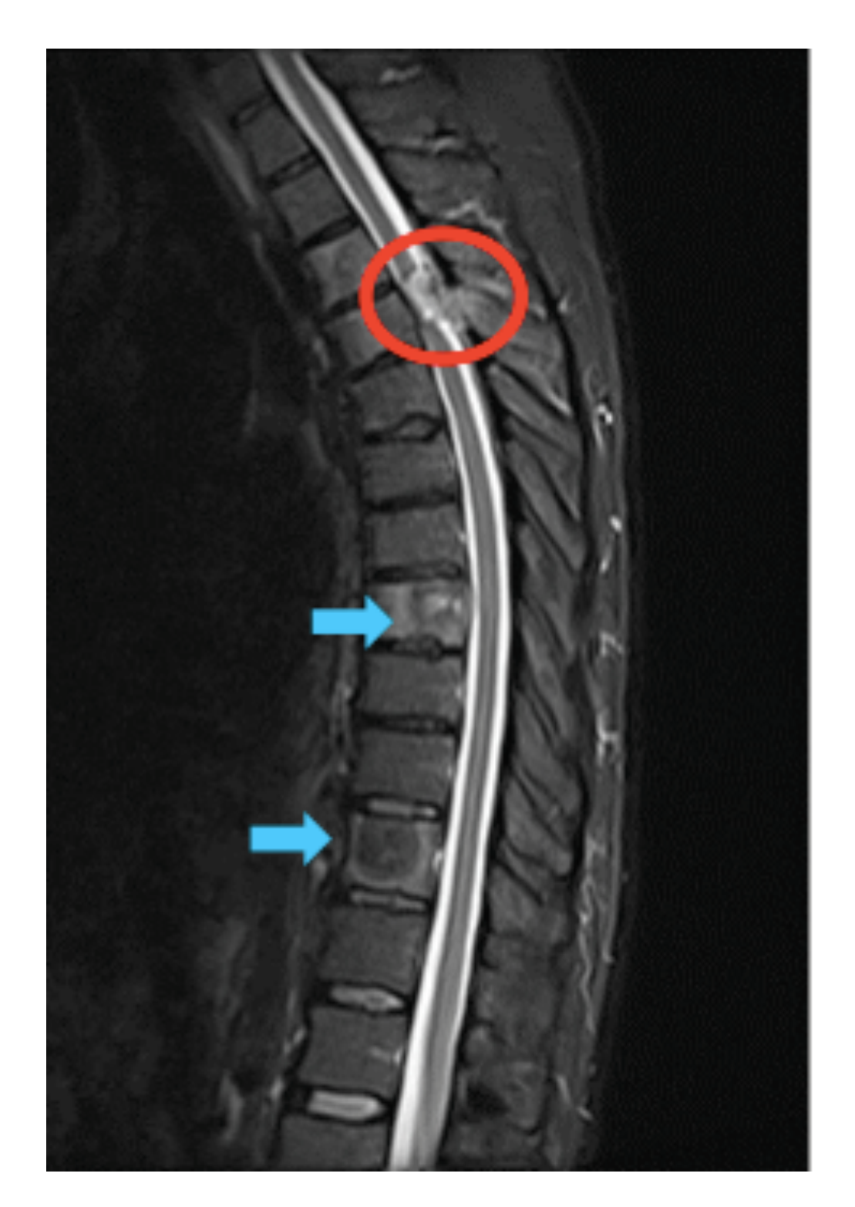
Figure 1: Epidural metastatic prostate cancer with spinal cord compression (red circle). Vertebral body metastatic prostate cancer (blue arrows).

Treatment

Pending outpatient oncology and neurosurgical follow-up, the patient developed lower extremity paralysis and urinary retention, prompting readmission. Magnetic resonance imaging revealed no significant interval changes. He underwent T2-4 laminectomy, T1-6 posterior spinal fusion, and partial mass resection of a lesion at the left transverse process/medial rib at the level of T4. Despite neurosurgical intervention, the patient did not immediately regain motor function to his legs and was recommended to start radiation therapy of the upper thoracic spine to control the metastatic disease and improve cord compression symptoms. He was started on dexamethasone, bicalutamide, and leuprolide with initiation of radiation therapy two weeks post-op.

Outcome and Follow-Up

Due to insurance costs, the patient could not maintain regular follow up with an oncologist. However, he continued to visit with his neurosurgeon. On last follow up, seven months after initial diagnosis, he complained of extremely painful muscle spasms in his back. After requiring complete use of a wheelchair to mobilize for six months, the patient started to have improved lower extremity function and can walk a distance of 10 meters at a time. Metastatic prostate disease is still present on thoracic X-rays. 47-gene panel hereditary cancer genetic testing did not reveal any pathogenic mutations or variants of uncertain significance. While these results do not entirely rule out genetic predispositions for cancer, they certainly make a genetic component to his pathology less likely.

Discussion

Case estimates of prostate cancer in the US are 191,930 cases and 33,330 deaths in 2020 [3]. Of the 6% of patients whose prostate cancer is metastatic at the time of diagnosis, the most common symptom is bone pain [4]. Metastatic Spinal Cord Compression (MSCC) is a rare complication of PCa, resulting via hematogenous spread from prostatic venous plexus drainage into the internal iliac vein, which connects with the vertebral venous plexus [5]. Most spinal cord lesions are related to epidural compression [6]. Treatment options, any combination of hormonal therapy, laminectomy, and radiation therapy, are predominantly palliative, especially when a patient has rapidly progressed to paraplegia [5]. There has been an increase in the incidence of distant metastatic disease since the United States Preventive Service Task force (USPSTF) prostate cancer screening recommendations changed in 2012 to Grade D: age 50-74 6.2 to 7.1 (per 100,000 persons) in 2010 versus 2015, respectively (p<.001) [7]. The latest USPSTF guidelines, updated in 2018, offer a Grade C recommendation for individualized decision-making based on patient characteristics (including family history, race/ethnicity, comorbidities) for males aged 55 to 59 years old [1]. In the coming years, data obtained after USPSTF 2018 prostate cancer screening guidelines were announced could very well show a reversal of metastatic disease incidence. However, guidelines that capture a broader patient population (e.g. males aged >50 years) and encourage providers to inquire about the aforementioned patient characteristics may further reduce the incidence of debilitating consequences from this common cancer, such as the ones that our patient suffered from.

Learning Points/Take Home Messages

Prostate cancer is the most common non-cutaneous malignancy in males. 6% of patients have metastatic cancer at the time of diagnosis. Maintain a high suspicion for metastatic spinal cord compression in patient with elevated prostate-specific antigen, neurological abnormalities, and sudden onset muscle weakness. Diagnostic tools to assist with this diagnosis include magnetic resonance imaging and computed tomography of the spine, and bone or tumor biopsies for pathology confirmation.

References

- Curry SJ, Owens DK (2018) US Preventive Services Task Force, Grossman, Screening for Prostate Cancer: US Preventive Services Task Force Recommendation Statement 319: 1901-1913.
- Prostate Cancer UK. PSA Consensus for Health Professionals.
- Siegel RL, Miller KD, Jemal A (2020) Cancer statistics, 2020. CA: A Cancer Journal for Clinicians 70: 7-30.
- Clinical presentation and diagnosis of prostate cancer-UpToDate.
- Eke N (2001) Symptomatic spinal cord involvement in prostate cancer. The Central African Journal of Medicine 47: 49-53.
- Jalali K, Denis C, Pierre R, et al. (2004) Spinal cord metastasis from prostate cancer. Progres en urologie 14: 554-557.
- Butler SS, Vinayak M, Shuang GZ, et al. (2020) Prostate Cancer Incidence across Stage, NCCN Risk Groups, and Age before and after USPSTF Grade D Recommendations against Prostate-Specific Antigen Screening in 2012. Cancer 15: 717-724.

