Review Article

Increasing Statin Therapy Compliance among Residents in a Substance Use Disorder Facility: A Quality Improvement Initiative

Rebekah Bradley, MSN, Britney Harper-Stephens, MSN, Tommi Hopper, MSN, Kara Horton, MSN, RN#, Carol Brickey, DNP, APRN, FNP-BC

Yancey School of Nursing, Kentucky Christian University, Kentucky, USA

#Corresponding author: Kara Horton, MSN, RN, Clinical Instructor, Yancey School of Nursing, Kentucky Christian University, 100 Academic Parkway, Grayson, Kentucky 41143, USA

How to cite this article: Bradley R, Harper-Stephens B, Hopper T, et al. (2022) Increasing Statin Therapy Compliance among Residents in a Substance Use Disorder Facility: A Quality Improvement Initiative. Int J Nurs & Healt Car Scie 02(02): 2021-99.

Submission Date: 12 December, 2021; Accepted Date: 13 January, 2022; Published Online: 18 January, 2022

Introduction

Individuals with substance use disorders also have chronic health conditions that must be managed while receiving rehabilitation services. The Kentucky Addiction and Recovery Treatment (KART) facility is a clinical practice in Fayette County, Kentucky, which provides individuals with substance use disorders with inpatient long-term rehabilitative services utilizing a cascade of care approach. The practice has difficulty with consistent initiation, monitoring, and maintenance of clients’ dyslipidemia as they progress through the levels of care. When client’s transition from one level of care to the next, their treatment team, including the health care provider, changes. This transition creates continuity of care issues for the management of chronic health conditions, including dyslipidemia. The capstone project conducted a review of current literature aimed at answering the question, “What quality improvement initiative will increase provider initiation and maintenance of statin therapy across the continuum of care among patients with dyslipidemia at the residential substance abuse rehabilitation center in Lexington, KY?” The purpose of this assignment is to synthesize the literature and propose a quality improvement initiative the practice can implement to address continuity of care for clients with dyslipidemia while receiving long-term rehabilitative services for substance use disorders. The intended recommendation aims to assist this facility in meeting the Merit-based Incentive Payment System (MIPS) for patients with elevated cholesterol. Lewin’s Theory of Change will be utilized to present specific strategies for practice implementation of the intervention.

Quality Improvement

Merit-based Incentive Payment System

The Merit-based Incentive Payment System (MIPS) is one way to participate in the Quality Payment Program (QPP), a program authorized by the Medicare Access and Children’s Health Insurance Program (CHIP) Reauthorization Act of 2015 (MACRA). The program changes how reimbursement is achieved for MIPS eligible clinicians for Medicare Part B covered by professional services. MIPS rewards them for improving patient care and outcomes [1]. Quality improvement (QI) indicators determine the rate of reimbursement for services. The more compliant with QI indicators, the better the reimbursement rate. The majority of the clients at this specific practice receive Medicaid (WellCare), a state and federal program that provides health coverage for low-income individuals. Practices must meet specific quality indicators to be eligible for the maximum reimbursement.

The KART facility is seeking an evidence-based strategy to enhance compliance with the MIPS for appropriate initiation of statin therapy to increase reimbursement rates and improve the overall health of their clients. The American College of Cardiology (ACC) and the American Heart Association (AHA) revised clinical guidelines about how and when to initiate statin treatment therapy in 2013. These guidelines are intended to be used along with a cardiovascular disease risk assessment tool as primary prevention for atherosclerotic cardiovascular disease [2]. The KART facility utilizes an initial inpatient screening tool for family health history and lifestyle for risk factors, checking routine lab work, and a fasting lipid panel. The current number of patients at the Lexington facility is 128, with approximately 60% (87/128) of the patients qualifying for statin therapy. Due to contraindications, 10% of the patients cannot take statins, and 20% have not been prescribed a statin due to the high risk of Hepatitis. The remaining 70/128 or 55% of those eligible were prescribed statin therapy. This compliance rate is below the expected 70% outlined by MIPS. This compliance decreases as client’s transition through the levels of care within the facility and new providers take over their treatment plan. Additionally, the lipid panel should be re-checked at 4-6 weeks and then at 3-months but is not done so consistently by providers. The facility also implements education (diet, exercise, lifestyle, and nutrition) and recommends lifestyle modifications as a first-line treatment for clients with minimal risk for cardiovascular disease per the ACC/AHA guidelines.

Quality Improvement Initiative

Review of Literature

The low compliance with the ACC/AHA guidelines and initiation of statin therapy is not unique to KART. According to a study by Chang, et al. [3], even when screening guidelines were being followed, many patients were only recommended statin therapy as a treatment option but not actually prescribed medication. A new intervention needs to be implemented to increase compliance with guidelines and improve patient outcomes.

Electronic health records have the capability to integrate “Hard Stops” for providers at relevant points to prompt an action. Hard stops prevent the provider from proceeding forward in the medical record until a response is given to the question [4]. A quantitative study by Powers, et al. [5] found when hard stops were integrated into the EHR, health outcomes improved by 79% and process outcomes by 88%. A tool such as a hard stop can also help to improve treatment choices for statin therapy. This allows for individualization, information, and aids in facilitation of the decision-making process for statin therapy [6]. A study by Ramirez [7] identified that when hard stops are implemented the provider’s attention to the alerts was effective at getting treatment for patients when it was indicated.

The National Center for Advancing Translational Science and the University of California conducted a study about using a command within the Electronic Health Record (EHR) to decide if and when to initiate treatment. This command was called a “Statin Macro,” which is much like the hard stop proposed in this capstone. The statin macro used the new clinical guidelines that the ACC and AHA indicated. The 11,877 patients incorporated in the study had at least one primary care visit during the study dates, had not been on any statin medications before the study period, and included patients who qualified for statin medications based on the modified ACC/AHA guidelines. One hundred twenty-five providers used the statin macro tool that was incorporated into the EHR during the study dates. The statin macro was utilized for 389 of the 11,877 total patients studied (3.2%). Of those 389 patients, 189 patients had a statin medication prescribed (28%). Of the 11,488 patients who did not have the statin macro utilized by their provider, 1,360 were prescribed a statin medication (13%). Even though the statin macro had a low incidence of usage, the study results still correlate with a higher percentage of statin medications prescribed (28% vs. 13%) [3]. This study shows proven positive outcomes of using a tool in the EHR like a hard stop.

Another research study evaluated the effectiveness of using hard stops in the EHR and looked at possible negative consequences of the addition of a hard stop. It was found that 90-95% of the time, hard stop alerts are overridden by providers [5]. Other factors that were found to negatively affect the addition of a hard stop include alarm fatigue, distraction, and clinical irrelevance [5]. These negative factors contribute to making hard stops simple to understand, relevant to the situation, quick, and easy to use. Thirty-two studies were evaluated in this article that proved “Hard Stops” to be more effective than “Soft Stops.” Hard stops require action from the provider to move on in the EHR or be overridden entirely. Soft stops are alerts that allow the provider to continue into the EHR as long as a reason for dismissal of the stop is entered. This study proved that hard stops were more effective than soft stops in three out of four of the studies. The addition and use of hard stops in the EHR increased patient outcomes by 79% [5]. This study proves how hard stops are effective in many aspects of patient care, not just to indicate statin therapy. This article also supports the intervention of hard stops into the EHR and increased continuum of care.

Increased continuum of care is important for all patients, but more important for patients who suffer from substance abuse. Substance abuse patients may already have a tendency not to adhere to their medical treatment plans. Thus, providers' increased education, coaching, and attention are necessary to ensure the best patient outcomes possible. Four mental health outpatient facilities were studied to evaluate how counseling, increased education, care coordination, and management could affect patient outcomes. The patients observed in this study had one or more cardiovascular disease risk factors. Treatment plans were more tailored to be more specific and individualized. Providers aided in risk factor identification, disease prevention, and health goals were determined. Lifestyle modifications were also included, like diet, exercise, and environmental interventions. There were two groups, an intervention group, and a control group, to compare results. The study's goal was to measure the changes in the Framingham Cardiovascular Disease Risk Assessment Tool, which assesses the 10-year probability of a cardiac event. Patients were studied at the onset of treatment and again in 18 months. At the onset of treatment, the intervention group had an 11.5% chance of a cardiovascular event. The control group had a 12.7% chance of cardiovascular events with the same assessment tool. In 18 months, the two groups were assessed again. The intervention group had the steps applied that were discussed above. The risk assessment decreased to 9.9%. The control group was reassessed with no additional interventions applied, and the risk assessment barely decreased at 12.3% [8]. This study proves how additional interventions to increase compliance can positively affect patient outcomes.

Providing a smooth transition between providers along the continuum of care regardless of the phase of treatment and recovery for the clients will fill treatment gaps in the plan of care for statin therapy and better treatment outcomes [9]. This also allows for treatment therapy to be implemented on multiple levels [9]. Using a patient-driven EHR with an algorithm for statin therapy could be beneficial in medication compliance for substance abuse patients and any patient in need of statin therapy. Along the continuum of care, more specific guidelines to tailor treatment plans, assessment of results, and contribution of a support plan for accountability will improve patient outcomes and compliance.

Proposed Quality Improvement Initiative

Based on a thorough review of the literature, the recommended quality improvement initiative for improving compliance with statin therapy is implementing a series of “Hard Stops” in the EHR at pertinent points of patient care. Hard stops will prompt providers to start or continue treatment and track the progress of the desired treatment for patients and address the following questions: 1) Does the patient require statin therapy and 2) Have client lipid levels improved? The hard stop will also create the ability for the practitioner to provide the patient with community resources to access upon discharge allowing for continued health maintenance. Provision of information about social, financial, medical, and educational resources in the community is imperative for patients to receive at discharge [8]. This is of particular importance for the patient population of KART due to their lack of employment and insurance. The hard stop will require acknowledgment by the provider to help identify specific components of the patient’s treatment plan that may otherwise have been overlooked. It will also allow healthcare team members to be notified of changes that ensure continuity of care for all aspects of the client’s treatment, not limited to their substance use disorder.

The goal for integration of hard stops in the EHR at KART is to initiate a simple, uncluttered tool to assist providers with effective treatment therapies without suffering alarm fatigue or provider burnout. When multiple hard stops or notifications are built within the EHR, providers may spend hours weeding through alerts which can be frustrating and desensitized. Reducing the number of notifications that are not relevant to the treatment of dyslipidemia will create a more user-friendly work system, providers will be less likely to dismiss alerts, and provider compliance will increase [4]. Currently, there are no other hard stops utilized within KART’s EHR. The hard stop that would be integrated into the EHR will initiate after the facility's primary screening. The providers will then be able to control when the next hard stop appears with the drop-down menus. See (Figure 1), (Figure 2), (Figure 3), and (Figure 4) for examples of the four proposed hard stops appearance and functionality that will display when indicated within the EHR.

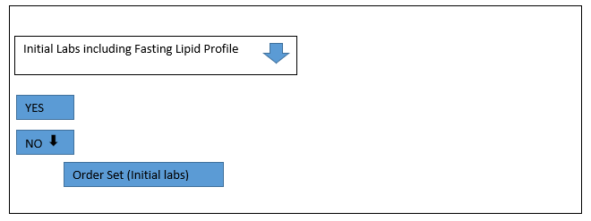

Figure 1: Initial EHR Hard Stop.

Note: (Figure 1) represents the first hard stop that providers will see. The hard stop pictured is after the initial intake of the patient. It is in place to ensure that initial labs have been drawn, including a fasting lipid panel. If initial labs have been completed, the provider will click the “Yes,” which will take the provider to the second figure. If labs have not been obtained, the provider will click on “No,” a drop-down menu will appear, and an order set will be in place for the provider to order labs. If the provider chooses to override at this point, the next hard stop will ultimately catch any labs that may have been missed.

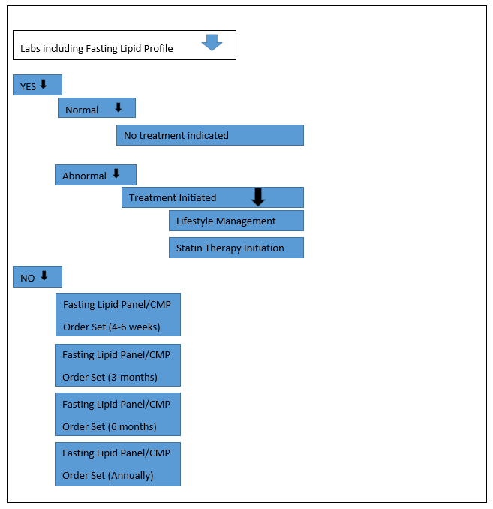

Figure 2: Initial Laboratory Value Result Review Hard Stop.

Note: (Figure 2) is the second hard stop that will be initiated. The hard stop will appear when the provider checks initial labs. If the patient had laboratory studies drawn and resulted, the provider would click on the “Yes” box. Once clicked, a drop-down menu will appear. The provider will choose “Normal” or “Abnormal.” If the fasting lipid panel is within normal limits, the provider will choose “No treatment indicated.” If the provider chooses “Abnormal,” a drop-down will appear with “Treatment Initiated,” and then the provider will choose what treatment was initiated, “Lifestyle management,” or statin therapy. If the provider chooses “No” within this hard stop indicating that a fasting lipid panel has not been obtained, a drop-down will open where the provider can order the indicated lab and proceed to order an additional lipid panel for a 4–6-week check. This will allow the provider to be proactive and order the next panel, and the recheck will not be missed. When the 3-month recheck is ordered, the hard stop will not appear until the next lipid panel has been obtained.

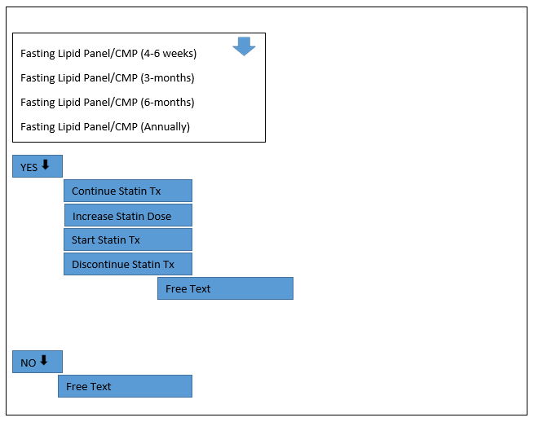

Figure 3: Follow-up Laboratory Result Review Hard Stop.

Note: (Figure 3) will populate within the client’s EHR at the 4-6 week check of the lipid level. The options are a simple “Yes” or “No.” The provider will choose “Yes” if the lipid panel was obtained, a pop-up window with previous and current results will appear, and a drop-down menu will appear where the provider will choose the appropriate treatment based on the lab results, “Continue current statin treatment,” “Start statin treatment,” “Increase statin dosage,” or “Discontinue statin treatment.” If the provider chooses to “Discontinue statin treatment,” a drop-down “Free Text” box will appear where the provider will be able to explain why treatment has been discontinued. If the provider chooses “No,” a “Free Text” box will appear, and the provider will be able to elaborate on why the client has not obtained the lab (i.e., refused). This hard stop can be specifically tailored for the facility according to how often the client’s lipid panel is obtained. If the lipid panel is checked at 4-6 weeks, 3-months, 6-months, 9-months, or annually, a pop-up window will appear with all previous lipid panel results for the provider to compare. The hard stop can be customized to populate within the EHR at a specific period according to what the provider chooses.

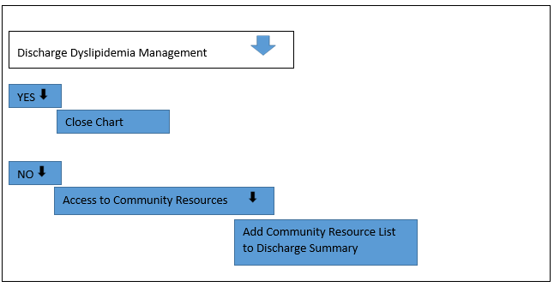

Figure 4: Dyslipidemia Discharge Management Hard Stop.

Note: (Figure 4) will populate at discharge. Once again, this is a simple “Yes” or “No” for the provider to choose from. If the provider chooses “Yes,” meaning the client already has treatment options set in place, the option will close at this time. If the provider chooses “No,” a drop-down will populate with all the available resources in the Lexington area to assist the client with dyslipidemia management after discharge. A few of the resources available to the clients are 1) Mission Health Lexington; 2) Salvation Army of Central Kentucky who partners with the University of Kentucky College of Medicine; 3) the Supplemental Nutrition Assistance Program Education; 4) Expanded Food and Nutrition Education Program and 5) the University of Kentucky Cooperative Extension Service.

Quality Improvement Effectiveness

Working collaboratively with the informatics team to build and integrate the hard stops in the EHR will ensure the desired data is extractable for evaluation of effectiveness. Data will be extracted at the six-month and one-year time frames. These are the only hard stops currently being utilized in the facility. The data collected and analyzed will aim to answer the following questions: 1) Were the hard stops utilized accurately by physicians and what percentage of the time? 2) The percentage of new statin therapy prescribed utilizing the hard stop has it improved? 3) Were the hard stops overridden by providers? 4) If so, how often? Has the initiation of statin therapy increased? 5) What is the current percentage? 6) Does the hard stop at discharge, offering community resources, seem effective from the provider's perspective?

Change Theory

In healthcare today, change is necessary to keep up with new and improved interventions, policies, treatments, procedures, and many other aspects of healthcare. Any change can cause a multitude of emotions for medical workers, fear of failure, anxiety, excitement, and renewed hope for future outcomes. Changing healthcare can not only result in better patient outcomes but can also reduce errors and negative consequences. How change affects organizations is better understood using Lewin’s Theory. They can also help to identify barriers to the successful implementation of the change. Identifying these barriers is more likely to overcome the resisting forces [10].

Lewin’s Change Theory Model

There are three stages involved in Lewin’s Theory: 1) unfreezing; 2) change and 3) refreezing. Unfreezing is a stage in the theory that applies to overcoming old patterns that are counterproductive to achieving the specific change. It is necessary to overcome old habits for change to occur. For unfreezing to occur, driving forces must increase to oppose the restraining forces. The driving forces refer to the Quality Indicators and the low compliance percentage by the practice and management for the recognition of a needed change. Then, the restraining forces must decrease for there to be a positive shift in the equilibrium. The restraining forces refer to the providers where the majority of push back will occur. Lastly, a sustainable combination of the first two steps needs to occur to facilitate the desired change.

The “Change” stage involves a process of change in thoughts, feelings, behaviors, or all three that is more productive and causes a difference in the equilibrium [11]. “Planned change occurs by design, as opposed to change that is spontaneous, or that occurs by happenstance or by accident” [12].

The refreezing stage is much like the first stage but includes innovative ideas and interventions to achieve the desired change. Refreezing incorporates new habits to make the change sustainable and successful. If refreezing does not occur, old habits will take over, and the desired outcome will not be achieved. Figure 5 explains how Lewin’s change theory model could be tailored to KART to implement the hard stops in the EHR.

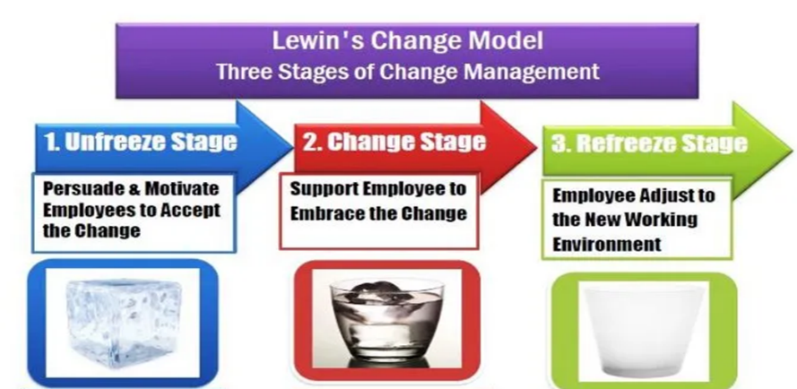

Figure 5: Application of Lewin’s Change Theory Model to KART.

Application of Lewin’s Change Theory

Lewin’s change theory can be identified when looking at educational institutions during COVID-19. Lewin's theory's “Unfreeze” stage was demonstrated when educational institutions nationwide decided to conduct virtual or online classes to ensure students continued their education while maintaining social distancing during the pandemic. The “Change” stage of the theory took place when instructors and students were placed into new ways of working and learning virtually. Google Meet, Zoom, and Google Classroom online platforms were used to connect students with their instructors. Numerous instructors, students, and parents were hesitant to proceed with the new process. However, educational institutions across the country implemented the shift from in-person to virtual despite resistance. School systems went to great lengths to support staff, students, and parents once the higher educational institutions implemented this change. Going virtual across the nation caused instructors, students, and parents to undergo a drastic change in their lives. This is where the “Refreeze” stage of Lewin’s theory can be seen. As a result of the changes made throughout the education system during COVID-19, the United States has adapted to a new way of instructing and learning what the “Norm” looked like before COVID-19 has changed. It is evident, although not optimal, students can continue their education while also following COVID restrictions [13].

Conclusion

In conclusion, the purpose of this research was to identify an effective strategy to allow providers within a network to successfully manage patients with dyslipidemia who are residents of a long-term drug rehabilitation facility. The aforementioned literature review demonstrates the rational use of hard stops within the electronic health record will improve the management of patients with dyslipidemia as they advance through their drug rehabilitation process. This change intends not to cause fatigue or provider burnout but instead lead to improvements in process and outcome measures. Continuity of care is crucial in the healthcare realm, and clear communication is imperative between the sending and receiving facilities. Implementing hard stops will ease the provider’s process of managing dyslipidemia throughout the organization and improve medical treatment, medication adherence, and quality of care.

References

- How do we determine MIPS eligibility? - QPP (2021).
- Rubenfire M (2019) 2019 ACC/AHA guideline on the primary prevention of cardiovascular disease American College of Cardiology 140: e596-e646.
- Chang TS, Buchipudi A, Fonarow GC, et al. (2019) Physicians voluntarily using an ehr-based cds tool improved patients’ guideline-related statin prescription rates: a retrospective cohort study. Appl Clin Inform 10: 421–445.
- Bresnick J (2018) Hard stops in EHRs, clinical decision support can improve care: the judicious use of hard stops in EHR workflows and clinical decision support systems can improve performance on process measures and lead to better care Health IT Analytics. xTelligent Healthcare Media.
- Powers EM, Shiffman RN, Melnick ER, et al. (2018) Efficacy and unintended consequences of hard-stop alerts in electronic health record systems: a systematic review. Journal of the American Medical Informatics Association 25: 1556–1566.
- Ye S, Leppin AL, Chan AY, et al. (2028) An informatics approach to implement support for shared decision making for primary prevention statin therapy. MDM Policy & Practice 3: 238146831877775.
- Ramirez M, Maranon R, Fu J, et al. (2018) Primary care provider adherence to an alert for intensification of diabetes blood pressure medications before and after the addition of a “Chart Closure” hard stop. Journal of the American Medical Informatics Association 25: 1167–7114.
- Daumit GL, Dalcin AT, Dickerson FB, et al. (2020) Effect of a comprehensive cardiovascular risk reduction intervention in persons with serious mental illness: a randomized clinical trial. JAMA Netw Open 3: e207247.
- Socías ME, Volkow N, Wood E (2016) Adopting the ‘cascade of care’ framework: an opportunity to close the implementation gap in addiction care? Addiction 111: 2079-2081.
- Sutherland K (2013) Applying Lewin’s change management theory to the implementation of bar-coded medication administration. Canadian Journal of Nursing Informatics 8.
- Petiptin A (2020) Lewin’s change theory. Nursing Theory.
- McEwen M, Wills EM (2018) Theoretical basis for nursing (5th edition). Philadelphia: Wolters Kluwer. Pg No: 608.
- Kobiruzzaman M (2021) Lewin’s change management model: unfreeze change refreeze example [Internet]. Educational Website for Online Learning.

