Review Article

CUNY Health & Human Service Programs Simulated Interprofessional Education Pilot

Patricia Simino Boyce, PhD, RN#, Susan Riekert MSN, RN, COS-C2, Nicole Saint-Louis, DSW, LCSW, Yasmine J. Awais, MPhil, LCAT

Department of Nursing, CUNY’s University, New York, USA

#Corresponding author: Patricia Boyce, PHD, RN, University Dean for Health and Human Services, Department of Nursing, CUNY’s University, The Graduate Center, CUNY, 365 Fifth Avenue, New York 10016, USA

How to cite this article: Boyce PS, Riekert S, Saint-Louis N, et al. (2021) CUNY Health & Human Service Programs Simulated Interprofessional Education Pilot. Int J Nurs & Healt Car Scie 01(14): 2021-78.

Submission Date: 31 July, 2021; Accepted Date: 22 September, 2021; Published Online: 29 September, 2021

Executive Summary

Healthcare teams have become increasingly complex in response to advances in medicine and practice delivery models, with each member of the team performing a unique yet complementary role in the provision of care. However, certain attributes and skills, such as effective communication and team coordination need to be acquired by each team member to complement each other’s roles and improve the quality of care. Interprofessional Education (IPE) occurs when two or more professions learn about, from and with each other to enable effective collaboration and improve health outcomes [1]. The City University of New York (CUNY) is uniquely positioned to lead a robust IPE initiative, as the largest urban public university in the nation, with close to 50,000 students enrolled in 350+ Health and Human Service (HHS) degree and credit bearing certificate programs in 60 disciplines across 25 campuses, graduating thousands of professionals entering practice in the New York City (NYC) metropolitan area each year. Thus, CUNY has a distinctive opportunity to contribute to team-based care by engaging HHS students in a myriad of IPE experiences to prepare them for successful participation in collaborative practice, ultimately improving care delivery and population health.

In winter 2020, prior to the official onset of COVID-19, the CUNY University Dean for Health & Human Services began planning a university-wide effort to integrate IPE into professional training programs. In response to COVID-19 and our newly adopted mode of distance learning education, CUNY immediately pivoted the design and initiation of this new initiative to virtually simulated IPE (Sim-IPE) learning events using in-patient, community-based and public health case scenarios designed in the context of COVID-19. With CUNY’s broad and diverse educational programs in health professions education (at the Associate, Baccalaureate, Master’s, and Doctoral levels), and joint operation with New York University Langone Health of NYSIM - one of the leading health science simulation education centers in the nation - a unique opportunity existed to enhance CUNY’s HHS professional training by offering an accessible and inclusive approach to engage faculty and students across the university in a fall 2020 CUNY HHS Sim-IPE Pilot program. Secondary objectives of the Pilot were to address skills training in a virtual environment and prepare students for evolving practice in response to the impact of COVID-19.

As a result of the crisis, the use of technology created an opportunity to include broader representation across disciplines and campuses that would not have been able to participate if sessions were designed as in- person events at NYSIM or individual campus settings. In addition, these virtual IPE experiences were used by several programs to replace or augment limited access to practice settings during COVID-19 and provide meaningful professional and clinical learning experiences for students. This initiative also aligned with CUNY’s mission for equitable and accessible higher education and the joining of HHS disciplines across CUNY campuses to improve student learning experiences, while demonstrating the importance of teamwork and collaborative practice for 640 students, representing eight HHS disciplines in 15 programs across nine colleges. An extensive evaluation of the initiative was conducted, including qualitative and quantitative assessments of students, faculty, facilitators, and team performance for 28 two-hour IPE sessions during the Pilot. This paper provides an overview of the essential components of IPE; describes development, roll-out and evaluation of CUNY’s HHS Sim-IPE Pilot; discusses implications for health professions programs and plans for expanding the CUNY HHS IPE initiative.

Background and Overview of IPE

According to the WHO, IPE can play a significant role in mitigating many of the challenges faced by health systems around the world [1]. Communication errors and barriers between disciplines is cited as one of the main causes of medical errors [2,3]. IPE promotes interdisciplinary communications before actual work with patients [3,4]. This call to action has motivated HHS professions to shift from traditional, discipline-specific, and siloed methods of education to a collaborative, practice-ready workforce [1].

The WHO [1] suggests that IPE should be compulsory for health professions training. In Canada, IPE is a requirement in nursing curricula [5]. The Health Council of Canada recommends that each university health sciences program offer an IPE subject [6]. IPE is now a mandatory requirement in the United Kingdom for pre-registration training in health and social care [6]. Although IPE is recommended in the United States, there is no such widespread requirement, with individual programs or colleges typically determining their own approach by following recommendations of professional accrediting bodies. Meanwhile, the Health Professions Accreditors Collaborative (HPAC) in conjunction with the National Center for Interprofessional Practice and Education, are working together to develop guidelines for leaders of Higher Education Institutions (HEI) who are responsible for planning IPE activity and curricula, along with various accreditation bodies, to integrate IPE standards for health professions training.

IPE involves multiple disciplines participating in shared learning experiences. According to a 10-year literature review of works published between 2007 and 2017, nursing, medicine, Physical Therapy (PT), pharmacy, Respiratory Therapy (RT), Occupational Therapy (OT), dentistry, and paramedic students are the most common professions participating in IPE [7]. In this analysis, a range of 2-13 professions participate in IPE activities, with three to six professions being the most common arrangement. While HPAC identified 25 fields and specialties as members, and those studying in these HHS programs participate in varying levels of IPE experiences, disciplines outside of the health professions are also reported as participating in IPE activities, such as criminal justice [8], early childhood education, child and youth care [9], and even art [10].

IPEC Core Competencies

The Interprofessional Education Collaborative [11] has identified four core competencies to prepare future health professionals for enhanced team-based care of patients and to improve population health outcomes: 1) values/ethics of interprofessional practice; 2) roles/responsibilities; 3) interprofessional communication; and 4) teams and teamwork. Developing innovative experiences for HHS professional students to meet the four IPEC competencies is critical. These four competencies entail working with other disciplines of the healthcare team to promote and sustain mutual respect and shared values, understanding and awareness of the roles and responsibilities of the interprofessional healthcare team, interprofessional communication that promotes a team approach in the promotion of health and prevention of disease, and applying teamwork skills to plan, implement and evaluate patient centered-care [11].

IPE Modalities

There are various methods of conducting IPE, such as in the classroom, the simulation (Sim) lab, online, and in practice settings. Likewise, there are various learning activities that may be implemented for IPE, including: didactic learning; Sim using Standardized Patients (SPs), high-fidelity mannequins or other simulators; clinical observation; and clinical practice [12]. Service learning is another activity utilized in IPE [10,12]. Based on a review of the literature (2007-2017), the most common types of simulations were mannequin alone (n = 33), or SP alone (n = 17), SP plus mannequin (n = 11) or other types of multiple simulations (n = 18) [7].

While not the primary purpose of IPE, Christopher, and colleagues [3] found that between Physician Assistant (PA) and pharmacy students, each discipline learned more about the other, which is “Vital to comprehensive healthcare education”. Students also expressed valuing the SP learning experience. Similarly, faculty found it useful to assess the skills of students, particularly clinical reasoning and clinical thinking skills [13]. Another demonstrated benefit of IPE is enhancing confidence in students [14].

Asynchronous Modalities

IPE experiences that involve independent learning are considered asynchronous. This can include student reading materials [15], watching videos [16], participating in discussion boards [17] or other online modules [18] either as the entire IPE experience or as a component of a synchronous or live event (see Hybrid Modalities).

Synchronous Modalities

IPE experiences in which learners conduct an activity together are considered synchronous. These modalities include live in-person, online or virtual technology and virtually simulated experiences.

Live in-person. Based on a review of the literature, live, in-person learning was the most common type of IPE experience prior to COVID-19. These events occurred in the classroom, in the community to simulate a disaster scenario or other clinical event [19], at student and/or faculty led clinics [20], and in practice settings [9,21]. In-person experiences take place with a mannequin [22], standardized patients [23,24], and via role-play. Role-play can also occur without a patient, such as meetings in which the interprofessional team engages in care planning, treatment planning, or discharge planning discussions.

Virtually Simulated IPE (Sim-IPE). Virtually simulated IPE experiences is another delivery method, with some programs including a mix of online and in-person components [25-28]. Due to social distancing recommendations in addition to campus and clinical site restrictions, many programs needed to turn to online formats during COVID to refine clinical skills while in-person classes and clinicals were suspended. Since the onset of pandemic, online IPE efforts continue to be very common [27,28]. Similar to live, in-person educational opportunities, these virtual experiences take place with SPs, virtual patients [29], and via role-play (i.e., student plays the role of a patient or other roles) [27] in cases such as discharge planning [28]. One IPE for nursing and Speech-Language-Pathology (SLP) students was developed to take place entirely online, utilizing both synchronous and asynchronous components [30]. By conducting IPE entirely online, Gurevich and colleagues [30] argue that this is more similar to “real life” interdisciplinary team communication as the different disciplines often do not meet together and tend to communicate via charts and case notes. By conducting communication of cases asynchronously and then debriefing synchronously, students can learn from each other. In another exercise, nursing students participated virtually to mimic a telehealth experience while the SP and other students (medical, pharmacy, SW, and dietetics) were in-person [24]. Benefits to employing Sim-IPE include convenience, particularly around scheduling, and accessibility [28].

During COVID, schools have commonly used synchronous methods via the Zoom© (Zoom Video Communications Inc., 2020) platform [27,28]. Robertson and colleagues [28] evaluated nursing and medical students who participated in the IPE experience and found that students felt they should be required to speak at least once and to utilize the video function of Zoom to increase participation as the online environment. In contrast, Prasad and colleagues [27] found that not requiring the video to be on encouraged shyer students to participate more. Some programs used virtual Sim-IPE to teach Personal Protective Equipment (PPE) skills for the eventual return to practice [27]. Prior to COVID, telehealth was not heavily promoted and when used was typically profession-specific; COVID provided an opportunity to train with telehealth in mind, using an interdisciplinary approach [26].

Hybrid Modalities

The core attributes of the hybrid IPE (HIPE) model are a) objectives based on IPEC core competencies; b) asynchronous and synchronous models; c) collaborative communication technologies; d) phased delivery; and e) fidelity/realism [31]. Blended or hybrid learning has several definitions, but a commonly cited definition describes it as “the thoughtful integration of classroom face-to-face learning experiences with online learning experiences” [32]. The use of information and communication technologies for IPE can lead to positive attitudinal and knowledge change and favorable reaction to IPE activities delivered in this format [33]. Effective hybrid learning is supported by instructional design theory or models which define essential elements aimed at achieving a particular outcome. e) fidelity/realism. The HIPE model has 3 main phases, like simulated learning experiences. Most often, the first 2 phases, pre-briefing and interprofessional interaction, occur asynchronously. The third phase, debriefing, typically occurs synchronously. The HIPE model addresses IPE delivery format to improve its feasibility, which has been particularly useful during COVID. The model is flexible and not bound by temporal curricular factors, reducing traditional logistical barriers of physical space and schedules while successfully influencing student perceptions in IPEC core competencies [31].

Facilitators and Barriers of IPE Programs

Upon examination of IPE programs for HHS professions, there are various factors that contribute to or impede successful IPE programs. Barriers to implementing IPE tend to be related to implementation, rather than the curriculum [34]. There are a number of potential barriers associated with implementing IPE activities, including challenges associated with group dynamics, faculty support and training, and, in some cases, inflexible curricula [35]. These barriers mirror what happens in practice: identified obstacles to interprofessional collaboration involve multiple competing priorities, internal politics, miscommunication, lack of leadership to bridge disparate groups and foster trust, and group dysfunction when team members do not collaborate [36].

IPE Leadership: Building Faculty and Institutional Support

Lawlis and colleagues [37] identified five key ‘‘fundamental elements’’ across stakeholder levels that enhance or inhibit IPE success and/or sustainability: 1) government funding; 2) HEI funding; 3) faculty development programs; 4) HEI organizational structures to support the embedding of IPE into health professional curricula; and 5) staff ownership and commitment across all disciplines involved in IPE programs (p. 4). These fundamental elements involve institutional organizing structures, which are necessary for scheduling, maintaining inventory of IPE offerings, and promoting the IPE program. A survey of schools with established IPE programs revealed that IPE was organized or coordinated by workgroup or advisory committees; individual schools, faculty or syllabi; a center or centralized website; an IPE database, calendar, catalogue; or a staff member [38]. The logistics of a database or calendar are notable as scheduling and cost have been identified as additional barriers to participating in IPE [7].

Schools with established IPE programs also have faculty representatives from the involved disciplines as part of the staff (see McGill University, Penn State, Texas Tech, University of California, San Francisco, University of Texas, & Indiana University). These school websites indicate that the primary responsibility of these faculty is to their programs, but also hold rotating or time-limited appointments to the IPE center.

Faculty development and IPE-specific training is promoted as an imperative to successful IPE programs [37-9]. Involvement of faculty is important in the development, growth, and assessment of IPE in order to implement innovative ideas, represent all disciplines involved, and develop best practices for IPE at each institution. IPE faculty development is essential to provide well-designed, high-quality IPE offerings for students. As such, 28 of 30 universities state that they have IPE faculty development programs in place, many having a variety of different options available [37]. Frequency of IPE faculty development activities included: yearly (10); monthly; (8); once a semester (5); as needed/“Just in Time” (5); online/webinar (4) and quarterly (2) [38]. Faculty development programs are seen as key drivers in addressing barriers to IPE, and facilitating institutional, professional and cultural changes for successful IPE initiatives [37].

Scheduling and Participation

Scheduling is a common barrier. When scheduling across programs and disciplines, it is most likely that an IPE experience will occur outside of a student’s regularly scheduled class time, which can negatively impact attendance [39]. In a survey of 30 health professions programs with IPE, 73% of programs coordinated IPE scheduling at both the school and university level [38]. Timing of the workshop is important to students. Some expressed a preference for the workshop to run earlier in the semester or during a break so it didn’t cut into their study and assignment preparation. Students also appreciated when IPE scheduling accounted for their regular class time to avoid extra workload on top of their normal week responsibilities [40].

Institutional level barriers include the development and delivery of IPE within the curriculum. The different timetables and varying program calendars for each of the health professional degree programs impact on the scheduling of IPE within different curriculum streams [37]. Scheduling can impact programs differently; what may be work for one may not work for another. Anecdotal feedback suggests that the time of the session also impacted attendance [41].

Key facilitators for optimal scheduling include representation of more than two professions including at least one learner per profession on each team [7]. Barriers to the use of simulations included not having enough learners, learner’s lack of experience with IPE or simulations, learners feeling uncomfortable with being observed, differing knowledge and skill levels by profession, poor learner attitudes, and incorporating learners who are required and elect to participate in the simulation [7]. Including simulations in required courses is also documented as furthering IPE success [7].

Requiring participation and possibly including incentives, such as course credit [35] and full integration into the curriculum fosters engagement of students and faculty and highlights the benefits of IPE. In Sim-IPE using video cases, Willgerodt and colleagues [34] found that students required to attend had higher levels of participation. Likewise, Caines and colleagues [14] felt that attendance for their IPE was excellent for registered dietitian students because it was a course requirement. It has also been suggested that IPE programs should offer additional course credit when not a part of a course [35] and/or offer class release time [41]. Willgerodt and colleagues [34] recommend creating agreements (not only verbal promises) to encourage faculty and program engagement. According to an intensive literature review of 40 papers on IPE in higher education, barriers related to curriculum integration are due to resource intensiveness, requiring dedicated staffing and funding [37].

Team composition. Three factors pertaining to team composition are most frequently highlighted by students: level of learner, professional relevance of team members, and mentor-team mismatch [35]. Furthermore, it is recommended that at least two students from each program participate to increase participation and confidence from students in the experience [34] or a somewhat even balance of participants from various disciplines [39]. In a study with OT, SLP, and dietetic students in Australia, when only one student was part of a breakout group, that discipline’s perspective did not receive as much attention [40]. In Smith et al.’s IPE with pharmacy and dental students, students requested to be placed in smaller interprofessional teams with a more even distribution of pharmacy to dental students to collaborate more effectively [42]. In another IPE experience, student participants felt that having nursing students would have improved the overall learning and experience [40]. Robertson and colleagues [28] evaluated nursing and medical students who participated in the IPE experience about the IPE experience itself and found that students felt that the breakout groups should have been larger (i.e., 7-8 students instead of 5) and that student should be required to speak at least once and to utilize the video function of Zoom to increase participation as the online environment can encourage only a couple of student participants. This aligns with Prasad and colleagues use of Zoom© (Zoom Video Communications Inc., 2020) breakout groups, where 10-12 students participated. Enablers of IPE identified in a literature review of IPE programs in higher education found the strength of the facilitators significantly contributed to perceived success - their facilitation skills, enthusiasm, ability to act as role models, and respect for other disciplines [37]. While training facilitators is necessary, it is just as important for facilitators have actual, real world interprofessional experiences to draw from [43].

Differentiating Clinical Experiences and Simulation. IPE is typically not seen as a replacement for clinical interactions but used to support both classroom and work-based learning [27]. In a survey of 30 health professions programs with established IPE, over 50% of respondents reported that they had a required first year course or experience in place [38]. While some students have criticized the usefulness of IPE SIM experiences when they already had clinical experiences [28,35], studies show that Sim-IPE can be beneficial for advanced students, when designed with these learners in mind [34]. It may not be realistic to expect students from various disciplines to have similar clinical experiences and these clinical differences can be used to the advantage in a Sim-IPE scenario. Prasad and colleagues [27] conducted an IPE in which midwifery students had prior experience in the delivery suite and medical students had none. As a result, midwifery students were able to initiate more relevant questions and discussion, which reportedly helped to engage the medical students. The discussion was enhanced and more in-depth because of their collective contributions.

Case Scenario Design

Using realistic cases that may be adapted to reflect the learner's knowledge and skills is another facilitator to a successful IPE experience. Additionally, allowing repetitive practice to learn from mistakes and including a debriefing session are useful [7]. In a survey of 30 health professions programs with established IPE programs, a range of activity types are offered: didactic electives, required coursework, service learning, standalone events, seminar series, student organization activities, online activities, and “Other” activities, i.e., student run free clinics, simulations with and without SPs, and clinical rotations [38]. Student expressed wanting cases that feature contemporary situations that they may face in the real world [43] such as transgender health care [23] and regional specific disasters such as wildfires [41].

CUNY HHS Virtually Simulated IPE (Sim-IPE) Pilot

Interprofessional collaboration is an essential component and a core competency across all HHS professional education programs. However, providing IPE practice-based opportunities is challenging for school programs due to limited clinical sites, faculty shortages [44,45], complex logistics, schedule coordination challenges, and lack of faculty development in the teaching of IPE [46]. The recent standstill of clinical experiences due to COVID made implementing such experiences even more challenging. The CUNY HHS Sim-IPE Pilot was designed to optimize existing challenges and opportunities presented during the pandemic, building upon documented barriers and best practices for successful IPE programing.

Recognizing that simulation is an effective platform for promoting IPE, 25 faculty representing 19 HHS disciplines across 14 campuses within CUNY rose above the surrounding chaos in spring and summer 2020 to develop the virtually-simulated IPE Pilot program. This project was created in collaboration with expertise and technical support provided by NYSIM [47]. The goals were to ensure that students successfully learned with, about and from each other to enable effective collaboration and improve health outcomes while adapting to remote learning [48]. The results of this extensive collaboration proved to be an astounding synergism of faculty engagement as a community of educators joined together, during a time of uncertainty and fear, to develop and implement Sim-IPE experiences for CUNY HHS students.

In spring 2020, the University Dean for Health and Human Services swiftly formed a university-wide CUNY HHS IPE Council to ignite a three-fold vision for IPE: 1) facilitating the development of caring HHS professionals who transform health, human and social services delivery through high quality interprofessional practice; 2) advancing CUNY academic and clinical experiential interprofessional education programs for the development of HHS profession students’ proficiencies in the four core competencies for interprofessional collaborative practice; and 3) foster research and scholarship that advances interprofessional collaboration and engagement with local healthcare systems, social services, and community organization partners. The primary focus of the CUNY HHS IPE Council was to design and implement an overarching approach for IPE implementation across HHS programs using succinct conceptual approaches that would cultivate Sim-IPE case scenario designs in collaboration with NYSM.

During the inaugural meeting of the CUNY HHS IPE Council, a conceptual model and approach was confirmed by CUNY HHS and NYSIM faculty who eagerly volunteered to engage in workgroups to design, implement, and evaluate three separate Sim-IPE case scenarios. Using an unfolding case model [49], the plan was to highlight the same patient, Ann Thomas, as she transitioned from different levels of care in the healthcare system during the stages of her COVID-19 diagnosis.

Registration

For ease of scheduling, a cloud-based spreadsheet was available to all HHS faculty to register selected students as participants and observers for a pre-determined block of 50 available sessions. Faculty were asked to self-identify if willing to serve as an IPE session facilitator, with the option to nominate students in the role of “team coordinator” or “evaluation observer” for registered sessions. Lastly, faculty were invited to select a preferred case scenario among the three available COVID-related cases.

Taking scheduling and timing into consideration, the CUNY HHS SIM-IPE Pilot intentionally provided a myriad of time options to accommodate different faculty and course needs, offering morning, afternoon and evenings time slots from Monday through Friday, and Saturday morning sessions, integrating the scheduled offerings into existing coursework or required clinical training hours, and the option of participating in sessions at alternate class times. The virtual platform and wide variability of scheduling options for the Sim- IPE sessions made scheduling more attractive and accessible to a larger number of students and faculty.

A total of 28 sessions were finalized from September 28 to December 3, 2020. An IPE session was confirmed when at least two disciplines were scheduled. Once the schedule was finalized, faculty were contacted to negotiate a case scenario for each session, or faculty were rescheduled to a different time-slot if a particular case scenario was preferred and not available at their originally selected time. At least one week prior to the session, faculty were contacted to provide student participant names and confirm the number of observers from their program. At that time, the evaluation observer, team coordinator and session facilitators were also confirmed, with detailed instructions for students, including Zoom© (Zoom Video Communications Inc., 2020) links and pre-session training materials to prepare for the scheduled sessions.

Pilot Participation

Building on learning from IPE experiences documented in the literature, the sessions allowed up to two student participants from each program, with an unlimited number of student observers, if at least one student was participating from an individual program/course. The CUNY HHS Sim-IPE Pilot required a minimum of two and maximum of six disciplines per session. Keeping prior clinical experiences in mind, the Pilot instituted an initial requirement of at least one year of clinical experience for all student participants to provide similar learning experiences, with consideration for different levels of learners (undergraduate and graduate) at each session However, due to pandemic-related rapid reductions in clinical site availability across HHS disciplines, first semester CUNY HHS students were ultimately given opportunities to engage in the pilot, with almost all sessions including mixed learners. Reflective student feedback during faculty debriefing sessions revealed that these first semester students not only verbalized tremendous satisfaction in collaborating with other HHS disciplines but fully met IPEC core competencies that were otherwise not integrated into their curricula. In addition, students frequently commented on the value of learning with and from peers with varying levels of clinical and professional experience.

The initial response to the CUNY HHS Sim-IPE Pilot was remarkable (Figure 1). Two to six disciplines participated across sessions, with an average of three disciplines per session. Five to eleven student participants engaged in each session, with an average of seven students across disciplines per session. The number of student observers ranged from 2 to 40 students representing the disciplines participating in the session. In addition, student participant teams consisted of mixed learners, which included undergraduate and graduate program participants, and varied among students in early semesters of their program to professional students completing a Bachelor’s degree or graduate students with varying levels of experience. Eight HHS disciplines (human services, medicine, nursing, nutrition, PT, public health, SW and SLP) from 15 HHS programs across nine CUNY campuses participated in 28 two-hour virtual SIM-IPE sessions from September 28th through December 3rd, 2020. A total of 640 students engaged in the virtual IPE sessions: 187 scenario participants and 453 scenario observers, facilitated by 13 volunteer HHS faculty across disciplines.

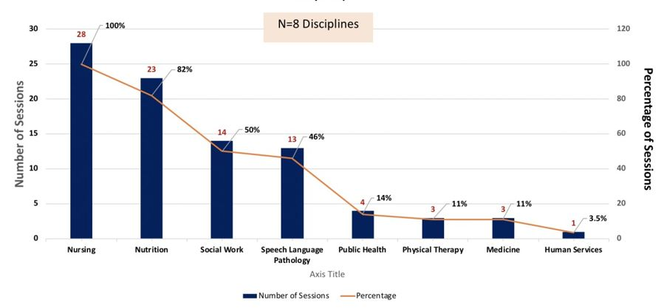

Figure 1: Sim-IPE Preliminary Evaluation Data (Fall 2020) Participation in IPE Sessions (by Discipline).

Support and Training

Faculty development programs are seen as key drivers in addressing barriers to IPE, facilitating institutional, professional and teaching cultural change [37]. Understanding the need to prepare faculty in their roles for successful implementation and facilitation of Sim-IPE sessions, this plot offered faculty training sessions prior to and during the CUNY HHS SIM-IPE Pilot. In addition, 15-minute pre- and post- session huddles were held with faculty, NYSIM staff and the University Dean for each session. The pre-session huddle was intended to review key elements of the session, including roles, participants, case scenario details, and address any questions. The post-session huddle allowed for faculty and staff reflections, highlighted lessons learned and encouraged faculty to share how they may be best prepared and supported for future facilitation experiences. During each Sim-IPE session, NYSIM staff provided simulation and technical expertise to CUNY HHS faculty, students, and facilitators. In addition to the “just in time” training ongoing training and support were provided prior to the start of the pilot and throughout the implementation period.

During the semester, but prior to the start of Sim-IPE sessions, NYSIM and the University Dean for Health and Human Services provided faculty and facilitator participants with one-hour virtual training sessions using the Zoom platform. Training sessions included an overview of the specific Sim-IPE case scenario; a facilitator guide, PowerPoint slides and a script for conducting the IPE simulation; faculty and student resources for pre- learning prior to the Sim-IPE session; and logistics information, such as Zoom links and technical instructions for the events. Trainings were held several times before the Sim-IPE sessions began and were also recorded for faculty and facilitators who were unable to attend and/or wanted to review the materials. The training sessions and facilitator guide, along with the registration document were provided on a dedicated Dropbox folder accessible across CUNY campuses (i.e., not campus specific). As the CUNY HHS Sim-IPE Pilot involved various programs across campuses, ease of communication involving scheduling and registration was of utmost importance. As noted earlier, scheduling difficulties has been identified in the literature as a barrier and centralized documentation as a facilitator to successful IPE programming.

The faculty, student and facilitator guides were developed by CUNY HHS-IPE workgroup members as the case scenarios were developed. These comprehensive guides equipped students and faculty with the resources needed to prepare for partaking in the Sim-IPE activity. The guides also defined the four roles that students could participate in.

Active student participants have both their camera and audio on, engaging live (i.e., synchronously) with other active participants to discuss the case.
The team coordinator was a designated student participant who would kick-off the 30-minute IPE team discussion and hep summarize the recommended plan of care prior to debriefing.
The evaluation observer was either a selected student, or faculty member, with camera and audio off, and responsibility for completing an assessment tool on IPE team performance.
Students in observer roles had their cameras and audio off, participating in the case discussion debrief with active student participants and faculty via the Zoom chat feature. Students were only permitted to be in this role if a fellow student in their course/program was an active student participant. In other words, if an SLP student was in an active student participant role, then other SLP students in the course could participate as observers.

Structure of the Sim-IPE Session

Faculty facilitators had their videos and sound on at the start of the session to share sessions slides, including the Sim-IPE agenda. Based on the literature supporting the use of video to promote participation, all active student participants were required to use the video function of Zoom to fully engage with each other in the experience during the dedicated 30-minute student IPE patient case discussion. Students were asked to rename their video to reflect their name and discipline. Students were recommended to utilize Zoom “Gallery View” to see only each other during the IPE simulation component of the session. Faculty facilitators, student observers, and support staff were all muted with their videos off, so only student participants were visible.

During the final debrief component, student observers were encouraged to participate via chat, introducing themselves and sharing comments. Faculty facilitators would communicate with observers and highlight key comments from chat during the debrief. Technical-related issues and links to student surveys were also conducted on the chat function of Zoom. Students were asked to complete a post-survey following the session, using the Student Perceptions of Interprofessional Clinical Education-Revised (SPICE-R) Survey Tool (Appendix A). Upon completion of the post-surveys, students in the active participant role were provided documentation of participation. Students participating in the pilot were issued digital certificates of participation by the University Dean.

Pilot Case Scenarios

As noted in the literature, realistic cases facilitate positive IPE experiences for students. The CUNY HHS Sim- IPE Pilot utilized Team Steps and Strategies to Enhance Performance and Patient Safety as one model linked to the ICU case scenario. More commonly known as TeamSTEPPS, this systematic approach developed by the Department of Defense and the Agency for Healthcare Research and Quality (AHRQ) is designed to integrate teamwork into practice [50]. Members of the HHS-IPE council used TeamSTEPPS as the conceptual model upon which to build the first foundational Sim-IPE case scenario. Key components of this model include communicating critical information, mutual support among team members, effective leadership of and within the team, and situation monitoring, with the overall goal of patient safety [50]. This case scenario was designed specifically to teach students about the critical components of the TeamSTEPPS framework in which they deliberately practice teamwork skills. During this scenario, patient Ann Thomas is transferred from ICU to a medical-surgical unit and the students are called to a roundtable discussion to collaborate on her plan of care. Students also learn TeamSTEPPS language such as huddles, briefs, “CUS” assertive statements (I am Concerned!; I am Uncomfortable!; This is a Safety issue!), and hand-offs (i.e., transfer of clinical information). Faculty participated in development sessions on TeamSTEPPS®, facilitation and debriefing using a scripted approach [51] to enhance their understanding of the TeamSTEPPS approach.

The Interprofessional Collaborative Care Model [52] was the conceptual approach used for the second case scenario on discharge planning since it depicts the step-by-step process of patient discharge, highlighting the importance of interprofessional collaboration during transitions of care [52]. This community-focused discharge case scenario was designed to prepare students for discharging a hospitalized patient to the home or rehabilitation setting while identifying factors that can impede effective transitions in care. In this scenario, Ann Thomas is now ready to be discharged from the hospital and the students are called to a roundtable discussion to make safe and appropriate interdisciplinary team-based discharge recommendations while implementing clear teamwork and communication skills.

In mirroring the Public Health Services Model [53], the third case scenario was intended to promote student understanding of the value of interdisciplinary public health roles in the community and, more specifically, about adaptive resilience and the coordination of care during the COVID-19 pandemic. In this case scenario, students come together for a roundtable discussion about Ann Thomas’ public health needs and to critically consider social isolation issues, community resources, contact tracing, and telehealth considerations.

Sim-IPE Pilot Evaluation Results

The pilot encompassed several evaluation points for faculty, facilitators, and students prior to the start of the CUNY HHS Sim-IPE Pilot and after, including both quantitative and qualitative data. In total, evaluative data was obtained by 460 students and 13 faculty from eight campuses and nine disciplines.

Quantitative Results

The pilot included several evaluation modalities. At the start of the pilot, faculty (n=13) were asked to complete and submit the Interprofessional Education Assessment and Planning Instrument (IEAP) (see Appendix B) used for academic institutions for the assessment and improvement of IPE programs. The IEAP identifies the level of integration on a 4-point scale, with 0 being the least integrated and 4 being the most integrated (see Appendix B for more details on the scale). Baseline results from 13 programs participating in the CUNY HHS Sim-IPE Pilot revealed that most programs do not have dedicated faculty or resources for IPE, and do not formally encourage faculty to participate in IPE for tenure or promotion (Table 1 and Figure 2). Most programs have some level of integration of IPE into courses and clinical/field placements, though limited to no IPE in community projects or extracurricular activities. In addition, most respondents have limited, if any, standardized approach for assessing or evaluating IPE in the program or curriculum.

IPE Courses | Level 0: 38.5%  Level 1: 53.8% | Majority of respondents (53.8%) claimed to have some level of integration of IP experiences within a single course for learners within that discipline, with 38.5% having no integration of IP concepts into program  courses.
IPE Clinical/Field Placements | Level 0: 30.8%  Level 1: 30.8%  Level 2: 30.8%  Level 3: 7.7% | Integration of IPE experiences into clinical/field placements results were evenly split at 30.8% in the following responses: no integration of IPE in placements; IP collaborative concepts within a single discipline placement without planned interaction/integration across learners; and IPE collaborative concepts  coordinated at a single discipline placement for learners from multiple disciplines, using parallel learning.
IPE Community Projects | Level 0: 69.2%  Level 1: 23.1%  Level 3: 7.7% | Majority of respondents (69.2%) did not have any IP community project experiences within the program; while 23.1% have IP community projects within single discipline placement for learners from multiple  disciplines.
IPE Standardized Assessment | Level 0: 53.8%  Level 1: 38.5%  Level 3: 7.7% | Majority of respondents (53.8%) did not have any standardized IPE assessment/evaluation in place; and 38.5% had IPE collaborative assessment/evaluation  conducted by a single discipline for their learners.
IPE Extracurricular Activities | Level 0: 61.5%  Level 1: 23.1%  Level 2: 7.7%  Unable to Assess: 7.7% | Majority of respondents (61.5%) do not have IPE extracurricular experiences available to students; while 23% coordinate some level of extra‐ curricular activities for single discipline learners.
HHS Student Participation | Level 0: 61.5%  Level 1: 38.5% | Majority of respondents (61.5%) do not have students participate in any IPE activity, while 38.5% have up to 25% of students participating in some IPE learning  experience.
IPE Personnel Support | Level 0: 84.6%  Level 1: 7.7%  Unable to Assess: 7.7% | Majority of respondents (84.6%) do not have any dedicated staffing or resources for IPE.
Campus Policy Support | Level 0: 30.8%  Level 1: 7.7%  Level 4: 7.7%  Unable to Assess: 53.8% | Majority of respondents (53.8%) were unable to assess if they had a program or campus-specific policy in place for IPE; while 30.8% reported having no policy in place.
IPE Faculty Members | Level 0: 15.4%  Level 1: 46.2%  Level 2: 30.8%  Level 4: 7.7% | 46.2% of respondents reported having faculty participate in IPE based on an individual interest; while 30.8% reported encouragement of faculty to participate in IPE/team teaching (add‐on responsibility).
IPE Faculty Incentives | Level 0: 7.7%  Level 1: 23.1%  Level 2: 23.1%  Level 3: 7.6%  Unable to Assess: 38.5% | 38.5% of respondents reported unable to assess if faculty incentives are provided to participate in IPE activities; with 23.1% reporting that participating in IPE not considered in tenure or promotion and another 23.1% reporting that it wasn’t encouraged or discouraged for tenure or promotion.

Table 1: CUNY HHS Sim-IPE Pilot IEAP Results.
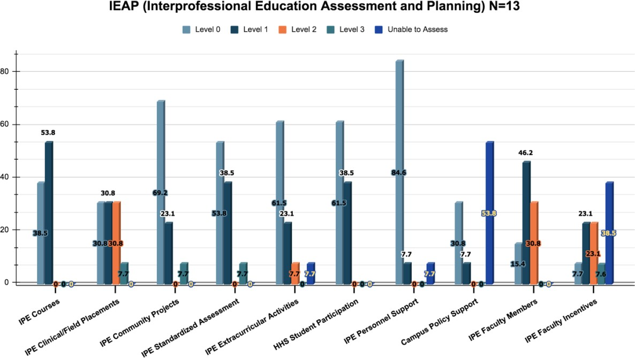

Figure 2: IEAP (Interprofessional Education Assessment and Planning) N=13.

Student participants and observers (N=460) evaluated their perception of IPE upon completion of each session by using the online Student Perception of Interprofessional Clinical Education Revised (SPICE-R) Tool, with an average rating of 4.65 on a 5-point Likert scale (see Appendix A for SPICE-R Tool and (Figure 3) for results). Student participants (n=180) had a slightly higher perception of role definition than student observers (n=280) across all questions, seeing their role as more clearly defined, having a better understanding of their role within an interprofessional team, and feeling interprofessional teams should collaborate.
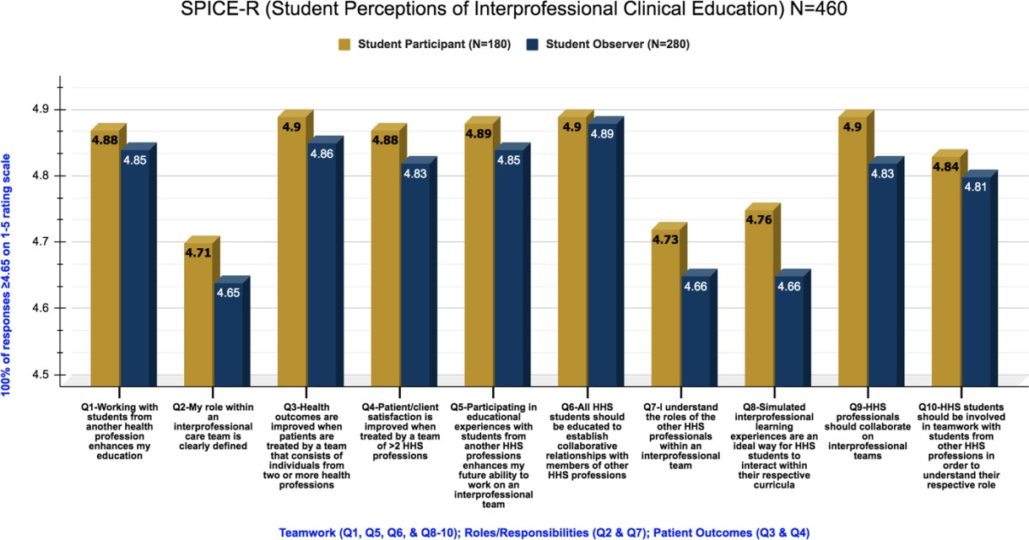

Figure 3: SPICE-R (Student Perceptions of Interprofessional Clinical Education) N=60.

Noteworthy results include the gaps that existed between the students that participated in the simulation and the students that attended the session as observers (Figure 4). The largest gap (Q8) seems to indicate that students who participated in the simulation are more likely to see participation in IPE learning experiences as an ideal way to interact with their respective curricula than students that observed the sessions. Additionally, the gaps indicate that student participants saw their role as more clearly defined (Q2), have a better understanding of their role within an interprofessional team (Q7), and felt interprofessional teams should collaborate (Q9).
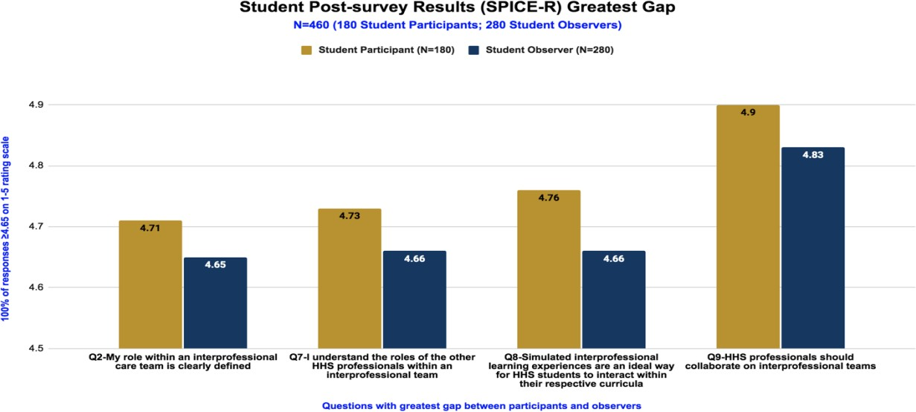

Figure 4: Student Post-survey Results (SPICE-R) Greatest Gap.

Additionally, assigned evaluation observers completed the Performance Assessment Communication and Teamwork (PACT) Tool [54] to rate team performance on the five TeamSTEPPS domains: 1) team structure, 2) leadership, 3) situational monitoring, 4) mutual support, and 5) communication (n=28) (See Appendix C for PACT Tool and (Figure 5) for results). Novice and expert surveys reported mutual support as the highest-ranking domain, which includes advocating for the patient, working collaboratively, and resolving conflict. All responses were above 4.6 (which is between average and excellent) on a 5-point Likert scale. The lowest scoring domain was Team Structure, which includes identifying team goals, assigning roles and responsibilities, and holding members accountable.

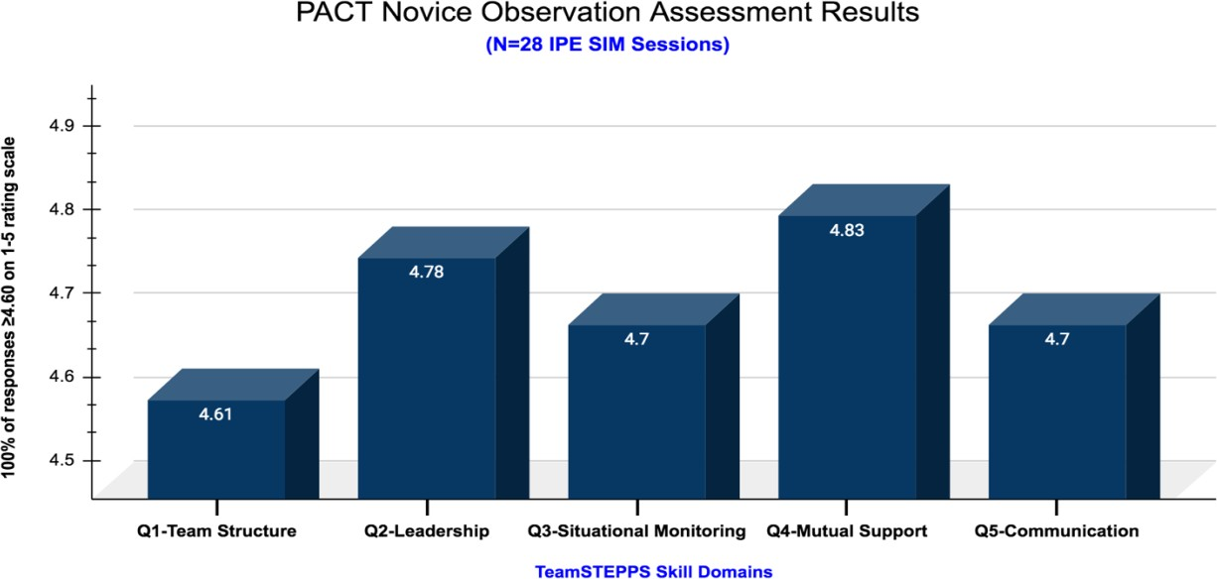
Figure 5: PACT Novice Observation Assessment Results.

Qualitative Results

Faculty focus groups were conducted by a Nursing Organization Leadership graduate student to assess faculty facilitation experiences during the Sim-IPE sessions. A total of 10 faculty participated (N=83%) in one of two focus groups. Faculty participant responses were categorized into 5 main topic areas: 1) role perceptions; 2) training and materials; 3) opportunities to improve preparation and support; 4) likelihood of future participation; and 5) suggested improvements for recruiting future facilitators.

The focus group responses were aggregated into 14 subthemes. Five key themes emerged regarding the faculty facilitator role. Faculty feedback during the focus groups revealed positive reactions to working with colleagues from other HHS disciplines (see Appendix D for Focus Group Guide and (Table 2) for results).

Perceptions of Faculty-Facilitator Role | Faculty facilitators expressed that their “roles were less difficult than expected” and the role became “easier after multiple experiences.” Participants encouraged observations of the role for faculty considering future participation in IPE-Sim Session.
Impressions of Training and Materials to Support Faculty Facilitator Role | Faculty found the “training sessions and materials useful,  though need to be streamlined for future use.” The pre- and post-huddles for faculty facilitators were perceived as “useful” in preparing faculty immediately prior to the start of the session, while providing a chance to briefly reflect on the experience, ask questions, and consider lessons learned after the session. In addition, faculty suggested that disciplines may benefit from program-specific debriefing following the session to provide a more immersive discussion with their respective students. The focus groups also revealed positive reactions to working with other HHS disciplines, stated that their  participation in the IPE sessions provided a “unique opportunities to assess student knowledge and skills”,  “offered opportunities to assess student knowledge and skills”  and offered “great opportunities for faculty development.”
Opportunities to Improve Preparation and Support for Faculty Facilitator | Faculty suggested opportunities for “additional training in simulation and debriefing” and “more in-depth orientation to the case scenarios” across all disciplines. Several faculty noted the value of enhancing learning of discipline-specific  documentation, assessment, and plan of care processes.
Likelihood of Volunteering to Participate in the Future | They were very likely to facilitate future IPE sessions and enjoyed working with faculty from other disciplines. They suggested strategies for improving training, support, and  engagement for future IPE sessions.
Suggestions for Improving Engagement and Supporting Future Faculty Facilitator | Faculty provided recommendations for recruiting additional faculty, including a targeted marketing campaign to share benefits of the experience to faculty and students’ professional development. Faculty also noted the value of IPE in complementing clinical experience and professional role  development for each of the participating HHS disciplines.

Table 2: Faculty Facilitator Focus Groups Five Key Themes (N=10).

Discussion

One of the key elements of the three case scenarios was that each case was contextualized to include "real world” aspects of COVID-19, reflecting knowledge of the virus, relevant clinical practice guidelines, and current public health interventions. This provided great interest from students and faculty, with the added benefit of supplementing timely practice considerations for the evolving nature of the disease. Each case included a patient summary that served as a mini-medical record, highlighting patient history, presentation, medications, and an assessment note with a recommended plan of care for each of the participating disciplines. Students were required to read the patient summary in advance of the session and review a separate student instructions document outlining roles and suggested issues to consider before the session. The IPE session was typically integrated into the course for the participating program, ranging from every student in the course serving as a participant in at least one IPE session during the semester, to a sample of students participating from a program/course to assess applicability of the IPE experience to the course and/or curriculum. In addition, the majority of participating faculty conducted a review of the patient case with students in advance of the session, and many required students to conduct reflection activities of interprofessional practice before and/or after their participation in the session. Given the significant restrictions to clinical practice sites, the IPE sessions often supplemented and/or replaced other training experiences during the semester.

The positive impact on student learning outcomes during IPE activities has been widely reported in the literature [55]. Moreover, Institute of Medicine’s [56] systematic review of IPE initiatives using the Kirkpatrick Model reported changes in behavior and organizational practice as an aftereffect of implementing IPE experiences. The purpose of the CUNY HHS SIM-IPE Pilot was to implement and assess a university-wide multi-focal vision for IPE.

The energy and dedication of CUNY HHS faculty volunteers throughout the duration of the pilot was contagious and the driving force to its success. The results of this pilot suggest that all faculty, student participants and observers were ready for interprofessional learning. The diligent, behind the scenes work of CUNY IPE faculty to design case scenarios that were complex and multi-layered added to the richness of the IPE sessions and spurred critical thinking skills among students. Student attitudes towards teamwork and collaboration significantly improved after the Sim-IPE sessions. All students agreed that the Sim-IPE session gave them a greater awareness of IPE core competencies. Through active experiential learning, reflection and application, students developed confidence in their ability to collaborate with other healthcare disciplines while learning the importance of team-based patient-centered care in improving patient outcomes. Student verbal testimonies spoke highly of their engagement in the Sim-IPE sessions while faculty feedback revealed a sense of fulfillment in enabling optimal learning experiences for their students. Faculty also expressed the added advantage of assessing students’ application of knowledge and skills through their demonstrated performance of their respective professional roles in the case scenarios.

Implications

IPE program sustainability is often a concern due to obstacles that can impede successful implementation. Ways to overcome these barriers include institutional support, training, and development of faculty in Sim- IPE, development of interprofessional relationships amongst faculty, strong conceptual frameworks, and challenging communication and teamwork scenarios [57]. Keys to the success of the CUNY HHS Sim-IPE Pilot included the powerful institutional support from both CUNY and its multi-disciplinary faculty across campuses. Faculty training and development efforts by NYSIM fostered confidence in faculty to prepare students and facilitate Sim-IPE scenarios in the virtual environment. Using a strong conceptual framework and design for the Sim-IPE scenarios, fostered by a robust foundation, was further enhanced by enduring relationships among faculty which continue to flourish in the ongoing expansion of this initiative.

Future evolutions for CUNY’s IPE initiative include the incorporation of a modified Kirkpatrick model (Table 3) as the conceptual approach for IPE; adapting the IPE competency framework from the Universities of Alberta and British Columbia to reflect exposure, immersion and integration for students to develop the four IPE competencies (Figure 6); expanding the type and complexity of the IPE case scenarios; widening discipline engagement in the development of scenarios that address the social determinants of health, health disparities and implicit bias; and launching an annual HHS IPE Summit as an all-day faculty development opportunity to engage national experts and highlight CUNY experiences and expertise in IPE.

Level | Description
Level 1: Learner’s reaction | Learners’ views on the learning experience and it’s interprofessional nature
Level 2a: Modification of attitudes/perceptions | Changes in reciprocal attitudes or perceptions between participants groups; changes in attitudes or perceptions regarding the value and/or use of team approaches to caring for a specific group
Level 2b: Acquisition of knowledge/ skills | Including knowledge and skills linked to interprofessional collaboration
Level 3: Behavioral change | Individuals’ transfer of interprofessional learning to their practice  setting and their changes professional practice
Level 4a: Change in organizational practice | Wider changes in the organization and delivery of care
Level 4b: Benefits to patients, families, and communities | Improvements in health or well-being of patients, families, and communities

Table 3: Modified Kirkpatrick Model.
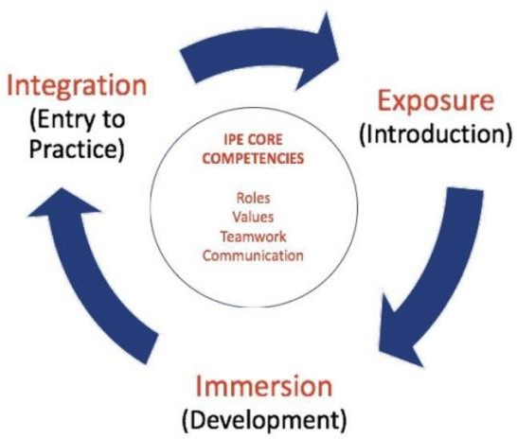
Figure 6: Interprofessional Competency Framework IPE Learning Trajectory*. *Adapted from the Universities of Alberta and British Columbia.

Lessons Learned and Best Practices

The CUNY HHS Sim-IPE Pilot considered the four competencies identified by IPEC [11] in the development and implementation of the program: values/ethics of interprofessional practice, the importance of understanding differing roles and responsibilities, interprofessional communication, and working in teams/teamwork. Though the CUNY HHS Sim-IPE Pilot was limited to participation in 28 two-hour virtual IPE session, the pilot was expanded in spring 2021 to include an additional 30 IPE sessions, two additional disciplines (occupational therapy and recreational therapy), and new campus participants. Also, during spring 2021, the CUNY HHS IPE Faculty Workgroup remained engaged to design and pilot three new case scenarios: surgical ENT, pediatric, and substance use disorder. Finally, in the spring 2021 semester, students were issued IPE digital badges or micro-credentials to replace the digital certificates, which can be shared on professional websites or social media platforms such as LinkedIn. Plans are underway to develop multiple modalities and IPE learning experiences, including asynchronous modules, embedding simulated persons (designated HHS students) into IPE sessions, and offering IPE in virtual, in-person and hybrid formats to expand the application of IPE case scenarios and modalities.

Increasing Participation

The CUNY HHS Sim-IPE Pilot was the first attempt by CUNY for a university-wide approach to integrated IPE across HHS degree programs, disciplines, and campuses. Despite tremendous recruitment efforts, the biggest challenge was widespread participation in the Pilot, particularly while faculty encountered many obstacles for maintaining their programs and student engagement during COVID. Another challenge was having a large percentage of nursing program participants in the Pilot, which was not surprising given the 50+ undergraduate and graduate nursing programs across 14 CUNY campuses. This resulted in an uneven participation of students and faculty across disciplines in many of the Pilot sessions, though each of the sessions represented at least two disciplines. Nevertheless, as mentioned earlier, eight HHS disciplines from 15 different programs across nine campuses successfully participated in the Pilot. Future steps for engaging more HHS programs and disciplines to promote more balanced participation of faculty and students include ongoing expansion of case scenarios to encompass a multitude of discipline-specific needs, extensive marketing which includes a new CUNY SIM-IPE website, and CUNY-wide informational sessions supported by CUNY Sim-IPE faculty representatives across campuses.

Supportive Organizational Structures

The University Dean for Health and Human Services led the HHS-IPE Council involving an interdisciplinary group of faculty across CUNY campuses. In addition, a new Office of Interprofessional Education was established within the Office of the University Dean, with a newly-appointed Faculty Fellow who has been instrumental in the design and implementation of the initiative to date. A new IPE webpage with access to openly accessible resources were launched in summer 2021 to organize the effort, foster communication, share resources, and enhance engagement across HHS faculty, programs, disciplines, and campuses.

Conclusion

The innovative pilot of a university-wide virtually simulated approach to IPE for CUNY’s HHS programs proved to be very successful during a time of great uncertainty with limited clinical training experiences for students in health and social service programs. The success of the Pilot was largely due to the contributions of a faculty-led effort designed to provide meaningful learning experiences and prepare CUNY graduates for collaborative practice. The 640 students participating in this effort were highly engaged and demonstrated keen insight on the value of these experiences prior to entry into practice. In all 28 pilot sessions, students expressed gratitude for the opportunity to engage in these experiences and identified the value of interacting with peers across programs, disciplines, and campuses to learn about various professional roles and to collaborate on a realistic plan of care. Students also highlighted the importance of the COVID-19 case scenarios, and the applicability of addressing the evolving clinical and care considerations for the quickly evolving disease.

Though some educators feel that engaging in an IPE session too early may not be beneficial [58], the CUNY HHS Sim-IPE Pilot mirrors experiences cited in the literature that IPE can enhance students’ attitudes and perceptions towards collaborating and interprofessional skills [6,59] and enhance clinical decision making, regardless of learner level [6]. The Pilot evaluation results revealed significant improvements in student perceptions of the roles of HHS disciplines and the core competencies of communication, mutual support, and teamwork. Most importantly, students had the unique opportunity to learn with, from and about each other during virtual Sim-IPE experiences that underscored the vital need for teamwork and collaboration in providing optimal patient-focused care.

Through Sim-IPE training offered by NYSIM, changes in faculty confidence levels and self-efficacy became fully evident, serving as a catalyst for the success of the pilot.

As national health care organizations and employers emphasize the importance of team-based care to improve health care delivery, minimize costs and maximize patient outcomes, it’s crucial for CUNY’s graduates to gain experience as members of an interprofessional team to enhance their readiness to successfully engage in professional practice through distinctive collaborative training. Given CUNY’s vast portfolio of HHS programs, this represents a unique opportunity to build a robust IPE program through realistic patient scenarios and faculty-trained IPE facilitators to engage students across disciplines via multiple modalities to facilitate interprofessional learning experiences, ultimately serving as one of the largest such programs in the country and a national model for innovative curriculum. Ideally, these high-quality collaborative practice experiences will significantly enhance the professional training and career readiness of CUNY students.

References

- World Health Organization (2010) Framework for action on interprofessional education and collaborative practice.
- Brock D, Abu-Rish E, Chiu C, et al. (2013) Interprofessional education in team communication: Working together to improve patient safety. Postgraduate Medical Journal 89: 642-651.
- Christopher A, Hammett L, Fischer K, et al. (2019) Anemia interprofessional team role-play case for students in outpatient primary care. Journal of Interprofessional Education & Practice 16.
- Carp S, Skrzat JM, Brown M, et al. (2020) Utilizing simulation to assess clinical decision making between physician assistant and physical therapy students. Journal of Interprofessional Education & Practice 19.
- Donato E, Lightfoot N, Carter L, et al. (2016) Interprofessional education in Canadian nursing programs and implications for continuing education. Journal of Professional, Continuing, and Online Education 1.
- Lapkin S, Levett-Jones T, Gilligan C (2013) A systematic review of the effectiveness of interprofessional education in health professional programs. Nurse Education Today 33: 90-102.
- Lee CA, Pais K, Kelling S, et al. (2018) A scoping review to understand simulation used in interprofessional education. Journal of Interprofessional Education & Practice 13: 15-23.
- Schuler M, Viveiros J (2020) An interprofessional education pilot project examining the issue of substance abuse with nursing and crime and justice students. Journal of Interprofessional Education & Practice 21.
- Fortugno M, Chandra S, Espin S, et al. (2013) Fostering successful interprofessional teamwork through an undergraduate student placement in a secondary school. Journal of interprofessional Care 27: 326-332.
- Stetten N, Black E, Edwards M, et al. (2019) Interprofessional service learning experiences among health professional students: A systematic search and review of learning outcomes. Journal of Interprofessional Education & Practice 15: 60-69.
- Interprofessional Education Collaborative (2016) Core competencies for interprofessional collaborative practice: 2016 update. Washington, DC: Interprofessional Education Collaborative.
- Speakman E, Tagliareni E, Sherburne ASS (2016) Guide to effective interprofessional education experiences in nursing education. National League of Nursing.
- Zheng A, Macauley K, Namba J, et al. (2015) A large scale interprofessional simulation experience for medical, nursing, and pharmacy students. MedEdPORTAL 11.
- Caines L, Asiedu Y, Dugdale T, et al. (2018) An interprofessional approach to teaching nutrition counseling to medical students. MedEdPORTAL: The Journal of Teaching and Learning Resources 14.
- Hanson C, Custer T, Schmidt C, et al. (2017) Following the growth of Sarah's baby: An interprofessional education activity for medical nutrition education and diagnostic medical sonography students. Journal of Interprofessional Education & Practice 7: 17-20.
- Grey C, Constantine L, Baugh GM, et al. (2017) Advance care planning and shared decision-making: An interprofessional role-playing workshop for medical and nursing students. MedEdPORTAL: The Journal of Teaching and Learning Resources 13.
- Smith K, Antony R, Koeuth S, Collins L, et al. (2013) A computer supported interprofessional education initiative: Using technology to advance interprofessionalism. MedEdPORTAL 9.
- Martinez I, Rose-St.Prix C (2013) A hybrid educational experience training future health professionals to work together to improve patient outcomes. MedEdPORTAL 9.
- Robinson A, DeSandre C, Parrish K (2019) Building interprofessional collaboration and role identification: A mock disaster with student and professional responders. Journal of Interprofessional Education & Practice 16.
- Charrette AL, Sullivan KM, Kucharski-Howard J, et al. (2019) Physical therapy and pharmacy interprofessional education in the context of a university pro bono physical therapy setting. Journal of Interprofessional Care 34: 315-323.
- Mangum SW, Johnson JL, Gunaldo TP, et al. (2017) Developing student interprofessional competence through a support group assignment. Journal of Interprofessional Education & Practice 9: 17-20.
- Hollamby J, Taylor I, Berragan E, et al. (2018) Preparing students for safe practice using an interprofessional ward simulation. Journal of Interprofessional Education and Practice 12: 78-82.
- McCave EL, Aptaker D, Hartmann KD, et al. (2019) Promoting affirmative transgender health care practice within hospitals: An IPE standardized patient simulation for graduate health care learners. MedEdPORTAL: The Journal of Teaching and Learning Resources 15.
- Ward LD, Bray BS, Odom-Maryon TL, et al. (2016) Development, implementation, and evaluation of a longitudinal interprofessional education project. Journal of Interprofessional Education & Practice 3: 35-41.
- Phillips WRm Keys T (2018) Interprofessional primary care course curriculum and evaluation. Family Medicine 50: 217-222.
- Langlois S, Xyrichis A, Daulton B J, et al. (2020) The COVID-19 crisis silver lining: Interprofessional education to guide future innovation. Journal of Interprofessional Care 34: 587-592.
- Prasad N, Fernando S, Willey S, et al. (2020) Online interprofessional simulation for undergraduate health professional students during the COVID-19 pandemic. Journal of interprofessional Care 34: 706-710.
- Robertson B, McDermott C, Star J, et al. (2020) Synchronous virtual interprofessional education focused on discharge planning. Journal of Interprofessional Education & Practice 22.
- Timmis J, Orlu M, Park S (2018) Educational potential of using virtual patients for promoting interprofessional learning between medical and pharmacy students: A qualitative study. Journal of Interprofessional Care 32: 794-796.
- Gurevich N, Osmelak D R, Farris C (2020) Interprofessional education between speech pathology and nursing programs: A collaborative e-platform curriculum approach. Journal of Interprofessional Care 34: 572-575.
- Lazinski M J, Ross L, Wolf S, et al. (2021) Interprofessional education at a distance: The hybrid interprofessional education model. The Internet Journal of Allied Health Sciences and Practice 19.
- Garrison DR, Kanuka H (2004) Blended learning: Uncovering its transformative potential in higher education. Internet Higher Education 7: 95-105.
- Curran V, Reid A, Reis P, et al. (2015) The use of information and communications technologies in the delivery of interprofessional education: A review of evaluation outcome levels. Journal of Interprofessional Care 29: 541-550.
- Willgerodt M, Sonney J, Liner D, et al. (2018) The power of a team: Using unfolding video cases in interprofessional education for advanced health trainees. MedEdPORTAL 14.
- Doucet SA, MacKenzie D, Loney E, et al. (2014) Curricular factors that unintentionally affect learning in a community-based interprofessional education program: The student perspective. Journal of Research in Interprofessional Practice and Education 4: 1-30.
- Kaufman J (2020) Investigating conflict perceptions among health profession students in an interprofessional education activity. Journal of Interprofessional Education & Practice 18.
- Lawlis TR, Anson J, Greenfield D (2014) Barriers and enablers that influence sustainable interprofessional education: A literature review. Journal of interprofessional Care 28: 305-310.
- Congdon HB (2016) Interprofessional education (IPE) practices at universities across the United States with an established IPE infrastructure in place. Journal of Interprofessional Education & Practice 5: 53-58.
- Chen AS, Yau B, Revere L, et al. (2019) Implementation, evaluation, and outcome of TeamSTEPPS in interprofessional education: A scoping review, Journal of Interprofessional Care 33: 795-804.
- Mills B, Hansen S, Nang C, et al. (2020) A pilot evaluation of simulation-based interprofessional education for occupational therapy, speech pathology and dietetic students: Improvements in attitudes and confidence. Journal of Interprofessional Care 34: 472-480.
- Averill MM, Dillon-Sumner L, Stergachis A, et al. (2020)Integrating public health students into interprofessional education. Journal of interprofessional care 34: 427-430.
- Smith KJ, Childs GS, Sposetti VJ, et al. (2019) Collaborating to care for a standardized patient in the outpatient setting: An interprofessional learning activity for dental and pharmacy students. Journal of Interprofessional Education & Practice 17.
- Branch-Mays G, Gladding S, Sick B (2018) Implementation and evaluation of a longitudinal multisession interprofessional education course designed for foundational learners. Journal of Interprofessional Education & Practice 13: 59-64.
- Health Resources and Services Administration (2018) Enhancing community based clinical training sites.
- American Association of Colleges of Nursing (2020) AACN fact sheet: Nursing shortage.
- West C, Graham L, Palmer RT, et al. (2016) Implementation of interprofessional education (IPE) in 16 U.S. medical schools: Common practices, barriers and facilitators. Journal of Interprofessional Education & Practice 4: 41-49.
- NYSIM (2021) About NYSIM.
- The National Center for Interprofessional Practice and Education (2020) About interprofessional practice and education.
- Tagliareni ME, Cline DD, Mengel A, et al. (2012) Quality care for older adults: The NLN Advancing Care Excellence for Seniors (ACES) project. Nursing Education Perspectives 33: 144-149.
- Agency for Healthcare Quality and Research. (2019) TeamSTEPPS 2.0.
- Cheng A, Hunt EA, Donoghue A, et al. (2013) Examining pediatric resuscitation education using simulation and scripted debriefing: A multicenter randomized trial. JAMA Pediatrics 167: 528-536.
- Scotten M, Manos EL, Malicoat A, et al. (2015) Minding the gap: Interprofessional communication during inpatient and post discharge chasm care. Patient Education and Counseling 98: 895-900.
- Centers for Disease Control and Prevention (2020) 10 essential public health services.
- Chiu C, Brock D, Abu-Rish E, et al. (2016) Performance Assessment Communication and Teamwork Tools set.
- Guraya, S. Y, Barr H (2018) The effectiveness of interprofessional education in healthcare: Systematic review and meta-analysis. The Kaohsiung Journal of Medical Sciences 34: 160-165.
- Institute of Medicine (2015) Measuring the impact of interprofessional education on collaborative practice and Patient outcomes.
- Xavier N, Brown MR (2020) Interprofessional education in a simulation setting. Stat Pearls.
- Gill AC, Cowart JB, Hatfield CL, et al. (2017) Patient safety interprofessional training for medical, nursing, and pharmacy students.MedEdPORTAL: The Journal of Teaching and Learning Resources 13.
- Clauser J, Richardson B B, Odom-Maryon T, et al. (2020) Standardized patient simulation using SBIRT (Screening, Brief Intervention, and Referral for Treatment) as a tool for interprofessional learning. MedEdPORTAL: Journal of Teaching and Learning Resources 16.

