Case Report

Gouty Tendonitis of the Hand: An Algorithmic Approach

Irene T. Ma MD¹, Justine S. Kim¹, Debra A. Bourne MD², Alexander M. Spiess MD¹, Joseph E. Imbriglia MD ^{1,3}

¹Department of Plastic Surgery, University of Pittsburgh Medical Center, Pittsburgh, Pennsylvania, USA
²Division of Plastic Surgery, University of Kentucky, Lexington, Kentucky, USA
³Hand and UpperEx Center, Wexford, Pennsylvania, USA

#Corresponding author: Joseph E. Imbriglia, Hand and UpperEx Center, 6001 Stonewood Drive, Wexford, Pennsylvania 15090, USA

How to cite this article: Ma IT, Bourne DA, Spiess AM, Imbriglia JE (2021) Gouty Tendonitis of the Hand: An Algorithmic Approach. Int J Surg and Repo 01(01): 2021-07.

Submission Date: 29 June, 2021; Accepted Date: 22 July, 2021; Published Online: 28 July, 2021

Abstract

Aim: To provide an algorithm for diagnostic and treatment recommendations developed based on our findings and review of the literature.
Background: Gouty tendonitis of the hand is an uncommon diagnosis. It has primarily been reported to involve the extensor tendons, tendon sheaths, or carpal tunnel with rare direct infiltration of tendons.
Design/Method: A retrospective review of two hand surgeons’ patients was completed. We report three cases of patients who presented with a range of gouty infiltration of flexor and extensor tendons that resulted in limited finger excursion as well as tendon rupture.
Conclusion: Existing literature and our clinical experience support the step-by-step approach to this disease based on the degree of tendon involvement and injury.

Keywords: Algorithm; Gout; Hand; Tendon; Tendonitis

Introduction

Gout is the most common form of inflammatory arthritis characterized by monosodium urate crystal deposits within joints and soft tissue with both acute and chronic manifestations [1]. The upper extremity is a less common site of disease. Gouty tendonitis occurs with uncontrolled pathology resulting in tophaceous deposition within a tendon. It is one manifestation of extra-articular gout. Clinical involvement of the hand can present as arthritis, skin ulceration, draining sinus formation, nerve entrapment, tendon rupture, infection, and tenosynovitis [2,3]. There is a paucity of literature describing the infiltration of tophaceous deposits within tendon; the majority of which are individual case reports [3,4]. We describe our experience with three patients diagnosed with gouty infiltration of tendons. Based on our clinical experience and review of the literature, we present an operative treatment algorithm for the management of patients with this disease.

Case Series

Patient 1

A 53-year-old right-hand dominant man with a history of chronic gout medically managed with colchicine, allopurinol, and ibuprofen, and daily alcohol use presented with a complaint of progressive pain and limited small finger range of motion. On exam, his right small finger had a total arc of 80 degrees of motion at the Metacarpophalangeal (MCP) joint, 30 degrees at the Proximal Interphalangeal (PIP) joint, and 0 degrees at the Distal Interphalangeal (DIP) joint. A large gouty tophus was present on the dorsum of the small finger. Serum uric acid level was 10 mg/dL (normal 2.9-9) pre-operatively.

To improve range of motion and to alleviate pain, this patient underwent operative treatment in November 2018. A Brunner incision over the PIP joint of the small finger revealed significant infiltration of both the Flexor Digitorum Profundus (FDP) and Flexor Digitorum Superficialis (FDS) tendons (Figure 1). The A3 pulley was released and excursion of the flexor tendons was assessed by traction using a Ragnell retractor. The FDS tendon was noted to be completely fixed in position due to gouty disease and was, thus, excised. The FDP tendon maintained near normal excursion (Supplemental Material 1: video). Gouty deposits were debrided, creating a smoother surface to improve tendon gliding. Exploration of the extensor tendon was performed through a separate incision. Upon inspection, 50% of the extensor tendon had ruptured due to gout infiltration (Figure 2) and was primarily repaired. One-month follow-up demonstrated improvement in flexion at the MCP (85 from 80 degrees), mild worsening of PIP flexion (20 from 30 degrees), and no change for the DIP joint. The patient endorsed pain relief post-operatively.

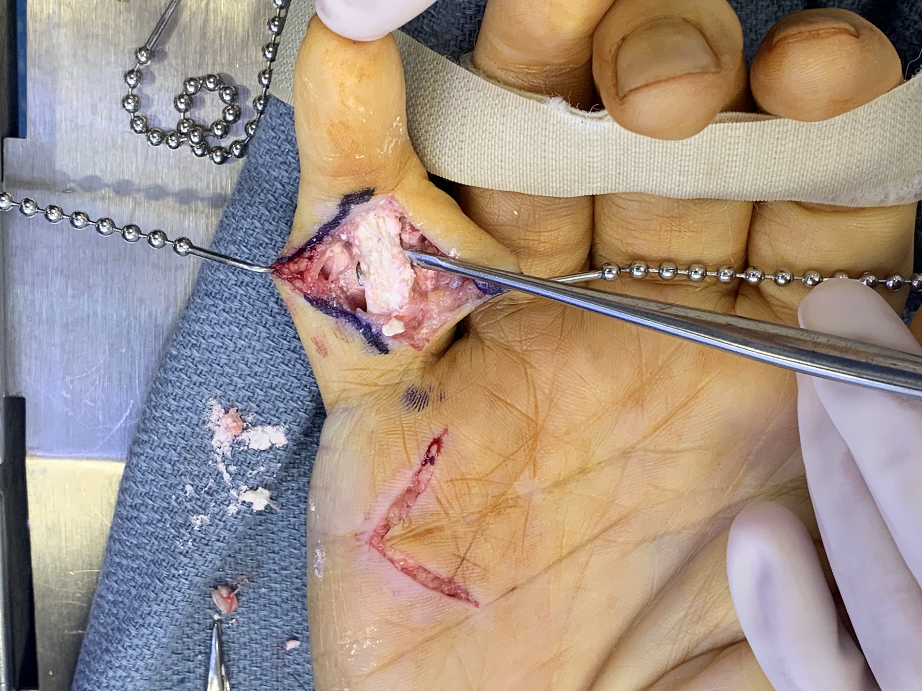

Figure 1: Gouty infiltration of the flexor digitorum superficialis and flexor digitorum profundus tendons.

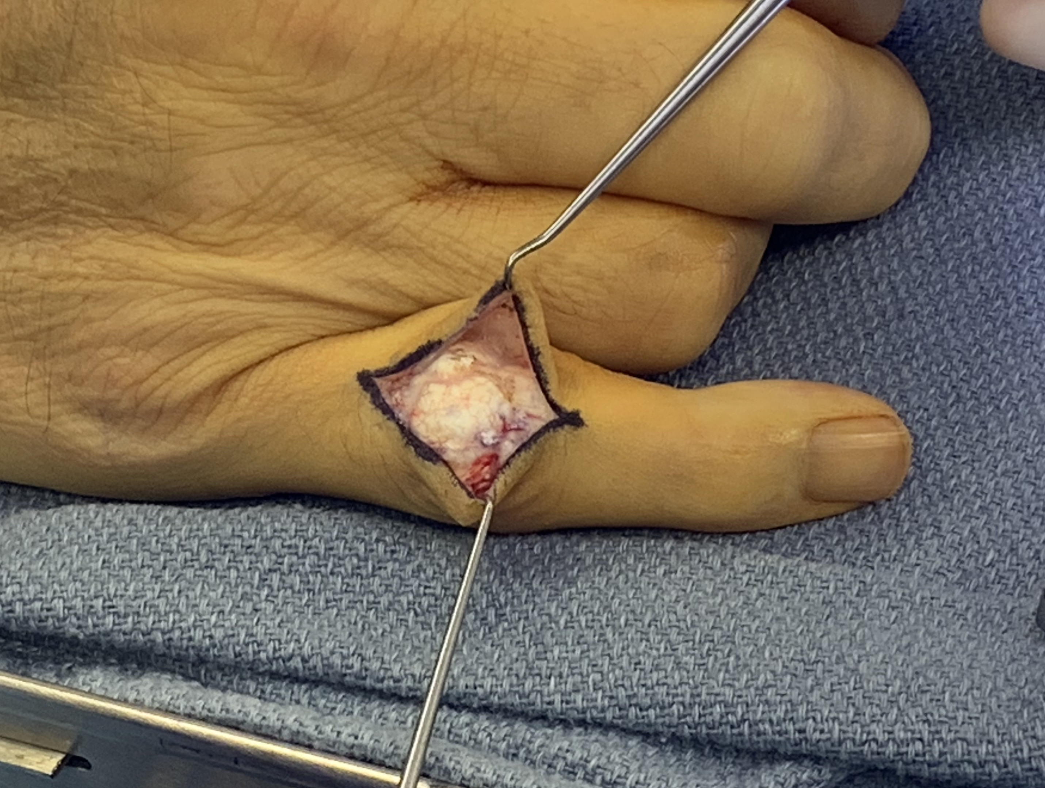

Figure 2: Gouty infiltration of the extensor tendon.

Patient 2

A 52-year-old right-hand dominant male nurse with a history of hypertension and previous gout flare of the knee (not on any urate-lowering medications) presented seven weeks after breaking up a dog fight during which he obtained several open wounds to his bilateral hands. He underwent wound irrigation in the Emergency Department at the time of injury and was discharged on antibiotics. His course was complicated by ongoing swelling and tenderness of the right hand, and he received additional treatment with Levofloxacin. Symptoms were acutely exacerbated after a ground level fall. The patient endorsed persistent pain with active and passive motion of the thumb, ring, and small fingers. On evaluation, there was prominent edema, erythema, and pain of the right hand along the thumb, small finger, and across the palm. Magnetic Resonance Imaging (MRI) demonstrated skin and subcutaneous edema and enhancement as well as heterogeneity and disorganization consistent with tenosynovitis of the flexor tendons of the thumb and small finger extending from the carpal tunnel to the distal phalanges (Figure 3). He remained afebrile with a normal white blood cell count (9.3).

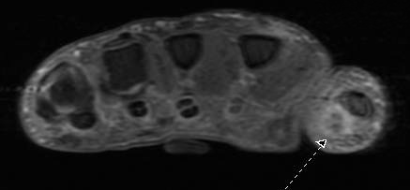
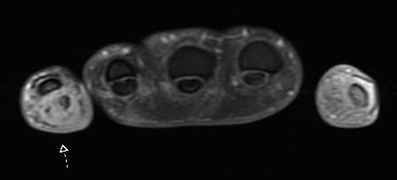

Figure 3: MRI demonstrating skin and subcutaneous edema and enhancement as well as heterogeneity and disorganization consistent with tenosynovitis of the flexor tendons of the thumb (top) and small finger (bottom).

To treat suspected suppurative flexor tenosynovitis, the patient underwent operative irrigation and debridement. Intraoperatively, caseating granulomas were found embedded in soft tissue, flexor tendons, and tendon sheaths (Figure 4). The ulnar half of the flexor pollicis longus was excised as it was invested in caseating granulomatous tissue. Remaining structures in the thumb were preserved. In the small finger, the majority of the pulley system required debridement. Extensive tenosynovectomy of the FDP and FDS tendons improved range of motion. Caseating granulomas encasing all flexor tendons within the carpal tunnel were excised. Granulomas within the soft tissue were debrided from the elevated skin flaps. Pathology confirmed crystalline material consistent with monosodium urate deposition. The patient received 3 months of hand therapy, improving range of motion significantly.

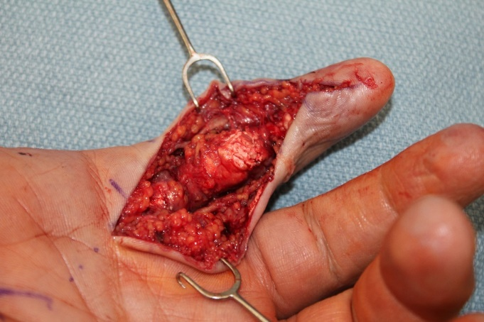

Figure 4: Caseating granulomas embedded in soft tissue, flexor tendons, and tendon sheaths.

Patient 3

An 82-year-old right-hand dominant man with a known history of gout, managed medically with allopurinol and colchicine, presented with middle finger flexion contracture, complaining of increasing pain and dysfunction. He had previously undergone right middle finger metacarpophalangeal arthroplasty in 2011 at which time gout was found within the joint. He subsequently underwent a left ulnar nerve neurolysis at the elbow and carpal tunnel release with tenosynovectomy in May 2016 without evidence of gouty deposits at these sites. On exam, he had rigid flexion contracture of the right middle finger with the PIP joint fixed at 80 degrees and the DIP joint at 45 degrees. In September 2018, he underwent tenosynovectomy to improve motion. A Brunner incision was made; A1 and A3 pulleys were released with preservation of A2. Gout was found within FDS and FDP tendons; FDP was ruptured, precluding FDS tendon gliding. Due to the extent of disease, the remaining ruptured ends of the FDP were resected (3.8 cm of tendon length). Tenolysis of the FDS tendon and PIP joint capsulectomy improved PIP joint flexion contracture (from 80 to 10 degrees) and DIP joint contracture (from 45 to 5 degrees). At 1-month follow-up, the patient showed mild flexion contracture of the right middle finger (30 degrees from 80 degrees on initial presentation).

Discussion

Gout develops when elevated levels of serum uric acid lead to deposition of monosodium crystals within the body including synovial fluid, subcutaneous tissues, joints, and kidneys [5]. Under rare circumstances, deposits within tendons in the hand can occur. Due to its infrequent incidence, diagnosis of gouty tendinitis is often missed. Patients typically have a chronic history of gout at other sites, highlighting the importance of a thorough medical history on initial evaluation [5]. Common physical exam findings include visible tophaceous deposits, ulceration, joint contractures, dermatitis, and carpal tunnel syndrome among other compression neuropathies. Imaging such as MRI can be valuable in determining the extent of disease.

Medical management is the first line of treatment for gout. Options can be grouped into three categories: urate-lowering therapy, gout flare prophylaxis, and anti-inflammatory therapy. The first (e.g. allopurinol, probenecid) is the mainstay of treatment as it addresses the primary pathophysiologic cause of gout, hyperuricemia. Colchicine and non-steroidal anti-inflammatory medications are used for gout flare prophylaxis to decrease inflammation and to improve pain [5,6]. However, data shows that medications can be ineffective in 5% of cases [7]. Furthermore, delays in medication administration, dose adjustment, non-compliance, and time to effect can lead to disease progression. For example, tendon involvement can progress to tenosynovitis, and subsequently limit range of motion. Advanced disease can even lead to joint contracture and tendon rupture [7].

Indications for surgical management for upper extremity gout include: 1) treatment of infection, 2) alleviation of pain, 3) range of motion improvement, 4) nerve decompression, and 5) improvement of aesthetic deformity. Two of the patients discussed underwent elective intervention primarily for improvement of range of motion, while the third patient underwent surgical intervention to address infection as well as pain. Peri-operative management should include prophylactic colchicine and anti-inflammatory therapy as surgery itself may induce an acute gouty attack [4,6,8]. Intra-operatively, we recommend biopsy of tophaceous material, if there is any doubt of the diagnosis or concern for infection. Tissue biopsies should be sent in formalin to diagnose an infectious etiology and in ethanol to rule out gout; ethanol prevents degradation of the monosodium urate crystals [8,9]. The presence of needle-shaped, negatively birefringent crystals on microscopy is diagnostic for gout.

With regards to surgical approach, we recommend a Brunner incision for access to affected flexor tendons and a midline longitudinal dorsal incision for extensor tendon involvement. This allows for wide access. Debridement of subcutaneous tophaceous deposits should then be performed. The tophus consistency and degree of joint involvement can guide this surgical approach as previously described by Kasper, et al. [6] Tendons should be circumferentially freed from the firm, crystalline deposits that envelope them. As the urate crystals infiltrate the tendon substance, some deposits will need to be left to maintain the integrity of the tendon. If the pulley system is intact, an effort should be made to maintain A2 and A4. However, in cases with significant tendon involvement, the pulleys are often degraded from gouty disease and can be debrided without concern for bowstringing. We suggest the following algorithm for treatment of involved tendons (Figure 5). First, assess the degree of gout involving the tendon. If less than or equal to 50% of the tendon is ruptured, primary repair can be performed. If greater than 50% of the tendon is ruptured or the tendon is completely immobile after dissection, it should be excised. Next, determine if a tendon transfer or reconstruction is needed. If there is a nearby intact tendon that performs the same function as the excised tendon (e.g. intact FDP in setting of excised FDS), then no further reconstruction is necessary. If no other tendon performing the same function is available, then perform a tendon transfer or reconstruct the excised tendon using an expendable tendon such as the palmaris longus. Importantly, if the patient demonstrates symptoms of carpal tunnel syndrome, a carpal tunnel release and debulking of tophaceous deposits compressing the median nerve should be performed.
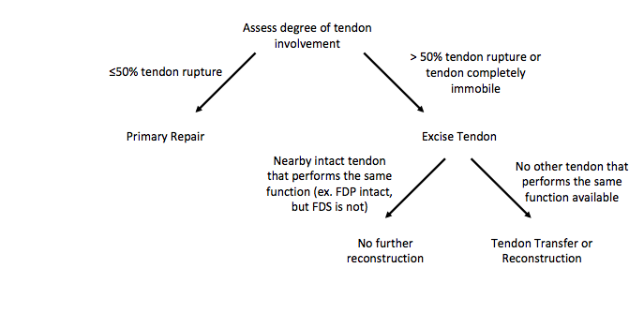

Figure 5: Treatment algorithm for the management of gouty tendonitis of the hand.

There are limitations to this study. This is a small case series. Since this is a rare diagnosis, only three patients were included. Furthermore, analysis was performed in a retrospective manner.

Despite the limitations, we aimed to provide an algorithmic approach to surgical treatment of gouty tendonitis. Existing literature and our clinical experience support the step-by-step approach to this disease based on the degree of tendon involvement and injury.

Disclosures

The authors have no relevant disclosures.

References

- Meyer zu Reckendorf G, Dahmam A (2018) Hand involvement in gout. Hand Surg Rehabil 37: 197-201.
- Sakti M, Usman MA, Lee J, Benjamin M, et al. (2019) Atypical musculoskeletal manifestations of gout in hyperuricemia patients. Open Access Rheumatol 11: 47-52.
- Wurapa RK, Zelouf DS (2002) Flexor tendon rupture caused by gout: a case report. J Hand Surg Am 27: 591-3.
- Weniger FG, Davison SP, Risin M, et al. (2003) Gouty flexor tenosynovitis of the digits: report of three cases. J Hand Surg Am 28: 669-672.
- Neogi T (2016) Gout. Ann Intern Med 165: 1-16.
- Kasper IR, Juriga MD, Guirini JM, Shmerling RH. (2016) Treatment of tophaceous gout: when medication is not enough. Semin Arthritis Rheum 45: 669-74.
- Tajika T, Kuboi T, Mieda T, et al. (2019) Digital flexion contracture caused by tophaceous gout in flexor tendon. SAGE Open Med Case Rep 7: 1-3.
- Schuind FD, Clermont D, Stallenberg B, et al. (2003) Gouty involvement of flexor tendons. Chir Main 22: 46-50.
- Hankin FM, Mayhew DE, Coapman RA, et al. (1985) Gouty infiltration of a flexor tendon simulating rupture. Clin Orthop Relat Res 194: 172-175.

