Research Article

Diabetes Foot Screening in Rural Tanzania: Nurse-led Intervention

Kimberly K. Hall, MSN, FNP-BC, CDE#, Siana John Nkya, RN

Graduate School of Nursing, University of Massachusetts Medical School, Massachusetts, USA

#Corresponding author: Kimberly K. Hall, DNP, FNP-BC, Assistant Professor, Graduate School of Nursing, University of Massachusetts Medical School, 55 Lake Avenue North, Worcester, Massachusetts 01655, USA

How to cite this article: Hall KK and Nkya SJ (2021) Diabetes Foot Screening in Rural Tanzania: Nurse-led Intervention. Int J Nurs & Healt Car Scie 01(11): 2021-68.

Submission Date: 16 July, 2021; Accepted Date: 06 August, 2021; Published Online: 12 August, 2021

Abstract

Aim: Standardized diabetes foot risk assessment and patient education was needed in Tanzania to potentially reduce ulcers, infection, and amputation. The goal of this project was to document assessments and patient education on at least 25% of visits.
Background: Prevalence rates in Africa of diabetes foot ulcers, which can lead to infection and amputation, have been estimated between 4% and 19%. Preventive guidelines could be implemented by nurses in resource-limited settings.
Design: A quality improvement project to implement the International Diabetes Federation’s (IDF) foot risk assessment guidelines involved education of staff in an outpatient department in rural Tanzania, employing use of the Plan- Do-Study-Act (PDSA) model.
Method: Elements of the IDF foot risk assessment guidelines were incorporated into a standardized documentation form. Baseline documentation data were collected, followed by classroom education with pre- and post-tests of confidence in performing elements.
Conclusion: Comparison of baseline (N=44) and post intervention (N=33) chart reviews demonstrated significant differences for documentation of diabetes foot risk assessment (chi-square p < .01) and patient education (chi-square p < .001). Results support implementation of preventive guidelines by nurses for chronic conditions such as diabetes in low-resource settings.

Keywords: Diabetes foot ulcers; IDF guidelines; Nurse-led clinic; Sub-Saharan Africa

Introduction

Cardiovascular-metabolic diseases, including diabetes and hypertension, remain the leading causes of death world-wide among the non-communicable diseases [1]. Rising prevalence of Non-Communicable Diseases (NCDs) and associated premature mortality in Sub-Saharan Africa has contradicted the widely accepted premise that health risks in African countries are dominated only by infectious diseases [2]. The International Diabetes Federation (IDF) estimated 15.5 million adults aged 20-79 in Africa have Type 2 diabetes (T2DM) and that two-thirds of cases were undiagnosed [3].

Africa contains 25% of global disease yet has only 3% of the world’s healthcare workers [4]. There were approximately three doctors for every 100,000 residents, compared to 255 doctors for every 100,000 residents in the U.S. in 2014 [5]. Thus, millions in Africa cannot access medical care. This problem was compounded by the fact that most medical services for NCDs take place in urban center hospitals [5]. Therefore, people in rural communities have had even more limited access to medical care, especially for NCDs. Furthermore, front-line providers in the rural clinics have had less training and experience with NCD management, as well as deficits in guidelines, diagnostic equipment, and availability of first line drug therapy [5].

A public health survey in Tanzania reported many undiagnosed and untreated cases of diabetes; in addition, the authors found a high prevalence of diabetes-associated complications [6]. Foot ulcers remain a major complication of diabetes with the burden of diabetic foot disease increasing worldwide. In Africa, the prevalence of active diabetes foot ulceration has been estimated between 4% and 19% [7]. An emphasis on prevention, treatment, and management of diabetes complications has been noted as a matter of growing urgency as the prevalence of diabetes increases in this region [6].

Problem Statement

A current problem in rural Tanzania has been the lack of standardized diabetes foot screening to identify and address risk factors predictive of foot ulcers, which could progress to infection and amputation, a potentially socially and economically devastating outcome. An examination that includes foot risk assessment could increase efforts aimed at prevention, early intervention, and patient teaching opportunities to prevent progression to injury, ulceration, infection, and amputation. Education of patients with diabetes on self-care was needed, including foot care, which could decrease the likelihood of these foot complications.

Purpose of the Project

The purpose of this quality Improvement (QI) project was to employ international evidence-based guidelines for foot screening, risk assessment and patient education in a nurse-led diabetes clinic, demonstrated by documentation in at least 25% of adult visits for T2DM.

Clinical Question

Can diabetes foot risk screening and patient education regarding foot care be implemented in a nurse-led diabetes clinic of a busy outpatient center in a low-resource setting?

Review of the Literature

A literature review was performed between 9/2017 and 6/2018 for articles in English less than 10 years old, using database search terms for PubMed: diabetes AND foot AND Africa AND education, and using the same terms for Scopus except adding AND NOT South Africa, which revealed 55 potential articles. Review of articles recommended by expert mentors and reference lists yielded an additional 43 articles. After eliminating duplicates, a total of 93 abstracts were reviewed, of which 41 were too old or did not apply to this population. The remaining 52 full articles were reviewed and 29 were excluded that did not apply to the study subject. A total of 23 articles, including 6 studies and a meta-analysis of an additional 12 studies, were used. An overview of the literature follows.

In light of diabetes as a global threat, studies of diabetes education efforts supported the observation that self-management education helps to meet this challenge [8]. Improved glycemic control, a cornerstone metric of diabetes management, has resulted from several approaches [9-11]. A meta-analysis of 12 studies demonstrated that culturally-tailored interventions were particularly effective at increasing knowledge that led to improved self-management [11]. Authors recommended rigorous randomized controlled trials for tailored diabetes education with ethnically-matched educators.

Several tools for diabetes screening and management have been studied by Muchira and Stuart-Shor [12] and were found to have applicability in reducing barriers to screening for diabetes at the community level, especially among low-income populations. The authors reported that such tools provided the opportunity for nurse-led prevention visits, allowing guidelines to be used for treatment critical to reducing the development of comorbid diabetes and cardiovascular disease. They further noted their utility in resource-constrained settings.

The literature has further supported the use of nurse-led interventions for diabetes. Researchers did a study of a large sample using descriptive, retrospective clinic data from two integrated primary health facilities in Kenya, a neighboring country with a similar landscape to Tanzania, this project’s setting [13]. The conclusion was that nurses were able to adhere to standardized protocols and guidelines to relieve the healthcare gap in developing countries.

Additional findings have supported the use of nurse interventions in resource-limited settings [14,15,16]. A systematic review of studies on patient teaching interventions showed improved outcomes in disease-specific knowledge and adherence to foot care in patients with diabetes, though not always statistically significant [17].

A cross-sectional study of patients with diabetes in four clinics in Tanzania confirmed the presence of foot complications in this population, and noted that a majority of people with diabetes did not receive guideline-recommended foot care, including regular foot exams [7]. Foot assessment is important, as neuropathy and poor perfusion predict higher amputation risk [18]. Education of providers has been shown to increase the percentage of patients with diabetes who received a foot exam [19]. Foot screening exams and patient education could also reduce the likelihood of foot complications [8,20]. Self- assessment could improve foot care in diabetes [8,17,21].

Finally, a large-scale diabetes foot project done in Tanzania from 2004-2007 [22] addressed diabetes foot risk factors and followed outcomes. Peripheral neuropathy was confirmed to be a contributing factor to increased risk of amputation [23]. The multi-year project consisted of a three-day education program to train healthcare personnel in diabetic foot management, including screening and improved patient education. A total of 11,714 patients were screened across fifteen centers in Tanzania. In the period following initiation of the project, except for an initial rise in the proportion of foot ulcers and amputation attributed to enhanced case finding, there were decreases in incidence of both foot ulcer and amputation. The authors concluded that the program was considered an effective model for improving outcomes in less-developed countries [22].

In summary, the literature supported the need for: 1) regular foot exams in patients with diabetes in Tanzania; 2) education of providers to increase the percentage of patients receiving foot exams; 3) education of patients in self-care that could improve foot care; 4) use of guidelines and protocols by nurses to manage chronic conditions in resource-constrained settings; and 5) improved foot care and patient education by healthcare personnel in persons with diabetes to reduce complications, including foot ulcers and amputation.

Conceptual Framework

The interventions in this project involved teaching nurses and other professional staff.

Since the staff consisted of adult learners, Knowles’ theoretical principles of adult learning were employed in teaching the use of IDF guidelines [24]:

Adults need to be involved in the planning and evaluation of their instruction.
Experience (including mistakes) provides the basis for the learning activities.
Adults are most interested in learning subjects that have immediate relevance and impact to their job or personal life.
Adult learning is problem-centered rather than content-oriented.

The diabetes staff members were involved in the planning and evaluation of their learning. An initial meeting with management leaders was held and a staff self-assessment of learning needs took place in order to plan the educational process. Experiential learning was used, with demonstration and teach back, first by the instructor and then by the staff in a classroom setting, followed by demonstrations of the foot exam by students on each other, and finally the exam was done on patients in the clinic. The staff expressed enthusiasm for this method, and felt they were able to apply the learned skills in their clinic duties.

The ability to directly address what is perceived to be a problem through their skills further engaged the students in the learning process. Evaluation included confidence of learners in performance of the elements of the foot exam and patient education following a formal training class, on-site observation and coaching on application of the screening guidelines, and feedback in team meetings using a Plan-Do-Study-Act cycle of improvement ((Figure 1), [25]). A chart review for documentation of the elements of the IDF foot screening tool for foot examination and patient education included a checklist based on the IDF guidelines (see Appendix B).

Translational Model: The Plan-Do-Study-Act Model

This Quality Improvement (QI) project was guided for translation by the Plan-Do-Study-Act (PDSA) process [25]. A cyclical strategy framework, as shown in (Figure 1), was selected as recommended by the WHO in its guide to implementing processes for prevention and control of non-communicable diseases [1]. Application of the PDSA model, with explanation of the use of the four steps of the improvement model, follows.

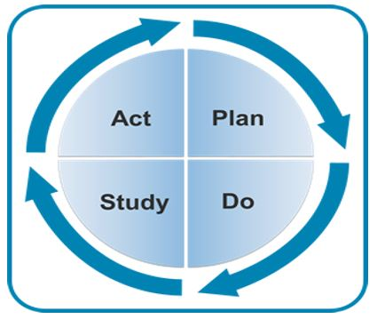

Figure 1: PDSA Model [25].

Plan - Develop the Initiative

Develop the improvement initiative, along with a team selected to be involved in the improvement initiative. The makers of the model suggested that the people doing the work should be the ones planning and guiding the improvement initiative. The team should represent all those affected by the improvement; a maximum of ten people recommended. Expectations were set for the team to continue working together throughout implementation. A plan was made for those not on the team to receive regular updates about the initiative's progress.

An on-site assessment was done with the team collaborators along with the DNP student to discuss the agreed-upon approach to institute a weekly diabetes clinic. Initially, the collaborators included the nurse manager, medical director, and a physician knowledgeable in QI. A diabetes team of four nurses, a pharmacist, a receptionist, and a social worker were selected and trained.

A documentation form was implemented at weekly diabetes clinic visits, which further informed the quality improvement project interventions in August, based on the timeline (see Appendix D).

Do - Implement Plan

With a committed team identified and a specific plan, the next step was to implement the quality improvement initiative, with regular communication on the process. At the time of the first meeting, collection of baseline data could begin for purposes of ongoing measurement and continued throughout implementation.

Implementation of diabetes foot assessment and patient education took place by the staff in the diabetes clinic. This was done in conjunction with documentation of foot assessment and patient teaching according to the IDF guidelines on the standardized form.

Study- Evaluate Measures

The measures chosen by the team during the planning phase to evaluate the success of the project were reviewed. The team compared actual results to expected results, as well as to the previous outcomes, and considers the factors that contributed to the findings. Charts of visits in the diabetes clinic from its inception in April through July, 2018 were reviewed for baseline data of documentation. This showed steady decline in documentation of all elements of foot screening and patient education, indicating the need for a QI intervention.

Act- Also Referred to as the Adjustment Phase

During this stage of the PDSA cycle, the team would take one of two courses of action. If the plan was not achieving desired results, the cycle would restart with planning. If the plan was meeting or surpassing desired results, the current process would be refined.

In August, teaching and coaching interventions took place, and the PDSA cycle was used to remove barriers to documentation of foot exam and patient teaching. Post-intervention data was collected based on documentation of four out of five elements, defined as “complete screening,” and patient education from September through December, 2018.

Project Design

This quality improvement (QI) project focused on a practice improvement method for foot screening for risk assessment and patient teaching on foot self-care in adult T2DM patients in a diabetes clinic in rural Tanzania. Specific international guidelines developed by a panel of experts, along with an accompanying foot screening chart, were released by the IDF in 2017 to guide protocols for routine assessment and care of the feet and patient education in people with diabetes (see Appendix A, Diabetic Foot Screening). This project implemented 2017 IDF foot care guidelines. As part of overall education of staff in a newly instituted diabetes clinic within an established general outpatient department in rural Tanzania, a team of nursing and professional staff was taught general diabetes care, including foot screening. A standardized documentation form was developed and introduced, since medical records were paper-based and had no established mechanism for documenting and tracking diabetes care. The form included a section for the foot exam, to support program evaluation to determine whether this intervention would work in the environment.

Ethical Considerations

This activity was intended solely to improve the quality of patient care, involved staff in the delivery of an evidence-based practice of foot assessment and teaching for patients, and was not designed to inform practice outside of the clinic or to contribute to generalizable knowledge. Established evidence-based guidelines were implemented with evaluation regarding whether the staff was utilizing guidelines as expected. The activity did not employ any novel interventions. No identifying data was used. Therefore, the Institutional Review Board (IRB) form for consideration as not human subjects research determination was submitted to the University of Massachusetts Medical School Institutional Review Board, and approved.

Methodology

Diabetic foot screening for ulcer risk guides prevention, early intervention, and patient teaching opportunities to prevent progression from neuropathy to injury, ulceration, infection, and amputation. The IDF guidelines advise assessment during the window of presentation, defined as the time between when neuropathy is diagnosed and prior to developing an ulcer. Once an ulcer has developed, the risk would be considered very high, and outside this window of presentation for screening, as referral for medical treatment is indicated. For this project, the categories from low to high were utilized for screening as shown in a simplified schematic in (Figure 2) (for complete guidelines see the Diabetic Foot Screening Pocket Chart, Appendix A).

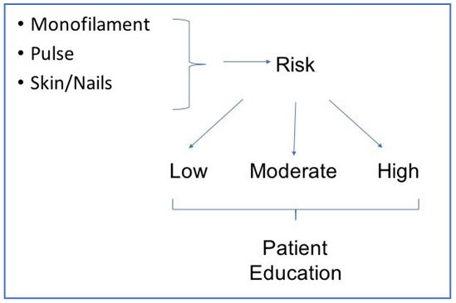

Figure 2: Simplified IDF Foot Screening for “Window of Presentation”.

The IDF guidelines outline screening with a foot exam for risk assignment and patient education. The elements of the foot exam included assessment of protective sensation by detection of a monofilament test, presence of pulses, condition of skin and nails, and presence of a current ulcer or history of a prior ulcer. These exam elements result in a stratified risk assessment which then determines appropriate patient education for self-care and follow-up.

Patient education components involved daily inspection, self-care of skin and nails, use of proper footwear, and advice regarding scheduled or interim follow-up, as well as counseling on glycemic control and tobacco cessation. A standardized documentation form (see Appendix B) included a section for the documenting the elements of the foot exam, based on the elements of the IDF guidelines, as shown in (Figure 3).

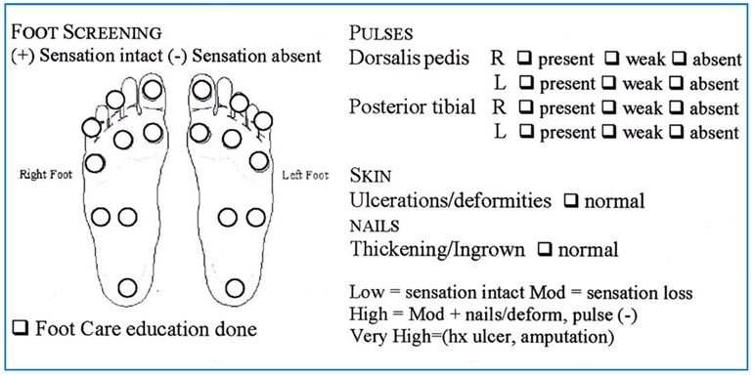

Figure 3: Foot Exam Section of Standardized Documentation Form.

Participants

A team of staff at the diabetes clinic were taught on use of the IDF foot assessment guidelines for adult patients with T2DM. Inclusion criteria for patient visits included all adult patient visits to the diabetes clinic between August and December, 2018. Exclusion criteria included visits involving children under age 21 and patients with Type 1 diabetes. Patients were referred by primary providers from the general outpatient department.

Setting

The project took place with the team of staff in a weekly nurse-led diabetes clinic in rural Tanzania. The clinic is part of a non-governmental medical center which has over 25,000 outpatient visits per year, with diabetes listed as one of the top five diseases seen [4]. The clinic’s medical staff was overwhelmed with the acute care needs of its population [4]. The medical director of the center identified the need for chronic disease management. A nurse-led intervention for management of diabetes and preventive education had been launched to address this need in April, 2018.

Tools

The project evaluation tools, with all data entered by hand using a password encrypted laptop, included: 1) chart review of documentation of the variables of the diabetes screening exam according to the IDF guidelines at baseline and after interventions, and 2) staff confidence in diabetes foot screening, based on application of the IDF guidelines, after a formal training class.

Chart review of documentation: Data were collected by chart review for documentation of each of the foot screening variables at baseline, one month during, and for three months post- intervention, using a checklist (see Appendix C). Patient education was tracked separately for all intervals. Data were entered into an excel spreadsheet. A run chart was initiated to track the presence or absence of complete exams, defined as including four elements of the foot exam and risk assessment. Patient education was tracked in a separate line on the run chart. Baseline documentation of aggregate data was then compared for three months pre- and three months post- intervention, using a bar graph.

Staff confidence scores: Basic demographics and consent for data collection were included on a survey form (see Appendix D), and a table of demographic characteristics was generated. A pre-test survey of staff confidence in elements of foot screening guidelines was administered before a formal education class held in August. The survey consisted of 10 items on a four point Likert scale of confidence from not at all to very confident in performance of foot exams, expected to take five minutes to complete. The survey instrument was developed based directly on evidence-based IDF guidelines, and was reviewed by a diabetes expert to assess content validity, since no prior instruments existed. The same confidence scale was administered as a post-test. Staff confidence scores were averaged.

Intervention and Data Collection

The DNP student was on-site during August, 2018 to carry out the training and coaching interventions and PDSA cycles, and for an interim chart review of documentation for progress during the interventions. A detailed narrative of the QI process interventions follows:

- Formal training class. A training class for staff (N=10) was held in the first week of August, 2018, specifically reviewing each element of the diabetes foot exam and patient education. The objectives of the class were taken directly from the IDF guidelines (see Appendix E) with a pre and post test administration of confidence survey. The class included a didactic presentation of the IDF guidelines, a demonstration of the foot exam, and partner practice of the diabetes foot exam and patient education.
- Observation and coaching. The DNP student was present in the diabetes clinic during August, 2018 for observation and coaching on the foot exam, risk assessment, and patient education based on the IDF guidelines.
- PDSA cycles. Barriers to performing and documenting the foot screening elements and patient education were explored with the team. These were addressed by use of a pocket screening chart given to all staff members as well as laminated and posted in the diabetes clinic exam area, and by clarification of the documentation form (see Appendix G). At that time, the diabetes clinic staff were also formally recognized with identification tags as diabetes team members.

For follow-up on chart documentation, an interim chart review was repeated for one month of visits at the end of August, 2018, following the interventions above.

Starting in September, on-going tracking of documentation data was done by chart reviews for “Complete screening,” defined as including at least four elements of the exam and risk assignment. If present, a “yes” was entered into an excel spreadsheet that was maintained by the on-site team leader; if not, a “No” was entered. These combined data were used to track “Complete Screening” as a single line on a run chart. Baseline data were then converted according to this same definition for comparison on a run chart. From September to December, post- intervention chart review of documentation was continued by the on-site team leader (N=33).

Documentation of patient education was tracked separately as present (“yes”) or absent (“no”). Results for September to December were entered into an excel spreadsheet by the on-site team leader, then converted into a monthly run chart by the DNP student.

Budget

Foot screening took place in the weekly diabetes clinic. Staff education took place at afternoon staff meetings, and during the existing time set aside for the weekly staff conference. A formal class on foot risk assessment took place in August, 2018, along with coaching in the clinic and PDSA cycles with the diabetes team by the DNP student. The diabetes clinic is run by one receptionist, a social worker, and four nurses, and supported by a pharmacist as needed. An MD consultant is utilized as needed. Administration was committed to providing staff educational time as needed. No additional costs or income specific to this project were incurred. No outside funding sources were used.

Timeline

The DNP student was on-site for three weeks in April, 2018 at the inception of the clinic. The student returned for the QI project in August, 2018. After a baseline chart review, the QI project took place over four weeks with targeted teaching and coaching interventions, and included ongoing review of the PDSA cycle. A physician familiar with the QI process and the nurse manager of the diabetes team remained on-site full time, were fully invested in this project with the support of the medical director, and continued data collection in the months following the interventions. (See attached GANTT chart for specific milestones, Appendix F). A mechanism was established for ongoing data monitoring.

Results/Analysis

Staff Training Class Data

Descriptive statistics were used to analyze demographic characteristics of the staff who participated in the August training class (Table 1).

Demographic data | Mean (SD) | %
Age* | 42 (10.15) | ----
Females |  | 8 (80%)
Males |  | 2 (20%)
Years in Practice* Range: 1-31 Years | 14.88 (9.16) | ------

Table 1: Demographic Characteristics of Class Participants. * - Two with No Data

There were eight females and two males in the class. The average age of participants was 42 years (SD 10.15), but two people did not report their age. The mean years in practice was (SD 9.16), with a wide range of one year to 31 years. It was not possible to match participants’ pre- and post-test data before and after the class. The asterisk indicates one person who was late to class and missed the pretest, but was present for the remainder of the class. Therefore, post test results were included in the analysis. Confidence scores are shown in (Figure 4).

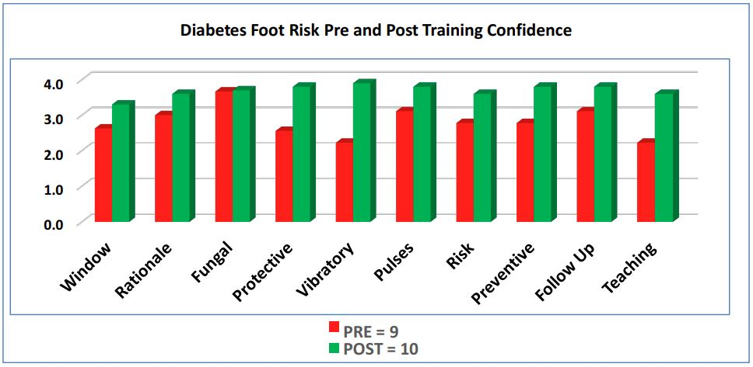

Figure 4: Likert Scale for Confidence (Pre-N = 9, Post-N = 10*).

(Figure 4) shows the average confidence ratings in the pre- and post-test periods. Higher means indicate greater confidence. Overall confidence was increased in the ability to perform all of the skills noted in (Figure 4).

In the pre-test, confidence scores were lower overall than in the post-test, especially in assessing protective and vibratory sensation and pulses. Confidence increased post-training in all areas, with a single exception for assessment and treatment of fungal infections, which was high pre-test, and therefore showed minimal increase. Confidence in patient teaching increased markedly from pre- to post-test. Again, it is noted that one participant missed the pre-test but was present for the entire class, therefore the participant’s post-test results were included.

Chart reviews

The data from the chart reviews initially separated out each of the elements of the foot exam to allow for analysis of which exam elements were least performed as shown in Table A baseline chart review of documentation in July, 2018 of each individual element of the foot screening in patient visits from April to June, 2018 (N= 44) showed a steady decline in documentation of all screening elements (Table 2).

Element | 18-Apr | 18-May | 18-Jun | 18-Aug
Skin | 100% | 75% | 44% | 88%
Nails | 100% | 75% | 44% | 88%
Pulses | 83% | 75% | 44% | 66%
Monofilament | 88% | 75% | 55% | 88%
Risk | 72% | 50% | 22% | 66%
Patient Education | 66% | 60% | 22% | 77%

Table 2: Variables documented from chart review at baseline and month of intervention.

It is clear that documentation of all elements steadily declined from the initial inception of the diabetes clinic in April, 2018 over the following four months, with patient education and risk assessment declining the most. Note there is no data point on the graph for July, 2018, as no diabetes clinic was held at that time, due to a visiting team of consultants using the clinic space allocated. Data were again collected at the end of August as an interim check on progress. An initial rise is seen when the DNP student was present and the interventions were taking place.

During August, 2018, the DNP student implemented the Quality Improvement (QI) project. The objective was set for at least 25% of visits to the diabetes clinic to include a complete foot screening, defined as documentation of at least four of five elements of the screening, and patient education based on the IDF guidelines.

In order to directly compare pre- and post-intervention data, baseline data were converted into the new variable labeled “complete screening” over the entire time period. If at least four elements were documented, this was defined as a “complete screening,” and a “yes” was entered into an excel spreadsheet. Documentation of patient education was tracked separately as “yes” if present or “no” if absent. For the post-intervention chart review of documentation, according to the same definition, if at least four elements were documented, a “yes” was entered into an excel spreadsheet by the team leader; otherwise a “no” was entered. Documentation of patient education was tracked separately, entered as “yes” if present or “no” if absent. Run charts tracked the documentation as percentages pre-intervention April to July for comparison to post- intervention data from September to December, 2018 as shown in (Figure 5). Also shown was one month of data collected in August as an interim check. Note there is no data point in October, as no clinic was held that month due to space utilization.

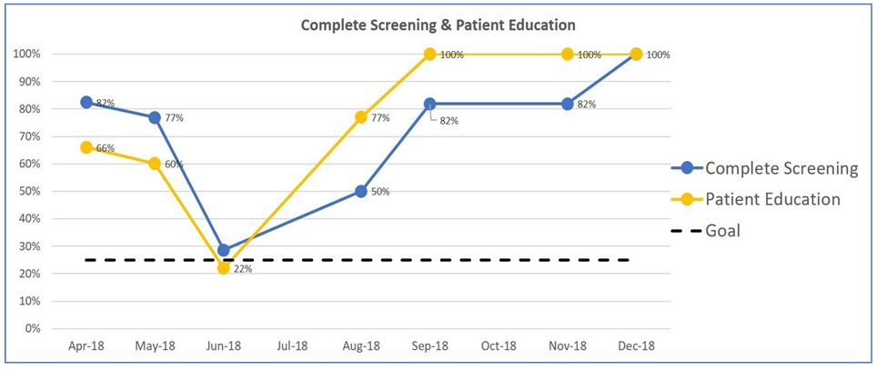

Figure 5: Combined Elements of Foot Exam Pre- and Post-Intervention Period.

Aggregate chart documentation data were then analyzed regarding differences in the pre- and post-educational intervention periods regarding documentation of complete foot screenings and patient education. Using chi-square demonstrated that change in documentation from pre- and post-interventions was statistically significant. Documentation of complete screening (p <.01) and patient education (p < .001) both increased for the interval of September to December; post-intervention results showed that patient education was documented at 100% of visits, and complete screenings were documented at 94% of visits, as shown in (Figure 6).

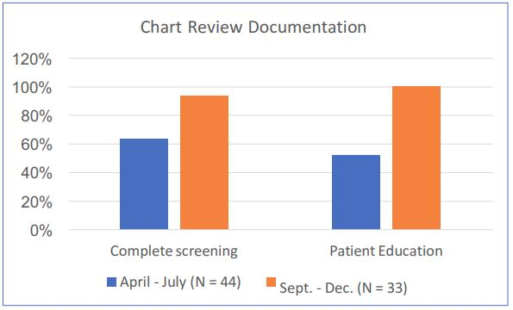

Figure 6: Bar Graph of Aggregate Pre- and Post-Data Documentation. *complete screening: chi-square p < .01, ** pt ed: chi-square p <.001.

Discussion

The objective of this QI project was achieved, as more than 25% of visits were shown to have complete foot screening exams and patient education documented at four months post interventions. Overall, the interventions during the month of August showed a positive improvement in the documentation of complete diabetes foot screening and patient education, which was potentially influenced by the active interventions taking place at the time. However, this difference persisted over the four months following the interventions, and was statistically significant. These findings align with previous work that shows nurses can adhere to standardized guidelines [13]. These findings also supported that educational and coaching interventions increased the percentage of patients who received foot exams, as shown in previous work by Szpunar and colleagues [19].

The findings of this project showed that the context-appropriate preventive guidelines can be effectively implemented in nurse-led clinics. Classroom teaching and in-clinic coaching using Knowles’ principles of adult education were directly applicable to this process, to enhance staff engagement. Specific international guidelines appropriate to low-resource settings released by the IDF were feasible in guiding the clinic protocol for assessment and education in people with diabetes. The IDF committee stressed in its findings that properly implemented foot care guidelines would be a cost-effective investment [26].

Significant improvement in documentation and patient education was found in diabetes foot risk assessment screening with staff at this diabetes clinic in Tanzania. Foot ulcers secondary to diabetes have been found to be associated with increased morbidity and mortality [8]. Consistent foot assessments to identify risk factors predictive of foot ulcers, along with educating patients on self-care, could reduce the likelihood of complications and the incidence of amputations [8,19,20]. It was noted that application of PDSA cycles were very effective in supporting the results.

The steps in the PDSA cycles were helpful in identifying the need for a QI project, as well as in guiding what steps to follow throughout the project, outlined as follows.

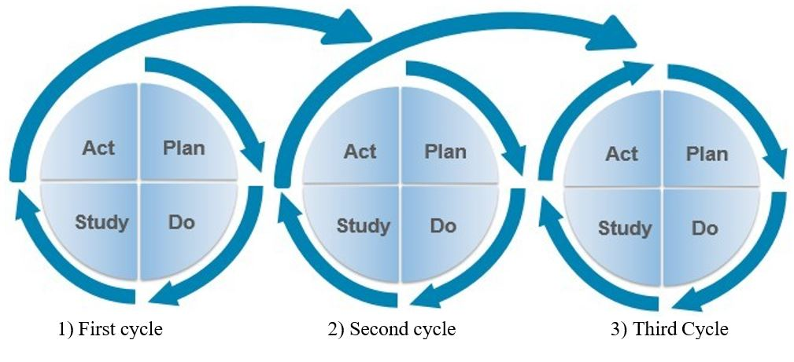

Application of the repeated PDSA cycle is summarized as follows:

P: Clinic established; D: Documentation started; S: Baseline data reviewed; A: Noted low #s
P: Determined education needs; D: Taught Class, coached; S: Checked data; A: Improved #s
P: Set goal for change; D: Collected data; S: Noted sustained change; A: Reviewed goal

Improvement was shown during and following the period of interventions and continued through completion of this project in December, 2018. Use of run charts was a clear way to monitor progress. The next step would be to continue to monitor for sustained improvement, and to consider raising the goal. PDSA, an iterative and cyclical process, was very effective throughout this project. Coaching was an inherent part of on-site review process. The combination of formal training, in-clinic observation and coaching, and PDSA cycles demonstrated appropriate use of the IDF guidelines for foot screening and patient education.

Limitations

Even though confidence was shown to improve in all participants in the class, the specific impact of the class was difficult to assess, since not all those in the class were on the diabetes team, and only a subset of the diabetes team attended the class. In addition, not all requested demographic data were entered by class participants. Furthermore, the pre- and post- confidence ratings were unable to be compared one-to-one, due to an unsuccessful method planned for matching pre-and post-test results. Since the DNP student was not in Tanzania from September to December,2018, follow-up chart reviews for collection of documentation data were delegated to a second individual. Lack of electronic records required data collection by hand using a paper format. All of these factors imposed challenges in interpretation of the data.

Significance and Implications

Challenges of instituting diabetic foot screening and preventive guidelines are inherent in resource-limited settings such as the rural clinic in this study. In a 2007 global review of diabetes, the IDF described diabetes as the global epidemic of the 21st century, and noted that the increasing incidence of diabetes along with its complications would stress available resources and especially required the implementation of preventive measures [26]. For 2019, the WHO has declared diabetes second on the list of global threats to health [27,28]. The indigent population, the high demands of acute care, financial constraints, and the nomadic nature of a proportion of the patients stress available medical providers to meet the overwhelming acute needs of those they serve.

However, studies have shown the value of instituting preventive guidelines to reduce complications that would further stretch limited resources, and that nurses can effectively implement evidence-based guidelines.

Recommendations include increased training of the approximately 20 million nurses worldwide who can successfully address the gap in available medical healthcare providers in resource-limited settings [1]. Such efforts can optimize all the resources available, especially when targeting management of chronic conditions which are becoming more prevalent in resource-limited regions of the world. Furthermore, preventive guidelines are cost-effective in reduction of complications related to these chronic conditions. Public health policies and funding initiatives to support nurse training can improve access to care that can enhance the overall health of these vulnerable populations.

Conclusions

Several factors facilitated this global health project on diabetic foot care. It was evident that stakeholder engagement was critical at all stages of the project, and learning was supported by use of Knowles’ theoretical principles. The DNP student’s acceptance as part of the team, while working alongside the staff teaching, observing, and coaching, further elicited their engagement with the QI project. The PDSA cycle was directly relevant in that it utilized feedback from the team, which positively impacted the practice of the local staff. Use of relevant evidence- based, international guidelines appropriate to the global health context of the project was essential. It was clear that the stakeholders’ investment in the project promoted effectiveness in realizing the objective, exceeding the benchmark, and sustaining the improvements achieved.

Acknowledgment

Thanks to Boucher Jean and Strowman, Shelley for mentoring me during the project.

References

- World Health Organization (2017) World Health Statistics 2017: Monitoring health for the SDGs.
- Pastakia SD, Pekny CR, Manyara SM, et al. (2017) Diabetes in sub-Saharan Africa - from policy to practice to progress: targeting the existing gaps for future care for diabetes. Diabetes, Metabolic Syndrome and Obesity 10: 247-263.
- International Diabetes Federation Atlas (8th Edition).
- Epe C, Edwards R, Artress J, Eds (2017) FAME Annual Report.
- Peck R, Mghamba J, Vanobberghen F, et al. (2014) Preparedness of Tanzanian health facilities for outpatient primary care of hypertension and diabetes: a cross-sectional survey. Lancet Global Health 2: e285- 292.
- Stanifer JW, Cleland CR, Makuka GJ, et al. (2016) Prevalence, Risk Factors, and Complications of Diabetes in the Kilimanjaro Region: A Population-Based Study from Tanzania. PloS One 11: e0164428.
- Chiwanga FS, Njelekela MA (2015) Diabetic foot: prevalence, knowledge, and foot self- care practices among diabetic patients in Dar es Salaam, Tanzania - a cross- sectional study.Journal of Foot Ankle Research 8: 20.
- Miller JD, Carter E, Shih J, et al. (2014) How to do a 3-minute diabetic foot exam. Journal of Family Practice 63: 646-656.
- Kindarara DM, McEwen MM, Crist JD, Loescher LJ (2017) Health-Illness Transition Experiences with Type 2 Diabetes Self-management of Sub-Saharan African Immigrants in the United States. Diabetes Educator 43: 506-518.
- Miller RS (2017) An Innovative Approach to Using the AADE7 and Group Medical Visits. AADE in Practice 5: 28-32.
- Nam S, Janson SL, Stotts NA, et al. (2012) Effect of culturally tailored diabetes education in ethnic minorities with type 2 diabetes: a meta-analysis. Journal of Cardiovascular Nursing, 27: 505-518.
- Muchira JM, Stuart-Shor EM (2016) Using Noninvasive Tools to Screen for Prediabetes and Undiagnosed Diabetes: Value Added to Cardiovascular Disease Prevention. Journal of Cardiovascular Nursing 31: 488-491.
- Some D, Edwards JK, Reid T, et al. (2016) Task Shifting the Management of Non-Communicable Diseases to Nurses in Kibera, Kenya: Does It Work? PloS One 11: e0145634.
- Agyeman-Duah JN, Theurer A, Munthali C, et al. (2014) Understanding the barriers to setting up a healthcare quality improvement process in resource-limited settings: a situational analysis at the Medical Department of Kamuzu Central Hospital in Lilongwe, Malawi. BMC Health Services Research 14: 1.
- Durand AM (2010) Quality improvement and the hierarchy of needs in low resource settings: perspective of a district health officer. International Journal for Quality in Health Care 22: 70 72.
- Nyamhanga T, Fruemnce G, Mwangu M, et al. (2013) Achievements and challenges of resource allocation for health in a decentralized system in Tanzania: perspectives of national and district level officers. East Africa Journal of Public Health 10: 416- 427.
- Ha Dinh TT, Bonner A, Clark R, et al. (2016) The effectiveness of the teach-back method on adherence and self-management in health education for people with chronic disease: a systematic review. JBI Database System Rev Implement Rep 14: 210-247.
- Boyko EJ, Seelig AD, Ahroni JH (2018) Limb- and Person-Level Risk Factors for Lower-Limb Amputation in the Prospective Seattle Diabetic Foot Study.Diabetes Care 41: 891-898.
- Szpunar SM, Minnick SE, Dako I, et al. (2014) Improving Foot Examinations in Patients with Diabetes: A Performance Improvement Continuing Medical Education (PI-CME) Project. Diabetes Educator 40: 281-289.
- Ibrahim A (2017) IDF Clinical Practice Recommendation on the Diabetic Foot: A guide for healthcare professionals. Diabetes Research and Clinical Practice 127: 285-287.
- Chin YF, Liang J, Wang WS, et al. (2014) The role of foot self- care behavior on developing foot ulcers in diabetic patients with peripheral neuropathy: a prospective study. International Journal of Nursing Studies 51: 1568-1574.
- Abbas, ZG, Lutale J, Bakker K, et al. (2011) The ‘Step by Step’Diabetic Foot Project in Tanzania: a model for improving patient outcomes in less- developed countries. International Wound Journal 8: 169- 175.
- Rwegerera Godfrey (2014) Diabetic foot complications among patients with Type 2 diabetes mellitus at Muhimbili National Hospital, Dar es Salaam, Tanzania. Conference paper. Pan-African Diabetic Foot Study Group, At Dar-es-Salaam, Tanzania.
- Knowles MS, Holton EF, Swanson RA (2015) The Adult Learner (8th edition). London and New York: Routledge.
- Plan-Do-Study-Act (PDSA) Worksheet (2017) Institute for Healthcare Improvement.
- Apelqvist J, Bakker K, van Houtum WH, et al. (2008) The development of global consensus guidelines on the management of the diabetic foot.Diabetes/Metabolism Research and Reviews, 24: 116-118.
- World Health Organization (2019) Ten Threats to Global Heath in 2019.
- Bakker K, Apelqvist J, Lipsky BA, et al. (2016) The 2015 IWGDF guidance on the prevention and management of foot problems in diabetes. International Wound Journal 13: 1072.

