Case Report

Endoscopic Ultrasound-Guided Gastrojejunostomy Stent Placement - A Novel Technique to Manage Afferent Loop Syndrome

Seetha Lakshmanan MD#, Nabil Toubia MD, Vincent Armenio MD, Abdul Saied Calvino MD MPH

Roger Williams Medical Center, Rhode Island, USA

#Corresponding author: Seetha Lakshmanan MD, Department of Internal Medicine, Roger Williams Medical Center, 825 Chalkstone Avenue, Providence, Rhode Island 02908, USA

How to cite this article: Lakshmanan S, Toubia N, Armenio V, Calvino AS (2021) Endoscopic Ultrasound-Guided Gastrojejunostomy Stent Placement - A Novel Technique to Manage Afferent Loop Syndrome. Colu J Cas Repo 01(01): 2021-04.

Submission Date: 15 June, 2021; Accepted Date: 26 June, 2021; Published Online: 30 June, 2021

Abstract

Introduction: Afferent Loop Syndrome (ALS) is a complication caused by obstruction of the biliopancreatic limb after gastrointestinal reconstruction. Re-operation is preferred in surgically fit patients, but higher-risk patients have limited surgical options.
Case presentation: A 60-year-old man presented to us after he developed ALS secondary to duodenal cancer recurrence after a Whipple procedure. He was treated successfully with the novel endoscopic ultrasound-guided gastrojejunostomy stent placement with significant relief in his symptoms.
Discussion: ALS post-Whipple procedure has been reported in 13% of patients, especially those who survive >3 years following surgery. In these cases, palliative approaches remain the mainstay of treatment. Novel endoscopic procedures, like the one presented here, have encouraging success rates with lower complications compared to other reported procedures.

Keywords: Afferent loop syndrome; Axios stent; Duodenal cancer

Introduction

Afferent loop is the duodenojejunal loop proximal to gastrojejunal anastomosis that carries biliopancreatic contents. Afferent Loop Syndrome (ALS) occurs when an intrinsic or extrinsic obstruction causes partial or complete blockage of the afferent loop. Increased intraluminal pressure in ALS causes severe abdominal pain, nausea, vomiting, and occasionally, bowel ischemia [1]. Surgical reconstruction is the preferred treatment, but in high-risk surgical patients, endoscopic placement of an enteral stent is an alternative [2,3]. Endoscopic Ultrasound-Guided Gastro Jejunostomy Stent Placement (EUS-GJ) is a novel technique that allows endosonographic localization of the jejunum from inside the stomach and placement of a lumen-opposing stent across the newly created fistulous tract [3,4].

Case Presentation

A 60-year-old man initially presented with a respectable duodenal adenocarcinoma with pancreatic invasion. He underwent a Whipple procedure complicated by a pancreatic anastomotic leak that improved with non-surgical management. The patient later developed pulmonary embolism and was started on oral anticoagulation with IVC filter placement. Adjuvant chemotherapy with FOLFOX was started after, but discontinued due to severe abdominal pain, persistent nausea, anorexia and upper gastrointestinal bleeding. Computerized Tomography (CT) Abdomen revealed multiple hypodense hepatic lesions concerning for metastasis, a solid mass in the pancreatic bed suspicious for local recurrence and evidence of a distended afferent loop proximal to the area of local recurrence, with decompressed bowel distally (Figure 1A). Subsequent CT-guided biopsy of the liver lesions revealed metastatic adenocarcinoma of duodenal origin. After a multidisciplinary discussion, we decided to first try decompression by endoscopic or percutaneous approaches to avoid surgical morbidity due to his advanced malignancy. Our goal was to palliate his symptoms and allow him to restart systemic chemotherapy. The first attempt to place an intraluminal stent endoscopically failed because the afferent limb was significantly looped, preventing us from reaching the area of obstruction. The alternative was to use EUS-GJ from the stomach to the obstructed afferent loop. Although this technique has not been well-studied in these situations, it seemed viable as our patient’s afferent loop was dilated and fluid-filled. Moreover, the distance between the stomach and loop seemed appropriate on CT imaging (Figure 1B).

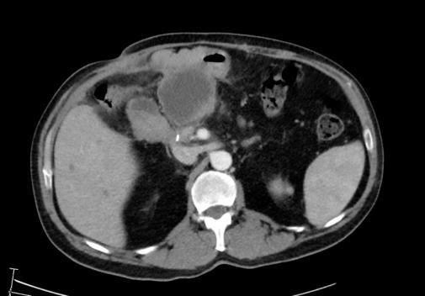

Figure 1A: Thick arrow: area of recurrence and obstruction. Thin arrow: distended afferent loop.

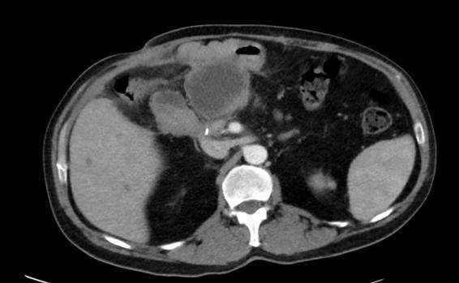

Figure 1B: Thin arrow: fundus of the stomach. Thick arrow: distended afferent loop.

The gastroenterology team, with surgical backup, performed an esophagogastroduodenoscopy and a therapeutic linear echoendoscope was used to identify the dilated afferent loop. The distance between the stomach wall and bowel loop was 5.4mm, ideal for gastrojejunostomy stent placement. Thus, a fistula was created and a 20mmx1cm lumen-apposing stent (Axios stent; Boston Scientific, Natick, MA, USA) was deployed in the usual fashion, opposing the afferent loop to the distal gastric body wall (Figure 2A,2C). After creating the fistulous tract and deploying the stent, a large amount of bile was seen gushing through the stent. The stent was cannulated using a 5.5cm CRE 15mm balloon, with dilation performed at 15mm and held for 1 minute (Figure 2B). Within 24 hours post-procedure, the patient’s symptoms had improved significantly. He was allowed a clear liquid diet, which he tolerated well. A follow-up CT Abdomen demonstrated decompression of the obstructed loop with a stent in place without evidence of intra-abdominal complications (Figure 3). He was discharged three days later and the stent was left in place for 8 weeks to allow therapeutic fistula formation before removal.

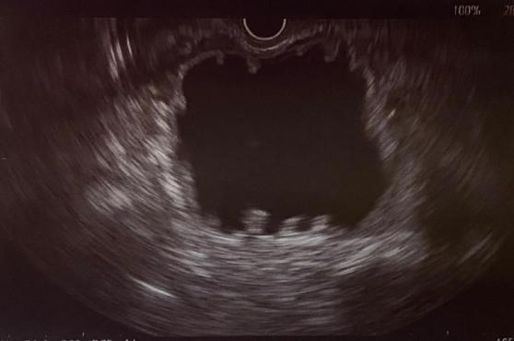

Figure 2A: Endoscopic-ultrasound view of the distended afferent loop from the stomach.

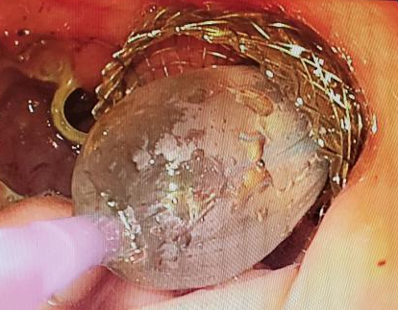

Figure 2B: Balloon dilation of the Axios gastrojejunostomy stent.

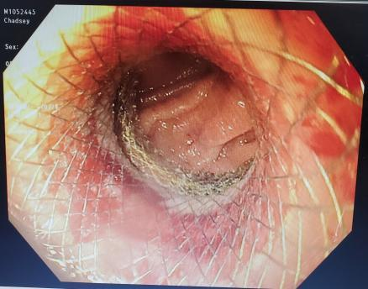

Figure 2C: Intraluminal picture of the Axios gastrojejunostomy stent after balloon dilation. Arrow: jejunal mucosa.

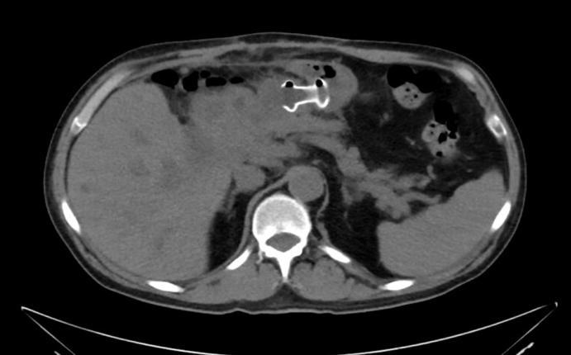

Figure 3: CT scan image of the Axios stent in place between the gastric fundus and the decompressed afferent jejunal loop.

Discussion

EUS-GJ is a novel fully-endoscopic procedure that allows us to create a functional anastomosis decreasing the risks of surgical intervention. Axios stent use for ALS was first described by Shah et al. [5] and has since been adopted by others [2,5,6]. Success rates using this technique ranges from 90%-100% [7,8]. However, complications have been reported in up to 40% [9], highlighting the importance of a multidisciplinary approach with surgical backup. The use of endoscopic ultrasound to localize the target bowel, cautery for fistula tract creation, and the self-expanding stent are novel features that improve its safety and success rates. However, examination of large series is needed to better understand its risks and potential complications.

Localization of the target bowel or jejunum can be challenging but in ALS, target identification is usually straightforward because the loop tends to be fluid-filled and distended. If the target loop is not distended, intraluminal assisted methods such as dedicated balloon catheters inflated with saline or contrast, nasobiliary drain catheters, or jejunal distention using a 22-gauge needle for saline injection could be used [3]. Nevertheless, these methods may increase risk of complications and their success depends greatly on user experience. Another potential problem

after target localization is misplacement of the lumen-apposing stent. Tyberg, et al. [2] reported a 27% rate of misplacement, the only reason for technical failure overall [3]. When the target is a fixed organ like in pancreatic pseudocyst cases, misplacement seems to be lower than when dealing with mobile targets such as small bowel.

ALS secondary to malignancy or local recurrence after a Whipple procedure, like in our case, has been reported in 13% of patients, especially those who survive three years or longer following surgery [10-12]. In cases of ALS secondary to unresectable malignancy, palliative approaches remain the mainstay of treatment. There are different methods to deal with ALS in these cases. Pannala et, al. [10] reported 24 patients with ALS in pancreatic cancer, 63% underwent endoscopic inventions including 3 balloon dilations, 8 double-pigtail stents traversing the afferent limb stricture, 1 balloon dilation and double-pigtail stent placement, 1 afferent limb metal stent placement, and 2 biliary stent placements [10]. Those who did not receive endoscopic interventions underwent percutaneous transhepatic biliary drainage or a rendezvous procedure for afferent limb strictures at multiple sites, while those with obstructive jaundice or cholangitis underwent percutaneous biliary and luminal drainage by catheter placement in the proximal afferent limb [10]. Novel endoscopic procedures, like the one presented here, have encouraging success rates with lower complications than previously mentioned procedures.

In our patient, multidisciplinary collaboration helped us identify innovative potential endoscopic solutions that allowed us to avoid more morbid surgical interventions. A team experienced in this advanced technique in collaboration with a surgical team is crucial to identifying patients who could potentially benefit from this procedure [13,14].

Financial Disclosure / Conflicts of Interest

None to report.

Informed Consent

Informed consent was obtained from the patient for publication.

Prior Presentation

None.

References

- Blouhos K, Boulas KA, Tsalis K, et al. (2015) Management of afferent loop obstruction: Reoperation or endoscopic and percutaneous interventions?. World J Gastrointest Surg 7: 190-195.
- Davis JL, Ripley RT (2017) Postgastrectomy Syndromes and Nutritional Considerations Following Gastric Surgery. Surg Clin North Am. A 97: 277-293.
- Tyberg A, Perez-Miranda M, Sanchez-Ocaña R, et al. (2017) Endoscopic ultrasound-guided gastrojejunostomy with a lumen-apposing metal stent: a multicenter, international experience. Endosc Int Open 4: E276-E281.
- Dawod E, Nieto JM (2018) Endoscopic ultrasound guided gastrojejunostomy. Transl Gastroenterol Hepatol 21: 93.
- Shah A, Khanna L, Sethi A (2015) Treatment of afferent limb syndrome: novel approach with endoscopic ultrasound-guided creation of a gastrojejunostomy fistula and placement of lumen-apposing stent. Endoscopy 47.
- Yamamoto K, Tsuchiya T, Tanaka R, et al. (2017) Afferent loop syndrome treated by endoscopic ultrasound-guided gastrojejunostomy, using a lumen-apposing metal stent with an electrocautery- enhanced delivery system. Endoscopy 49: E270-E272.
- Khashab M, Alawad A S, Shin E J, et al. (2013) Enteral stenting versus gastrojejunostomy for palliation of malignant gastric outlet obstruction. Surge Endosc 27: 2068-207.
- Phillips M S, Gosain S, Bonatti H. et al. (2018) Enteral stents for malignancy: a report of 46 consecutive cases over 10 years, with critical review of complications. J Gastrointest Surg 12: 2045-2050.
- Medina-Franco H, Abarca-Pérez L, España-Gómez N. et al. (2017) Morbidity-associated factors after gastrojejunostomy for malignant gastric outlet obstruction. Am Surg 73: 871-875.
- Pannala R, Brandabur JJ, Gan SI, et al. (2011) Afferent limb syndrome and delayed GI problems after pancreaticoduodenectomy for pancreatic cancer: single-center, 14-year experience. Gastrointest Endosc 74: 295-302.
- Bushkin FL, Woodward ER (1976) The afferent loop syndrome. Major Probl Clin Surg 20: 34-48.
- Sakai, Arata, Shiomi, et al. (2020) Endoscopic Self-Expandable Metal Stent Placement for Malignant Afferent Loop Obstruction after Pancreaticoduodenectomy: A Case Series and Review. Clinical Endoscopy.
- Binmoeller KF, Shah J (2011) A novel lumen-apposing stent for transluminal drainage of nonadherent extraintestinal fluid collections. Endoscopy 43: 337-342.
- Kida A, Kido H, Matsuo T, et al. (2020) Usefulness of endoscopic metal stent placement for malignant afferent loop obstruction. Surg Endosc 34: 2103-2112.

