Case Report

Irreversible Electroporation of a Metastatic Pancreatic Neuroendocrine Tumor: A Case Study

Jacob Butman¹, James R. Ouellette², Julie A. Brockman^{1#}

^{1#}Wright State University, Ohio, USA
²Ohio State University, Ohio, USA

#Corresponding author: James R. Ouellette, DO, Associate Professor, Department of Surgery, Wright State University, Premier Surgical Oncology 2300 Mimi Valley Dr, Suite 350, Dayton, OH 45458 USA

How to cite this article: Butman J, et al. (2022) Irreversible Electroporation of a Metastatic Pancreatic Neuroendocrine Tumor: A Case Study. Int J Surg and Repo 02(01): 2022-18.

Submission Date: 08 August, 2022; Accepted Date: 18 August, 2022; Published Online: 23 August, 2022

Abstract

Background: Current standard treatment for metastatic Pancreatic Neuroendocrine Tumors (PNETs) is definitive resection of primary and metastatic lesions if possible. There are limited reports, if any, regarding the use of Irreversible Electroporation (IRE) to treat metastatic PNETs. This is a report of using surgery and IRE as an alternative therapy to treat a PNET of the pancreatic head with lymph node and liver metastasis.
Case Report: A 50-year-old male initially presented with diarrhea and gastrointestinal upset for two months. After laboratory studies, esophagogastroduodenoscopy, and biopsy, he was diagnosed with probable gastrinoma with lymph node involvement and metastasis to the liver. He was initially recommended to undergo right liver lobectomy and pancreaticoduodenectomy as standard therapy for PNETs with liver metastasis. After seeking several opinions due to his opposition to pancreaticoduodenectomy, an alternative treatment course including right liver lobectomy, lymph node resection, and irreversible electroporation of the intraparenchymal pancreatic head mass was performed. He was monitored for complications and tumor recurrence in the 6-month postoperative period. At 6-months there was no evidence of recurrence on scans.
Conclusions: PNETs of the pancreatic head are rare tumors that are traditionally treated with pancreaticoduodenectomy, even when metastasized. IRE has previously been studied for pancreatic adenocarcinoma, but there is limited research available about its use for PNETs. This case suggests that IRE may be an effective alternative treatment option compared to radical surgery. Further long-term studies are warranted to determine efficacy of IRE use for primary and metastatic PNETs.

Keywords: Cancer ablation; Irreversible electroporation; Liver metastasis; Pancreatic neuroendocrine tumor; Surgical resection

Abbreviations

PNET : Pancreatic neuroendocrine tumor
IRE : Irreversible electroporation
LAPC : Locally advanced pancreatic carcinoma
MWA : Microwave ablation
RFA : Radiofrequency ablation
CT : Computed tomography
MRI : Magnetic resonance imaging
PET : Positron emission tomography

Background

Pancreatic neuroendocrine tumors (PNETs) are rare, making up less than 2% of all pancreatic cancers with an incidence of 0.48 per 100,000 persons [1-3]. PNETs are a group of tumors that develop due to uncontrolled proliferation of neuroendocrine cells in the pancreas and can be classified as either functioning or non-functioning. Functioning PNETs are named after the hormone they make, and cause symptoms related to hormone hypersecretion [4]. Examples of functioning PNETs include insulinoma, glucagonoma, gastrinoma, and VIPoma among others [4]. Non-functioning PNETs do not make enough hormones to cause symptoms which can allow them to grow large and metastasize undetected over time [3,4]. Compared to the more common pancreatic adenocarcinoma, which has a median survival time of 6-months, PNET prognosis is more favorable with a 4.1-year median survival time [5]. Patients with stage 1 PNETs have 5-year survival rates ranging from 90-100% whereas those with stage 4 disease have a 60% 5-year survival rate [6]. In cases of local, low-grade neoplasms, parenchymal sparing surgery including enucleation is sometimes considered [7]. For metastatic PNETs, the current surgical standard of care is pancreaticoduodenectomy [8].

As a less invasive alternative to radical surgery, ablative techniques have been rising in popularity over the last several years for treatment of pancreatic cancers. Thermal ablative therapies including Radio frequency Ablation (RFA) and Microwave Ablation (MWA) first became widespread for their use in local tumor ablation in the early 2000’s. These technologies rely on extreme hyperthermia to destroy tissue. While tissue destruction is effective, there is a risk of damaging surrounding vessels and structures with the high intensity heat generated [9,10]. In 2011, NanoKnife, a new type of non-thermal ablation device using Irreversible Electroporation (IRE), was approved by the FDA. IRE destroys tumors by generating electrical fields between probes placed around target soft tissue and delivering pulses that create permanent nanopores in cell membranes, thereby disrupting homeostasis [11]. Irreversible cellular swelling through the pores leads to apoptosis and cell death [11]. One major advantage of IRE is its ability to preserve critical surrounding structures in highly vascular areas [9]. Previously, IRE has been shown to be an effective ablation therapy for locally advanced pancreatic adenocarcinoma (LAPC) tumors [12]. Up to this point, IRE efficacy for treatment of PNETs has not been clearly determined. Though metastatic disease is frequently treated with ablative techniques (typically liver), the scenario is switched in this case by resecting the metastases but treating the primary with ablation. This is the first report of our knowledge of IRE as an alternative treatment in the setting of a metastatic PNET.

Case Presentation

This is a 50-year-old Caucasian male with no significant past medical history who presented to his primary care doctor in January 2021 with complaints of diarrhea and dyspepsia for two months. Laboratory results revealed transaminasemia and elevated alkaline phosphatase. Esophagogastroduodenoscopy showed ulcers in the gastroesophageal junction and the second and third part of the duodenum. Patient was started on omeprazole, famotidine, and sucralfate which improved his symptoms. Further laboratory workup showed an elevated gastrin level of 743 pg/mL and chromogranin A of 1874 ng/mL.

He underwent abdominal Computed Tomography (CT) in June 2021 which showed a 6.5 cm hypervascular lesion in the right liver lobe along with pancreatic ductal dilation. Biopsy of the liver lesion revealed a well-differentiated grade 2 neuroendocrine tumor with a Ki-67 of 4.9%. Gallium-68 dotatate PET/CT scan redemonstrated the liver lesion along with a pancreatic head mass and peripancreatic lymph node enlargement (Figures 1, 2). Biopsy of the peripancreatic lymph nodes further demonstrated a well differentiated grade 2 neuroendocrine tumor.

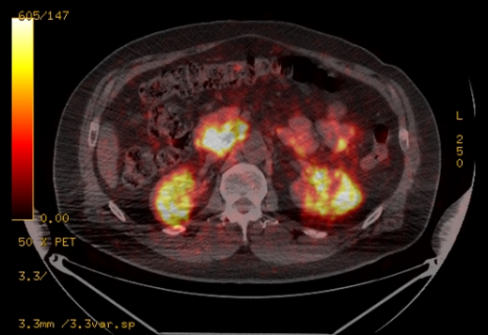

Figure 1: Uptake lesion demonstrated in the pancreas on Positron Emission Tomography (PET) scan (July 2021).

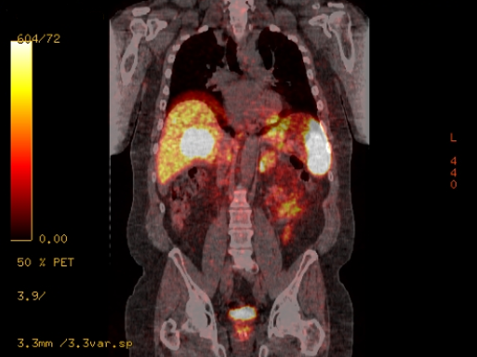

Figure 2: Liver lesion on PET scan (July 2021).

The patient obtained opinions from several surgical oncologists who recommended liver lobectomy and pancreaticoduodenectomy. Concerned with undergoing radical surgery due to being relatively asymptomatic and unwilling to experience the required lifestyle changes after the procedure, the patient wished to explore alternative treatment options. It was decided to proceed with right liver lobectomy and peripancreatic lymph node resection followed by irreversible electroporation of the pancreatic head mass using the IRE. The patient understood that he may ultimately still need a pancreaticoduodenectomy should the ablation fail or if the recurrence develops.

In late August 2021 prior to surgery the patient had a Magnetic Resonance Imaging (MRI) of the abdomen including Magnetic Resonance Cholangiopancreatography (MRCP) which showing a 3.2 cm pancreatic head mass with two enlarged peripancreatic lymph nodes, 6.1 cm mass in the right lobe of the liver, and diffuse main pancreatic ductal dilation measuring 0.7 cm (Figures 3, 4). He underwent Endoscopic Retrograde Cholangiopancreatography (ERCP) to place biliary and pancreatic duct stents to minimize risk of obstruction related to expected edema following IRE ablation. In mid-October 2021, laparoscopic converted to open right hepatic lobectomy, cholecystectomy, peripancreatic lymph node dissection, and ultrasound guided IRE was performed.

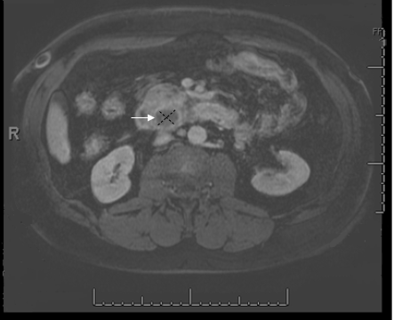

Figure 3: Primary pancreatic neuroendocrine tumor on MRI imaging (August 2021).

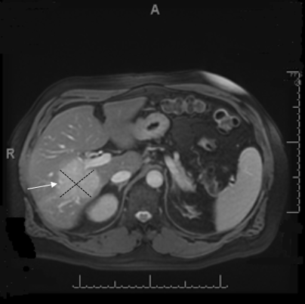

Figure 4: Metastatic liver lesion on MRI imaging (August 2021).

Postoperatively the patient developed perihepatic abscess that resolved with antibiotics and CT guided drain placement and was discharged home. Follow-up imaging showed eradication of all visible disease (Figures 5, 6). Patient will continue long-term follow up.

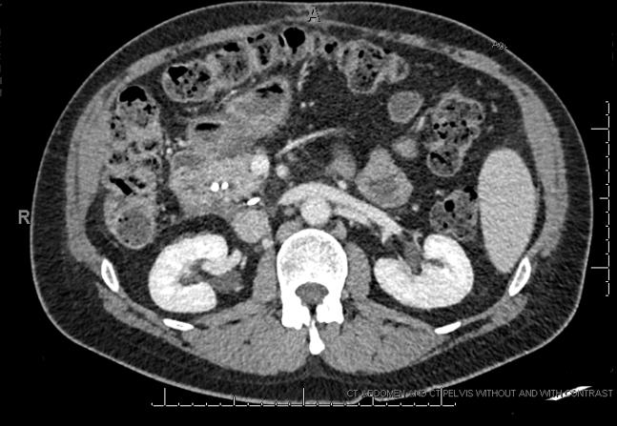

Figure 5: Postoperative pancreas CT imaging (January 2022).

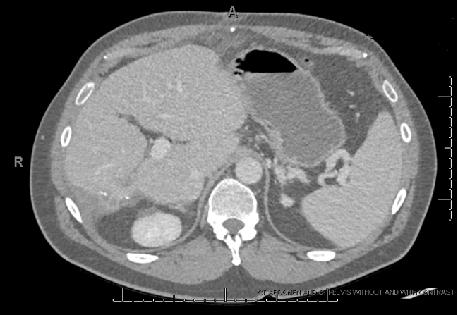

Figure 6: Postoperative liver CT imaging (January 2022).

Discussion

The IRE device works by creating permanent nanopores in the lipid bilayer of the cell membrane through delivery of high-voltage electrical pulsations produced between probes placed around tumor tissue [11]. Increased membrane permeability disrupts homeostasis leading to immediate cell death by apoptosis [11]. IRE is believed to be a safe and effective nonthermal ablative technique when compared to thermal ablation. Both MWA and RFA rely on the generation of thermal energy to induce cell death by means of coagulative necrosis [10]. These modalities can cause thermal injury to vessels, ducts, and other tissue surrounding the targeted tumor leading to scarring and fibrosis which inhibits the potential for cellular regeneration and return of function of the ablated area [9,10,13]. Alternatively, IRE causes focused cell apoptosis followed by phagocytosis, thus preserving the capability of neighboring cells to regenerate [9]. Thermal ablative therapies have also been found to be less effective when tumors are located adjacent to large vessels because of the heat sink effect, a phenomenon where blood flow has a cooling effect, limiting the success of complete ablation [14,15]. As a type of nonthermal ablation, IRE is not impacted by the heat sink effect and allows for sharp boundaries making it appealing among hepatobiliary surgeons who work frequently with tumors located in highly vascular areas such as the pancreas as seen in our patient [9,11].

Complications associated with IRE use for pancreatic tumors include pancreatitis, bleeding, and vascular injury related to probe placement, infection, and nearby structure injury [16]. IRE is contraindicated in patients with a history of cardiac arrhythmias because pulses need to be synchronized with R-waves on electrocardiogram to prevent the development of a ventricular arrhythmia [16].

PNETs are associated with familial genetic alterations including MEN1, VHL, NF-1, and TSC although the majority of tumors (90%) are sporadic [4]. Early diagnosis of PNETs is often incidental and tumors may remain inactive for long periods of time, but have the potential to metastasize, commonly to the liver, which is a cause of high mortality if left untreated [4]. In the case of our patient, a diagnosis of probable gastrinoma was made due to gastrin levels of 743, chromogranin of 1874, and multiple ulcers extending into the second and third parts of the duodenum.

Currently, surgical resection is widely recognized as the standard treatment for local and metastatic PNETs [8]. Local, low-grade tumors are considered for parenchyma sparing resection, whereas pancreaticoduodenectomy is recognized as necessary in metastatic disease, as observed in our patient with lesions located in the pancreas, liver, and regional lymph nodes [7,8]. Although the mortality rate associated with pancreaticoduodenectomy has significantly decreased in the last several decades, there is still a 35% morbidity rate [17,18]. In the short-term postoperative period, common morbidities include delayed gastric emptying, pancreatic fistula, and surgical site infection [19]. Endocrine and exocrine insufficiencies, with incidences of 36% and 20% respectively, are frequent long-term complications that can impact patient quality of life [20].

For our patient with a primary mass in the head of the pancreas, enlarged peripancreatic lymph nodes, and right liver lobe mass, pancreaticoduodenectomy was offered as first-line treatment. The patient had concerns about radical surgery, potential complications, and long-term side effects and wished to pursue alternative therapies. After discussion about the risks and benefits, it was decided to perform IRE on the pancreas lesion, peripancreatic and portal lymph node removal, and major hepatectomy. The patient was advised that if tumor regrowth occurred, pancreaticoduodenectomy would ultimately be required. At the 6-month scan in May 2022, the patient remained tumor free although frequent monitoring will continue.

Up to this point, there are very few reports of IRE as a surgical treatment for PNETs. A 2016 case report discusses three patients with small (<2 cm), low-grade PNETs who were treated with IRE, all of whom remained disease free after 12-month follow-up [21]. There were no reports found during literature review of IRE use for PNETs with regional lymphadenopathy or distant metastasis. Previous studies on IRE as a treatment for unresectable locally advanced pancreatic adenocarcinomas showed promising results [22]. PNETs are much less common than other pancreatic cancers and have the propensity to be slow growing, leading to more favorable outcomes and longer survival time [4]. Because of this, there is an opportunity to continue considering less radical surgical options such as IRE as a primary treatment modality in future cases.

Conclusion

IRE is a new nonthermal ablative technology that has shown promising potential for the treatment of pancreatic cancers, though its use has not yet been broadly studied for PNETs. Pancreaticoduodenectomy is currently the standard treatment for pancreatic head PNETs with resectable metastases, but the procedure has a high morbidity risk and potential long-term complication rate. This is the first report that we know of using IRE for treatment of a probable gastrinoma with metastasis to the liver. Conclusions are limited based on this single case report. Further studies are warranted to evaluate the efficacy of IRE as a primary surgical treatment for PNETs.

Declarations

Ethical Consent

Not applicable.

Funding

No funding.

Conflicts of Interest

The authors have no conflicts of interest to disclose.

Authors' contributions

All authors read and approved the final manuscript.

JB participated in patient’s care during his surgery clerkship and wrote the introduction, case presentation, discussion, and conclusion for the manuscript. JB also assisted with literature review.
JRO is the surgical oncologist who performed the procedure and provided guidance and suggested edits throughout the writing of the manuscript.
JAB performed the literature review and assisted in editing the manuscript.

Acknowledgements

Not applicable.

References

- Yao JC, Hassan M, Phan A, et al. (2008) One hundred years after “Carcinoid”: Epidemiology of and prognostic factors for neuroendocrine tumors in 35,825 cases in the United States. J Clin Oncol 26: 30633-3072.
- Dasari A, Shen C, Halperin D, et al. (2017) Trends in the incidence, prevalence, and survival outcomes in patients with neuroendocrine tumors in the United States. JAMA Oncol 3: 1335-1342.
- American Cancer Society. Pancreatic neuroendocrine tumor. Cancer.org.
- Ro C, Chai W, Yu VE, et al. (2013) Pancreatic neuroendocrine tumors: biology, diagnosis, and treatment. Chin J Cancer 32:312-324.
- Brooks JC, Shavelle RM, Vavra-Musser KN (2019) Life expectancy in pancreatic neuroendocrine cancer. Clin Res Hepatol Gastroenterol 43: 88-97.
- Clancy TE (2016) Surgical management of pancreatic neuroendocrine tumors. Hematol Oncol Clin North Am 30: 103‐118.
- Cherif R, Gaujoux S, Couvelard A, et al. (2012) Parenchyma-sparing resections for pancreatic neuroendocrine tumors. J Gastrointest Surg 16: 2045-2055.
- Jeune F, Taibi A, Gaujoux S (2020) Update on the Surgical Treatment of Pancreatic Neuroendocrine Tumors. Scand J Surg 109: 42-52.
- Kourounis G, Paul Tabet P, Moris D, et al. (2017) Irreversible electroporation (Nanoknife® treatment) in the field of hepatobiliary surgery: Current status and future perspectives. J BUON 22: 141-149.
- Ahmed M, Brace CL, Lee FT Jr, et al. (2011) Principles of and advances in percutaneous ablation. Radiology 258: 351-369.
- Jourabchi N, Beroukhim K, Tafti BA, et al. (2014) Irreversible electroporation (NanoKnife) in cancer treatment. Gastrointestinal Intervention 3: 8-18.
- Savic LJ, Chapiro J, Hamm B, et al. (2016) Irreversible electroporation in interventional oncology: Where we stand and where we go. Rofo 188: 735-745. doi:10.1055/s-0042-104203
- Girelli R, Frigerio I, Giardino A, et al. (2013) Results of 100 pancreatic radiofrequency ablations in the context of a multimodal strategy for stage III ductal adenocarcinoma. Langenbecks Arch Surg 398: 63-69.
- Pillai K, Akhter J, Chua TC, et al. (2015) Heat sink effect on tumor ablation characteristics as observed in monopolar radiofrequency, bipolar radiofrequency, and microwave, using ex vivo calf liver model. Medicine (Baltimore) 94: e580.
- Goldberg SN, Hahn PF, Tanabe KK, et al. (1998) Percutaneous radiofrequency tissue ablation: does perfusion-mediated tissue cooling limit coagulation necrosis? J Vasc Interv Radiol 9: 101-111.
- Narayanan G (2015) Irreversible Electroporation. Semin Intervent Radiol 32: 349-355.
- De Wilde RF, Besselink MGH, van der Tweel I, et al. (2012) Impact of nationwide centralization of pancreaticoduodenectomy on hospital mortality. Br J Surg 99: 404-410.
- Pastrana Del Valle J, Mahvi DA, Fairweather M, et al. (2021) The improvement in post-operative mortality following pancreaticoduodenectomy between 2006 and 2016 is associated with an improvement in the ability to rescue patients after major morbidity, not in the rate of major morbidity. HPB (Oxford) 23: 434-443.
- Mirrielees JA, Weber SM, Abbott DE, et al. (2020) Scarborough JE. Pancreatic fistula and delayed gastric emptying are the highest-impact complications after whipple. J Surg Res 250: 80-87.
- Kusakabe J, Anderson B, Liu J, et al. (2019) Long-term endocrine and exocrine insufficiency after pancreatectomy. J Gastrointest Surg 23: 1604-1613.
- Papamichail M, Ali A, Pizanias M, et al. (2016) Irreversible electroporation for the treatment of pancreatic neuroendocrine tumors. Korean J Hepatobiliary Pancreat Surg 20: 116-120.
- Martin RC 2nd, McFarland K, Ellis S, et al. (2013) Irreversible electroporation in locally advanced pancreatic cancer: potential improved overall survival. Ann Surg Oncol 20 Suppl 3: S443-S449.

