Research Article

Recording and Comparison of Mastectomy Specimen Dimensions

Kelvin Ampem-Darko, BA, Gabrielle Hernaizdejesus, BA, Devki Shukla, BA, C. Taylor J. Ibelli, BS MSc, Jordan M. Jacobs, MD, Peter W. Henderson, MD MBA FACS#

Division of Plastic Surgery, Department of Surgery, Icahn School of Medicine at Mount Sinai, New York, USA

#Corresponding author: Peter W Henderson, MD, MBA, FACS, Associate Professor, Division of Plastic and Reconstructive Surgery, Department of Surgery, Icahn School of Medicine at Mount Sinai, 10 Union Square East, Suite 2L New York, New York 10065, USA

How to cite this article: Ampem-Darko K, Hernaizdejesus G, Shukla D, et al. (2022) Recording and Comparison of Mastectomy Specimen Dimensions. Int J Surg and Repo 02(01): 2021-14.

Submission Date: 11 January, 2022; Accepted Date: 15 February, 2022; Published Online: 20 February, 2022

Abstract

Background: Breast reconstruction after total mastectomy has increased in recent years as surgical techniques continue improving. While the weight of the breast specimen is used to guide autologous reconstruction intraoperatively, other parameters such as the cranial-caudal (height), medial-lateral (width) and anterior-posterior (thickness) dimensions are given less priority. In fact, such mastectomy dimensions have never been reported in either breast surgery or plastic surgery literature. Therefore, the purpose of this study is to for the first time present data on mastectomy specimen dimensions, analyze patterns that are revealed, and use this information to make recommendations on autologous flap design and inset.
Methods: A retrospective review of all patients who underwent total mastectomy within Mount Sinai Health system between 2012 and 2018 was identified yielding 639 cases. Next, all cases were screened to verify the appropriate labeling of specimen dimensions in each pathology report, excluding cases that did not fit our criteria. The height, width, thickness, and weight of the mastectomy specimen were then recorded. Statistical tests were executed with Prism 8® for descriptive analyses. Mean values and a Pearson correlation matrix were calculated for the width, height, and thickness of the mastectomy specimens. Finally, a multiple linear regression analysis was calculated for each dimension, using the height as the predictive variable.
Results: From the screening of 639 cases, 100 breast pathology reports fit the inclusion criteria and thus were included in data collection. The mean values were: height = 16.43 cm, width = 16.86 cm, and thickness = 4.47 cm. The Pearson correlation matrix for Height vs. Width was r = 0.775, and Width vs. Thickness was r = 0.572. Multiple regression using the height as the predictive variable provided a coefficient of determination of R² = 0.578 with a p-value = 0.0001.
Conclusions: Results of analyses and strong correlations indicate that mastectomy specimen dimensions have the potential to better inform intraoperative reconstructive decision-making, particularly flap design and inset, as well as implant sizing. Ongoing studies are emphasizing more sophisticated static measurements, as well as dynamic measurements.

Keywords: Mastectomy; Microsurgery; Multivariate Analysis; Plastic; Reconstructive Surgery; Surgery; Surgical flap

Introduction

One of the classic tenets of plastic surgery is “To replace like with like.” When a woman has undergone a unilateral mastectomy, the goal is to achieve symmetry between the reconstructed breast and the contralateral, native breast. In such procedures, surgeons commonly use the weight of the mastectomy specimen as a guide when designing the size and shape of the flap. But, weight only tells part of the story, as two flaps of the same weight could result in very different reconstructed breast shapes. For instance, one could be narrow, tall, and thick, and the other could be wide, short, and thin. Therefore, knowing the dimensions of the excised breast tissue is potentially as important as the weight. Regrettably, the dimensions of the excised breast tissue are rarely taken into consideration. In fact, only one paper in the literature specifically references mastectomy specimen dimensions as a consideration in autologous breast reconstruction procedures [1], and neither this paper nor any other has ever presented quantitative information about mastectomy specimens.

Therefore, the purpose of this study is to present for the first time data on mastectomy specimen dimensions, analyze patterns that are revealed, and use this information to make recommendations on autologous flap design and inset.

Methods

After obtaining approval from the institutional review board at the Icahn School of Medicine at Mount Sinai, all mastectomy specimens from immediate reconstruction cases were analyzed by the Department of Pathology at Mount Sinai Beth Israel between 2012 and 2018 were queried. Tissue was transferred fresh and not placed in fixation fluid until after it had been measured and weighed. The current convention in the writing of pathology reports is that the largest dimension of the specimen is written first, followed by each additional dimension in descending order [2]. Whether the direction or orientation of each recorded dimension is at the discretion of the pathologist. Therefore, all cases were screened to determine whether the pathology report included details about the orientation of each reported measurement.

For each mastectomy specimen that had a report that included measurement orientations, three dimensions were recorded: cranial-caudal (“Specimen Height”), medial-lateral (“Specimen Width”), and anterior-posterior (“Specimen Thickness”) (Figure 1). In addition, specimen weight, patient demographics, patient height, patient weight, and patient Body-Mass Index (BMI) were recorded.

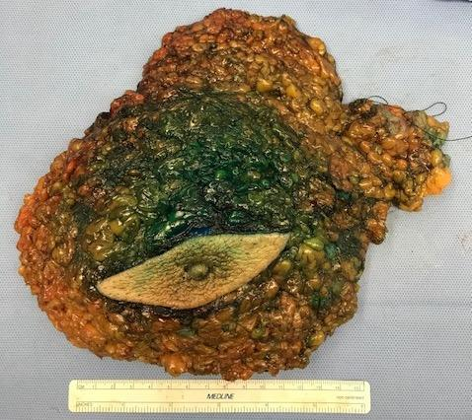

Figure 1: Sample mastectomy specimen.

The subsequent database was analyzed first by calculating the mean values for specimen height, specimen width, and specimen thickness. Next, a Pearson correlational analysis was calculated for each pair of variables. The purpose of the Pearson correlational analysis is to numerically quantify the strength of correlations by using a correlation coefficient, denoted by r. The possible values for r are from +1 (perfect positive correlation) to -1 (perfect negative correlation). A value of 0 indicates no correlation, a value of > 0.50 is considered to be a moderate correlation, and values of >0.70 are considered to indicate a statistically strong relationship [3]. A multiple regression analysis was calculated to statistically identify a predictive relationship, if any, between the specimen height, width, and thickness. This analysis assesses whether one dependent, unknown variable changes in response to another known variable, also called the predictor. The strength of each prediction is denoted by R² and reported in a correlation matrix, demonstrating the predictive value of each variable on others.

Results

For the period 2012 to 2018, the records for 639 mastectomy specimens were analyzed. One hundred of the specimens (16%) were found to have correctly oriented dimensions and thus were included in the database. The mean specimen height was 16.4 cm (range: 5.5 - 27.5cm), mean specimen width was 16.9 cm (range: 4.5 - 37.5cm), and mean specimen thickness was 4.5 cm (range: 1.2 - 11.1cm) (Table). The mean specimen weight was 1051g (range: 77.6 - 25300g).

Pearson correlational analysis provided specimen height and width correlation coefficient r = 0.77, specimen thickness and width correlation coefficient r = 0.57 and patient height and specimen height r = 0.21 (Figure 2). Multiple regression analysis resulted in R² = 0.578 (p-value = 0.0001) (Figure 3).

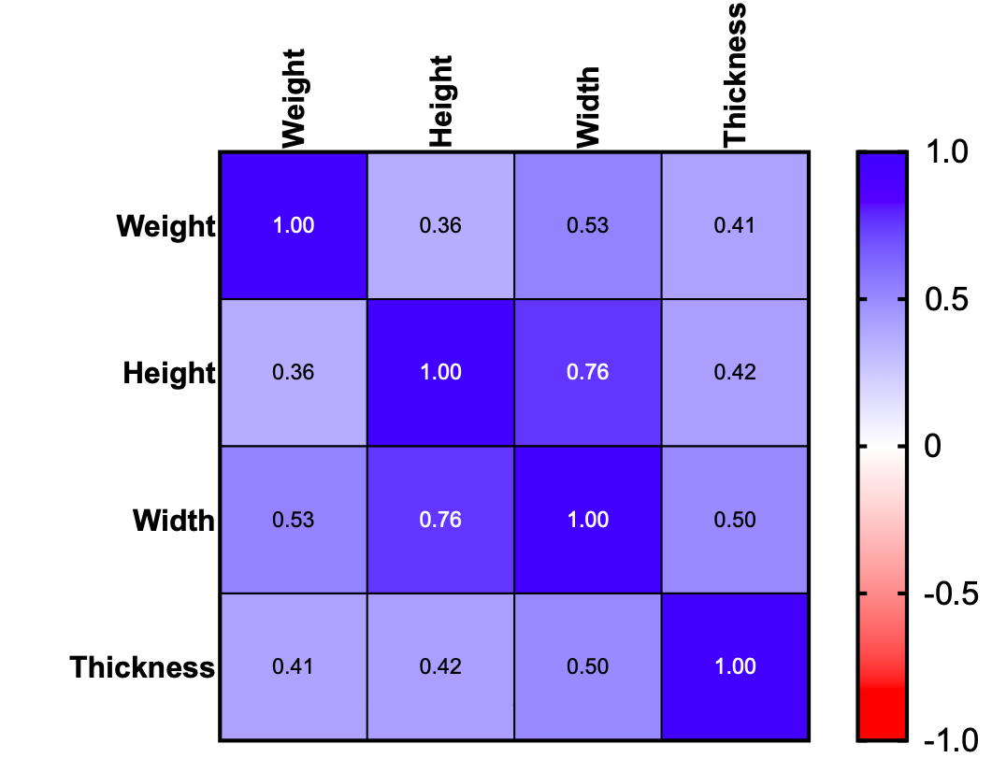

Figure 2: Correlation matrix of specimen height, width, and thickness.

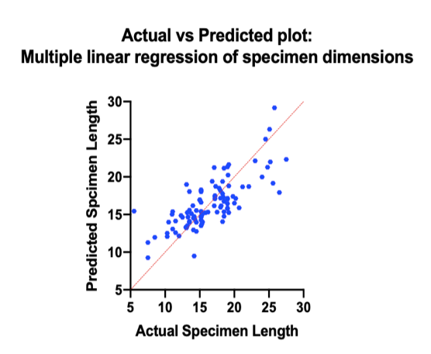

Figure 3: Multiple linear regression of specimen dimensions illustrating that specimen height was capable of predicting specimen width and thickness. R² is illustrated as a red line with a p-value = 0.0001.

Discussion

The data presented in this study provide, for the first time, objective information about the dimensions of mastectomy specimens. By developing a better understanding of the size and shape of the tissue that is removed during mastectomy, we believe that we can use that information to guide the design and inset of autologous tissue for breast reconstruction, and also, potentially impact implant-based reconstruction decision-making.

The most conclusive finding based on the data is that mastectomy specimens tend to be nearly as tall (mean 16.4cm) as they are wide (mean 16.9cm). Aside from these averages being within 0.5 cm of each other, the correlation matrix with an r = 0.77, which confirms a strong positive correlation. Of course, correlation does not imply causation, however, the multiple regression analysis with R² = 0.578 and a p-value = 0.0001 illustrates that if height were selected as an independent variable, the width and thickness of a given mastectomy specimen could be accurately predicted. Based on the data, it can be conclusively stated that the connection between specimen height and width is not simply one of correlation but of predictive value as well.

Mastectomy dimensions are easily measured, and we believe should become a standard element of intraoperative reconstructive planning during immediate breast reconstruction. This data can be used to influence autologous flap sizing, shaping and most significantly, inset angle. When performing deep inferior epigastric perforator flap flap breast reconstruction, lower abdominal tissue is generally wider than it is tall [4]. With the knowledge that the mastectomy specimen is nearly as tall as it is wide, the very commonly utilized 180 degree inset angle would thereby often lead to a flap that is wider than necessary, and not as tall as necessary. Thus, this study provides quantitative support for the choice of inset angle closer to 90 degrees, as this increases the likelihood that the flap matches the dimensions of what has been excised (namely, it is sufficiently tall, without being too narrow).

These findings have direct clinical implications for implant-based reconstruction, as well. Despite the mean width of mastectomy specimens being more than 16 cm, only the largest breast implants have a base width of 16cm. While it is not necessarily required to have an implant that wide in order to have a successful result, it is interesting to wonder if different implant dimensions should be considered in reconstructive scenarios (as opposed to augmentation). This suggests that there may be an unmet need for the development of implants specifically for use in reconstruction with dimensions that better approximate those of resected tissue by being wider than are currently offered.

Mastectomy dimensions are most helpful in the immediate reconstruction setting, but can be helpful in the delayed setting, as well (either when the patient had no immediate reconstruction, or else during conversion to autologous reconstruction because of failure of the initially performed immediate reconstruction). But this requires either measurement by the breast surgeon at the time of the mastectomy, or else, more reasonably, measurement of the mastectomy specimen during standard pathologic analysis. Fortunately, this would be easily done because breast surgeons by convention orient the mastectomy specimens (usually with stitches). Recording the orientation of the pathologic measurements would require no alteration in the standard protocol; the primary reason why this has never been implemented is that no one has advocated for it yet. Furthermore, a robust dataset of oriented mastectomy dimensions would provide the opportunity for retrospective reviews with a higher power which could allow for the creation of predictive models.

There are limitations to the approach to the measurement and quantification of mastectomy specimens used in this study. First, a mastectomy specimen has a complex three-dimensional shape that is not fully captured by the cranial-caudal, medial-lateral, and anterior-posterior dimensions. Second, static measurements of mastectomy specimen in the “Supine” position (flat on a table) provide incomplete information about the excised tissue, as the shape and dimensions in the “Upright” position are more clinically relevant, and reflect intrinsic tissue properties in regards to how the tissue changes with position. And third, sometimes during unilateral mastectomy the contralateral breast is intentionally altered with mastopexy or breast reduction, in which case reconstructing the ipsilateral breast to the same dimensions as the mastectomy specimen would not provide the best match. But, even in these situations, information about the mastectomy specimen is helpful, albeit not as an exact template for ipsilateral breast reconstruction.

Subsequent stages of this research project are currently underway that address the limitations listed above, and include more complex static measurements (including three-dimensional imaging), as well as evaluation of dynamic measurements that will lead to a better understanding of how dimensions are affected by positional changes.

Conclusion

The data presented in this paper provide for the first time objective information about the relative dimensions of mastectomy specimens, and this can be used to guide decision-making during autologous breast reconstruction, particularly flap design and inset. The data suggests that pathology reports should include the dimensions of a mastectomy specimen. Further study of not only static breast measurements but also of dynamic measurements and intrinsic properties of both breast tissue and the different forms of autologous tissue used in breast reconstruction can lead to even better results in post-mastectomy autologous reconstruction.

References

- Shamoun JM, Hartrampf CR (1996) Mastectomy specimen weight and skin dimensions as an adjunct in breast reconstruction. Annals of Plastic Surgery 36: 251-254.
- Velazquez EF, Amin MB, Epstein JI, et al. (2010) Protocol for the examination of specimens from patients with carcinoma of the penis. Archives of Pathology and Laboratory Medicine 134: 923–929.
- Schober P, Boer C, Schwarte LA (2018) Correlation Coefficients: Appropriate Use and Interpretation. Anesthesia & Analgesia 126: 1763-1768.
- Woo K, Kim E, Lee K, et al. (2016) A Novel Method to Estimate the Weight of the DIEP Flap in Breast Reconstruction: DIEP-W, a Simple Calculation Formula Using Paraumbilical Flap Thickness. Journal of Reconstructive Microsurgery 32: 520-527.

