Review Article

Sugar Consumption and Prevalence of Dental Decay among Children 6 Months - 12 Years of Age in Rural Honduras

Kendra Gail Wheeler, MD¹, Martha Ann Keels, DDS, PhD², Dennis Clements, MD, PhD, MPH^{3#}

¹Baylor Scott and White McLane Children’s Medical Center Temple, Texas, USA
²Department of Surgery, Duke University Durham, North Carolina, USA
^{3#}Department of Pediatrics, Duke University, Durham, North Carolina, USA

#Corresponding authors: Dennis Clements, MD, PhD, MPH, Professor, Departments of Pediatrics, Community and Family Medicine, Nursing and Global Health, Duke University, 310 Trent Drive, Durham, North Carolina 27710, USA

How to cite this article: Wheeler KG, Keels MA, Clements D (2022) Sugar Consumption and Prevalence of Dental Decay among Children 6 Months - 12 Years of Age in Rural Honduras. Int J Comm & Publ Healt 02(03): 2022-24.

Submission Date: 24 January, 2022; Accepted Date: 23 February, 2022; Published Online: 28 February, 2022

Abstract

Objectives: To determine the prevalence of dental caries among children 6-months to 12-years-old in rural Honduras, and to explore the hypothesis that sugar consumption is positively correlated with dental decay among children 6-months to 12-years old in rural Honduras.
Methods: An interviewer (KW) implemented a cross-sectional survey of dental health determinants using convenience sampling. The same interviewer then examined the dentition of survey participants for dental decay according to the dental caries criteria recommended by the World Health Organization (WHO).
Results: The study included a sample of 532 children from 8 rural communities. Seventy percent of children surveyed had decay of their primary dentition. The average dmft score in this population was 3.52 (SD=3.57). A logistic regression model yielded that children who eat more than 2.5 pieces of candy per day have at least twice the odds of dental decay compared to children who eat less candy.
Conclusion: These results establish that caries burden in primary dentition in these communities is higher than the WHO goal and support the hypothesis that increased sugar consumption correlates positively to increased burden of decay.

Background

Worldwide, dental caries affects nearly 100% of adults [1]. Additionally in the United States 59% of adolescents have dental caries in their permanent teeth (National Health and Nutrition Examination Survey (NHANES) [2]. This remarkably high prevalence reflects our bodies’ struggle to maintain a neutral oral pH in the face of frequent acid exposure. Over time, this acid exposure can weaken or destroy the outer layers of the tooth, the enamel and dentin (Figure 1) [2]. This acid demineralization of the enamel or dentin is called dental caries.
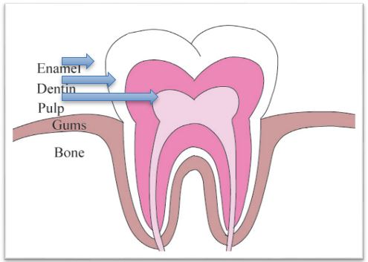

Figure 1: Anatomy of a Tooth.

The formation of dental caries starts at an early age, particularly in many industrialized and middle- to high-income developing countries [1]. Early caries experience has a number of negative impacts on child quality of life, including toothache, absence from school, difficulty eating, impairment of speech development, and even loss of life [3,4].

Determinants of Dental Health

To design effective interventions that prevent dental caries and their sequelae, we must first understand the determinants of dental health. There are several factors that influence the development of dental caries in children. Broadly, three categories of factors contribute: host factors, oral bacterial flora, and diet. Host factors determine susceptibility to colonization by cariogenic bacteria. Once the bacteria have colonized, they feed off dietary sucrose or refined sugars. Bacteria digest these sugars through fermentation, which produces acid [3,5]. This acid produced by bacteria demineralizes tooth surfaces to form dental caries [6]. The following diagram (Figure 2) elucidates the broad variety of determinants that play a role in dental health.

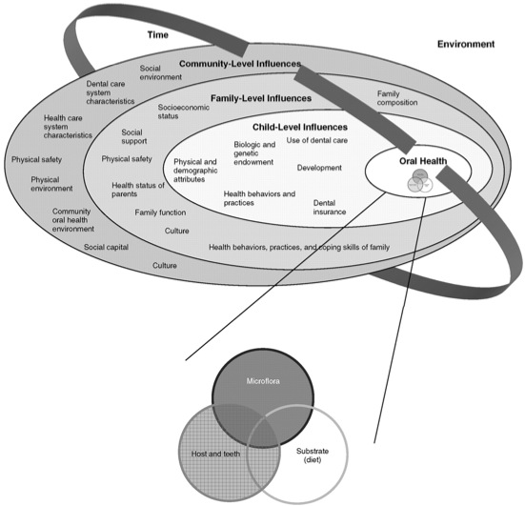

Figure 2: Determinants of Dental Health [7].

Nutrition

The link between sugar consumption and dental caries formation is painfully evident as westernized diets spread to the developing world [1]. A recent study of socioeconomic determinants of dental caries found a high correlation between sugar consumption and average national tooth decay, as measured by the Decayed, Missing, Filled Teeth (DMFT) score. In this study, 109 countries were divided into four economic levels and compared based on several socioeconomic factors. Per capita sugar consumption was found to have a positive correlation to national average DMFT score for all developing countries, but not for established economies [8]. This pattern for developing countries is thought to be the result of exposure to cariogenic foods, such a sugar, without the fluoride exposure present in established economies [1].

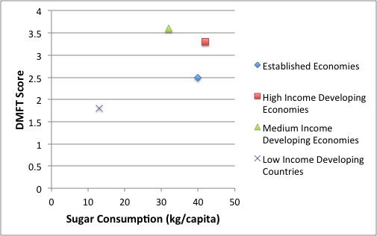

Figure 3: DMFT and Sugar Consumption by Economic Level [8].

The impact of a high sugar diet in the absence of fluoride exposure can be particularly detrimental in regions where malnutrition is prevalent. Enamel hypoplasia is associated with early exposure to low vitamin A, vitamin D, or protein energy malnutrition [6]. Teeth with hypoplastic enamel have a rougher surface, which facilitates bacterial colonization [5]. Although under-nutrition alone is not associated with dental decay, it does seem to exacerbate dental caries formation when combined with a high sugar diet [6].

Fluoride

Fluoride aids this process by inhibiting demineralization and enhancing remineralization [6]. If fluoride is present as the pH drops, fluorapatite can replace hydroxyapatite in tooth enamel. Fluoroapatite maintains enamel structure by lowering the pH at which the enamel demineralizes. If fluoride is present as the pH returns to normal, it facilitates the recovery of lost calcium and phosphate to the enamel [9]. Current methods of fluoride delivery, such as fluoride varnish, toothpastes, and fluoridated rinses, are effective because of their ability to maintain fluoride levels in the oral environment that are sufficient to promote these processes [9].

Introduction

Burden of Dental Caries in Honduras

The story of dental caries in Honduras is the same as the story in many developing countries. As a lower-middle-income developing nation, Honduras struggles with few public dental health clinics and fewer than 2 dentists per 10,000 people [10,11]. The existing public dental clinics primarily provide extractions [11].

The most recent national survey of child dental health in Honduras was conducted in 1997. This survey collected data from rural and urban schools in all 18 departments of Honduras. The study was designed to include a sample of over 2000 children, roughly half from rural and half from urban schools [12]. The survey found an average dmft score of 3.7. It also found that less than 10% of affected teeth had been filled and that 75% of affected teeth remained completely untreated (neither by filling nor extraction) [13].

In a 1999 review of the burden of dental caries in the Americas, researchers noted that countries such as Honduras who did not meet the WHO dmft goal by the year 2000 struggled with lack of dental care in rural areas. In these regions, extraction is the only treatment available [13].

Study Setting: Population, Resources

Over a decade after this review, the coordinator of the annual Duke medical mission trip to rural Honduras has become increasingly concerned about the burden of dental caries. For almost 10 years, this group has been returning to a small cluster of communities in the department of Intibucá. The mission serves about 15 communities organized into a co-op. Families in these communities belong to the Lenca ethnic group and primarily support themselves through agriculture. Most grow crops for their own consumption, while some are able to supplement their income by working as day laborers on larger farms for about $1-2 per day.

The communities are about 20-80 kilometers from La Esperanza, their only source of dental care. In La Esperanza, the financially accessible care option is tooth extraction, which costs about 100 Lempira in local currency, or $5.30USD. These services are typically only sought when dental pain becomes unbearable. The following study was undertaken with the intention that it could serve as the foundation for a preventive dental health intervention. Our goal was to assess the current burden of dental decay and the relationship of this burden to sugar consumption among children between the ages of 6-months and 12-years.

Methods

Study Design

A cross-sectional survey was conducted in 2011 among 6-month to 12-year-old children living in a group of communities within 80 kilometers of La Esperanza, Honduras. For the past 10 years, a medical team from Duke University has served these communities annually. Because of this existing relationship, these communities were chosen for the study. This age group was chosen because children are most susceptible to tooth decay immediately after tooth eruption. Primary teeth erupt between the ages of 6-months and 5-years, while permanent teeth erupt during early adolescence [6]. The water in these communities is not fluoridated.

Nine of the approximately 15 communities in the co-op were chosen for the survey based on accessibility. One community was excluded from the final analysis due to insufficient data resulting in a total of 8 communities included in the analysis. The water in these communities has undetectable levels of fluoride. Communities were informed in advance of the date that a fieldworker would visit the community school or church to conduct the survey. Families were invited to participate through community contacts. Convenience sampling was used, and only children whose parent or guardian signed an informed consent were included in the survey. Exam results were calibrated with the exams.

Ethical Approval

Ethical approval for this study was obtained through the Duke University Graduate School Institutional Review Board. A consent form was read to all parents or guardians of participating children in their native language (Spanish), and consent was obtained for all study participants. Child assent was obtained prior to examination.

Characteristic |  | % (n, total=532) | Mean (SD)
Gender | Male | 48 (257)
 | Female | 52 (275)
Age | 1 year old or less | 4 (20)
 | 2 years old | 3 (17)
 | 3 years old | 6 (30)
 | 4 years old | 4 (23)
 | 5 years old | 9 (48)
 | 6 years old | 9 (48)
 | 7 years old | 12 (63)
 | 8 years old | 11 (60)
 | 9 years old | 10 (51)
 | 10 years old | 12 (63)
 | 11 years old | 12 (63)
 | 12 years old | 9 (46)
Mother attended school? | Yes | 87 (463/531)
 | No | 13 (68/531)
Grade completed (Mom) | Mean |  | 3rd - 4th (2.27)
Father attended school? | Yes | 84 (445/527)
 | No | 16 (82/527)
Grade completed (Dad) | Mean |  | 3rd - 4th (2.36)
Mother’s primary occupation | Deceased or absent | 1 (5/524)
 | Housewife | 85 (443/524)
 | Agriculture | 11 (60/524)
 | Skilled trades | 3 (14/524)
Father’s primary occupation | Deceased or absent | 10 (52/517)
 | Unemployed | 1 (7/517)
 | Agriculture | 83 (431/517)
 | Skilled trades | 5 (24/517)

Table 1: Characteristics of Children 6-Months to 12-Years Old in Rural Communities near La Esperanza, Honduras.

Variable |  | % (n, total=532) | Mean (SD)
Reported previous dental pain | Yes | 52 (277)
 | No | 48 (255)
Frequency of dental pain | Never | 48 (257/531)
 | Rarely | 6 (30/531)
 | Monthly | 22 (119/531)
 | Weekly | 12 (64/531)
 | Daily | 11 (61/531)
Reported previous tooth extraction | Yes | 16 (84)
 | No | 84 (448)
Report missing school for tooth pain | Yes | 22 (115/531)
 | No | 78 (416/531)
Candies eaten per day | Mean |  | 6.11 (4.49)
Cups of coffee, juice, and soda consumed per day | Mean |  | 2.74 (1.70)
Reported brushing teeth on survey day | Yes | 42 (223)
 | No | 58 (309)
If they did not brush their teeth, why not? | No toothbrush/paste | 57 (177/309)
 | Does not like to brush | 5 (14/309)
 | Too young | 13 (40/309)
 | Forgot | 25 (78/309)
Reported ever having brushed their teeth | Yes | 73 (390)
 | No | 27 (142)
Times per day child brushes teeth (when they do brush) | 0 | 27 (144)
 | 1 | 21 (112)
 | 2 | 36 (193)
 | 3 | 16 (83)

Table 2: Dental Variables in Children 6-Months to 12-Years Old in Rural Communities near La Esperanza, Honduras.

Data Analysis

Variable | Statistical test | p-value
Gender | Chi square | 0.117**
Age | Chi square | 0.000**
Family | Univariate Regression | 0.003**
Community | Chi square | 0.029**
Mom attended school | Chi square | 0.918
Grade completed by mother | Chi square | 0.761
Dad attended school | Chi square | 0.649
Grade completed by father | Chi Square | 0.045**
Mother’s occupation | Fisher’s exact | 0.764
Father’s occupation | Fisher’s exact | 0.633
Brush teeth - yes/no | Chi square | 0.838
Number of primary teeth | Chi square | 0.000**
Number of times child brushes teeth per day | Chi square | 0.362
Number of candies consumed per day (4 categories by quartile) | Chi square | 0.013**
Number of drinks consumed per day (4 categories by quartile) | Chi squared | 0.179**
**p-value <0.25

Table 3: Bivariate Analysis: The Relationship between Decay in Primary Dentition and Potential Independent Variables.

Pairwise correlation coefficients were calculated for the variables with a p-value less than 0.25 to assess for collinearity between these variables. A correlation coefficient of 0.4 or higher (or -0.4 or lower) was considered highly correlated. The only highly correlated variables were Number of Primary Teeth and Age, with a correlation coefficient of -0.6975. This suggests that these two variables are collinear, which can make regression coefficients unreliable and inflates standard error. In considering the potential relationships between age, number of primary teeth, and decay, we concluded that number of primary teeth might be a more vital determinant to the regression model. Each primary tooth is an opportunity for decay. If there are no primary teeth, there can be no primary tooth decay.

The relationship between age and dental decay is more complicated. We hypothesized that there could be three ways by which age increases dental decay. First, age determines the number of primary teeth. In fact, a dental exam assessing the pattern of primary and permanent teeth can be used to closely estimate a child’s age. The relationship between age and dental caries would at first be positive as primary teeth erupt and have time to develop caries. However, beyond the age of six, this relationship would become negative as the child’s teeth are exfoliated.

The second way age could increase dental decay would be if age were used as a proxy for the amount of time each tooth had been exposed to other caries-causing determinants. Again, age would not be considered a cause of dental decay. As age increases, the time that each tooth has been exposed would initially increase, followed by an increase in the prevalence of tooth decay. However, as primary teeth are exfoliated this relationship also breaks down.

Finally, we considered the possibility that teeth simply degenerate over time, the only case in which age (or time) would be the proximal cause of tooth decay. Referring back to (Figure 4), the map of world caries burden argues otherwise. In low-income countries the caries burden is low, while children the same age in other countries have a high burden of caries. This suggests that time, in the absence of exposure to another caries-causing determinant, is not a major determinant of dental caries.

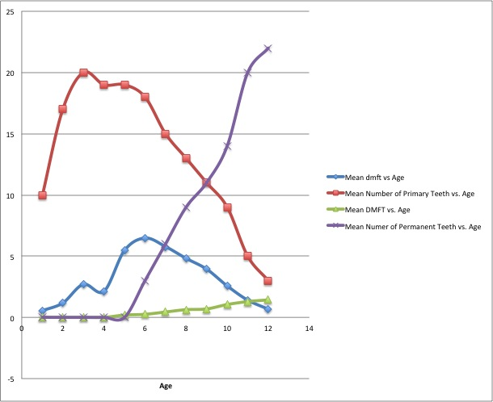

Figure 4: Relationship between Dental Decay, Age, and Number of Primary or Permanent Teeth in study patients.

Our conclusion then, was to leave number of primary teeth in the model while excluding age. Although this was not optimal, a more accurate variable incorporating primary tooth time (number of tooth-years) was beyond the scope of this paper.

In addition to the model of primary tooth decay, we considered developing a model a model of decay in permanent dentition. Unfortunately for the model (fortunately or the children), prevalence of decay in permanent dentition was too low in this sample for this modeling technique. This is to be expected given that all children in the sample were twelve years old or younger and, therefore, may not have had time to develop decay in their recently erupted permanent dentition.

Regression Modeling

All variables with a chi-squared p-value less than 0.25 (other than age) were included in a full preliminary logit model along with the two quadratic terms. We then eliminated one variable at a time, starting with the variable with the highest p-value, to see the effect of that variable on the model. If eliminating the variable changed the p-value of the candies variables by 20% or more we concluded that there was confounding between the two variables and retained the variable in question despite lack of significance. The drink consumption variable was not significant and did not contribute significantly to the model. To assess the goodness of fit of the model, We used the Hosmer and Lemeshow goodness-of-fit test with 8 degrees of freedom. The test yielded a p-value 0.4852 suggesting that the model fits reasonably well.

The final logit regression model is as follows:

Logit(D)= β₀ + β₁C₂ + β₂C₃ +β₃C₄ + β₄T + β₅T_{Sq} + β₆N_{C2} + β₇N_{C3} + β8N_{C4} + β₉N_{C5} + β₁₀N_{C6} + β₁₁N_{C7}+ β₁₂N_{C8} + β₁₃G + β₁₄F +β₁₅F_{Sq}

D is the dichotomous dependent variable representing the presence or absence of decay. The C variables represent dummy variables for quartiles of candy consumption. T represents number of primary teeth, and T_{Sq} is a quadratic term for number of primary teeth. The N_{C} variables are dummy variables representing the communities. The gender variable is represented by the G term. Grade completed by the father is represented by the F term, while F_{sq} represents the quadratic term for grade completed by the father. This model was run in a logistic regression, clustered by family in order to account for intra-class correlation within families.

Results

Caries Prevalence

One objective of this study was to determine the prevalence of dental caries among children 6-months to 12-years old in rural Honduras. Of the children with primary teeth, 75% had at least 1 dental caries in their primary dentition (Mean dmft 3.52, SD 3.57). Of the children with permanent teeth, 43% had at least 1 dental caries in their permanent dentition (Mean DMFT 0.86, SD 1.33).

(Figure 5) is a visual illustration of this relationship between decay, age, and number of primary or permanent teeth. The red and blue curves illustrate the dependence of primary-tooth decay upon the total number of primary teeth. The purple and green curves illustrate the same relationship between permanent-tooth decay and total number of permanent teeth.
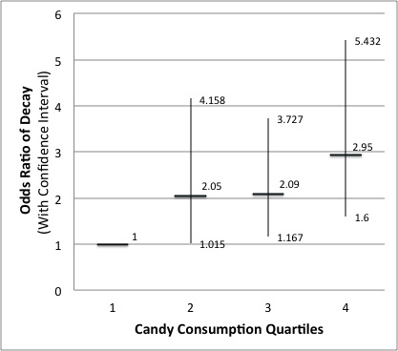

Figure 5: Dose Response to Candy Consumption in study patients.

Results of the Regression Model

 | Bivariate Estimates (logit) |  |  | Multivariate Adjusted Estimates
Variable | Prevalence Odds ratio | Confidence Interval | p-value | Prevalence odds ratio | Confidence interval | p-value
Pieces of candy (quartiles) | 1.14 | 0.968 - 1.338 | 0.118
2.5-5 pieces of candy per day | 1.59* | 00.941 - 2.694 | 0.083 | 2.05** | 1.015 - 4.158 | 0.045
5-8 pieces of candy per day | 1.45 | 0.854 - 2.445 | 0.17 | 2.09** | 1.167 - 3.727 | 0.013
8 or more pieces of candy per day | 1.56* | 0.948 - 2.581 | 0.08 | 2.95*** | 1.600 - 5.432 | 0.001
Female | 0.74 | 0.511 - 1.078 | 0.117 | 0.72 | 0.468 - 1.106 | 0.133
Number of primary teeth | 1.11*** | 1.075 - 1.143 | 0 | 1.92*** | 1.663 - 2.209 | 0
Number of primary teeth squared | 1.003*** | 1.002 - 1.004 | 0 | 0.98*** | 0.970 - 0.983 | 0
Grade completed by dad | 1.02 | 0.933 - 1.104 | 0.726 | 0.91 | 0.762 - 1.080 | 0.272
Grade completed by dad squared | 1 | 0.994 - 1.015 | 0.439 | 1.01 | 0.997 - 1.033 | 0.104
Family | 1 | 1.001 - 1.005 | 0.003
Community | 1.07 | 0.978 - 1.167 | 0.143
San Nicolas | 1.89* | 0.953 - 3.766 | 0.068 | 3.90*** | 1.480 - 10.253 | 0.006
El Rosario | 1.38 | 0.674 - 2.820 | 0.379 | 1.37 | 0.574 - 3.253 | 0.481
Rio Grande | 3.14*** | 1.462 - 6.731 | 0.003 | 4.35*** | 1.841 - 10.215 | 0.001
Belén | 1.5 | 0.757 - 2.957 | 0.247 | 2.55* | 0.942 - 6.911 | 0.066
Rio Colorado | 1.59 | 0.749 - 3.359 | 0.228 | 1.77 | 0.628 - 4.993 | 0.28
Las Crucitas | 1.16 | 0.496 - 2.692 | 0.738 | 1.07 | 0.410 - 2.769 | 0.896
San Antonio | 3.68*** | 1.468 - 9.208 | 0.005 | 5.17*** | 1.742 - 15.337 | 0.003
* p<0.10 | **p<0.05 |  | ***p<0.01

Table 4: Prevalence Odds Ratios for Dental Decay among Children 6-Months to 12-Years-Old in Rural Communities near La Esperanza, Honduras.

The final regression analysis included 532 six-month to twelve-year-old children from eight communities. Children who were in the second quartile of candy consumption (2.5 - 5 pieces of candy per day) had over two times the odds of having dental caries compared to children in the first quartile (who ate fewer than 2.5 pieces of candy per day). Children in the third quartile of candy consumption also had about twice the odds of having dental caries. Children in the fourth quartile (8 or more pieces of candy per day) had nearly three times the odds of having dental caries compared to children in the first quartile. By graphing the prevalence odds ratios, we can see a dose response curve that illustrates the increased prevalence of decay in the primary dentition as candy consumption increases (Figure 5).

Discussion

Principle Findings

Prevalence of Dental Decay

In this population, the prevalence of dental decay in the primary dentition among children with primary teeth is 75%. In that same population, the prevalence of decay in the permanent dentition among children with permanent teeth is 43%.

Three communities of the eight (San Nicolas, Rio Grande, and San Antonio) appeared to have a markedly higher prevalence of dental caries. These communities were also significant in the regression model and had about 4-5 times the odds of dental decay, compared to the community with the lowest decay burden, Las Mercedes. Two of these communities, San Nicolas and Rio Grande, are four to five times larger than the other communities in the study. These larger towns provide more grade levels, employ more teachers, and classrooms include a narrower range of grades. For example, Las Mercedes has a one-room schoolhouse with one teacher for 36 students, grades one through six. San Nicolas has a teacher for each grade and has first through eighth grade. San Nicolas and Rio Grande may have either higher socioeconomic status or a broader range of socioeconomic status influencing dental decay. For the broader sample, none of the potential socioeconomic indicators were significant, and the sample for these communities is too small to assess separately.

San Antonio is much smaller than either of these communities and possibly of lower socioeconomic status given that they were the only community without piped water. However, San Nicolas is close to San Antonio, and the study participants reported to me that some of the students go to school in San Nicolas. It is possible that inhabitants of San Antonio interact frequently with San Nicolas and are also being influenced by the determinants that are affecting caries prevalence in San Nicolas.

Of note, Las Mercedes, the referent community, had the lowest caries prevalence. This is the community where the mission trip stays annually. In this community, more of the inhabitants have annually received dental hygiene information and supplies for the last ten years than inhabitants of other communities. Although I have no way to thoroughly evaluate the relationship between the mission and the prevalence of dental decay, this is an encouraging observation.

The Correlation between Sugar Consumption and Dental Decay

Sugar consumption is positively correlated with dental decay prevalence among children six-months to twelve-years of age in rural Honduras. This is evident according to the dose response curve produced by the odds ratios from the regression model. This suggests that higher candy consumption leads to a higher prevalence of tooth decay.

Drink consumption, however, did not significantly correlate to dental decay. This may be due to the low variation in drink consumption. The average number of cups of drink per day was 2.74 with a standard deviation of 1.70. Only six children did not drink coffee, soda, or juice daily. The most common beverage was coffee. Only twenty children out of 532 did not drink coffee daily. It is also possible that they did not put as much sugar as expected in the coffee. The survey had no measure of the amount of sugar used, so this issue cannot be further evaluated through this data set.

Tooth brushing was also not significantly correlated with dental decay. Although about half of the children reported brushing their teeth on survey day, there are two reasons that this brushing may not have been effective. First, they may have poor brushing technique. At the end of each survey, we demonstrated proper brushing technique using a stuffed puppet with teeth and a large toothbrush. We then asked the children to show me how to brush their teeth using the puppet. Based on their demonstrations, it is likely that, when they do brush, they do not brush thoroughly or for a sufficient amount of time to be effective. Additionally, the survey data was collected about a month after the Duke medical mission visited bringing toothbrushes and toothpaste. This may have artificially inflated the prevalence of tooth brushing. In discussions with families, we surmised that most people do not buy their own dental hygiene supplies. It is likely that, although nearly 50% of those surveyed brushed their teeth on the survey day, they do not brush their teeth consistently.

Limitations

Age Discussion and Longitudinal Study to Calculate Correlation between Sugar Consumption and Dental Decay when Tooth/yrs is a Dependent Variable

Cross-Sectional Design

This was a cross-sectional survey, which provides evidence of the prevalence of a disease. Prevalence is a function of both incidence and duration of disease. The question must therefore be asked if the results are indicating that sugar consumption increases the incidence or duration of dental caries.

There is an accepted mechanism of action by which sugar in the diet causes dental caries and therefore increases incidence. After the sugar is consumed, bacteria in the mouth ferment it, producing acid. This acid demineralizes the teeth forming caries. Once caries form and are detectable by visual exam, they do not heal. The duration of disease is determined by when the primary tooth is exfoliated. Candy consumption would not alter this timeline. For these two reasons, the results of this regression model are indicating the impact of candy consumption on decay incidence rather than decay duration.

Convenience Sampling

The other main limitation of this survey was that it was conducted using convenience sampling. Because convenience sampling is non-random, it is more easily biased. One potential source of bias is that offering dental exams may have attracted children with more dental caries despite the fact that we were not offering treatment for the caries. However, 30% of the study participants had no dental decay (160/532). This means that, although the study may have enticed parents of children with decay to participate, it certainly did not deter parents from bringing children without decay.

Another source of bias may have been the requirement of parent participation. One result of this requirement may have been that more proactive parents were more likely to participate. These parents may also have been more proactive about dental hygiene for their children. This bias, however, would have overestimated the impact of dental hygiene on dental caries prevalence, whereas the study found that this determinant was not significant. Requiring parent participation may also have led to the exclusion of families that lived farther from the community center. If the families that lived closer had easier access to candy, this bias may have overestimated caries prevalence. Of the survey participants, 15% ate less than one candy per day, but only 3% never ate candy. Although this bias may have overestimated the caries prevalence found by the study, the variability of candy consumption should have improved the ability of the model to estimate the dose response between sugar consumption and dental caries prevalence.

Other Important Variables

This study did not include a measure of health literacy. Health literacy is the ability to obtain, process and understand the basic health information necessary to make health decisions [14]. Ability to read is typically used as a proxy to measure health literacy due to their strong correlation [15]. Low reading skills are associated with lack of knowledge of healthy behaviors, low use of preventive services, unhealthy behaviors, and, more specifically, lack of tooth brushing [15,16]. Although oral health literacy is likely to be an important determinant of dental decay in this population, there is little variation in parent education, and a literacy assessment was beyond the scope of this study.

We did attempt to approximate parental education through variables assessing the level of education completed by the parents of study participants. Unfortunately, neither these variables nor any of the other socioeconomic variables assessed by the survey were statistically significant. These variables included ownership of a radio and parent occupation in addition to the parent education variables. Because most community members work in agriculture growing crops for personal consumption, community members are not paid regularly offering no potential for an income variable. While ownership of an eco-stove, latrine, or piped water could be seen as potential economic indicators, these items are often donated and may not reflect the financial status of the family.

Implications

With 75% of children suffering from primary dental decay, there is a need for improved fluoride exposure. One option is water fluoridation. Seven out of the eight communities have piped water that comes from a single tank. These tanks are designed to be used to apply chlorine to the water and could easily serve for water fluoridation as well. Another option is the application of fluoride varnish. It is relatively inexpensive, fast and easy to apply, and only needs to be applied twice per year. A third option is to scale up the distribution of toothbrushes and toothpaste.
While distributing these supplies is helpful, it is also important to provide oral health education. Dental hygiene education through the schools and local clinics could greatly increase the uptake of dental hygiene practices and improve effectiveness of tooth brushing. Other smaller interventions to improve oral health awareness include hanging mirrors in public areas so that children can see their teeth, hanging pictures of people with healthy dentition in public areas to help people understand that healthy teeth are attainable, and educating parents of the relationship between sugar and dental decay.

Opportunities for Further Study

There were some interesting questions that this survey left unanswered. We were unable to assess access to dental care, or the roles of acid reflux, bacterial colonization, or dental crowding on the burden of dental caries.

In this population, most caries are left untreated until they are too painful to ignore. In order to improve the utilization of dental care, we must first understand why current utilization is so low. A second area of concern is that several of the children appeared to be suffering from dental decay caused by acid reflux. The erosion caused by acid reflux devastates the posterior dentition. Further work should be done to determine the prevalence of acid erosion and evaluate the best treatment method.

Two other dental health determinants were out of the scope of this study, but may contribute to the model of dental health. Many of the children had dental crowding, which can facilitate plaque formation. Additionally, some of the communities had notably higher decay prevalence. This may, in part, be due to oral flora particular to these communities. Although neither of these factors point to any obvious interventions in the short term, they would improve our understanding of dental health in this population.

Conclusion

This model shows that increased candy consumption correlates to an increase in the prevalence of dental caries in the primary dentition of six-month to twelve-year-old Lenca children in rural Honduras

The prevalence of caries in these communities is higher than the WHO goal, and, with 75% of children suffering from caries of their primary dentition, these communities could greatly benefit from a dental health intervention. Interventions to be considered include increasing fluoride exposure through water fluoridation or fluoride varnish and improving oral health literacy through dental hygiene education and educating the communities about the determinants of dental decay.

References

- Petersen P, Bourgeois D, Ogawa H, et al. (2005) The global burden of oral diseases and risks to oral health. Bulletin of the World Health Organization 83: 661-669.
- National Health and Nutrition Examination Survey (NHANES) 1999-2004 CDC, Atlanta, Ga.
- Zafar S, Harnekar S, Siddiqi A (2009) Early childhood caries:etiology, clinical considerations, consequences and management. International Dentistry SA 24-36.
- Gradella CM, Bernabé E, Bonecker M, et al. (2011) Caries prevalence and severity, and quality of life in Brazilian 2- to 4-year-old children. Community Dentistry and OralEpidemiology 39: 498-504.
- Caufield PW, Griffen AL (2000) Dental Caries: An Infectious and Transmissible Disease. Pediatric Oral Health 47: 1001-1019.
- Moynihan P, Petersen P (2004) Diet, nutrition and the prevention of dental diseases. Public Health Nutrition 7: 201-226.
- Fisher-Owens S, Gansky S, Platt L, et al. (2007). Influences on Children's Oral Health: A Conceptual Model. Pediatrics 120: e510-e520.
- Diehnelt D, Kiyak H (2001) Socioeconomic factors that affect international caries levels. Community Dentistry and Oral Epidemiology 29: 226-233.
- Cury J, Tenuta L (2008) How to Maintain a Cariostatic Fluoride Concentration in the Oral Environment. Advances in Dental Research 20: 13-18.
- World Bank (2011) World Bank, Data, By Country.
- Pan American Health Organization (2001) Regional Core Health Data System.
- Organización Panamericana de la salud, Ministerio de Salud de Honduras (1997) Estudio Epidemiologico de Salud Bucal en Niños de 6,7,8,12, y 15 años de Honduras. Organización Panamericana de la Salud, División de Sistemas y Servicios de Salud, Programa Regional de Salud Oral, Tegucigalpa, Honduras.
- Beltrán-Aguilar E, Estupiñán-Day S, Báez R (1999) Analysis of Prevalence and Trends of Dental Caries in the Americas Between the 1970s and 1990s. International Dental Journal 49: 322-329.
- Glassman P (2011) National Network of Libraries of Medicine.
- DeWalt D, Berkman N, Sheridan S, et al. (2004) Literacy and Health Outcomes: A Systematic Review of the Literature. Journal of General Internal Medicine 19: 1228-1239.
- Vann JR, Lee J, Baker D, et al. (2010) Oral Health Literacy among Female Caregivers :Impact on Oral Health Outcomes in Early Childhood. Journal of Dental Research 89: 1395-1400.

