Case Report

Laparoscopic Excision of an Abdominal Wall Schwannoma

Christian Renz, MD, Celia Divino, MD#

Division of General Surgery, Icahn School of Medicine at Mount Sinai, New York, USA

#Corresponding author: Celia M Divino, MD, Professor, Division of General Surgery, Icahn School of Medicine at Mount Sinai, 1 Gustave L. Levy Place, New York 10029-5674, USA

How to cite this article: Renz C and Divino C (2022) Laparoscopic Excision of an Abdominal Wall Schwannoma. Int J Surg and Repo 02(01): 2021-16.

Submission Date: 11 January, 2022; Accepted Date: 24 January, 2022; Published Online: 31 January, 2022

Abstract

Schwannomas are benign, peripheral nerve sheath tumors made up of Schwann cells, most commonly associated with vestibular schwannomas. We report a case of a 42-year-old male who was found to have a large abdominal wall schwannoma. Although common in other parts of the body, schwannoma’s of the abdominal wall are exceedingly rare, with very few cases reported. We believe this to be the first reported case of an abdominal wall schwannoma to be excised laparoscopically.

Introduction

Schwannomas are benign, peripheral nerve sheath tumors made up of Schwann cells [1]. These tumors most commonly originate from cranial nerves, spinal roots, or peripheral nerves. They are most often associated vestibular schwannomas, which are Schwann cell tumors of the vestibular branch of vestibulocochlear nerve, although they can occur anywhere in the body. The finding of a schwannoma in the abdominal wall is exceedingly rare, with very few cases reported.

Case Report

A 42-year-old male with no significant past medical history presented to our institution for evaluation of a symptomatic umbilical hernia. He was subsequently scheduled for an elective laparoscopic umbilical hernia repair a few weeks later. During the repair, it was noted that the patient had a large, smooth, firm, suprahepatic mass on the anterior abdominal wall, indenting into the liver. The hernia repair was completed, and the patient was scheduled to follow up to discuss the unusual abdominal wall finding. The mass was unable to be palpated on physical exam, and he did not complain of any abdominal pain. He had no history of weight loss or any other gastrointestinal symptoms. The initial suspicion was for an intramuscular lipoma, however, the patient was scheduled for a CT scan for further evaluation. This revealed an 8.6 cm mass in the right upper quadrant of the peritoneal cavity. It was noted to be compressing into the liver, but distinctly separate from the liver parenchyma, gallbladder, diaphragm, and rib cartilage (Figure 1).

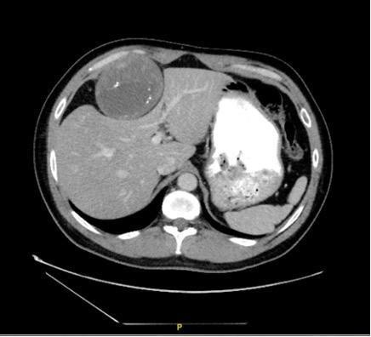

Figure 1: CT scan showing a transverse view of the abdominal wall schwannoma

The mass contained areas of calcifications as well as central necrosis. Given these rather concerning characteristics, the patient was sent for an MRI. The MRI showed that the mass appeared to be associated with the anterior chest wall with some evidence for feeding vessels arising from the chest wall. There was no fat component identified within the tumor.

The patient was subsequently sent for an ultrasound-guided core needle biopsy which revealed spindle cell proliferation, consistent with Schwannoma. S100 showed diffuse staining in the cellular areas and stained large cells in the fibrotic zones of the specimen.

Given the confirmed diagnosis of Schwannoma, the patient was scheduled for a laparoscopic excision of the mass. The patient was taken to the operating room, placed in the supine position with the arms left out. An initial 5mm incision was made in the left upper quadrant and the abdomen was entered via optiview technique. The patient was then placed in reverse Trendelenburg and additional 5mm trocars were placed in the left lower quadrant, right lateral and subxiphoid regions. Using a vessel sealer (Ligasure) and argon beam, the mass was gently dissected off the rib and intercostal muscle (Figure 2). The surrounding tissue was highly vascularized. The case was done entirely laparoscopically, with a larger subxiphoid incision being made for the sole purpose of extracting the specimen.
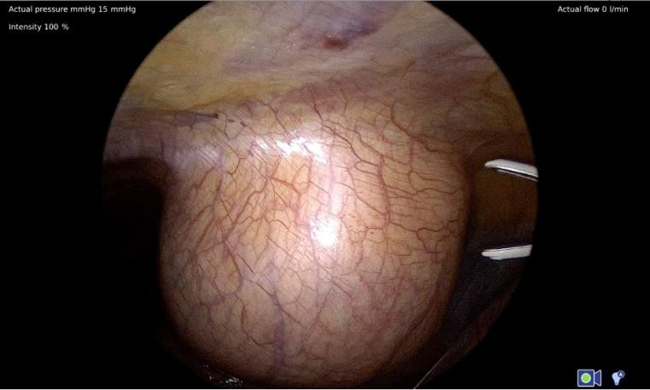

Figure 2: Intra-op image of the mass prior to resection.

Pathologic examination of the specimen showed an ovoid-shaped, pink-brown mass measuring 9.2 x 8.3 x 6.3 cm tumor. Sectioning revealed a pale-brown, variegated predominantly solid (80%) and cystic (20%) hemorrhagic, calcified cut surface. The tumor showed strong staining for S100. It was also negative for CD34, SMA, desmin, and nuclear beta-catenin. It was ultimately diagnosed as an Ancient Schwannoma (Figure 3). His post-operative course was uncomplicated and he was discharged home on post-operative day 1.
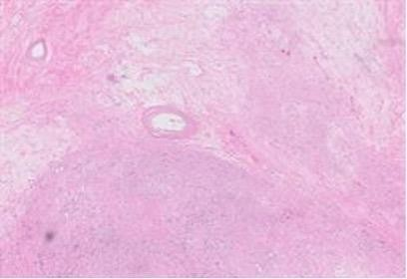

Figure 3: H&E staining showing denser, more cellular areas. Thick walled hyalinized blood vessels.

Discussion

Peripheral nerve tumors can be generally classified as either sheath or nonsheath in origin as well as benign or malignant. Schwannomas are also known as neurilemomas and are encapsulated nerve sheath tumors composed of neoplastic Schwann cells. These are the most common tumors of the peripheral nerve [2]. Schwannomas are most commonly found in the head and neck area. These tumors are largely benign, and only very rarely transform to malignancy if in the case of a few atypical cell types [2]. These patients are largely asymptomatic, with the most common symptom being pain from compression of nearby neural structures [3].

Schwannoma findings on imaging can be strikingly similar to other similar nerve sheath or neural origin tumors. A CT scan can often show a well-defined mass, hypodense in comparison to surrounding muscle. There are no enhancing cystic or necrotic areas typically found in schwannomas, a key element in differentiating them from neurofibromas.⁴ These tumors can be visualized with CT scan, however, the imaging of choice when trying to outline these lesions are MRI. “Ancient” schwannomas indicate a long-standing lesion with degenerative changes such as calcification, hyalinization, and cystic cavitation. All findings that can be reliably seen on imaging [4].

Proper treatment of a benign “Ancient” schwannoma includes complete surgical excision with negative margins. The overall prognosis is quite good, and these tumors will rarely recur. Malignant conversion is also quite unusual.

While schwannomas are not an uncommon finding, their presence in the abdominal and chest wall is quite rare. A recent review of the literature reported only eight other case reports of an abdominal wall schwannoma. Out of the previous eight cases (Table 1), we believe this to be the first to be excised entirely laparoscopically. Given the advances in laparoscopic surgery, with more procedures being done laparoscopically than ever before, this is a notable achievement.

Resection of these tumors by any means is rare, and now having a documented case of a laparoscopic resection should make this an option going forward, if it is encountered in a similar fashion.

Authors | Age/Gender | Location | Summary
Khorgami, et al. [5] | 28/F | Right abdomen | Presented with distention and pain for months. Mass was found to be abutting the liver and gallbladder with retroperitoneal extension. The tumor was not excised.
Bhatia, et al. [6] | 64/F | Right iliac fossa | Initially  asymptomatic and discovered incidentally. Laparoscopic converted to open resection and later discharged on POD2.
Mishra, et al. [7] | 29F | Left abdomen | Gradually increasing painless lump.  Resected en bloc, unclear her length of stay.
Balzarotti, et al. [8] | 57F | Left abdomen | Presented with left lower quadrant pain for 3 years, but no obvious physical exam findings. She was taken to the operating room and the mass was excised through an anterior incision, unclear her length of stay.
Liu, et al. [9] | 67F | Right abdomen | Patient presented with a painless mass gradually increasing size over many years and finally becoming painful prior to presentation. The mass was excised through an open technique and the patient was discharged on POD10.
Ginesu, et al. [10] | 62F | Right iliac fossa | Presented with vague abdominal pain and a palpable mass.  Excised through an open approach and she was discharged on POD2.
Lam, et al. [1] | 70M | Left abdomen | Presented withabdominal pain and a palpable mass. Removed via excisional biopsy with an unknown length of stay.
Tarchouli, et al. [11] | 34M | Right iliac fossa | Presented with chronic, intermittent abdominal pain localized to the right iliac fossa. Excised via a selective incision in the right iliac fossa, discharged on POD1.

References

- Lam R, Hunt BL, Arreola-Owen O (2019) Abdominal Wall Schwannoma. Fed Pract 36:129-133.
- Skovronsky DM, Oberholtzer JC (2004) Pathologic classification of peripheral nerve tumors, Neurosurgery Clinics of North America 15: 157-166.
- El-Sherif Y, Sarva H, Valsamis H (2012) Clinical reasoning: an unusual lung mass causing focal weakness. Neurology 78: e4-e7.
- Pilavaki M, Chourmouzi D, Kiziridou A, et al. (2004) Imaging of peripheral nerve sheath tumors with pathologic correlation: Pictorial review, European Journal of Radiology 52: 229- 239.
- Khorgami Z, Nasiri S, Rezakhanlu F, et al. (2009) Malignant schwannoma of anterior abdominal wall: report of a case. J Clin Med Res 1: 233-236.
- Bhatia RK, Banerjea A, Ram M, et al. (2010) Benign ancient schwannoma of the abdominal wall: an unwanted birthday present. BMC Surg 10: 1.
- Mishra A, Hamadto M, Azzabi M, et al. (2013) Abdominal wall schwannoma: case report and review of the literature. Case Rep Radiol 2013: 456863.
- Balzarotti R, Rondelli F, Barizzi J, et al. (2015) Symptomatic schwannoma of the abdominal wall: A case report and review of the literature. Oncol Lett 9: 1095-1098.
- Liu Y, Chen X, Wang T, et al. (2014) Imaging observations of a schwannoma of low malignant potential in the anterior abdominal wall: A case report. Oncol Lett 8: 1159-1162.
- Ginesu GC, Puledda M, Feo CF, et al. (2016) Abdominal Wall Schwannoma. J Gastrointest Surg 20: 1781-1783.
- Tarchouli M, Essarghini M, Qamouss O, et al. (2020) Abdominal wall schwannoma: a case report. Gastroenterol. Hepatol. Bed Bench 13: 95-100.

