Case Report

Reverse PET/CT Guided Biopsy to Differentiate Cancer and Reactive Changes in Bone: A Case Report

Majid Maybody, MD^{1#}, Cristina R. Antonescu, MD², Nicola Fabbri, MD³

¹Department of Radiology, Memorial Sloan Kettering Cancer Center, New York, USA
²Department of Pathology, Memorial Sloan Kettering Cancer Center, New York, USA
³Department of Surgery, Memorial Sloan Kettering Cancer Center, New York, USA

#Corresponding author: Majid Maybody, MD, Interventional Radiology Service, Department of Radiology, Memorial Sloan Kettering Cancer Center, 1275 York Ave., M276C, New York 10065, USA

How to cite this article: Maybody M, Antonescu CR, Fabbri N (2022) Reverse PET/CT Guided Biopsy to Differentiate Cancer and Reactive Changes in Bone: A Case Report. Colu J Cas Repo 02(01): 2021-17.

Submission Date: 07 December, 2021; Accepted Date: 04 January, 2022; Published Online: 10 January, 2022

Abstract

A 71-year-old female with a past medical history of breast cancer and uterine leiomyomas presented with extensive lytic and sclerotic bone lesions with mixed FDG avidity in the axial and appendicular skeleton. There was no splenomegaly or gross primary site of malignancy. An FDG-avid area was biopsied revealing marked fibrosis with no evidence of metastasis from breast or uterine cancer. Under the clinical suspicion for metabolically active areas to represent reactive cells to non-metabolically active primary neoplastic cells, FDG PET/CT guidance was used to localize a non-avid area of marrow for biopsy. This was diagnostic for an unusual spindle cell sarcoma with myoid/myofibroblastic differentiation. The new sample helped delineate cancer cells in the original biopsy sample and revise its interpretation.

Introduction

Traditionally, Positron Emission Tomography (PET)/Computed Tomography (CT) guided biopsy is indicated where the target lesion has an avidity for PET agent with no CT correlate. The Fluorodeoxyglucose (FDG)-avid target is localized with PET to help precision placement of biopsy needle under CT guidance for sampling. The role of PET/CT guided biopsies in increasing adequacy of samples is well established in the literature [1-3]. This case report shows utilization of reverse PET/CT guidance in targeting a non-avid lesion without CT correlate.

Case Report

A 71-year-old female with a remote history of breast cancer and uterine leiomyomas, both treated more than 30 years ago by mastectomy and hysterectomy respectively, was presented with mechanical pain in right thigh for a month. Physical examination revealed antalgic gait and pain along the medial side of the right thigh with a complete passive range of motion of the right hip and knee. Imaging workup including plain radiographs, magnetic resonance imaging, and radionuclide bone scan showed widespread marrow lesions suspicious for metastasis. CT scan and FDG-18 PET/CT scan showed widespread FDG-avid mixed lytic and sclerotic osseous lesions in the axial and appendicular skeleton representing metastases and no obvious primary malignancy. There was no splenomegaly. A site with the highest metabolic activity (SUV 8.0) in the left posterior iliac bone was biopsied. Since the lesion involved the entire left posterior iliac bone, the biopsy was performed under CT guidance with no need for PET guidance (Figure 1).

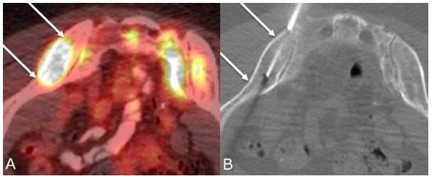

Figure 1: A. Fused axial PET/CT image demonstrates a highly metabolically active lesion involving the entire left posterior iliac bone (between 2 arrows). Image is flipped prone for ease of comparison. B. CT guided biopsy was performed using 11-gauge coaxial biopsy set (Laurane Medical, Saint-Arnoult, France) in prone position. The area correlating with the FDG avid focus is delineated between the 2 arrows. Five core samples were obtained.

Histopathologic examination showed marked fibrosis (3+ reticulin), only focal residual hematopoietic elements, and no extrinsic cells from breast or uterine cancer (Figure 2). Myelofibrosis could not be excluded, while fibrous dysplasia was not favored. There was increased fibrosis (3+ reticulin), while negative for a large battery of immunostains (S100, clusterin, CD21, CD35, CD117, PAX5, OCT2, CD30, Cytokeratins AE1:AE3, CK19, EMA, CD34, ALK, BOB1, CD15, CD61 and CD31). Polyclonal plasmacytosis seen with CD138, kappa, lambda, EMA; CD3+ small benign lymphoid cells, with scattered CD20, EBER1 was negative and CD68 showed a moderate histocytosis. Special stains for microorganisms were negative. The overall impression was for benign findings.

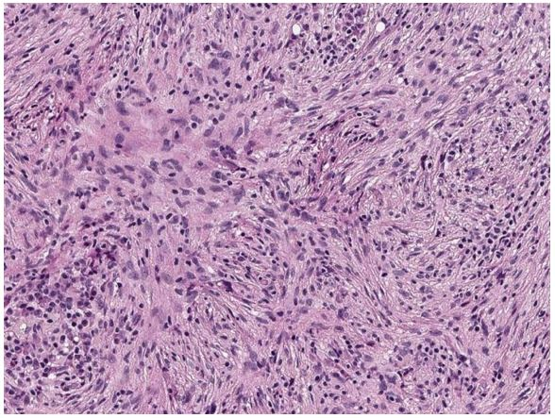

Figure 2: Left posterior iliac bone biopsy showing almost complete replacement of the marrow spaces with a spindle cell proliferation arranged in short fascicles and vague storiform growth. The lesional cells show plump ovoid nuclei with fine chromatin and inconspicuous nucleoli. A mild cytologic atypia is noted. Additionally, a variable lymphoplasmacytic infiltrate is noted interspersed. Although a myelofibrosis was considered in the differential diagnosis due to increased reticulin staining, the degree of cellularity and atypia was not in keeping with that consideration. Examination of the sample from non-FDG avid right iliac bone helped revise interpretation of this sample.

Peripheral blood tests were not supportive of a myeloproliferative malignancy. It was suspected that the metabolically active areas in the marrow represented reactive fibrosis to non- metabolically active neoplastic cells. Additional lesional tissue with less fibrosis was needed for further histopathologic evaluation. Due to widespread involvement of marrow and to decrease false-negative results, FDG 18 PET/CT guidance was used to specifically localize a non-FDG avid area of marrow for sampling (reverse PET/CT guidance) (Figure 3).

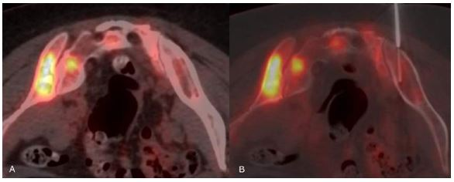

Figure 3: Reverse PET/CT guided biopsy. Following intravenous injection of 6.1 mCi F-18 FDG and an approximately 97-minute uptake period, CT and PET images of the pelvis were acquired (Discovery 690 PET/CT scanner, GE Healthcare, Waukesha, WI, USA) with the patient in the fasted state in prone position. A. Soft tissue window shows a large non-FDG avid lesion in the posterior right iliac bone. B. The non-FDG avid right posterior iliac bone lesion is targeted with an 11-gauge bone biopsy set (Laurane Medical, Saint-Arnoult, France). Five samples were obtained.

The biopsies showed a spindle cell proliferation with a fascicular growth composed of elongated cells with pink eosinophilic cytoplasm, mild to moderate nuclear pleomorphism (Figure 4). The spindle cells were positive with SMA and focally with Desmin. Further immunohistochemical stains performed which revealed that the tumor cells were negative for MDM2, CDK4, CD163 (high background), S100, and p63. An EBER-ISH preparation was negative in tumor cells. After extensive immunohistochemical workup, a hematologic process was ruled out. Leiomyosarcoma was ruled out due to lack of diffuse desmin reactivity and negativity for ER and PR expression. Based on overall findings, spindle cell neoplasm with fascicular growth, and above immunological profile, a spindle cell sarcoma with myoid/myofibroblastic differentiation was favored, most likely metastatic given its multicentricity. Examination of these samples helped identification of neoplastic spindle cells in the original biopsy samples and revision of its interpretation (Figure 2).

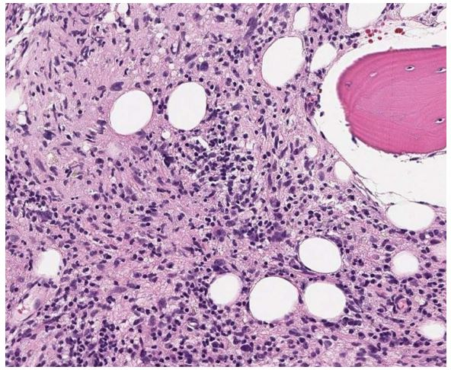

Figure 4: Right iliac crest biopsy showing marrow being partly replaced by a spindle cell proliferation with scattered more pleomorphic nuclei. A mixture of spindle and pleomorphic lesional cells are noted arranged in a haphazard growth, with interspersed lymphoplasmacytic cells and fibrotic stroma.

The patient was treated with liposomal doxorubicin which was switched to pazopanib followed by palliative radiation to painful lesions. Despite treatments, the disease progressed over the following several months, and other biopsy-proven metastases developed at T1-T3 vertebrae and endobronchially at bronchus intermedius. The patient expired due to the progression of disease 14 months after diagnosis.

Discussion
When a biopsy target is avid for PET agent with no CT correlate, PET/CT guidance with the same agent is preferred over CT guidance to decrease false-negative results. PET/CT guided biopsy is shown to have 100% sensitivity and diagnostic accuracy [1]. The typical scenario for PET/CT guided biopsy is to localize a PET-avid CT-occult target. In this report, PET/CT guidance was used to specifically localize a non-avid CT-occult target for biopsy. Reverse PET/CT guidance helped to establish a diagnosis of metastatic spindle cell sarcoma with myoid/myofibroblastic differentiation. The new biopsy samples helped delineate cancer cells in the original biopsy samples with revision of original interpretation.

Among malignancies with low FDG avidity, low-grade myeloproliferative disorders and some sarcomas may induce marrow fibrosis [4-5]. The inflammatory elements of marrow fibrosis are FDG-avid [6]. In this case, widespread involvement of marrow by FDG negative neoplastic cells did not cause gross CT changes, reverse PET/CT guidance became an ideal way to guarantee appropriate sampling of an area of interest. Its application may be helpful in similar scenarios.

Institutional Review Board Statement

IRB approval was obtained for this retrospective study.

Conflicts of Interests

All authors declare no conflicts of interest.

Acknowledgements

This research was funded in part through the NIH/NCI Cancer Center Support Grant P30 CA008748.

References

- Cornelis F, Silk M, Schoder H, et al. (2014) Performance of intra-procedural 18-fluorodeoxyglucose PET/CT-guided biopsies for lesions suspected of malignancy but poorly visualized with other modalities. European journal of nuclear medicine and molecular imaging 41: 2265-2272.
- Fanchon LM, Dogan S, Moreira AL, et al. (2015) Feasibility of in situ, high-resolution correlation of tracer uptake with histopathology by quantitative autoradiography of biopsy specimens obtained under 18F-FDG PET/CT guidance. Journal of Nuclear Medicine 56: 538-544.
- Maybody M, Grewal RK, Healey JH, et al. (2016) Ga-68 DOTATOC PET/CT-guided biopsy and cryoablation with autoradiography of biopsy specimen for treatment of tumor-induced osteomalacia. Cardiovascular and interventional radiology 39: 1352-1357.
- Kuter DJ, Bain B, Mufti G, et al. (2007) Bone marrow fibrosis: pathophysiology and clinical significance of increased bone marrow stromal fibres. British journal of haematology 139: 351-362.
- Flavell RR, Naeger DM, Mari Aparici C, et al. (2016) Malignancies with low fluorodeoxyglucose uptake at PET/CT: pitfalls and prognostic importance: resident and fellow education feature. Radiographics 36: 293-294.
- Derlin T, Alchalby H, Bannas P, et al. (2015) Assessment of bone marrow inflammation in patients with myelofibrosis: an 18 F- fluorodeoxyglucose PET/CT study. European journal of nuclear medicine and molecular imaging 42: 696-705.

