Case Report

CT-guided Aspiration for Treatment of Lumbar Discal Cyst

Haley S. Foster MD^{1#}, Anousheh Sayah MD²

^{1#}Department of Radiology, Medstar Georgetown University Hospital, Washington, D.C., USA
²Division of Neuroradiology & Neurointerventional Radiology, Medstar Georgetown University Hospital, Washington, D.C., USA

#Corresponding author: Haley S. Foster, MD, Department of Radiology, Medstar Georgetown University Hospital, 3800 Reservoir Rd NW, Washington, D.C., 20007, USA

How to cite this article: Foster HS and Sayah A (2021) CT-guided Aspiration for Treatment of Lumbar Discal Cyst. Colu J Cas Repo 01(01): 2021-13.

Submission Date: 21 October, 2021; Accepted Date: 28 October, 2021; Published Online: 02 November, 2021

Abstract

Discal cysts are a rare etiology of back pain and radiculopathy in young adults males for which there is no standardized treatment regimen. The great majority of patients who suffer from this condition typically undergo microscopic cystectomy with/without discectomy. At this time, only 14 patients have undergone CT-guided aspiration within the literature, all which report improvement in patient symptoms and complete regression or decreased cyst size. We present the case of a 41-year-old male with severe back pain radiating down the right lower extremity. Despite management with medication, physical therapy, and steroid injections the patient continued to suffer debilitating pain. CT-guided cyst aspiration was performed followed by epidural steroid injection with immediate resolution of the patient’s symptoms. This case illustrates the success of CT-guided aspiration for a discal cyst without the risks that an open may surgery pose.

Introduction

Discal cysts are intraspinal extradural cysts which are thought to directly communicate with the intervertebral disk [1,2]. Due to their location in the spine, discal cysts have the propensity to cause radicular back pain secondary to nerve root compression, but these symptoms are nonspecific and can be elicited by many different spinal pathologies. Discal cysts are important to recognize and differentiate from other causes of low back pain as they can be effectively treated, often with complete resolution of symptoms. A great majority of patients who suffer from this condition undergo microscopic cystectomy with or without discectomy [3]. An alternative to surgical treatment is CT-guided aspiration which has only been described in 14 patients in the literature [4-6]. The purpose of this case report is to discuss a single center experience and successful treatment of a lumbar discal cyst via CT-guided aspiration.

Case Presentation

The case being presented is of a 41-year-old male with a 2-month history of severe back pain radiating to the right lower extremity and foot. On presentation, the patient’s physical exam revealed a positive straight leg raise test on the right, concerning for sciatic root compromise. MRI lumbar spine was performed and revealed a 1 cm intraspinal extradural cystic lesion in direct communication with the L5-S1 disc which was compressing the right descending S1 nerve root. The lesion demonstrated homogeneous increased signal intensity on T2-weighted sequences, isointense to CSF, consistent with a discal cyst (Figure 1A, 1B). Conservative management with frequent physical therapy, lumbar epidural steroid injection, oral steroids, daily high dose gabapentin and occasional narcotic analgesics proved unsuccessful and the patient continued to suffer debilitating pain. In keeping with the patient’s desire for a conservative and minimally invasive approach for his symptoms, neurointerventional radiology was then consulted for CT-guided discal cyst aspiration.

Procedural consent was obtained after a discussion regarding the risks of the procedure, which included bleeding, infection, spinal headache, and potential spinal nerve or cord damage. An initial noncontrast CT was performed to determine the entry point at the L5-S1 disc space. Local anesthesia was administered, and a 22-gauge spinal needle was used to enter the L5-S1 posterior epidural space under CT fluoroscopic guidance. To better delineate the discal cyst margin and confirm extradural location, an air epidurogram was performed by injecting a small amount of air into the epidural space (Figure 1C, 1D). Subsequently, the needle was introduced into the cyst and 1.5 cc of serosanguinous fluid was aspirated with significantly reduced size of the discal cyst (Figure 2A, 2B). The needle was reintroduced into the epidural space and 10 cc of dexamethasone and 1cc of bupivacaine was injected. The procedure was successfully performed without complication.

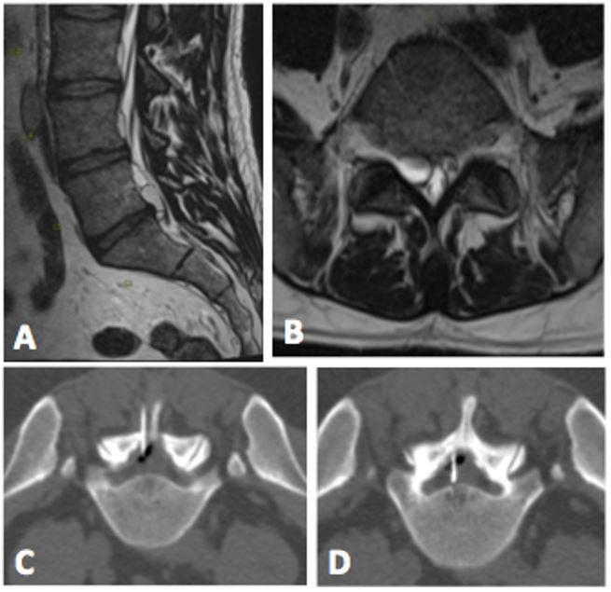

Figure 1: A and B demonstrate a 1.0 x 1.0 cm T2-hyperintense ventral extradural cyst which is contiguous with the L5-S1 disc and causes compression of the right descending S1 nerve root. C and D depict a CT-guided aspiration of the L5-S1 discal cyst with an air epidurogram to help delineate the cyst margins and the adjacent thecal sac.

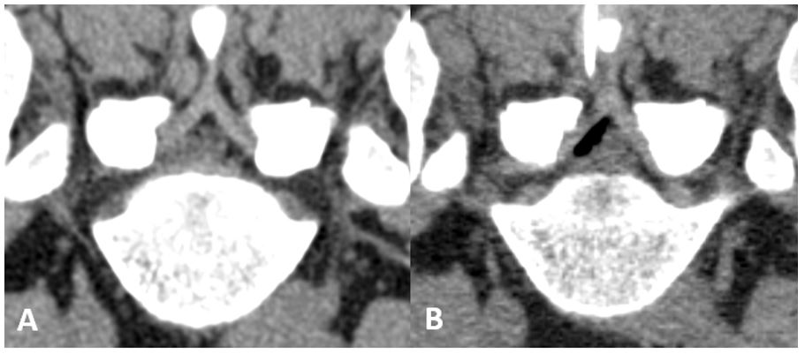

Figure 2: A demonstrates the noncontrast planning CT with the discal cyst at L5-S1 which caused compression of the right descending S1 nerve root. B is the post aspiration image with interval reduction in the size of the discal cyst and a small amount of air adjacent to the thecal sac.

Pathological analysis of the aspirated sample demonstrated amorphous proteinaceous material, red blood cells, histiocytes, and rare leukocytes, consistent with cyst contents. After the discal cyst aspiration, the patient clinically improved in the following weeks with near complete resolution of his symptoms. At a follow up appointment nearly one year later, the patient complained of mild residual pain in his right leg, which was not as severe as his initial presentation. Follow up imaging has not been performed at this time to evaluate for cyst recurrence and the patient has not yet required surgical intervention for his symptoms.

Discussion

Discal cysts are an uncommon cause of lumbalgia and radiculopathy in young adults. Young adult males, especially of Asian descent, have been quoted to comprise 90% of the demographic who suffer from this condition [7,8]. The pathogenesis of discal cyst formation is not well understood, but several mechanisms have been proposed to explain their occurrence in patients with minimal degenerative disc disease. With the exception of Chiba et al, who postulated that discal cysts form as the sequelae of a small epidural venous plexus hemorrhage from discal injury, other groups have advocated that discal cysts originate from herniated discs or annular injury which have undergone inflammatory or reactive change with exclusion of a small cystic structure [2,7,9,10]. Both the imaging and histologic characteristics of discal cysts support their discogenic origin.

Lumbar spine MR and discography are the standard imaging modalities for diagnosis of discal cysts, though the latter is infrequently performed due to the superior sensitivity and specificity of MR. On MR, discal cysts are characterized as well marginated cystic masses which have variable signal intensity on T1-weighted sequences due to the presence of blood products, isointense to cerebrospinal fluid (CSF) on T2-weighted sequences, often with a T2-hypointense rim which may have mild rim enhancement on post contrast sequences [1,2]. Discal cysts are most frequently found at the L4-L5 disc space, but can be seen throughout the lumbar spine, in the ventrolateral epidural space with no connection to the facet joint. On CT, lumbar discal cysts are described as hypoattenuating masses that may cause scalloping of the posterior vertebral body [11]. Unlike the symptoms of lumbar discal cysts which are ubiquitous to many conditions within the spine, the imaging findings are relatively specific, though differential diagnoses must be considered and include: disc herniation, synovial cysts, Tarlov cysts, and other nonspecific intraspinal cysts arising from the facet joint, ligamentum flavum, and intervertebral disc [1,12].

There are no standardized treatment regimens for lumbar discal cysts as they are infrequently encountered in clinical practice and are not well described in the literature, thus no guidelines have been created at this time [1]. Different approaches for the management of lumbar discal cysts have been described which include observation, physical therapy, epidural steroid injection, percutaneous needle aspiration with CT- or fluoroscopic guidance, endoscopic resection, and microscopic resection [11]. Patients who suffer from severe low back pain secondary to impingement from a discal cyst typically undergo conservative management initially with operative management being reserved for those patients with persistent neurological symptoms or pain which is refractory to nonoperative treatment [7]. The most well-described treatment modality is surgical discal cyst excision with or without microdiscectomy. Park et al retrospectively evaluated 27 different patients who suffered from lumbar discal cysts between 2000 and 2017 and reviewed the available literature to evaluate the necessity of disc removal following discal cyst excision. Microdiscectomy was most frequently performed to decrease discal cyst recurrence rate, which was determined by Park et al to occur at a rate of 1% in those patients who underwent discal cyst excision without discectomy. Spinal instability is a known complication following microdiscectomy, the detriments of which should be heavily considered in a young patient with an otherwise normal spine suffering from a discal cyst [13-15]. The patients at the author’s institution underwent partial hemilaminectomies and microscopic cyst resection without disc excision with complete resolution of symptoms in all patients and no instances of cyst recurrence [3]. Two of the 27 patients described by Park experienced complications related to the surgery which included a CSF leak and surgical site infection. Similarly, complications are reported in a minority of the cases within the literature, the most common being surgical site infection and paresthesias from iatrogenic injury to nerve roots [3].

Though conservative management (i.e. observation, physical therapy, medical management) is frequently used as an initial measure, only 14-15% of those cases have complete resolution of their symptoms [3]. Patients suffering from discal cysts are unlikely to experience spontaneous cyst regression and will most likely require definitive treatment. At this time, there are only 14 documented patients which have undergone CT-guided discal cyst aspiration in the literature, all of which report improvement in patient symptoms and complete regression or decreased cyst size on follow up imaging [4-6,8,16-19]. As discussed previously, CT-guided discal cyst aspiration is not without its own risks – including radiation exposure, nerve root damage, bleeding, and infection. The risk profile can be impacted by the approach taken for percutaneous access of the discal cyst, which depends on patient anatomy, degree of degenerative hypertrophy, and the exact location of the cyst. Direct injury to the spinal cord is rare given the infrequent occurrence of discal cysts outside of the lower lumbar spine, thus an interlaminar approach would pose a minor risk in the absence of a congenital abnormality. Compared to open or video-assisted spine surgery, percutaneous discal cyst aspiration is less likely to result in complications such as significant nerve root injury or CSF-leak. Additionally, during cyst-aspiration the patient can undergo concomitant steroid/anesthetic epidural injection for further pain relief. Although the reports of surgical microcystectomies have excellent outcomes, the patients may be poor surgical candidates or are reluctant to undergo an operation which would expose them to the potential risks of surgery and general anesthesia. Percutaneous cyst aspiration is performed with local anesthetics and obviates the need for general anesthesia, thereby offering a safe and minimally invasive treatment option which can escalate the patient’s conservative management with the potential to definitively treat the offending cyst without the risks of surgery.

Conclusion

We present an additional case of a discal cyst for which CT-guided cyst aspiration was performed with successful resolution of the patient’s presenting symptoms. The patient has continued to report improvement of his symptoms and has not required surgical intervention for greater than one year following his discal cyst aspiration. As a result, no follow up imaging has been performed to evaluate for cyst recurrence, which is a limitation of this case report. At this time the available literature suggests that surgical intervention (i.e. microdiscectomy) may be a more definitive therapy, though more research is needed to evaluate long term outcomes of percutaneous discal cyst aspiration. As illustrated by this case, CT-guided cyst aspiration is a viable alternative to surgery for patients who desire a more minimally invasive intervention and could potentially become first line therapy or a bridge to surgery if there are temporary contraindications for surgical intervention. This case exemplifies the success of CT-guided aspiration for a discal cyst without the risks that an open surgery poses.

References

- Diehn FE, Maus TP, Morris JM, et al. (2016) Uncommon manifestations of intervertebral disk pathologic conditions. Radiographics 36: 801-823.
- Kono K, Nakamura H, Inoue Y, et al. (1999) Intraspinal extradural cysts communicating with adjacent herniated disks: imaging characteristics and possible pathogenesis. AJNR Am J Neuroradiol 20: 1373-1377.
- Park JW, Lee BJ, Jeon SR, et al. (2019) Surgical treatment of lumbar spinal discal cyst: Is it enough to remove the cyst only without following discectomy? Neurol Med Chir (Tokyo) 59: 204-212.
- Koga H, Yone K, Yamamoto T, et al. (2003) Percutaneous CT-guided puncture and steroid injection for the treatment of lumbar discal cyst: A case report. Spine (Phila Pa 1976) 28: 212.
- Kang H, Liu WC, Lee SH, et al. (2008) Midterm results of percutaneous CT-guided aspiration of symptomatic lumbar discal cysts. AJR Am J Roentgenol 190: 310.
- Dasenbrock HH, Kathuria S, Witham TF, et al. (2010) Successful treatment of a symptomatic L5/S1 discal cyst by percutaneous CT-guided aspiration. Surg Neurol Int 1: 40.
- Sanjeevan R, Prabu S, Azizul A, et al. (2008) Discal cyst of the lumbar spine: Case report of a rare clinical entity. Malays Orthop J 12: 56-58.
- Endo Y, Miller TT, Saboeiro GR, et al. (2014) Lumbar discal cyst: Diagnostic discography followed by therapeutic computed tomography-guided aspiration and injection. J Radiol Case Rep 8: 35-40.
- Chiba K, Toyama Y, Matsumoto M, et al. (2001) Intraspinal cyst communicating with the intervertebral disc in the lumbar spine: discal cyst. Spine (Phila Pa 1976) 26: 2112-2118.
- Jeong GK, Bendo JA (2003) Lumbar intervertebral disc cyst as a cause of radiculopathy. Spine J 3: 242-246.
- Aljuboori Z, Altstadt T (2019) Symptomatic Lumbar Discal Cyst: A Rare Entity that Can Mimic Other Lumbar Cystic Lesions. Cureus 11: e5453.
- Nabeta M, Yoshimoto H, Sato S, et al. (2007) Discal cysts of the lumbar spine. Report of five cases. J Neurosurg Spine 6: 85-89.
- Kim SK, Lee BH, Song MB, et al. (2018) A novel technique for managing symptomatic spinal cysts using epiduroscopic neural laser decompression: technical note and preliminary results. J Orthop Surg Res 13: 136.
- Kotilainen E (1998) Long-term outcome of patients suffering from clinical instability after microsurgical treatment of lumbar disc herniation. Acta Neurochir (Wien) 140: 120-125.
- Kotilainen E, Valtonen S (1993) Clinical instability of the lumbar spine after microdiscectomy. Acta Neurochir (Wien) 125: 120-126.
- Friedman MV, Park A, Bumpass D, et al. (2015) Percutaneous discal cyst rupture in a professional football player using sublaminar epidural injection for thecal sac displacement. J Vasc Interv Radiol 26: 75-78.
- Yu HJ, Park CJ, Yim KH (2016) Successful Treatment of a Symptomatic Discal Cyst by Percutaneous C-arm Guided Aspiration. Korean J Pain 29: 129-135.
- Norman ER, Beall DP, Kitley CA, et al. (2006) Intervertebral disk cyst: a case report. J Comput Assist Tomogr 30: 313-315.
- Aydin S, Abuzayed B, Yildirim H, et al. (2010) Discal cysts of the lumbar spine: report of five cases and review of the literature. Eur Spine J 19: 1621-1626.

