Case Report

Narrative Description Regarding Experience of the C- Leg Prosthesis in a Case of Unilateral above-Knee Amputation

Pei-Yun Chen^{1,2}, Shi-Ming Chen³, Shin-Tsu Chang^{3,4#}

¹Department of Medical Education and Research, Kaohsiung Veterans General Hospital, Kaohsiung, Taiwan
²Department of Physical Medicine and Rehabilitation, Kaohsiung Armed Forces General Hospital, Kaohsiung, Taiwan
³Department of Physical Medicine and Rehabilitation, Kaohsiung Veterans General Hospital, Kaohsiung, Taiwan
⁴Department of Physical Medicine and Rehabilitation, Tri-Service General Hospital, School of Medicine, National Defense Medical Center, Taipei, Taiwan

#Corresponding author: Shin-Tsu Chang, Department of Physical Medicine and Rehabilitation, Tri-Service General Hospital, School of Medicine, National Defense Medical Center, No.386, Dazhong 1st Rd., Zuoying Dist., Kaohsiung 813414; No. 161, Section 6, Minquan East Road, Neihu District, Taipei 114201, Taiwan. ORCID: 0000-0003-4005-2094

Equal contribution

How to cite this article: Chen PY, Chen SM, Chang ST (2021) Narrative Description Regarding Experience of the C- Leg Prosthesis in a Case of Unilateral above-Knee Amputation. Colu J Cas Repo 01(01): 2021-03.

Submission Date: 08 June, 2021; Accepted Date: 01 July, 2021; Published Online: 07 July, 2021

Abstract

Aim: We present a 26 year-old female who underwent transfemoral amputation (above knee amputation) after a vehicle accident, and obtained different experience after wearing two kinds of prosthesis.
Background: The benefits of C-Leg include bigger range of motion, more sensitive to obstacles detected by prosthesis, and it adjusts steps automatically on uneven road decreasing the risk of tumbling down.
Design: The patient wore body-powered prosthesis initially and shifted to a myoelectric prosthesis, C-Leg, later due to experiencing several disadvantages.
Method: In this case report, we listed the advantages of C-Leg compared to conventional prosthesis.
Conclusion: The C-Leg exerts more range of motion, unique sensitivity to detect obstacles, automatic step on uneven road, decreasing the risk of tumbling down, and walking downstairs step over step steadily.

Keywords: Above-knee amputee; C-Leg, balance; Prosthesis; Transfemoral amputation; Walking

Introduction

Transfemoral amputation can be caused by trauma or disease. Both trauma and vascular complications are the major contributors to lower limb amputations [1]. Major lower limb amputation is an irreversible behavior that greatly reduces physical ability. It significantly changes body image, family roles, participation in activities, social relations and overall quality of life [2]. As lower limbs amputated, prosthesis was often suggested and prescribed for walking. Conventionally body-powered prosthesis is the only choice under economic consideration in the past decades. However, its function maximally depends on the amputee’s manual control. As technology advances, myoelectric control of the prosthesis has been generated which can control posture and swing phase while walking better stability, even costly. Of them, C-Leg can constantly detect and analyze the amputee’s condition when facing environment obstacles.

The C-Leg was fabricated with a built-in microprocessor in artificial knee in German in 1997, and significantly improved the functional ability and safety of these transfemoral amputees. The goal of prosthesis is aimed at achieving maximally safety and depending on the patient’s expectation and lifestyle. Its greatest strength is helping people achieve independence. From stairs and ramps to varying surfaces, C-Leg system adjusts itself dynamically to various everyday situations. In addition, issues including motivation, comfort, cosmetic appearance, functionality, reliability and degree of energy expenditure during use were all important. In this case report, we compared the advantages/ disadvantages of body-powered prosthesis and the myoelectric prosthesis according to the amputee’s self report.

Case Report

This is a 26-year-old female without any systemic disease. She got injury running over by a car in a vehicle accident on 2020/11/29 while riding motorcycle. She was sent to emergency room of local hospital. Due to disastrous crush in her right lower limb, transfemoral above knee amputation was performed on 2020/11/29. Pelvic fixation was also done for pelvic fracture. After wound healed (Figure 1), she was transferred for rehabilitation training of right stump. She was discharged on 2020/12/26.

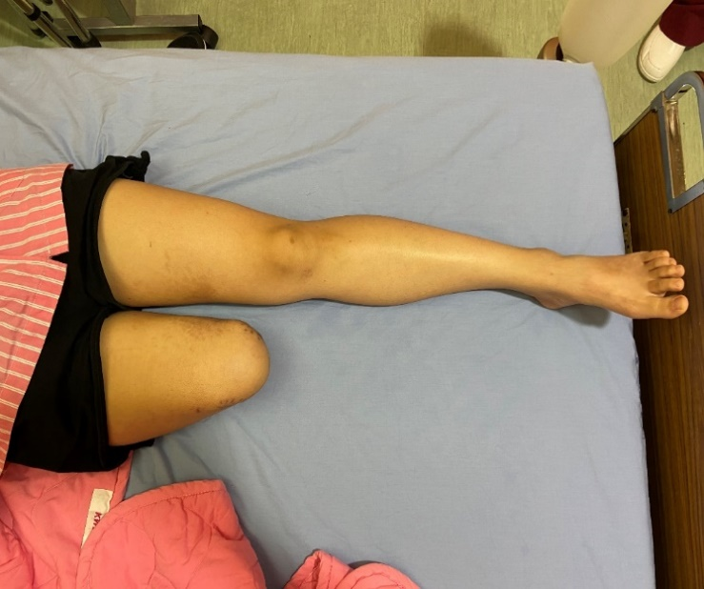

Figure 1: Lower legs of our case. Her right stump shows clean with well shrinkage (cone-shape) in the distal part of the stump.

Strengthening muscle and endurance of right stump was performed at home. Surgical stitches were removed in 2020/02. Initially, she tried body-powered prosthesis, but stumbles and falls occurred several times. The prosthetic fabricating employee suggested trying myoelectric prosthesis with microprocessor in artificial knee for better performance, that is C-Leg (Otto-Bock Healthcare, German, (Figure 2)) which exerts bigger range of motion, more sensitive to obstacles detection, and adjusting steps automatically on rugged ground. In consideration of these advantages, she chose to wear the C-Leg since 2021/03.

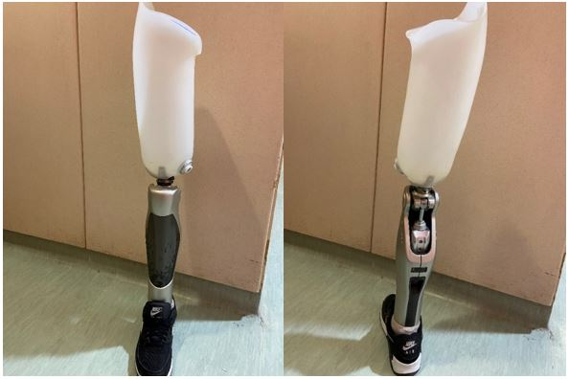

Figure 2: Front (left panel) and back side (right panel) of the C- Leg.

Mild scoliosis of lumbar spine was observed in plain films while taking off the C-Leg. Her right lower limb was measured 78.8cm (from femoral head to distal tibia) and left lower limb 77.2 cm (from femoral head to distal tibia), respectively, the difference was 1.6 cm (Figure 3). The difference of lower extremities between right amputation side and left intact side is 1.6 cm, with longer in the right side. The reason for the difference was to correct her malposture with uneven shoulders due to her prior lumbar scoliosis and slight elevation of right iliac crest. The diagnosis of the leg length discrepancy was confirmed. She was instructed to stand still on the platform with firm and foam surfaces, hanging her arms down naturally. Each condition was tested twice for 30 s, once with her eyes open and once with eyes closed, and she was allowed to rest for 1-2 min after each test. Analysis of postural sway was performed using a Biodex balance system (Biodex Medical Systems, SD, 950-440, Inc., New York, USA), which was based on a data logger itself to record signal data from a platform by means of test software. Using this system, the sway index was obtained, (Table 1). Clinical narrative description of posture and gait was listed in (Table 2). After adaption with wearing C-Leg, she did not tumble down again with the C-Leg. The drama lessons in videos that gave her confidence and how her artificial knee has helped her to do more than even her ambitious nature ever thought possible [3,4].

Conditions of Trial | Sway Index (Myoelectric C-Leg Prosthesis) | Sway Index (Body-powered Prosthesis) | Sway Index (One-leg Standing ) | Mean of Sway Index
Eyes Open Film Surface | 0.35 | 0.39 | 0.56 | 0.44
Eyes Closed Film Surface | 0.78 | 2.61 | 2.82 | 0.8
Eyes Open Foam Surface | 0.39 | 0.41 | 0.92 | 0.79
Eyes Closed Foam Surface | 1.36 | 1.54 | 2.58 | 2.41
Composite Score | 1.09 | 1.24 | 2.13 | 1.11

Table 1: Sway index of balance testing detected from four challenging conditions and the combination of the four in our case.

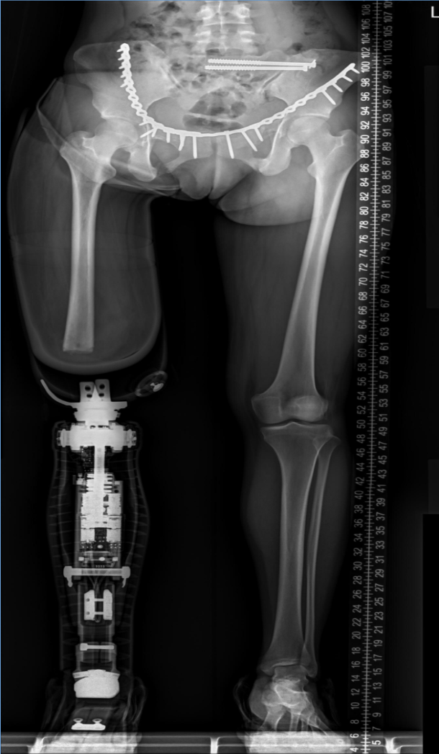

Figure 3: Scanography for length measurement of lower extremities in upright standing. C- Leg is seen in the right side from the triple films, AP projection. Internal fixation with pubic ramus plate and ilio-sacral screws are also seen in order to fix the pelvic fractures.

 | Myoelectric Prosthesis (C-Leg) | Conventional Body-powered Prosthesis
Gait | Safe | Unsafe
Posture | Completely even shoulders while upright standing (even mild scoliosis of lumbar spine) | Mildly uneven shoulders while upright standing
Safety in accident | Reducing the frequency of falls and stumbles | Falls and stumbles occur if loss of prosthesis control
Stair climbing | Step over step while downstairs | Step to gait while upstairs and downstairs
Comfort | More comfortable | Less comfortable

Table 2: Narrative description for comparison of practice experience using C- Leg and conventional prosthesis.

Discussion

Narrative description of experience of the C-Leg was the main issue of the case report. The C-Leg exerts more range of motion, unique sensitivity to detect obstacles, automatic step on uneven road, decreasing the risk of tumbling down, and walking downstairs step over step steadily. To our knowledge, this is the first case report in Taiwan presenting the experience of wearing C-Leg.

Absence of knee joint or ankle joint after amputation reduces movement control and stability while standing [5]. We examined the balance of our case standing with C-Leg by BIODEX Balance SD. It disclosed relatively stable in combination of all conditions with C-Leg use, as (Table 2). Gait pattern was affected due to increased variability of trunk and pelvic movement during walking on uneven ground and slope in amputees [6]. The individuals of transfemoral amputees usually stepped up with the intact extremity and then the prosthetic one due to lacking quadriceps like function on the prosthetic knee. The C-Leg could adapt a variety of gait speeds and allow safe descent of slopes and stairs with alternating foot. In going downstairs, C-Leg offers the possibility of eliminating assistive device use and improving step length in the absence of an assistive device. It increases performance of downstairs compared the body- powered knee joint [7]. The C-Leg results in 23% gait speed increase during ramp descent [8]. In addition, it increases mobility [9] and walking speed [10], and improves gait asymmetry [11,12]. C-Leg can reduce the risk of stumbling up to 80% [10]. Previous studies found improvements of health- related quality of life in C-Leg users compared with body- powered knee joints [13-15].

Posture has been demonstrated to be affected in lower-limb amputate with wearing prosthesis or without; therefore, postural sway quantifies a subject’s capacity to uphold center of steadiness. In the past, sway parameters of mean, area, velocity, and intensity were important [16-19]. The sway index is now an objective parameter of postural sway, which endows with a universal assessment of how well an individual may amalgamate various senses in consideration of balance, and reimburse while one or more of those senses are compromised. A high value of sway index indicates a reduction in the one’s ability to sustain upright posture during challenges. The lower the sway index the less unsteady the subject was under balance trials [20]. As shown in (Table 1), our case showed nearly normal sway index with the C-Leg, better than with a conventional prosthesis, and even better than those without wearing prosthesis, indicating the benefits from wearing the C-Leg.

A latest study indicated active transfemoral amputees with prescription of the C-Leg improves locomotor ability (Locomotor Capability Index 5), satisfaction (Quebec User Evaluation of Satisfaction with Assistive Device 2.0) and quality of life (Medical Outcomes Study Short Form 36) after 6 months of wear when compared with prior prosthesis [21]. C-Leg is more suitable for active young amputees, like our case. For older amputees, higher mortality rates and lower utility values reduced the additional benefits and the cost-effectiveness of C-Legs. A recent health economic study reported a negative impact of age on the benefits and cost effectiveness of the C-Leg [14]. With respect to the issue of cost- effectiveness, there was no study in Taiwan discussing C-Leg, so further research exploring the issue should be investigated in the near future.

Conclusion

The C-Leg exerts more range of motion, unique sensitivity to detect obstacles, automatic step on uneven road, decreasing the risk of tumbling down, and walking downstairs step over step steadily. We recommend that the young and active transfemoral above-knee amputee to obtain advantages of the C-Leg including decreasing episodes of falls, ability to walking downstairs step over step, and comfort while wearing.

Acknowledgement

There was no funding of this research. We sincerely thanked the patient for providing information about the use of C-Leg. We also thank Yong Chwen Prosthetic & Orthopedic Inc., was formed in Taiwan in 1976 for providing such outstanding prosthetic training.

References

- Esquenazi A, Amputation (2004) rehabilitation and prosthetic restoration. From surgery to community reintegration. Disability and rehabilitation 26: 831-836.
- Holzer LA, Sevelda F, Fraberger G, et al (2014) Body image and self-esteem in lower-limb amputees. PloS one 9: e92943.
- https://www.youtube.com/watch?v=GLeaaQCCNbg
- https://youtu.be/55ajrQI6FWM
- Ku PX, Abu Osman NA (2014) Wan Abas WA. Balance control in lower extremity amputees during quiet standing: A systematic review. Gait & posture 39: 672-682.
- Müßig JA, Brauner T, Kröger I, et al. (2019) Variability in trunk and pelvic movement of transfemoral amputees using a C-Leg system compared to healthy controls. Human movement science 68:102539.
- Hafner BJ, Willingham LL, Buell NC, et al. (2007) Evaluation of function, performance, and preference as transfemoral amputees transition from mechanical to microprocessor control of the prosthetic knee. Archives of physical medicine and rehabilitation 88: 207-217.
- Highsmith MJ, Kahle JT, Miro RM, et al. (2013) Ramp descent performance with the C-Leg and interrater reliability of the hill assessment index. Prosthetics and orthotics international 37: 362-368.
- Theeven PJ, Hemmen B, Geers RP, et al. (2012) Influence of advanced prosthetic knee joints on perceived performance and everyday life activity level of low-functional persons with a transfemoral amputation or knee disarticulation. Journal of rehabilitation medicine 44: 454-461.
- Eberly VJ, Mulroy SJ, Gronley JK, et al. (2014) Impact of a stance phase microprocessor-controlled knee prosthesis on level walking in lower functioning individuals with a transfemoral amputation. Prosthetics and orthotics international 38: 447-455.
- Kaufman KR, Frittoli S, Frigo CA (2012) Gait asymmetry of transfemoral amputees using mechanical and microprocessor-controlled prosthetic knees. Clinical biomechanics (Bristol, Avon) 27: 460-465.
- Schaarschmidt M, Lipfert SW, Meier-Gratz C, et al. (2012) Functional gait asymmetry of unilateral transfemoral amputees. Human movement science 31: 907-917.
- Brodtkorb TH, Henriksson M, Johannesen-Munk K, et al. (2008) Cost-effectiveness of C-Leg compared with non-microprocessor-controlled knees: A modeling approach. Archives of physical medicine and rehabilitation 89: 24-30.
- Cutti AG, Lettieri E, Del Maestro M, et al. (2007) Stratified cost-utility analysis of C-Leg versus mechanical knees: Findings from an italian sample of transfemoral amputees. Prosthetics and orthotics international 41: 227-236.
- Gerzeli S, Torbica A, Fattore G (2009) Cost utility analysis of knee prosthesis with complete microprocessor control (C-Leg) compared with mechanical technology in trans-femoral amputees. The European journal of health economics : HEPAC : health economics in prevention and care 10: 47-55.
- Chang ST, Ku CH (2007) Postural sway at ground and bevel levels in subjects with spina bifida occulta. European Spine Journal 16: 759-769.
- Chang ST, Ku CH, Hsieh MF, et al. (2008) Contribution of the multifidus muscle for control of upright posture in subjects with spina bifida occulta. Journal of Sport Rehabilitation 17: 283-299.
- Chang ST, Chen LC, Chang CC, et al. (2008) Effects of piroxicam-beta-cyclodextrin sachets on abnormal postural sway in patients with chronic low back pain. Journal of Clinical Pharmacy and Therapeutics 33: 495-506.
- Chang CC, Chu HY, Chiang SL, et al. (2009) Impairment of static upright posture in subjects with undifferentiated arthritis in sacroiliac joint in conjunction with elevation of streptococcal serology. Journal of Back and Musculoskeletal Rehabilitation 22: 33-41.
- Freeman L, Gera G, Horak FB, et al. (2018) Instrumented test of sensory integration for balance: a validation study. Geriatr Phys Ther 41: 77-84.
- Lansade C, Chiesa G, Paysant J, et al. (2021) Impact of C-Leg on mobility, satisfaction and quality of life in a multicenter cohort of femoral amputees. Annals of physical and rehabilitation medicine 64: 101386.

